Verification of PT7C4337 IBIS model
- Introduction:
To verify the correlation between the ibis model and hspice model, we need to do some simulations:

- IO: Add a 1KΩ pull-up resistor to the IO pad.
PT7C4337
VOUT

SCL_C
SDA_C
Input Signals

SCL_C
SDA_C
VIN

SCL_C
SDA_C
SDA
input
…..

SCL_C
SDA_C
VCC
R=1kOhm

SCL_C
SDA_C
The frequency of signal is 500KHz:
vin input pulse (0 power 0 1n 1n 1u 2u)
- without package;
- with package;

- OUTPUT: Add a 1KΩ pull-up resistor to the OUTPUT pad.
PT7C4337

VOUT

SCL_C
SDA_C
Input Signals

SCL_C
SDA_C
VIN

SCL_C
SDA_C
_INTA
input
…..

SCL_C
SDA_C
VCC
R=1kOhm

SCL_C
SDA_C
The frequency of signal is 500KHz:
vin input pulse (0 power 0 1n 1n 1u 2u)
- without package;
- with package;

- Conclusion:
For IO and OUTPUT, the simulation results of IBIS model can match quite well with the HSPICE model at above load conditions.

- IO Simulation Result:
- without package;
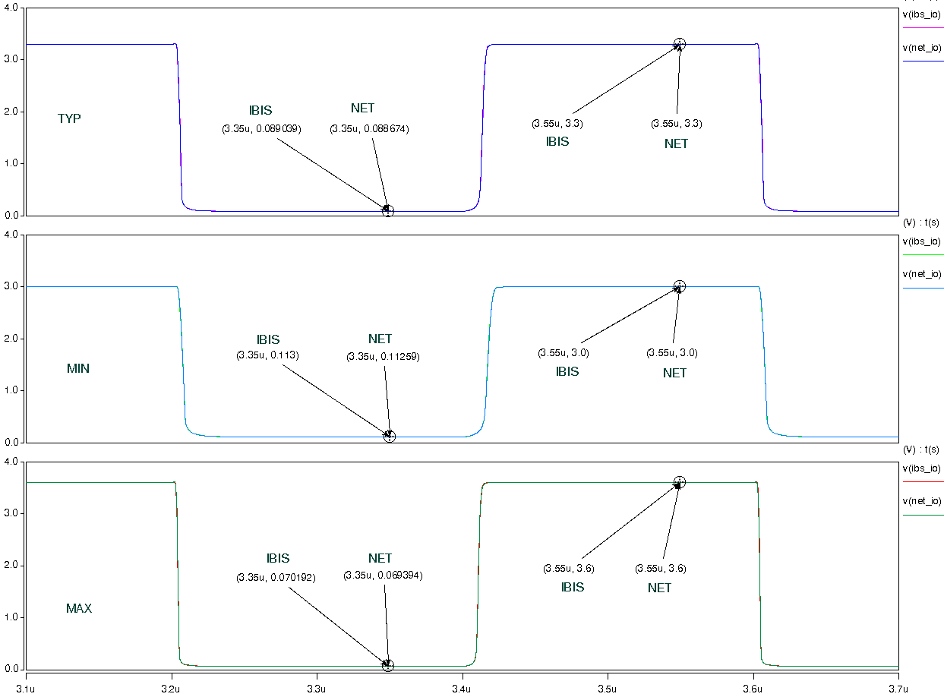

- with package;
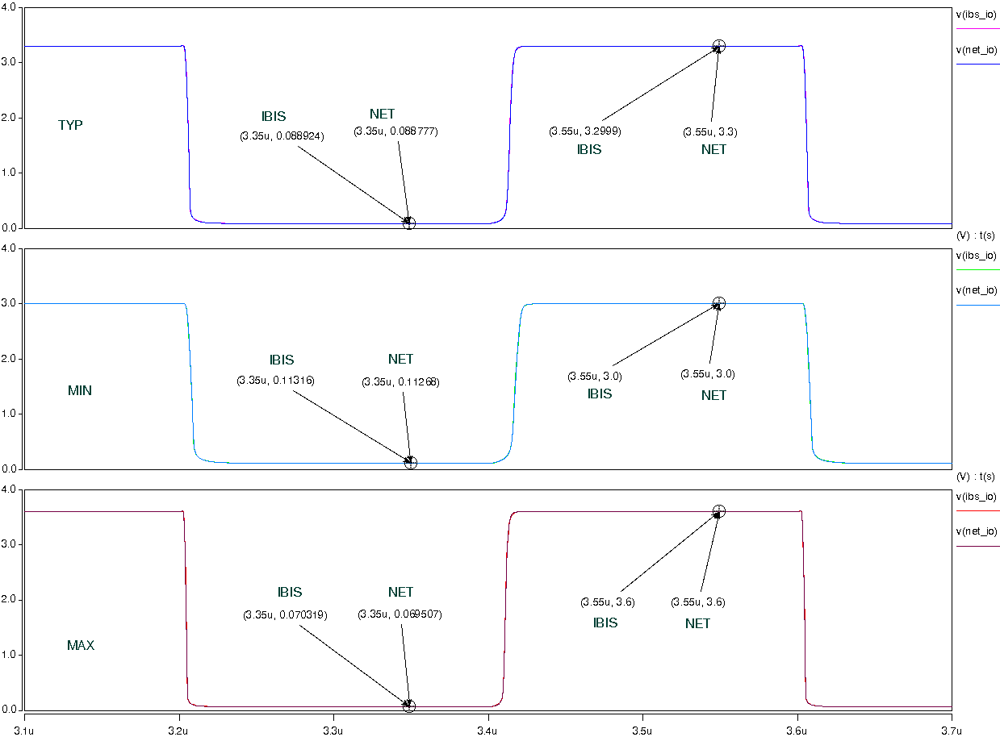
- OUTPUT Simulation Result:
- without package;
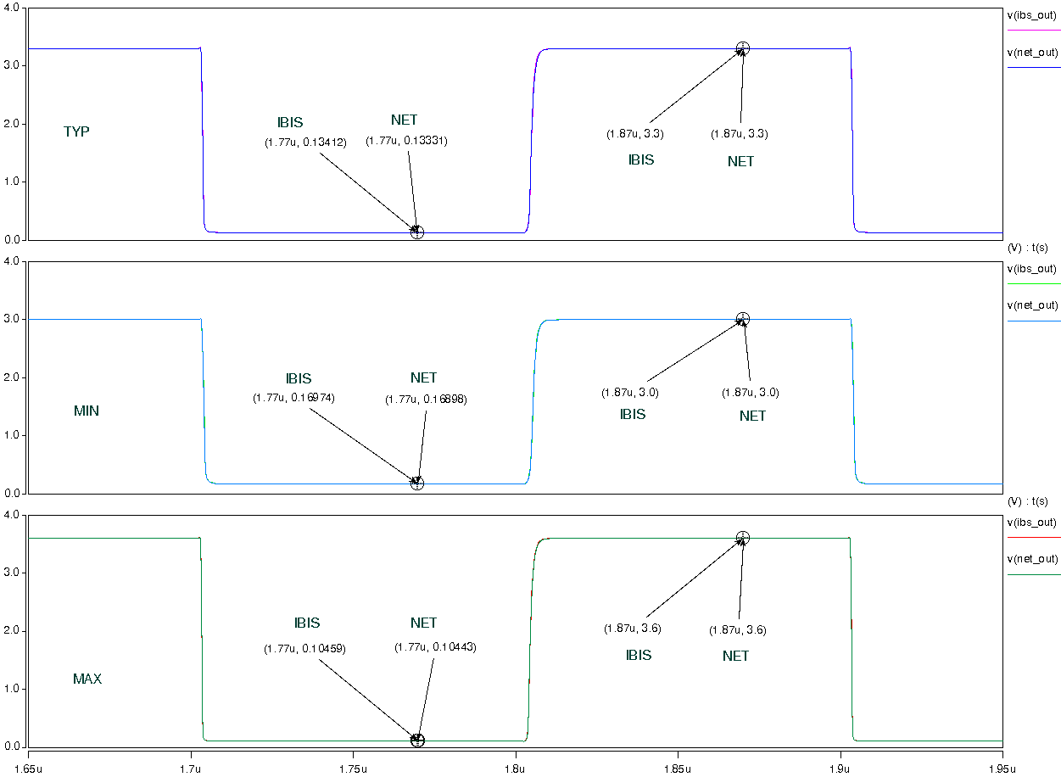
- with package;
