Verification of PI90LV02 IBIS model
- Introduction:
To verify the correlation between the ibis model and hspice model, we need to do some simulations:
Output condition according to the datasheet : Add 50Ω pull-down resistor to the INPUT and 5p pull-down capacitance to the OUTPUT:
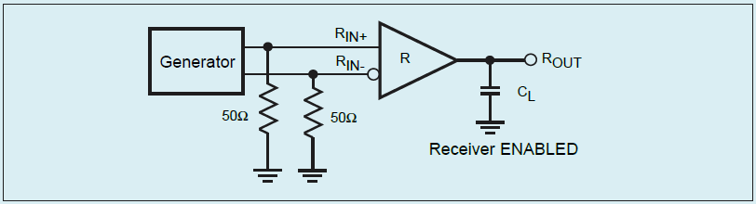

- The frequency of signal is 100MHz (200Mbps).
V_inp a gnd pulse ( 3 0 0 .1n .1n 4.9n 10n)
V_inn b gnd pulse ( 0 3 0 .1n .1n 4.9n 10n)

- The frequency of signal is 333MHz (666Mbps).
V_inp a gnd pulse ( 3 0 0 .05n .05n 1.45n 3n)
V_inn b gnd pulse ( 0 3 0 .05n .05n 1.45n 3n)

- Conclusion:
- For OUTPUT, the simulation results of IBIS model can match very well with the HSPICE model at different simulating conditions.

- Simulation Result:
Output condition according to the datasheet :
Simulation result:
- The frequency of signal is 100MHz (200Mbps).
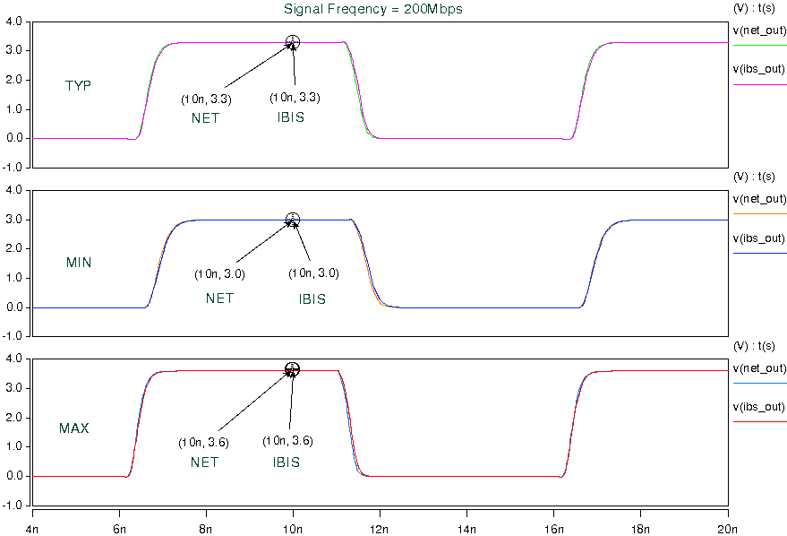

- The frequency of signal is 333MHz (666Mbps).
