**PI90LV01 IBIS Model Check**

**Two IBIS Models: PI90LV01_TE.ibs.**

**1. Model Type**

These two ibis models are just different in packaging, their pin information are the same.

pi90lv01te.ibs– 5-pin space-saving SOT23 (T)

**[Pin]** signal_name model_name

1 VCC POWER

2 GND GND

3 Z OUTPUT

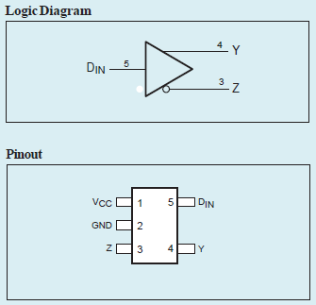4 Y OUTPUT

5 DIN INPUT

**Conclusion**

The PIN information described in IBIS model is **exactly correct** according to the datasheet.

**2. IBIS Data Graph of PI90LV01TE.ibs**

**(1) Model INPUT:**

a. POWER Clamp

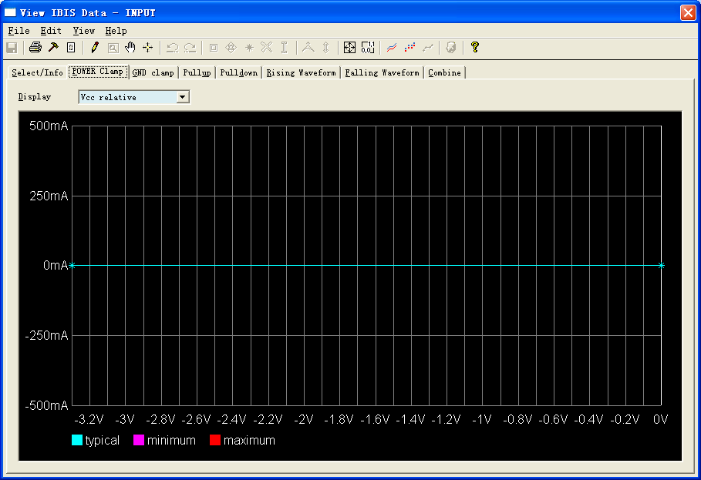

b. GND Clamp

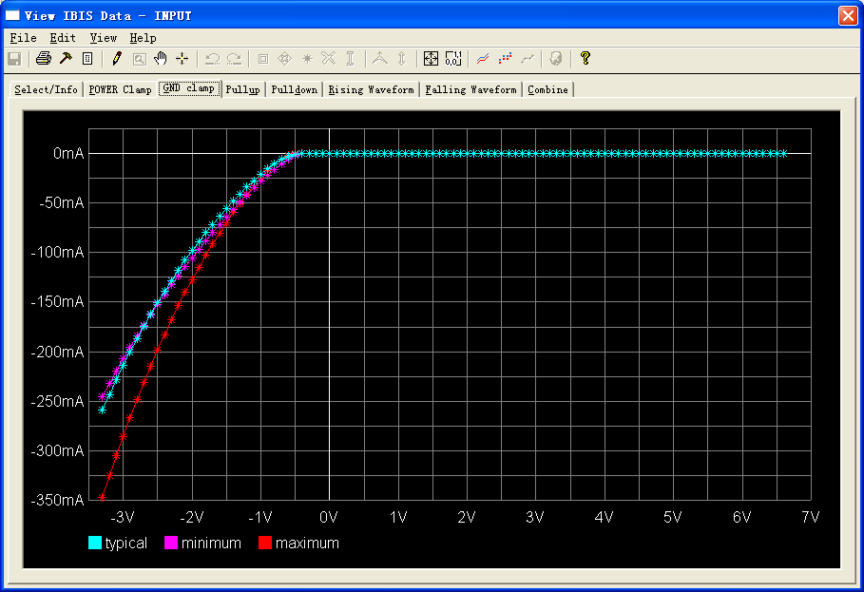

**(2) Model OUTPUT:**

a. POWER Clamp

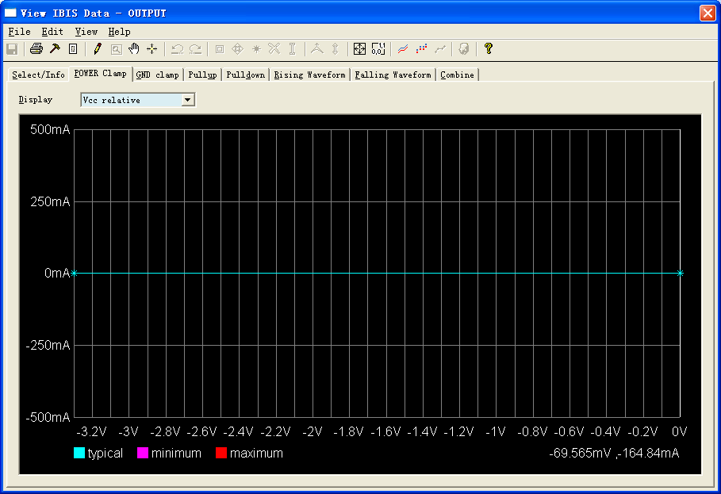

b. GND Clamp

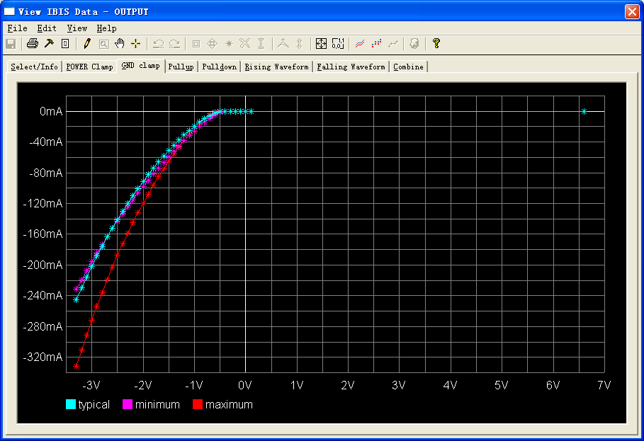

c. Pullup

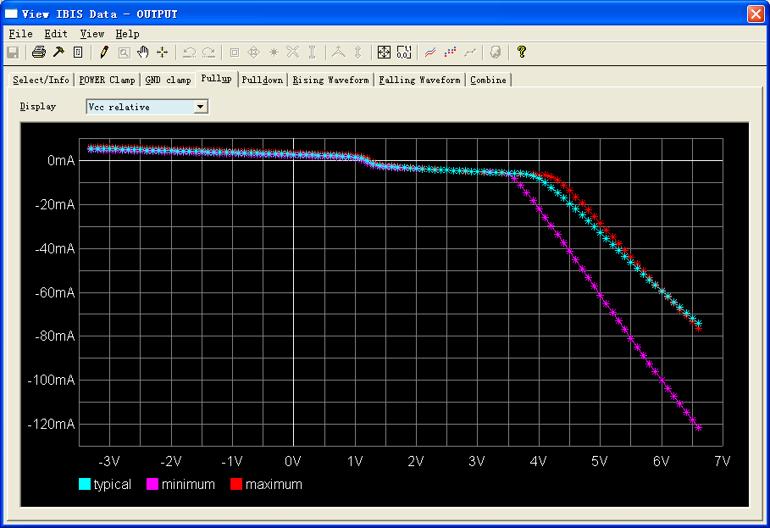

d. Pulldown

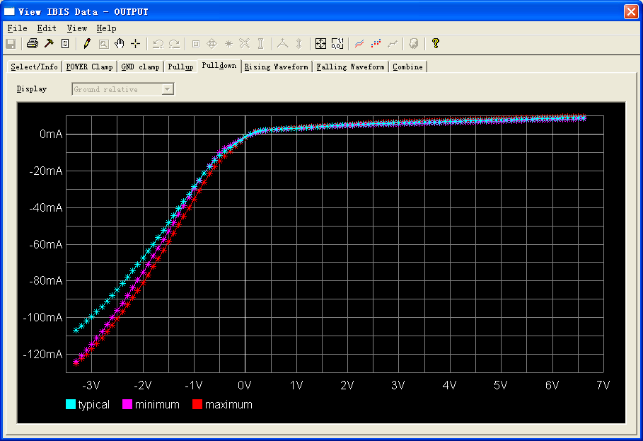

e. Rising Waveform

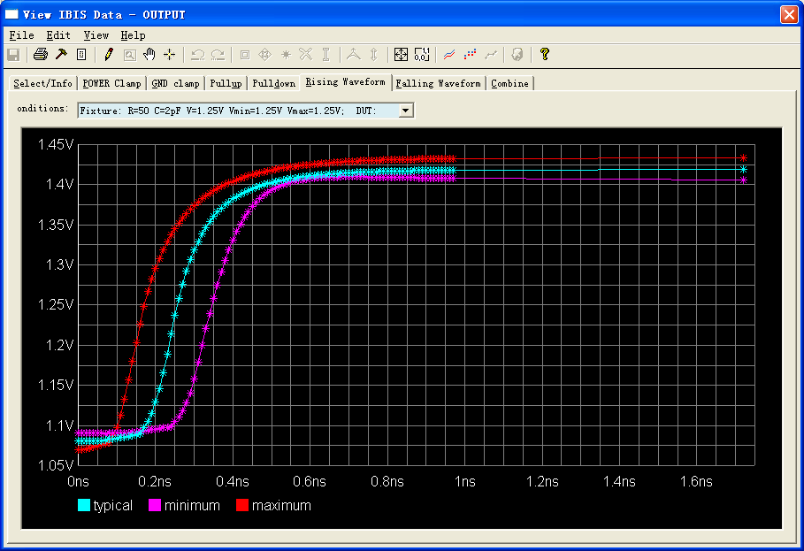

f. Falling Waveform

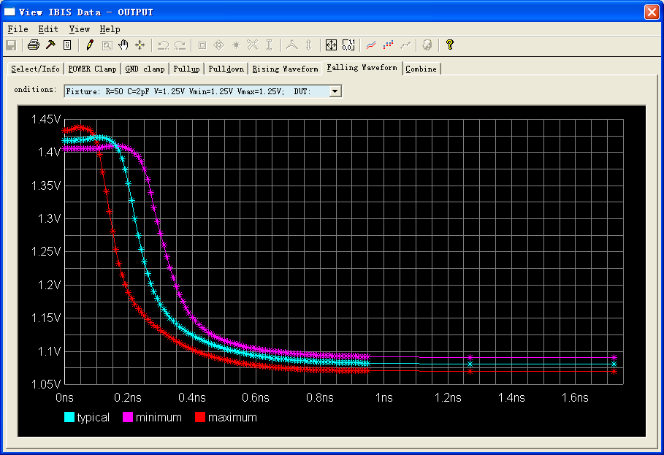

**3) Simulation waveform:**

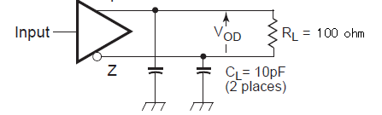

Condition: RL=100ohm, CL=10pF, Frequency=125meg

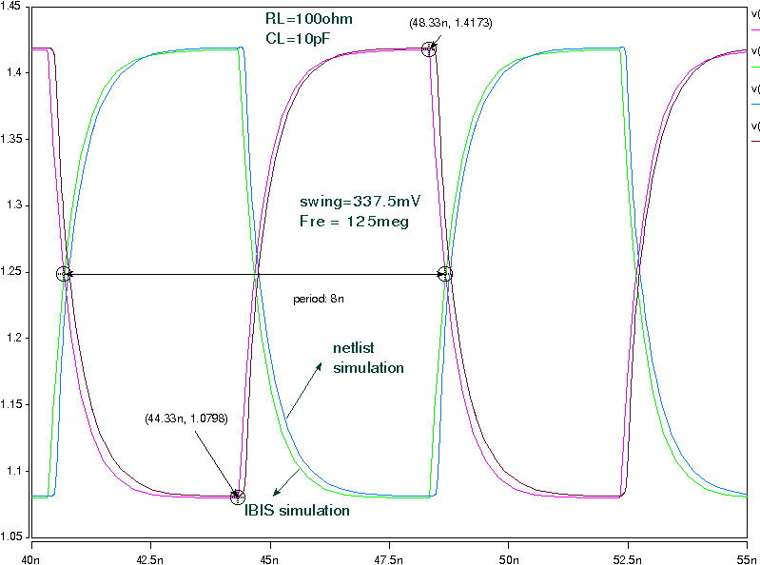

Condition: RL=100ohm, CL=10pF, Frequency=330meg

