Verification of PI7C1401 IBIS model
- Introduction:
To verify the correlation between the ibis model and hspice model, we need to do some simulations:
- IO(PCI, 1.8V Supply Voltage):
The frequency of signal is 5MHz:
- Pull-Down(Without Package):
PI7C1401-PCI
VOUT

SCL_C
SDA_C
R

SCL_C
SDA_C
A

SCL_C
SDA_C
C

SCL_C
SDA_C
Input Signals

SCL_C
SDA_C
PAD

SCL_C
SDA_C
VIN

SCL_C
SDA_C
…..

SCL_C
SDA_C
- Add 50Ω pull-down resistor and without capacitance to the output;
- Add 5p pull-down capacitance and without resistor to the output;
- Add 50Ω pull-down resistor and 5pF pull-down capacitance to the output;
- Pull-Up(Without Package):
PI7C1401-PCI

VOUT

SCL_C
SDA_C
R

SCL_C
SDA_C
A

SCL_C
SDA_C
C

SCL_C
SDA_C
Input Signals

SCL_C
SDA_C
VIN

SCL_C
SDA_C
VDDIO

SCL_C
SDA_C
PAD

SCL_C
SDA_C
…..

SCL_C
SDA_C
- Add 50Ω pull-up resistor and without capacitance to the output;
- Add 50Ω pull-up resistor and 5pF pull-down capacitance to the output;
- With Package:
PI7C8958-PCI

VOUT

SCL_C
SDA_C
A

SCL_C
SDA_C
Input Signals

SCL_C
SDA_C
VIN

SCL_C
SDA_C
PAD

SCL_C
SDA_C
…..

SCL_C
SDA_C
Package
(Including RLC Parameters)

SCL_C
SDA_C
- Without resistor and capacitance to the output;

- Conclusion:
- For IO (PCI, 1.8V Supply Voltage), the simulation results of IBIS model can match quite well with the HSPICE model at different simulating conditions.
- Simulation Result:
- IO(PCI, 1.8V Supply Voltage):
- Pull-Down:
- Add 50Ω pull-down resistor and without capacitance to the output;
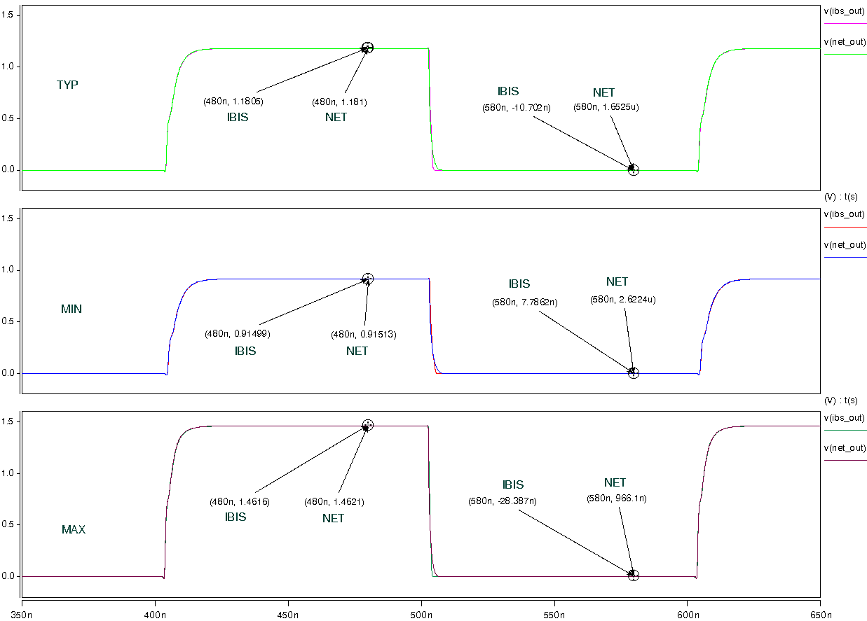
- Add 5p pull-down capacitance and without resistor to the output;
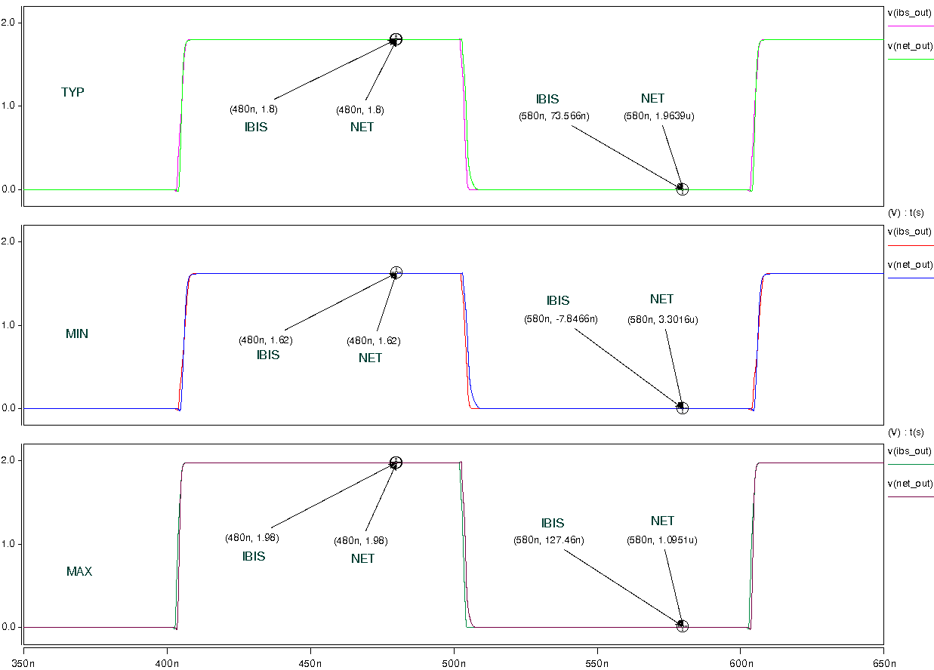
- Add 50Ω pull-down resistor and 5pF pull-down capacitance to the output;
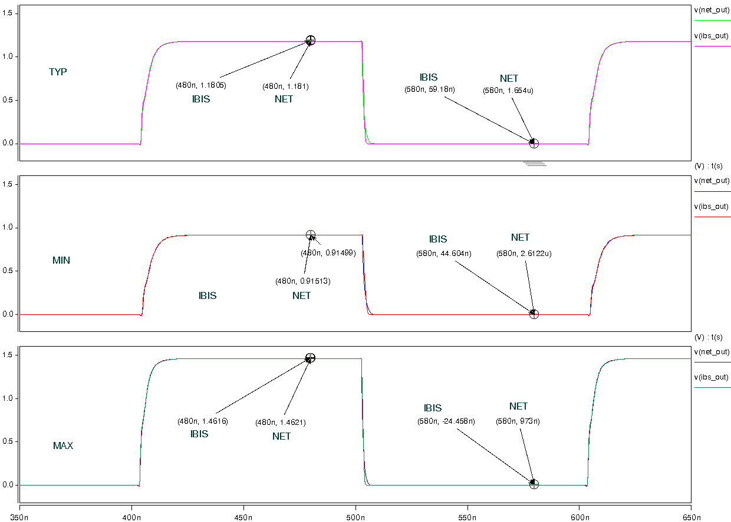
- Pull-Up:
- Add 50Ω pull-up resistor and without capacitance to the output;
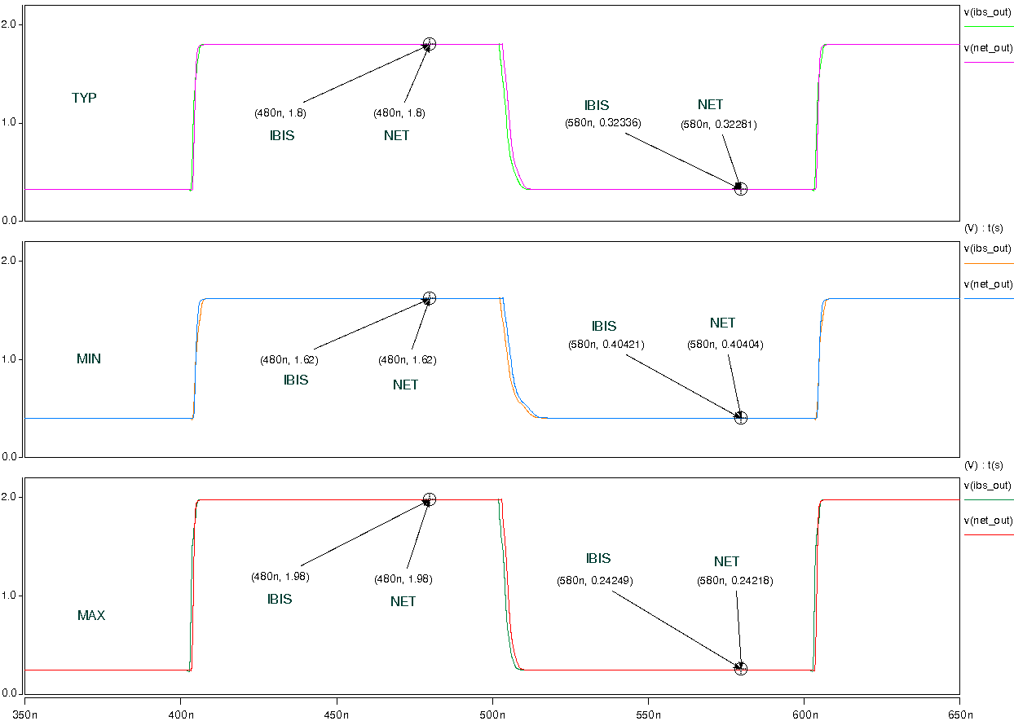

- Add 50Ω pull-up resistor and 5pF pull-down capacitance to the output;
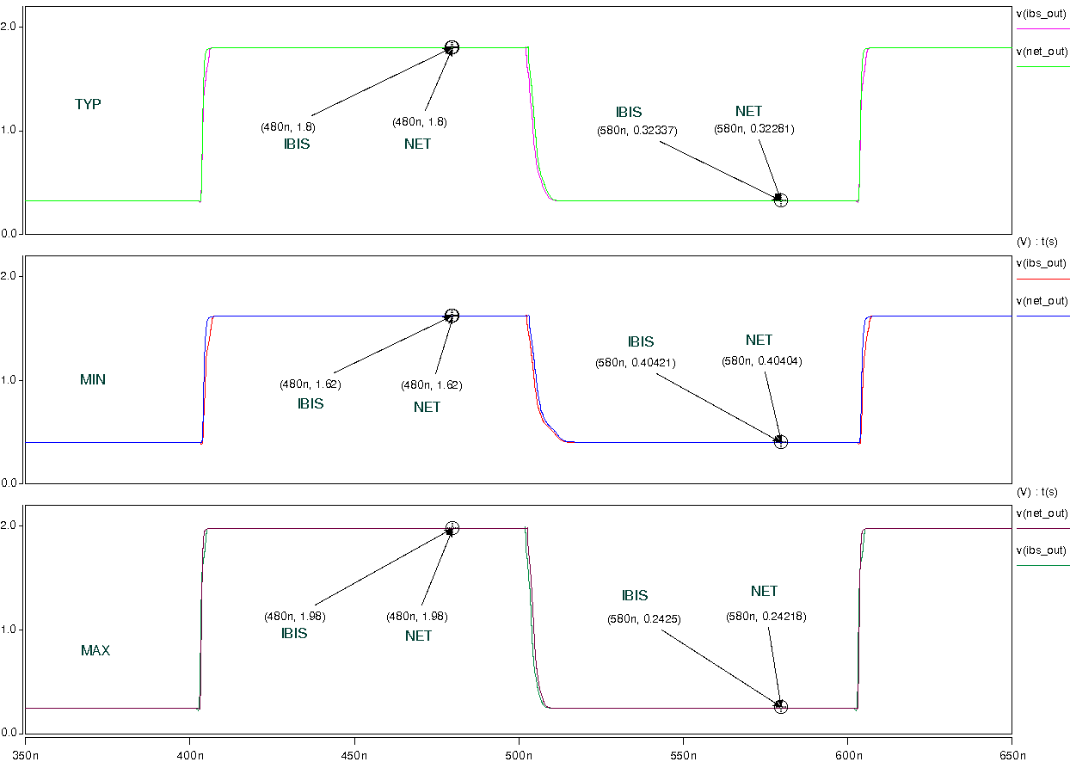
- With Package:
- Without resistor and capacitance to the output;
