Verification of PI6ULS5V9617A IBIS model
- Introduction:To verify the correlation between the ibis model and hspice model, we need to do some simulations:
- Port A to Port B: Vccb=3.3V.
PI6ULS5V9617A
VOUT

SCL_C
SDA_C
R

SCL_C
SDA_C
Input Signals

SCL_C
SDA_C
VIN

SCL_C
SDA_C
VDD

SCL_C
SDA_C
SCLB

SCL_C
SDA_C
SDAB

SCL_C
SDA_C
VOUT

SCL_C
SDA_C
R

SCL_C
SDA_C
VDD

SCL_C
SDA_C
SCLA

SCL_C
SDA_C
SDAA

SCL_C
SDA_C
C

SCL_C
SDA_C
C

SCL_C
SDA_C
- The frequency of signal is 1MHz: Vin input 0 pulse (0 pwr_a 0 1n 1n 499n 1u)
Add 1KΩ resistor between the output and VDD and 50p capacitance to the OUTPUT.
- Simulation without package data;
- Simulation with package data.
- The frequency of signal is 0.2MHz: Vin input 0 pulse (0 pwr_a 0 0.01u 0.01u 2.49u 5u)
Add 1KΩ resistor between the output and VDD and 200p capacitance to the OUTPUT.
- Simulation without package data;
- Simulation with package data.
- Port B to Port A:
The frequency of signal is 1MHz: Vin input 0 pulse (0 pwr_a 0 1n 1n 499n 1u)
Add 1KΩ resistor between the output and VDD and 50p capacitance to the OUTPUT
PI6ULS5V9617A
VOUT

SCL_C
SDA_C
R

SCL_C
SDA_C
Input Signals

SCL_C
SDA_C
VIN

SCL_C
SDA_C
VDD

SCL_C
SDA_C
SCLA

SCL_C
SDA_C
SDAA

SCL_C
SDA_C
VOUT

SCL_C
SDA_C
R

SCL_C
SDA_C
VDD

SCL_C
SDA_C
SCLB

SCL_C
SDA_C
SDAB

SCL_C
SDA_C
C

SCL_C
SDA_C
C

SCL_C
SDA_C
- Vcca=1.8V, Vccb=3.3V
- Simulation without package data;
- Simulation with package data.
- Vcca=3.3V, Vccb=3.3V
- Simulation without package data;
- Simulation with package data.

- Conclusion:
For the verification, the simulation results of IBIS model can match quite well with the HSPICE model at different simulating conditions.
- Simulation Result:
- Port A to Port B: Vcca=1.8V, Vccb=3.3V
- The frequency is 1MHz and add 50p capacitance to the OUTPUT.
- Simulation without package data;
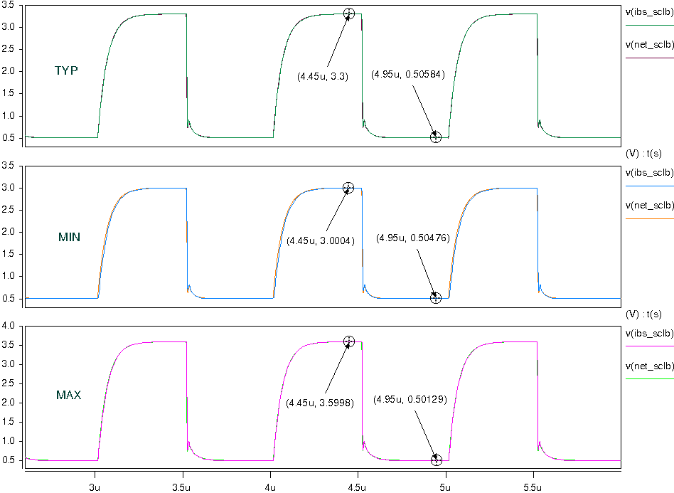
- Simulation with package data.
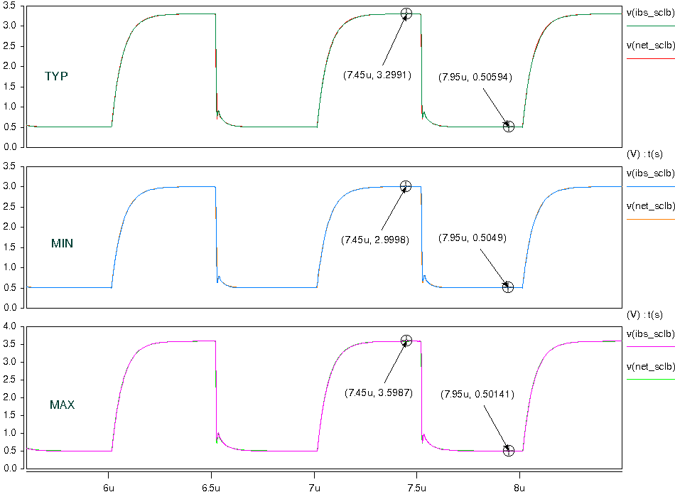
- The frequency is 0.2MHz and add 200p capacitance to the OUTPUT.
- Simulation without package data;
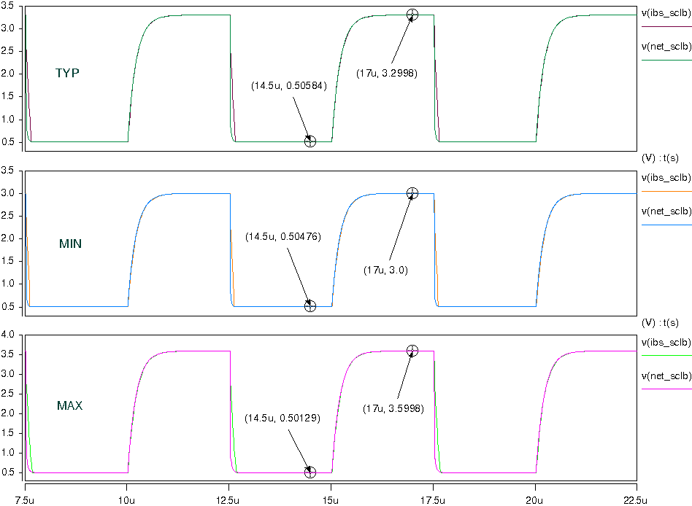
- Simulation with package data.
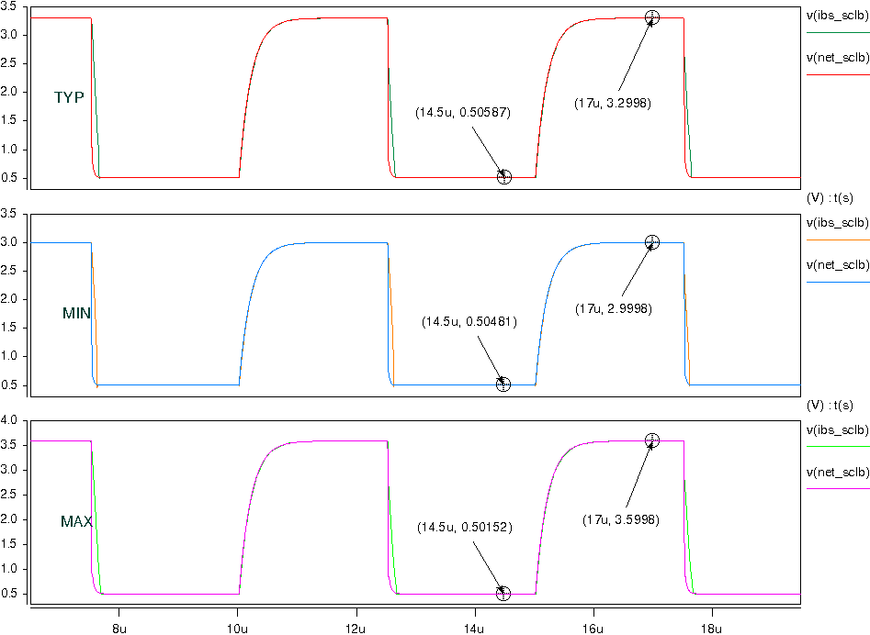

- Port B to Port A:
- Vcca=1.8V, Vccb=3.3V
- Simulation without package data;
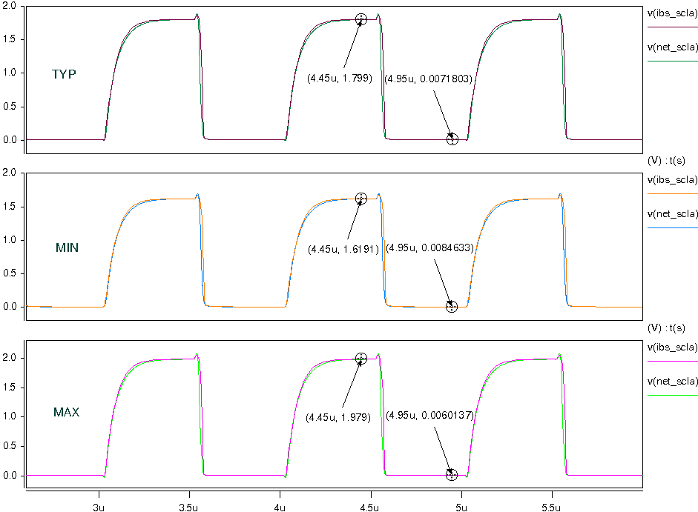
- Simulation with package data.
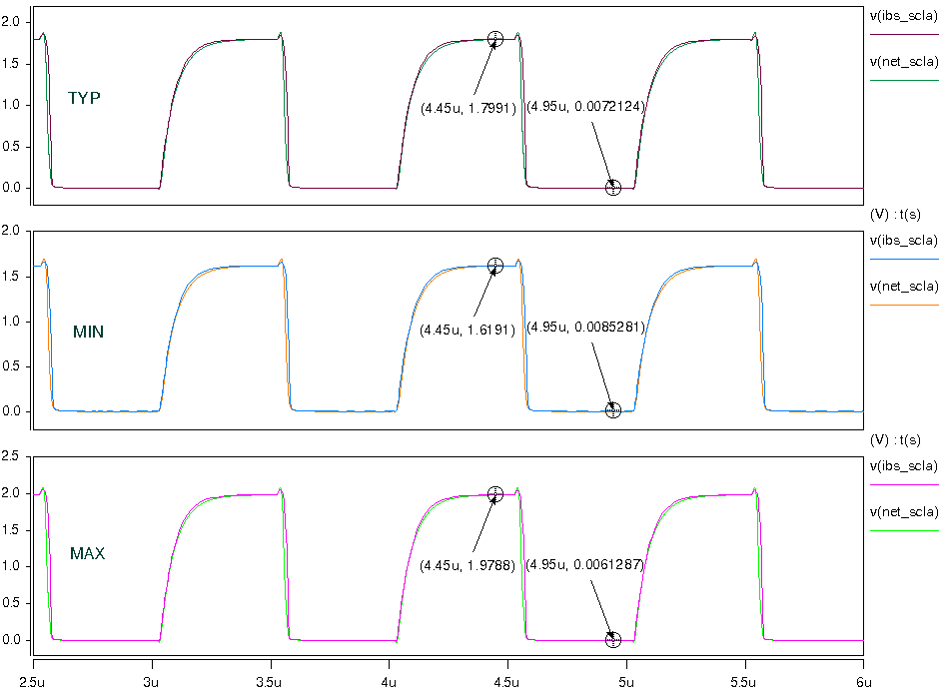
- Vcca=3.3V, Vccb=3.3V
- Simulation without package data;
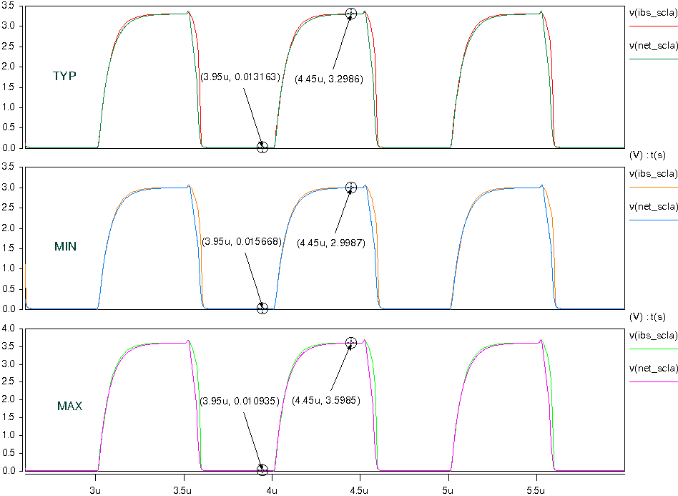
- Simulation with package data.
