IBIS model verification of PI6ULS5V9517B
Introduction: to verify the correlation between the ibis model and hspice model, we need to do some simulations:
- Netlist simulation V.S. IBIS simulation on A-side:
PI6ULS5V9517B
VOUT

SCL_C
SDA_C
Input Signals

SCL_C
SDA_C
VIN

SCL_C
SDA_C
SDAA

SCL_C
SDA_C
SDAB

SCL_C
SDA_C
…..

SCL_C
SDA_C
VDDA

SCL_C
SDA_C
R=1kOhm

SCL_C
SDA_C
C=50pF

SCL_C
SDA_C
- Simulation without package data;
- Simulation with package data.
- VDDB=3.3V, VDDA=0.95V, R=1K, CL=50p, frequency = 400k;
- VDDB=3.3V, VDDA=1.8V, R=1K, CL=50p, frequency = 400k;
- VDDB=3.3V, VDDA=2.5V, R=1K, CL=50p, frequency = 400k;
- VDDB=5.0V, VDDA=3.3V, R=1K, CL=50p, frequency = 400k;
- VDDB=5.0V, VDDA=5.0V, R=1K, CL=50p, frequency = 400k;

- Netlist simulation V.S.IBIS simulation on B-side:
PI6ULS5V9517B
VOUT

SCL_C
SDA_C
Input Signals

SCL_C
SDA_C
VIN

SCL_C
SDA_C
SDAB

SCL_C
SDA_C
SDAA

SCL_C
SDA_C
…..

SCL_C
SDA_C
VDDB

SCL_C
SDA_C
R=1kOhm

SCL_C
SDA_C
C=50pF

SCL_C
SDA_C
- Simulation without package data;
- Simulation with package data.
- VDDB=2.5V, VDDA=5V, R=1K, CL=50p, frequency = 400k;
- VDDB=3.3V, VDDA=5V, R=1K, CL=50p, frequency = 400k;
- VDDB=5.0V, VDDA=5V ,R=1K, CL=50p, frequency = 400k;

- Conclusion:
For the verification, the simulation results of IBIS model can match very well with the HSPICE model at above simulating conditions.

- Simulation waveform on A-side:
- VDDB=3.3V, VDDA=0.95V, R=1K, CL=50p, frequency = 400k;
- Without package
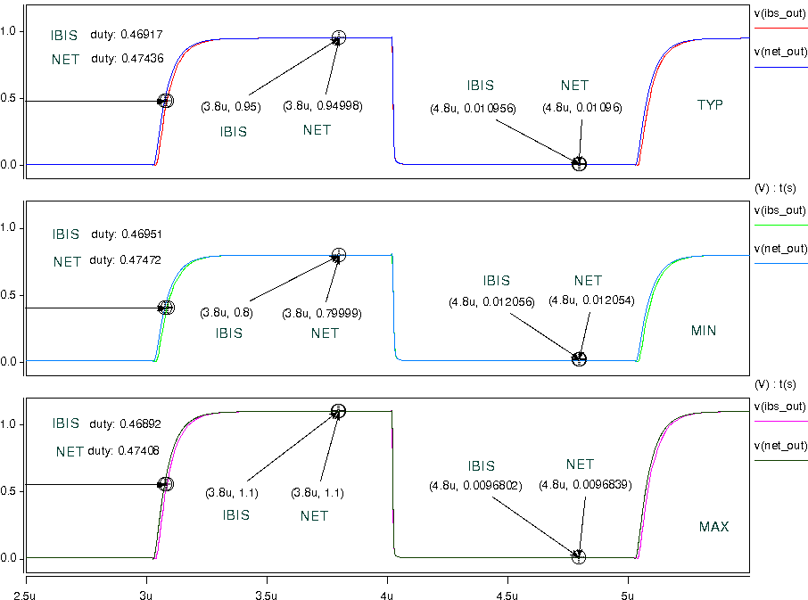
- With package
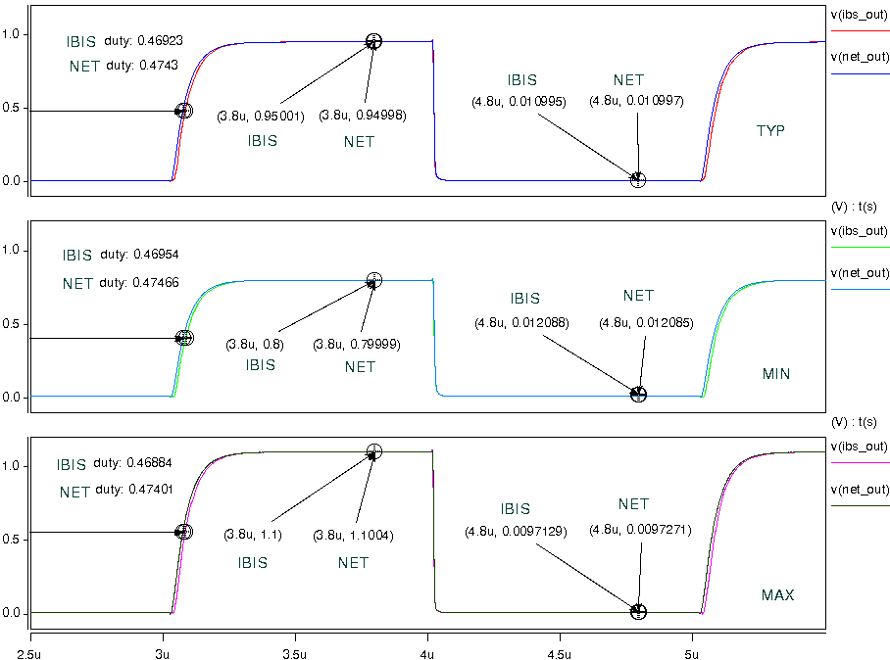
- VDDA=1.8V, VDDB=3.3V, R=1K, CL=50p, frequency = 400k;
- Without package
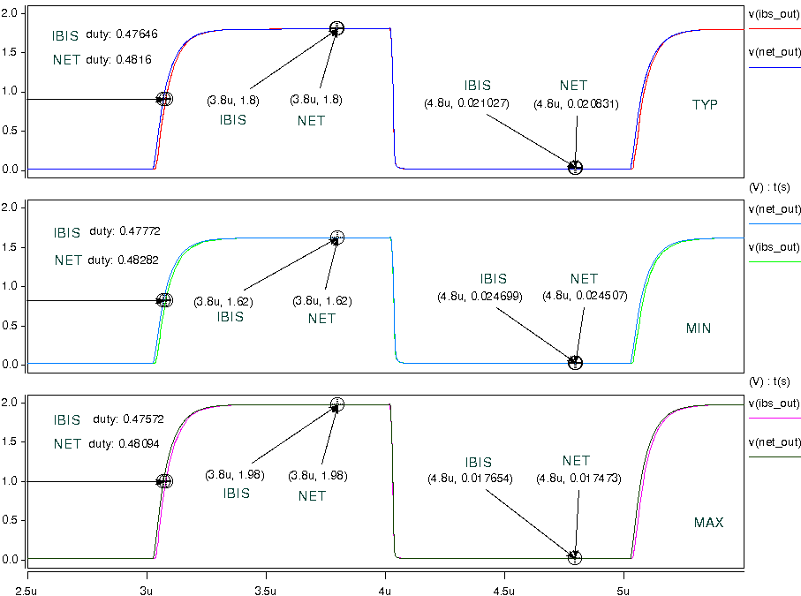
- With package
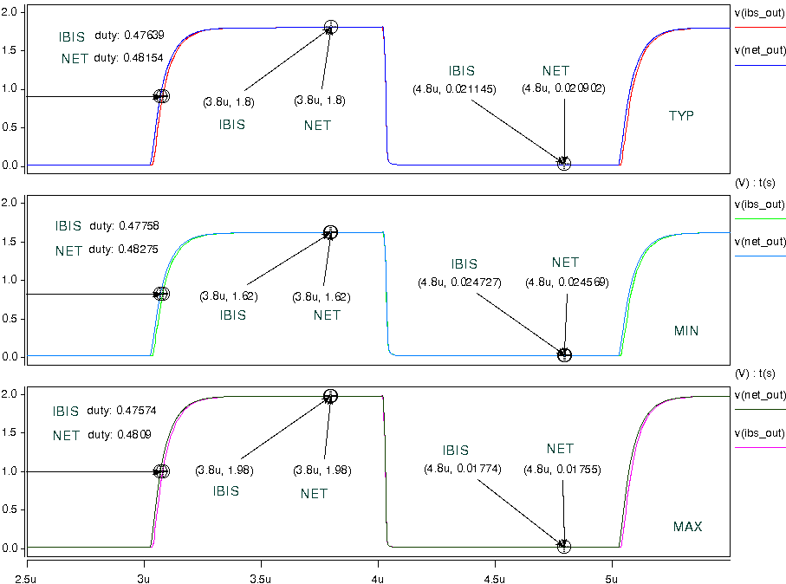

- VDDA=2.5V, VDDB=3.3V, R=1K, CL=50p, frequency = 400k;
- Without package
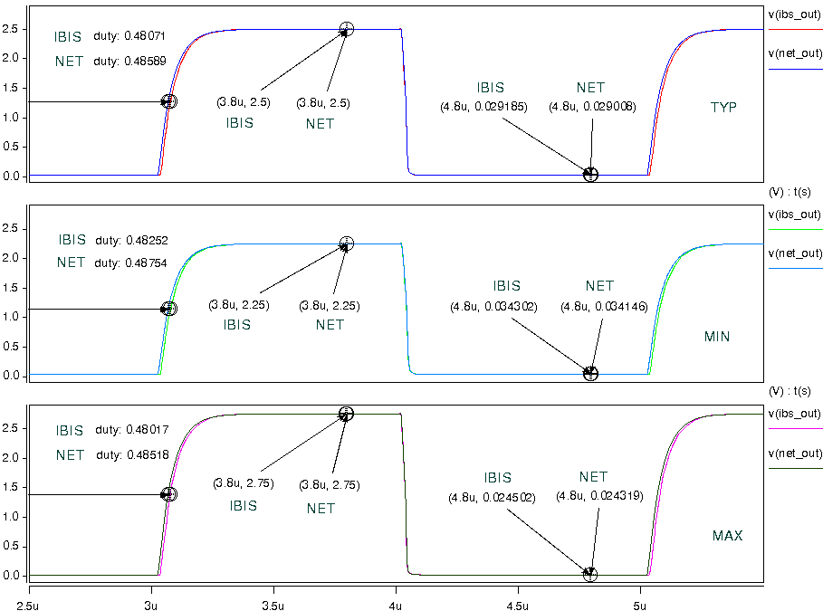
- With package
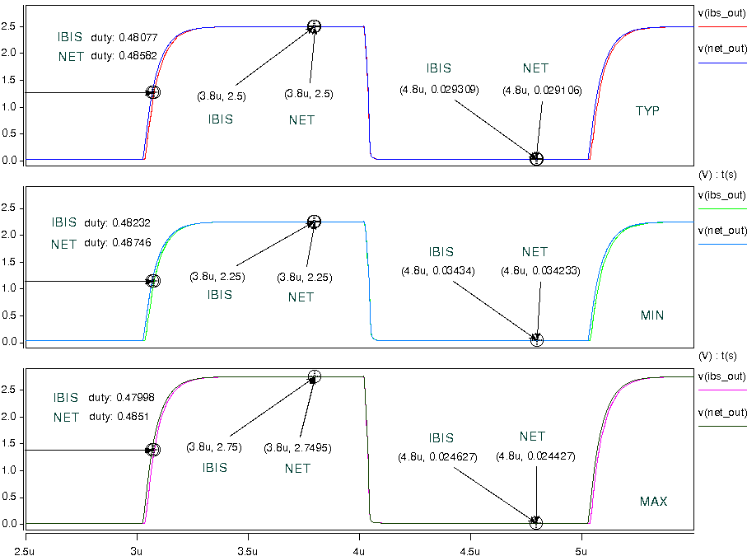

- VDDA=3.3V, VDDB=5.0V, R=1K, CL=50p, frequency = 400k;
- Without package
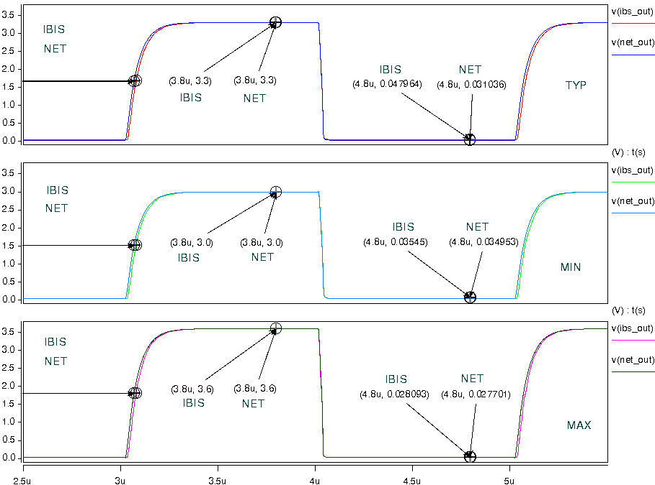
- With package
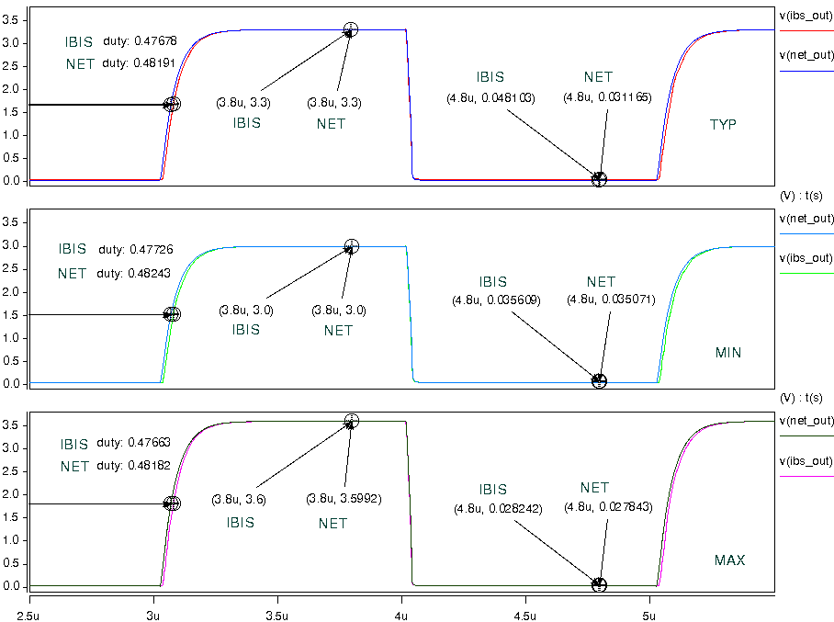

- VDDA=5.0V, VDDB=5.0V, R=1K, CL=50p, frequency = 400k;
- Without package
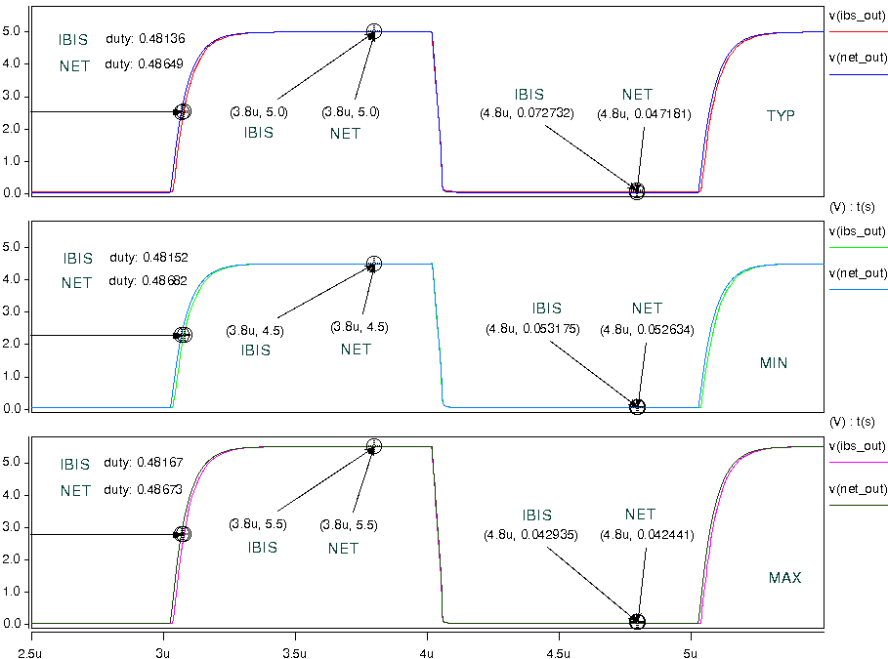
- With package
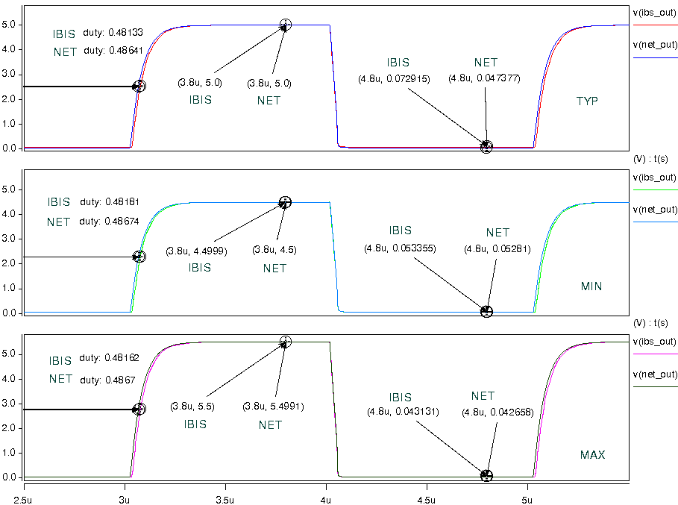

- Simulation waveform on A-side:
- VDDB=2.5V, VDDA=5V, R=1K, CL=50p, frequency = 400k;
- Without package
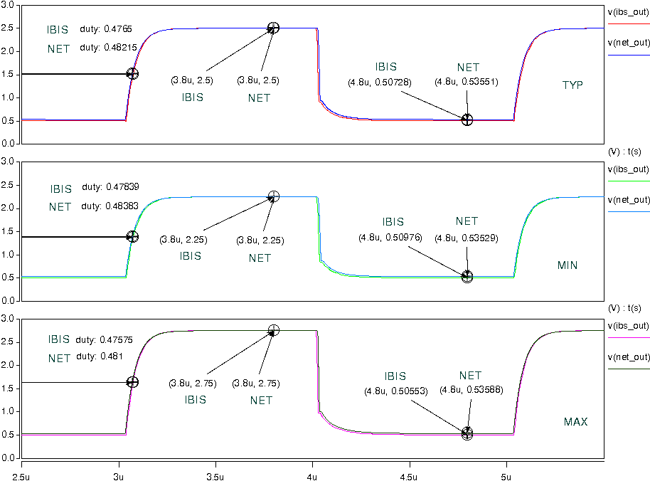
- With package
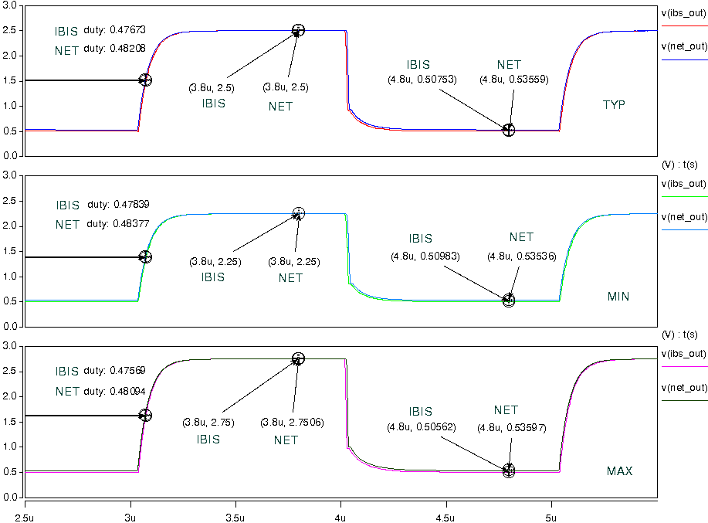
- VDDB=3.3V, VDDA=5V, R=1K, CL=50p, frequency = 400k;
- Without package
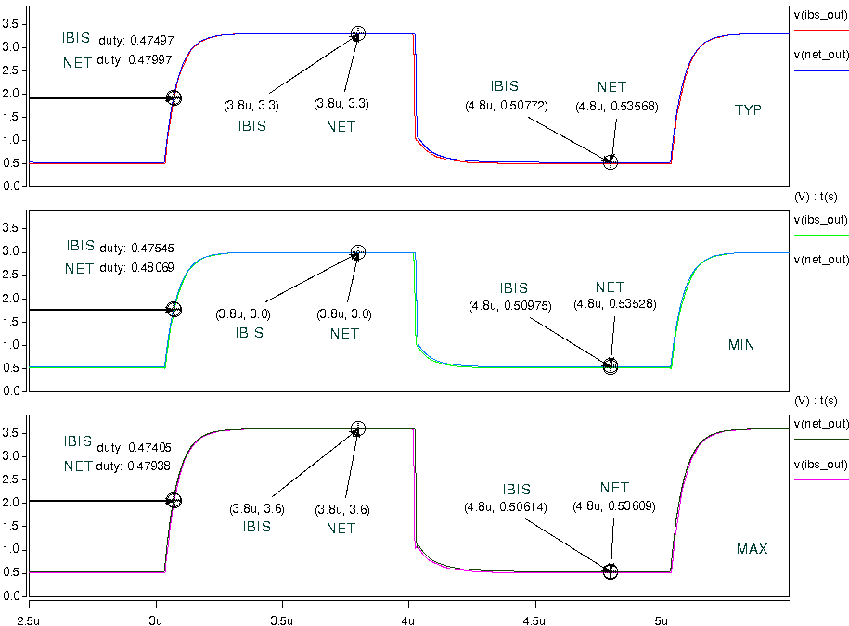
- With package
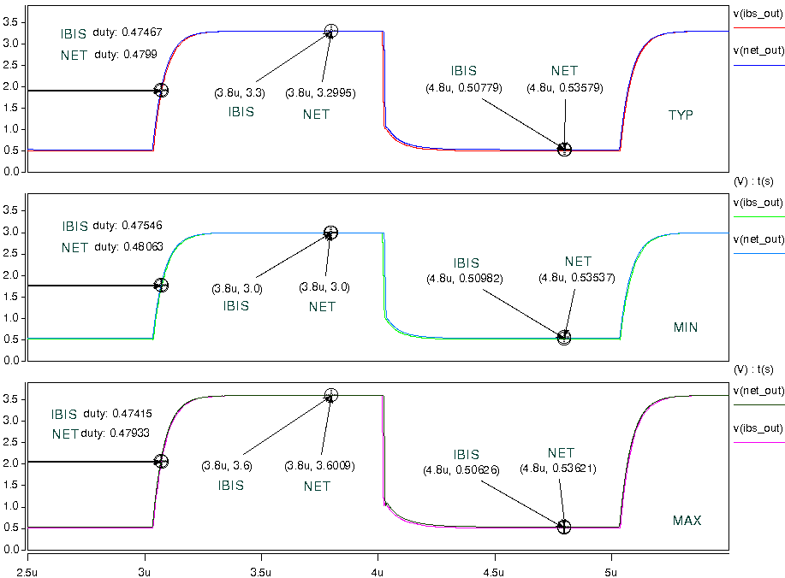

- VDDB=5.0V, VDDA=5V ,R=1K, CL=50p, frequency = 400k;
- Without package
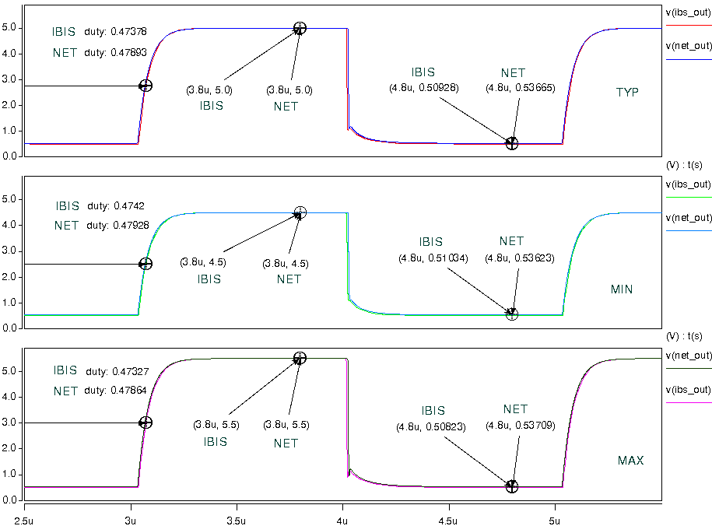
- With package
