PI6CV304 IBIS Model Check
One IBIS Models: PI6CV304.ibs.
1. Model Type
Modify the original PI6CV304.ibs to following two ibis models which are different in packaging, while their pins’ information is the same.
PI6CV304_L_RevA.ibs– 8-pin 173-mil wide TSSOP (L)
PI6CV304_W_RevA.ibs– 8-pin 150-mil wide SOIC (W)

[Pin] signal_name model_name Pin Configuration
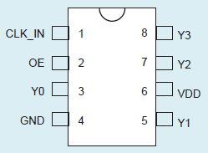
1 CLK_IN IN
2 OE IN
3 Y0 OUTPUT
4 GND GND
5 Y1 OUTPUT
6 VDD POWER
7 Y2 OUTPUT
8 Y3 OUTPUT

Block Diagram Function Table
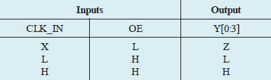
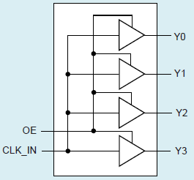

Conclusion
The PIN information described in IBIS model is exactly correct according to the datasheet.

2. Internal Series Resistor based on IBIS Model:
PI6CV304_L_RevA.ibs and PI6CV304_W_RevA.ibs share the same Pulldwon and Pullup data.
1). PullDown: TYP:
V = 0.20054V, I = 0.01232A, so Rs = 16.27760Ω
V = -0.20054V, I = -0.01228A, so Rs = 16.33062Ω
MIN:
V = 0.20054V, I = 0.011088A, so Rs = 18.08622Ω
V = -0.20054V, I = -0.011052A, so Rs = 18.14513Ω
MAX:
V = 0.20054V, I = 0.013552A, so Rs = 14.79782Ω
V = -0.20054V, I = -0.013508A, so Rs = 14.84602Ω

2). PullUp: TYP:
V = 0.09958V, I = -0.00614A, so Rs = 16.21824Ω
V = -0.09961V, I = 0.00607A, so Rs = 16.41021Ω
MIN:
V = 0.09958V, I = -0.005526A, so Rs = 18.02027Ω
V = -0.09961V, I = 0.005463A, so Rs = 18.23357Ω
MAX:
V = 0.09958V, I = -0.006754A, so Rs = 14.74386Ω
V = -0.09961V, I = 0.006677A, so Rs = 14.91838Ω

Conclusion:
The values of Internal Series Resistor based on IBIS model are quite correct according to the datasheet.
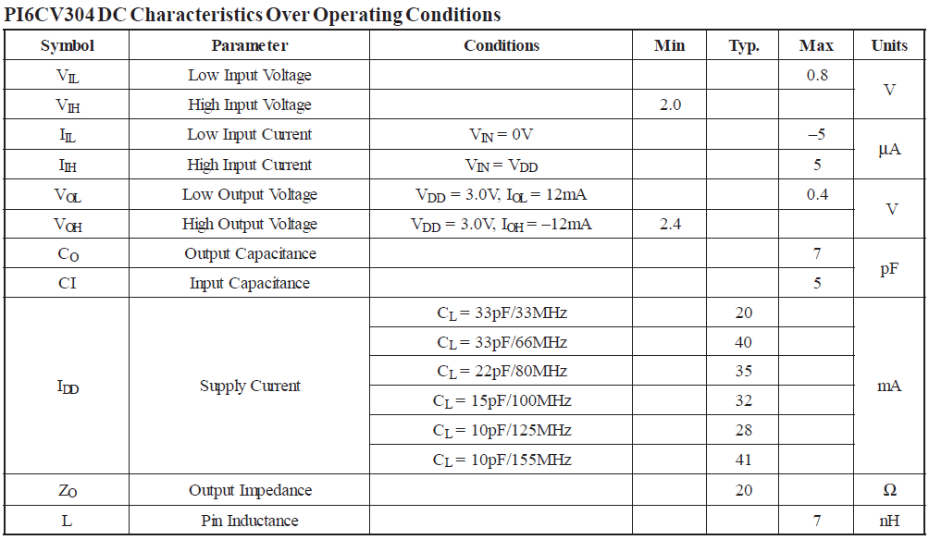
3. Analog Switch simulation result with following circuit diagram:
Input signal frequency is 125MHz: vin clk_in 0 pulse(0 clamp 0n 0.1n 0.1n 3.9n 8n)
1) Without trace, and add 50Ω pull-down resistor and 5pF pull-down capacitance to the output.
PI6CV304
OUT

SCL_C
SDA_C
50Ω

SCL_C
SDA_C
IN

SCL_C
SDA_C
C

SCL_C
SDA_C
IN

SCL_C
SDA_C
VDD/2

SCL_C
SDA_C
Without Package:
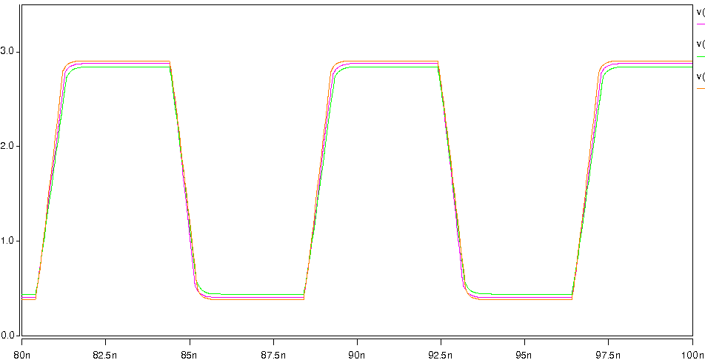
With Package:
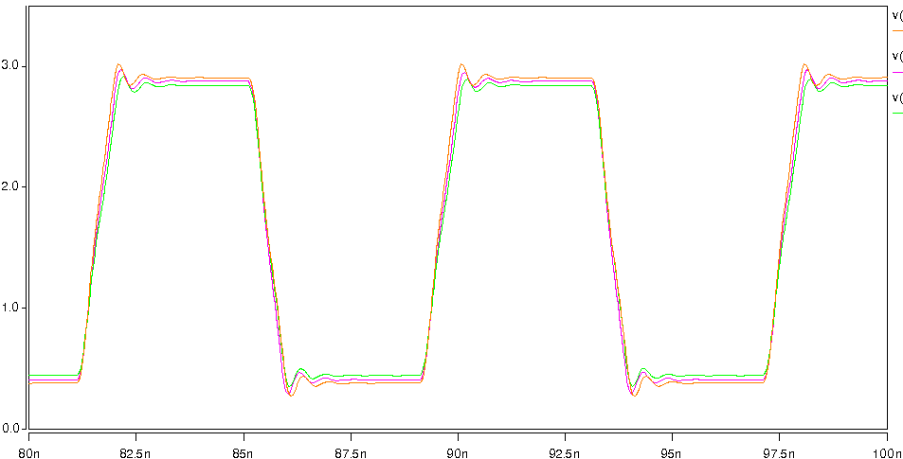

2) With 2inch trace before the output
PI6CV304

OUT1

SCL_C
SDA_C
25Ω / 33Ω

SCL_C
SDA_C
50Ω

SCL_C
SDA_C
IN

SCL_C
SDA_C
C

SCL_C
SDA_C
OUT

SCL_C
SDA_C
IN

SCL_C
SDA_C
OUT0

SCL_C
SDA_C
Trace=2inch

SCL_C
SDA_C
a. Add 25Ω resistor, 2inch trace and 5pF pull-down capacitance to the output.
Without Package:
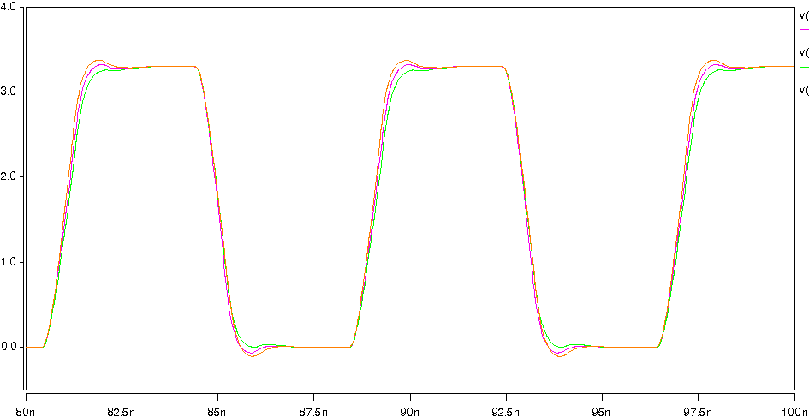
With Package:
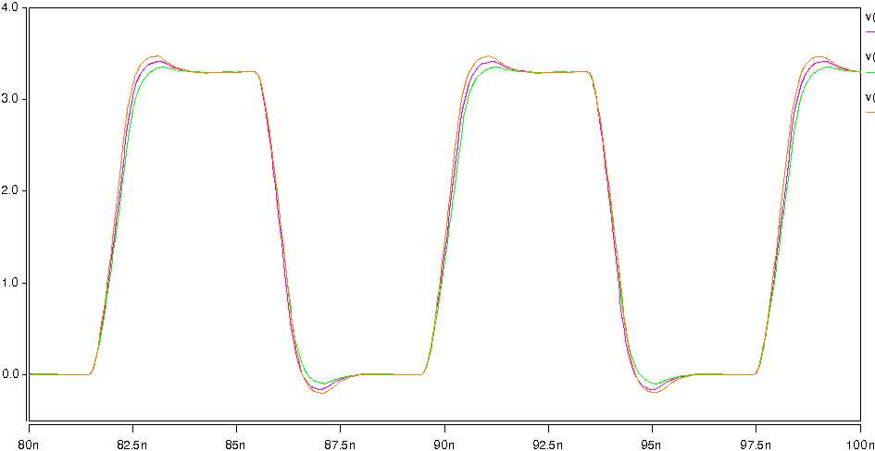

b. Add 33Ω resistor, 2inch trace and 5pF pull-down capacitance to the output.
Without Package:
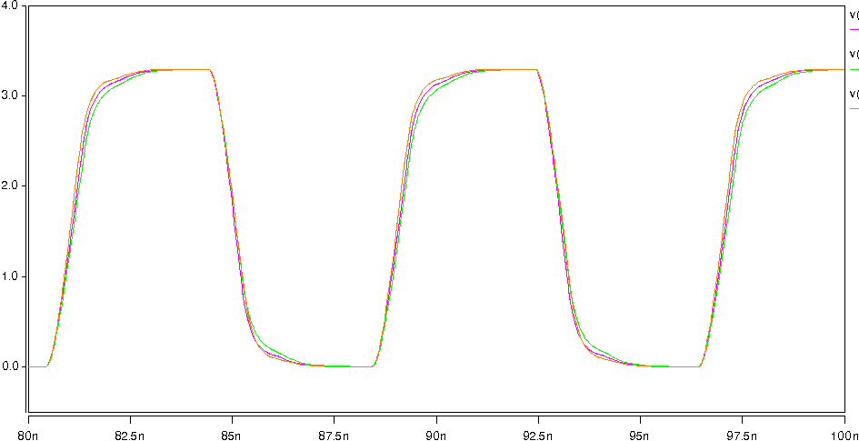
With Package:
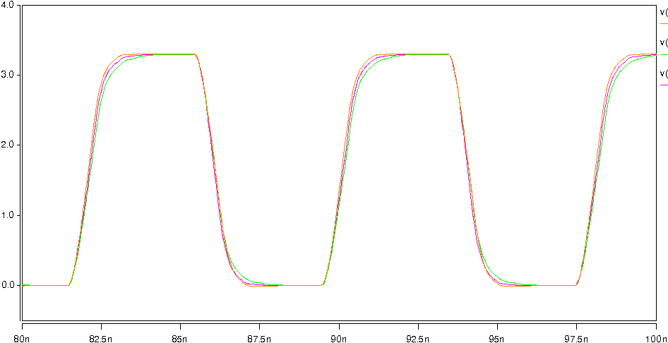

4. IBIS Data Graph of PI6CV304_L_RevA.ibs and PI6CV304_W_RevA.ibs
(1) Model IN: C_comp=4.000pF
a. POWER Clamp
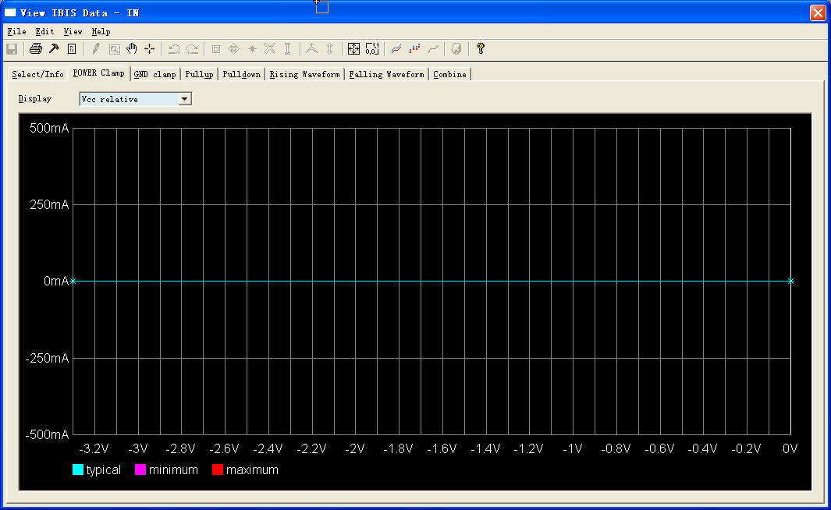
b. GND Clamp
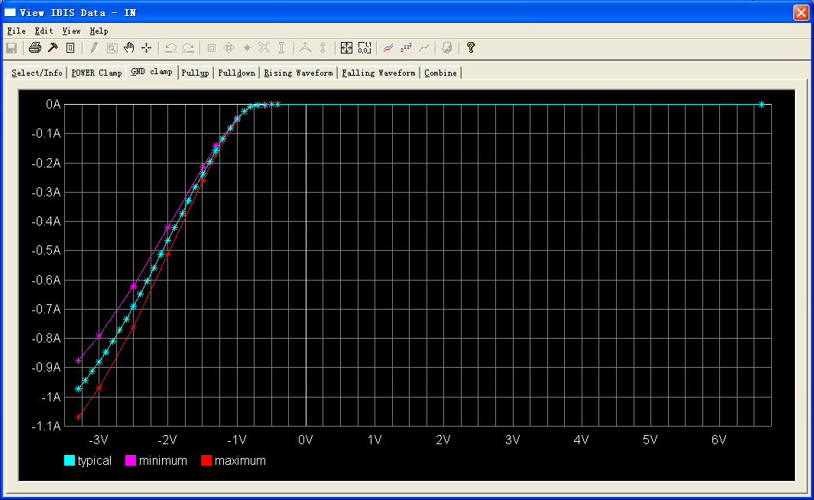

(2) Model TRI_OUT: C_comp=6.000pF
a. Pullup
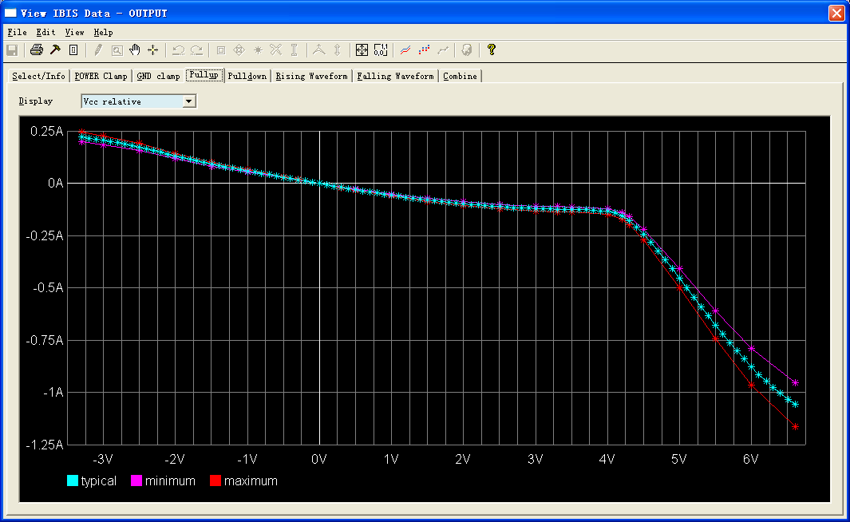
b. Pulldown
