Verification of PI6CG18801 IBIS model
- Introduction: to verify the correlation between the ibis model and hspice model, we need to do some simulations:
The frequency of signal is 2.5MHz:
vin sda_in 0 pulse(0 clamp dly 1n 1n 199n 400n)

- Add 10k Ohm pull-up resistor to the SDATA_IO:
PI6CG18801
VOUT

SCL_C
SDA_C
Input Signals

SCL_C
SDA_C
VIN

SCL_C
SDA_C
SDA_IO

SCL_C
SDA_C
SDA_IN

SCL_C
SDA_C
…..

SCL_C
SDA_C
3.3V

SCL_C
SDA_C
R=10kOhm

SCL_C
SDA_C
- Simulation without package data;
- Simulation with package data.

- Conclusion:
For the verification, the simulation results of IBIS model can match very well with the HSPICE model at different simulating conditions.

- Simulation Result:
- Add 10k Ohm pull-up resistor to the SDATA_IO:
- Simulation without package data;
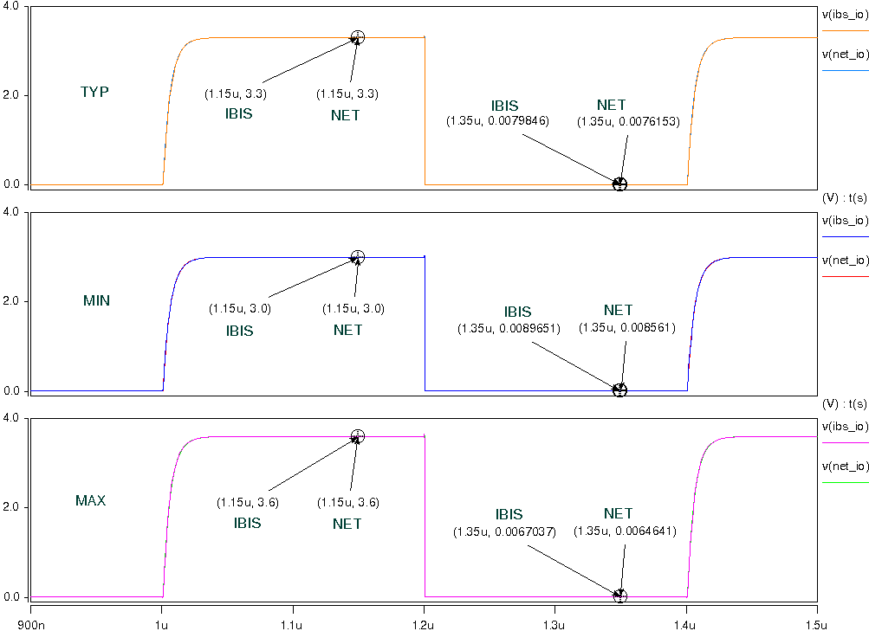
- Simulation with package data.
