Verification of PI6CG18801 IBIS model
- Introduction: to verify the correlation between the ibis model and hspice model, we need to do some simulations:
The frequency of signal is 25MHz:
vin clkin 0 pulse(0 power 0 0.01n 0.01n 19.99n 40n)

- Without trace to the OUTPUT:
PI6CG18801
VOUT

SCL_C
SDA_C
Input Signals

SCL_C
SDA_C
VIN

SCL_C
SDA_C
REFOUT

SCL_C
SDA_C
CLKIN

SCL_C
SDA_C
…..

SCL_C
SDA_C
- CMOS_SLOWEST
- Simulation without package data;
- Simulation with package data.
- CMOS_SLOW
- Simulation without package data;
- Simulation with package data.
- CMOS_FAST
- Simulation without package data;
- Simulation with package data.
- CMOS_FASTEST
- Simulation without package data;
- Simulation with package data.

- With 33Ohm resister, 2-inch trace and 5pF pulldown capacitance to the OUTPUT:
Input Signals

SCL_C
SDA_C
VIN

SCL_C
SDA_C
…..

SCL_C
SDA_C
PI6CB18801
CLKIN

SCL_C
SDA_C
REFOUT

SCL_C
SDA_C
2-inch
VOUT

SCL_C
SDA_C
C

SCL_C
SDA_C
R=33Ohm

SCL_C
SDA_C
- CMOS_SLOWEST
- Simulation without package data;
- Simulation with package data.
- CMOS_SLOW
- Simulation without package data;
- Simulation with package data.
- CMOS_FAST
- Simulation without package data;
- Simulation with package data.
- CMOS_FASTEST
- Simulation without package data;
- Simulation with package data.

- Conclusion:
For the verification, the simulation results of IBIS model can match quite well with the HSPICE model at different simulating conditions.

- Simulation Result:
- Without trace to the OUTPUT:
- CMOS_SLOWEST
- Simulation without package data;
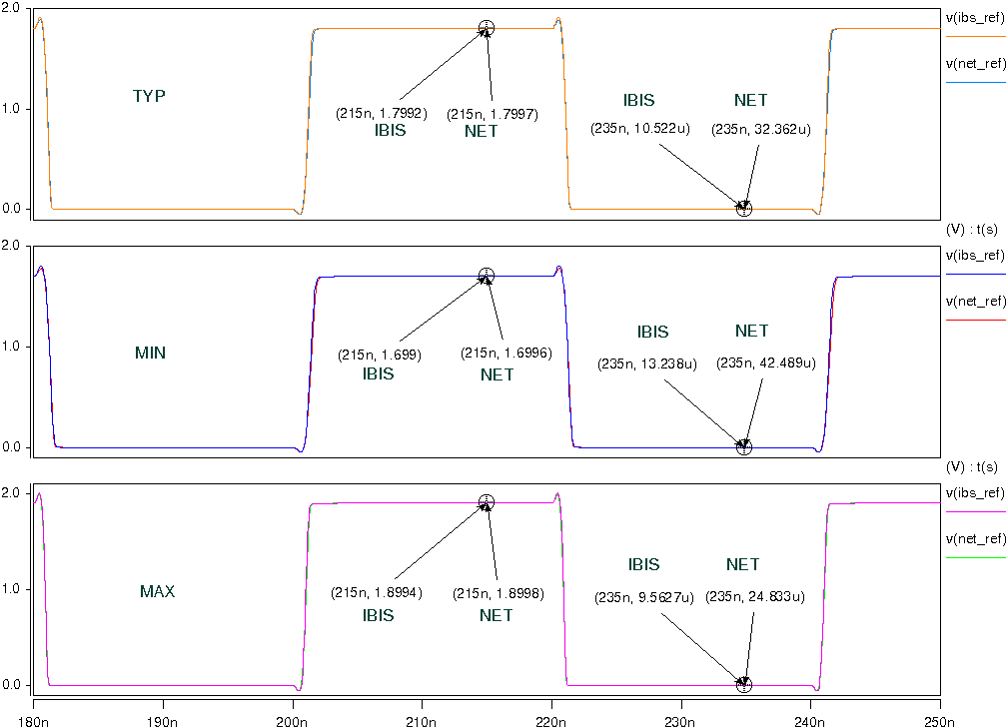
- Simulation with package data.
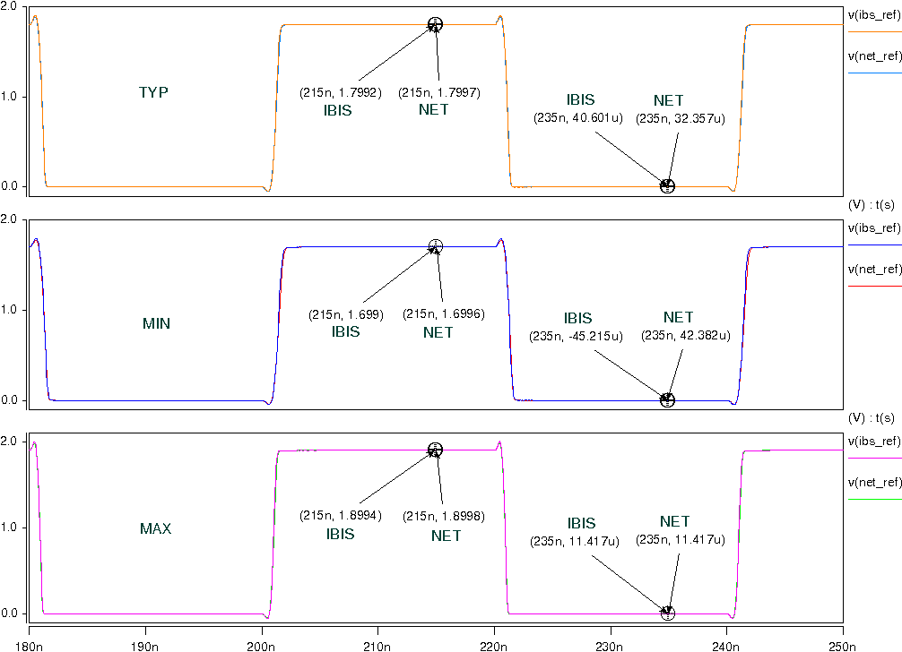
- CMOS_SLOW
- Simulation without package data;
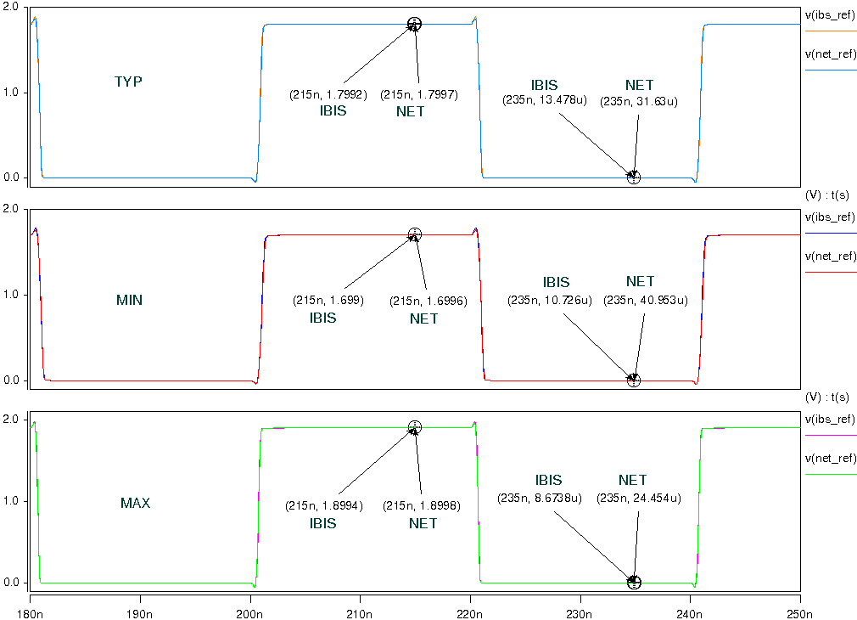
- Simulation with package data.
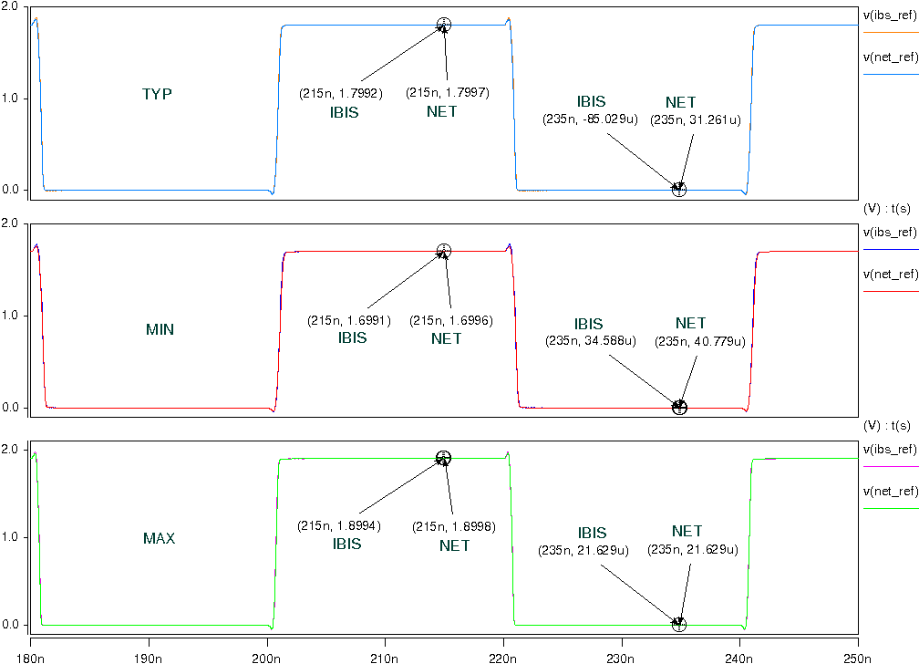

- CMOS_FAST
- Simulation without package data;
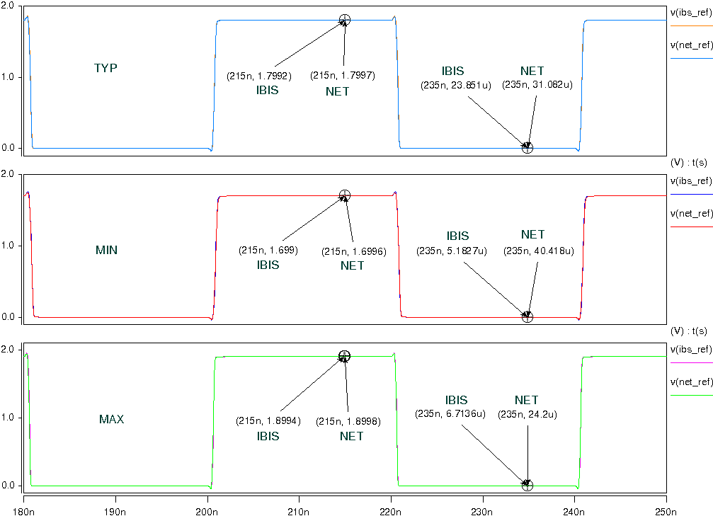
- Simulation with package data.
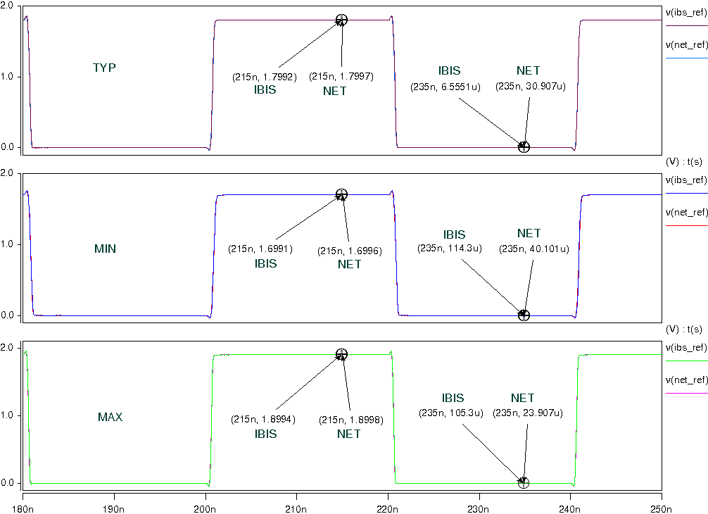

- CMOS_FASTEST
- Simulation without package data;
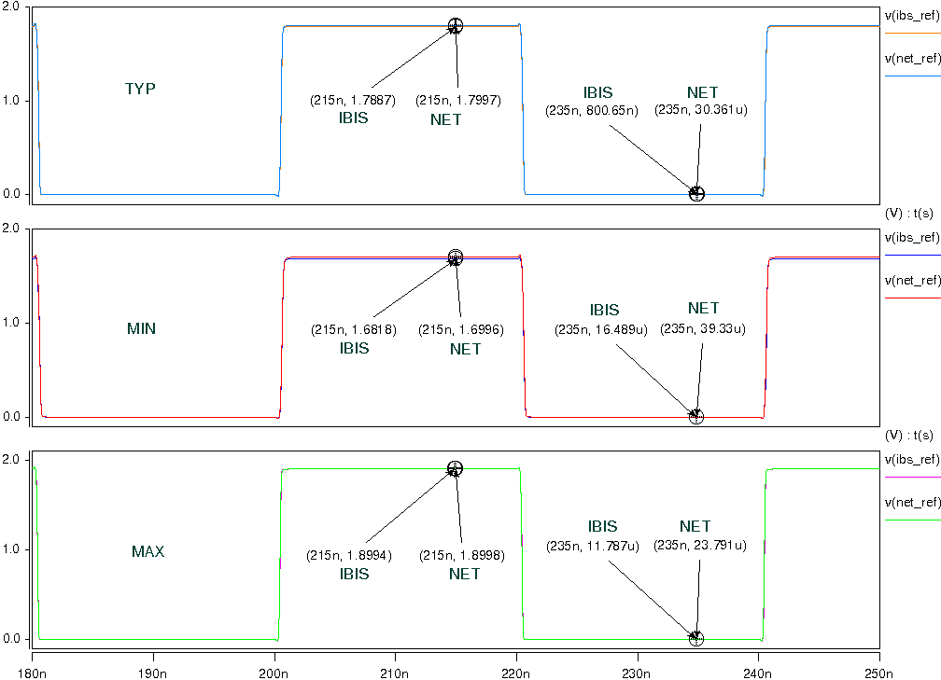
- Simulation with package data.
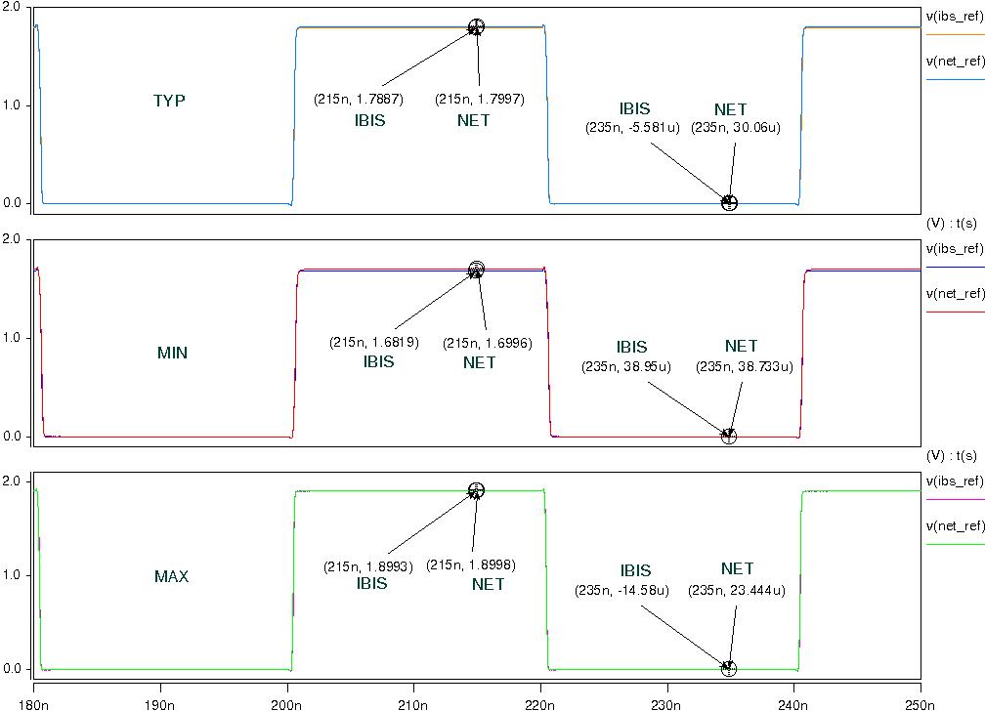

- With 33Ohm resister, 2-inch trace and 5pF pulldown capacitance to the OUTPUT:
- CMOS_SLOWEST
- Simulation without package data;
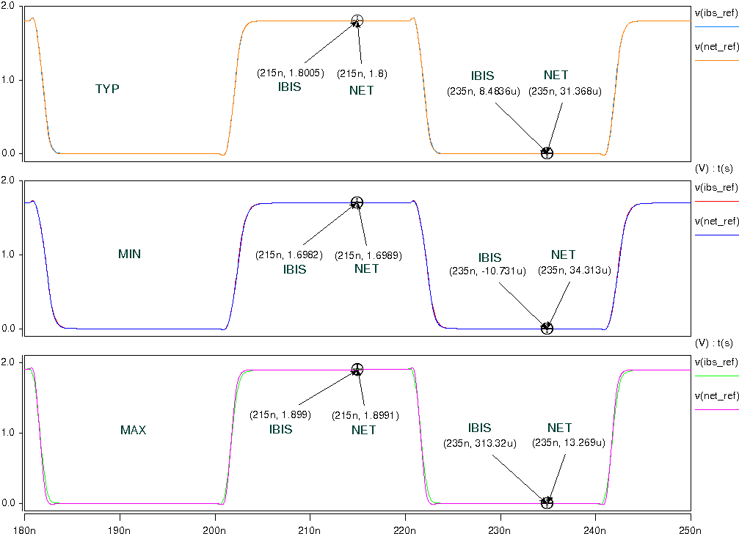
- Simulation with package data.
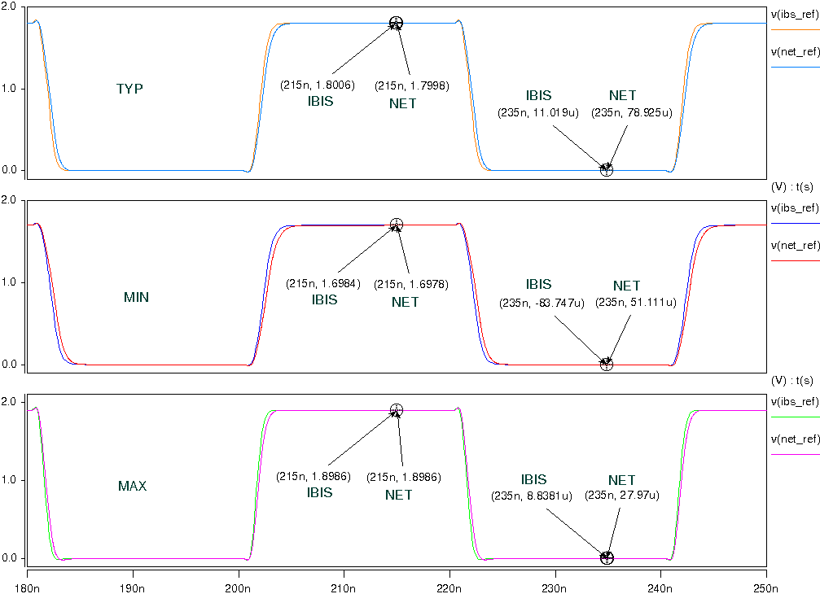
- CMOS_SLOW
- Simulation without package data;
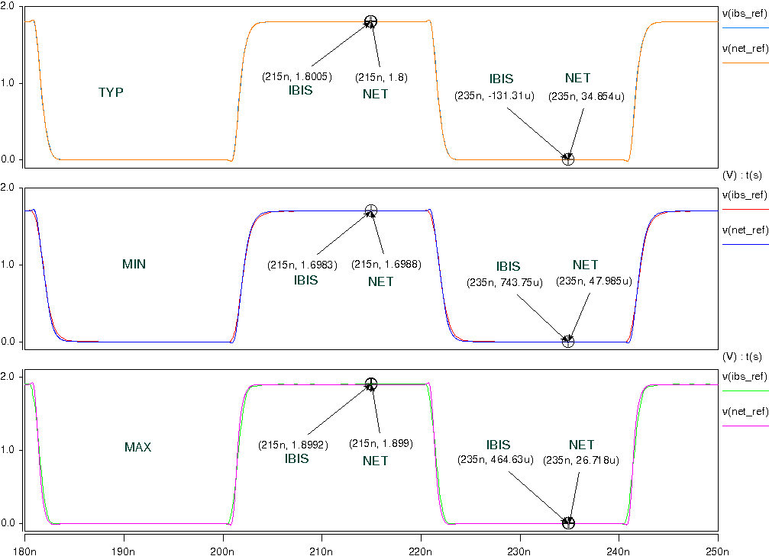
- Simulation with package data.
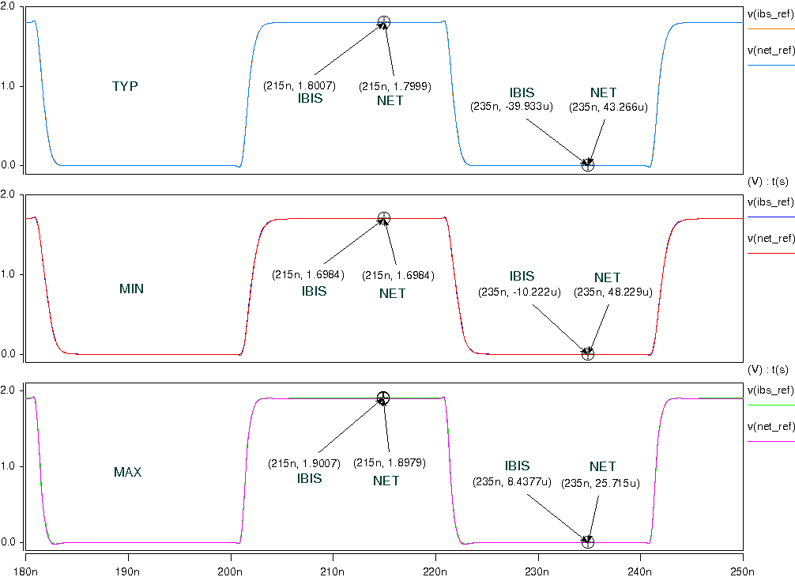

- CMOS_FAST
- Simulation without package data;
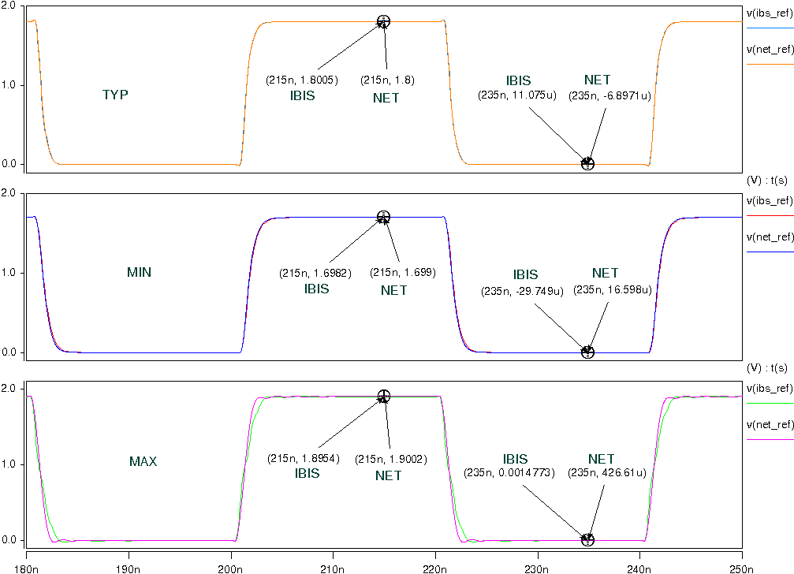
- Simulation with package data.
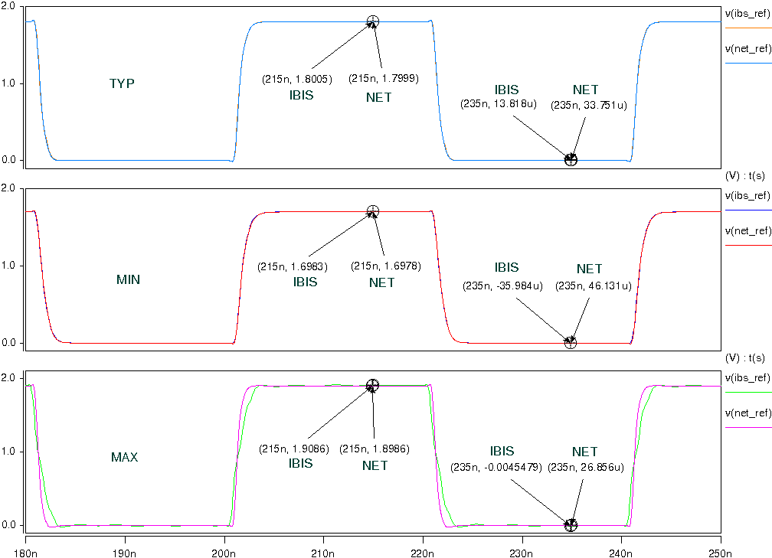

- CMOS_FASTEST
- Simulation without package data;
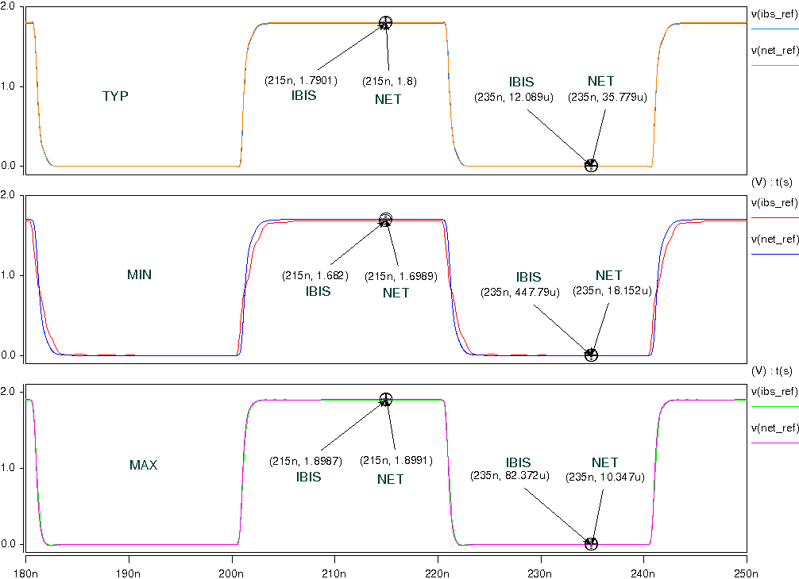
- Simulation with package data.
