Verification of PI6CG18801 IBIS model
- Introduction: to verify the correlation between the ibis model and hspice model, we need to do some simulations:
The frequency of signal is 50MHz:
vvin clkin 0 pulse(0 power 0 0.1n 0.1n 9.9n 20n)
Note: DIF0 Q0+; DIF0# Q0- .
- Without trace to the HCSL:
PI6CG18801
VOUT

SCL_C
SDA_C
Input Signals

SCL_C
SDA_C
VIN

SCL_C
SDA_C
DIF0

SCL_C
SDA_C
CLKIN

SCL_C
SDA_C
VOUT

SCL_C
SDA_C
DIF0#

SCL_C
SDA_C
…..

SCL_C
SDA_C
- HCSL_0P6_FAST
- Simulation without package data;
- Simulation with package data.
- HCSL_0P6_SLOW
- Simulation without package data;
- Simulation with package data.
- HCSL_0P7_FAST
- Simulation without package data;
- Simulation with package data.
- HCSL_0P7_SLOW
- Simulation without package data;
- Simulation with package data.
- HCSL_0P8_FAST
- Simulation without package data;
- Simulation with package data.
- HCSL_0P8_SLOW
- Simulation without package data;
- Simulation with package data.
- HCSL_0P9_FAST
- Simulation without package data;
- Simulation with package data.
- HCSL_0P9_SLOW
- Simulation without package data;
- Simulation with package data.

- With 5-inch trace and 2pF pulldown capacitance to the HCSL:
VOUT

SCL_C
SDA_C
CLKIN

SCL_C
SDA_C
Input Signals

SCL_C
SDA_C
VIN

SCL_C
SDA_C
DIF0

SCL_C
SDA_C
…..

SCL_C
SDA_C
5-inch
PI6CG18801
VOUT

SCL_C
SDA_C
DIF0#

SCL_C
SDA_C
5-inch
C

SCL_C
SDA_C
C

SCL_C
SDA_C
- HCSL_0P6_FAST
- Simulation without package data;
- Simulation with package data.
- HCSL_0P6_SLOW
- Simulation without package data;
- Simulation with package data.
- HCSL_0P7_FAST
- Simulation without package data;
- Simulation with package data.
- HCSL_0P7_SLOW
- Simulation without package data;
- Simulation with package data.
- HCSL_0P8_FAST
- Simulation without package data;
- Simulation with package data.
- HCSL_0P8_SLOW
- Simulation without package data;
- Simulation with package data.
- HCSL_0P9_FAST
- Simulation without package data;
- Simulation with package data.
- HCSL_0P9_SLOW
- Simulation without package data;
- Simulation with package data.

- Conclusion:
For the verification, the simulation results of IBIS model can match quite well with the HSPICE model at most of different simulating conditions.

- Simulation Result: (DIF0 Q0+; DIF0# Q0-)
- Without trace to the HCSL:
- HCSL_0P6_FAST
- Simulation without package data;
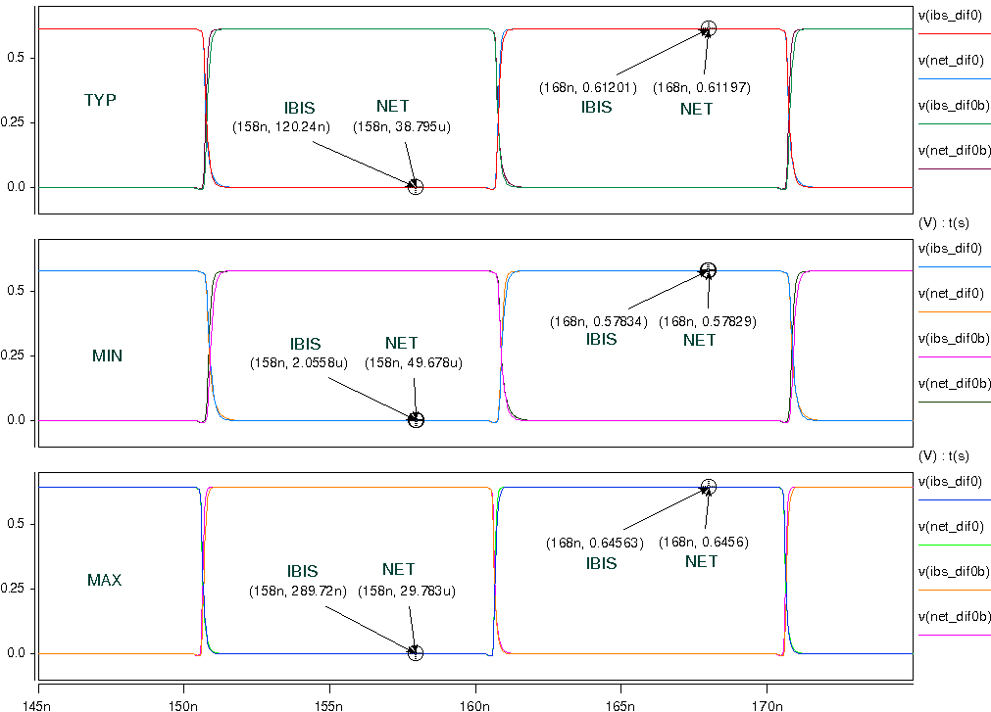
- Simulation with package data.
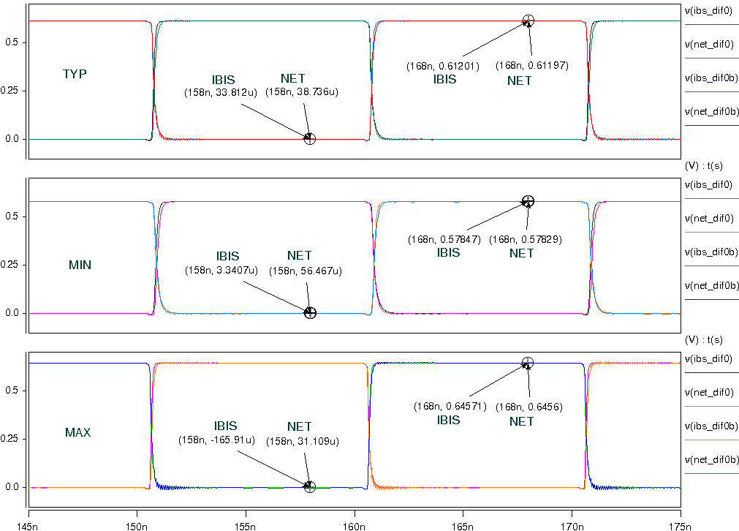
- HCSL_0P6_SLOW
- Simulation without package data;
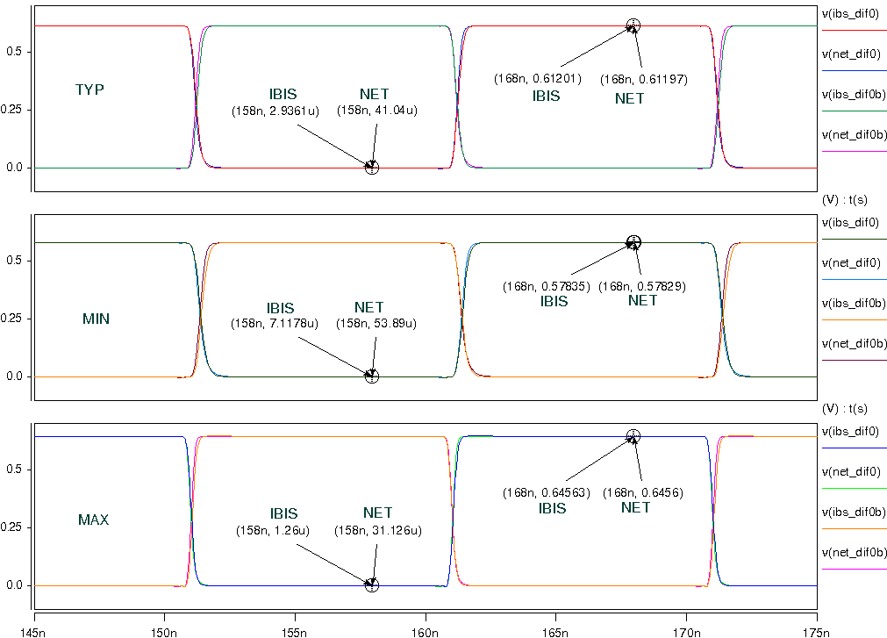
- Simulation with package data.
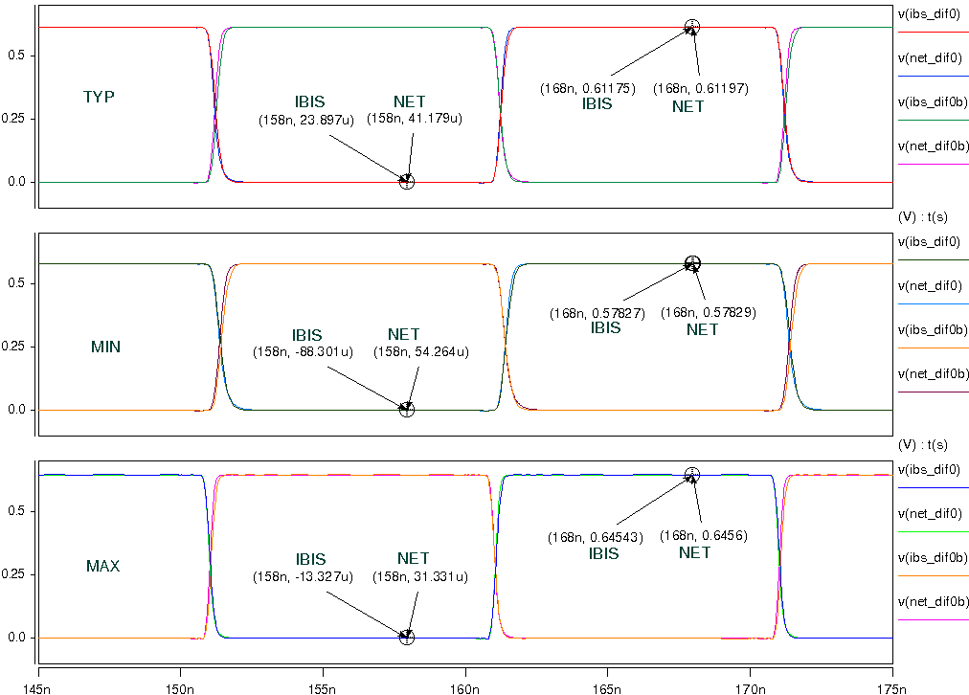

- HCSL_0P7_FAST
- Simulation without package data;
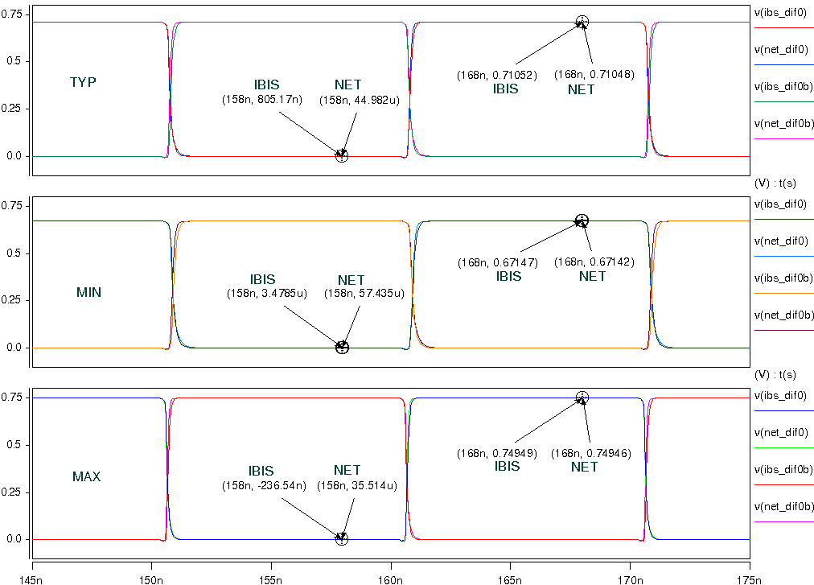
- Simulation with package data.
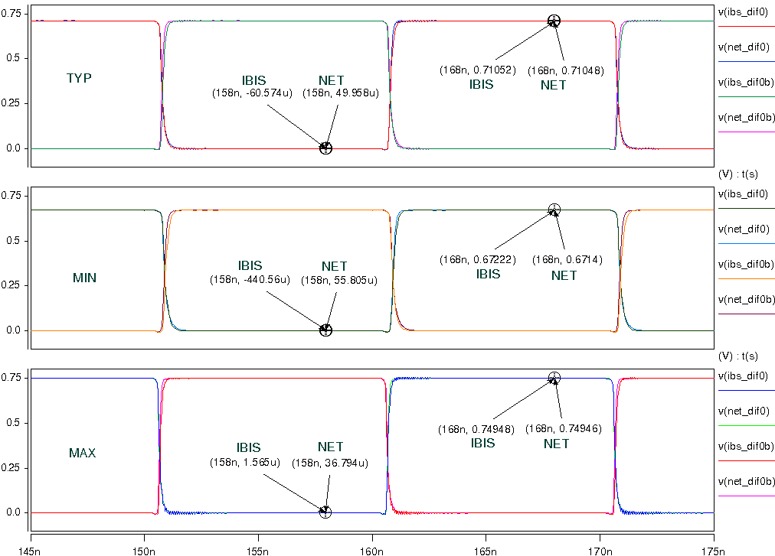

- HCSL_0P7_SLOW
- Simulation without package data;
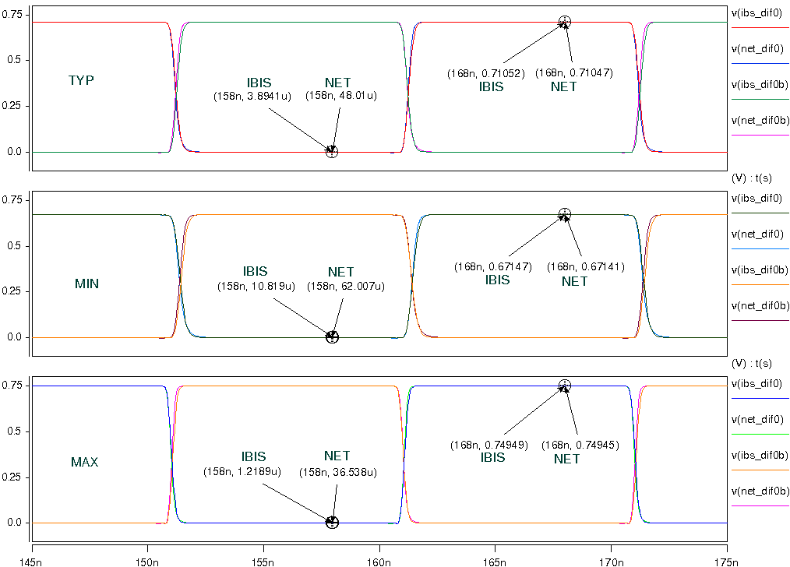
- Simulation with package data.
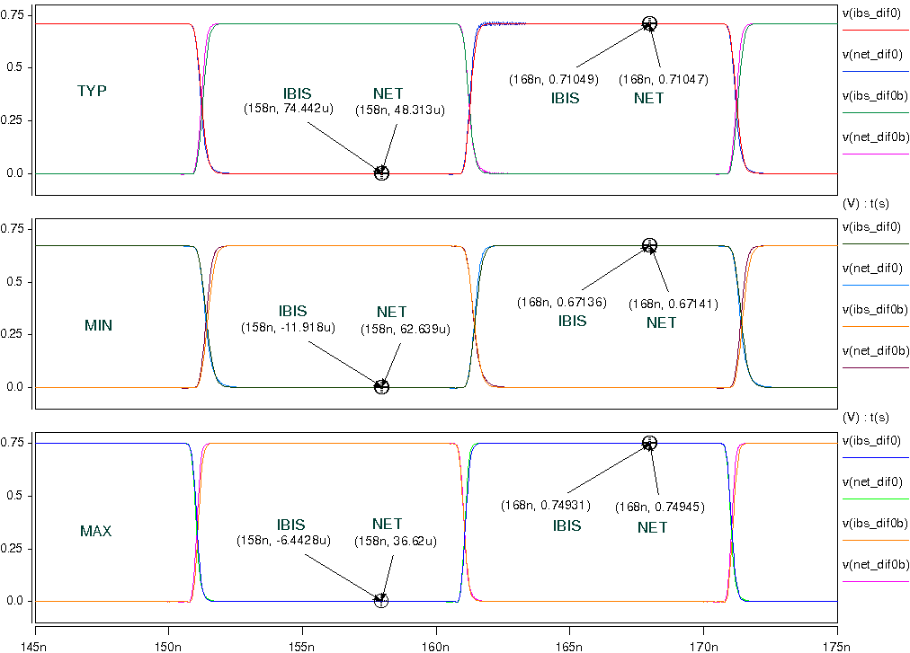

- HCSL_0P8_FAST
- Simulation without package data;
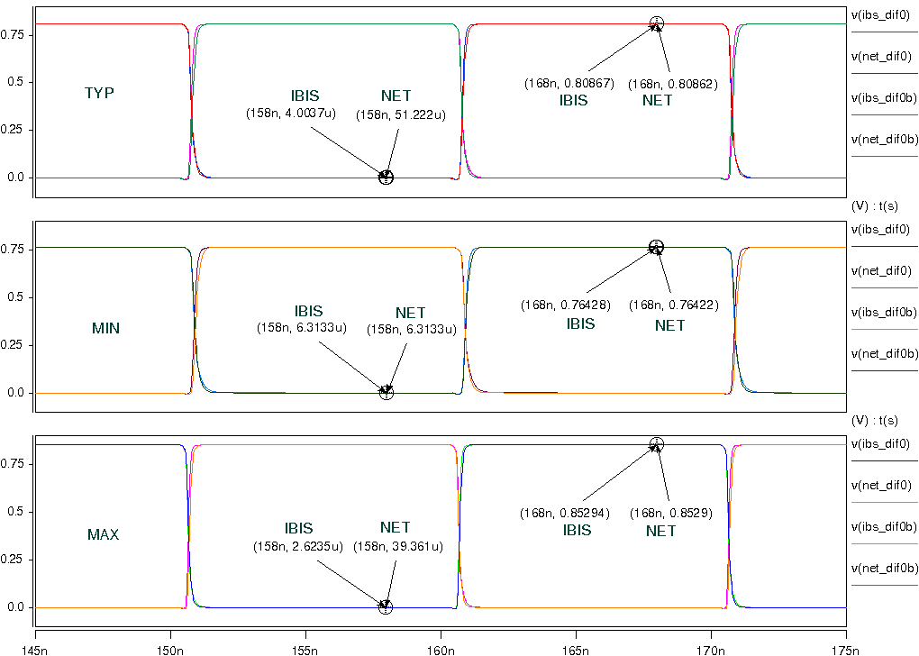
- Simulation with package data.
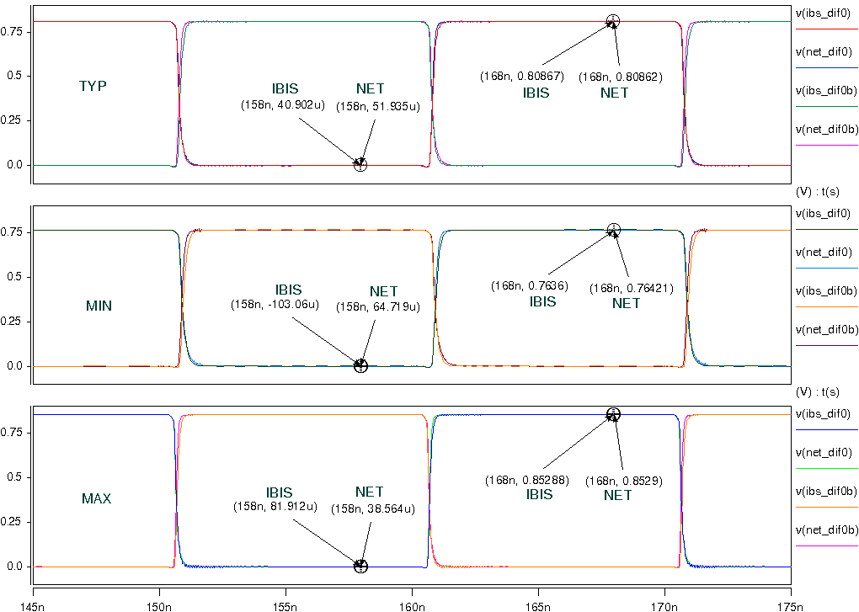

- HCSL_0P8_SLOW
- Simulation without package data;
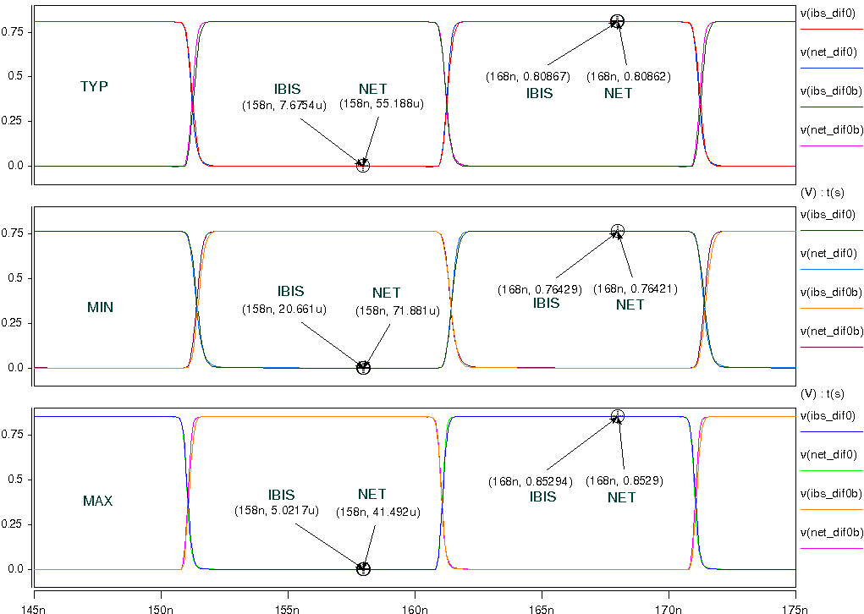
- Simulation with package data.
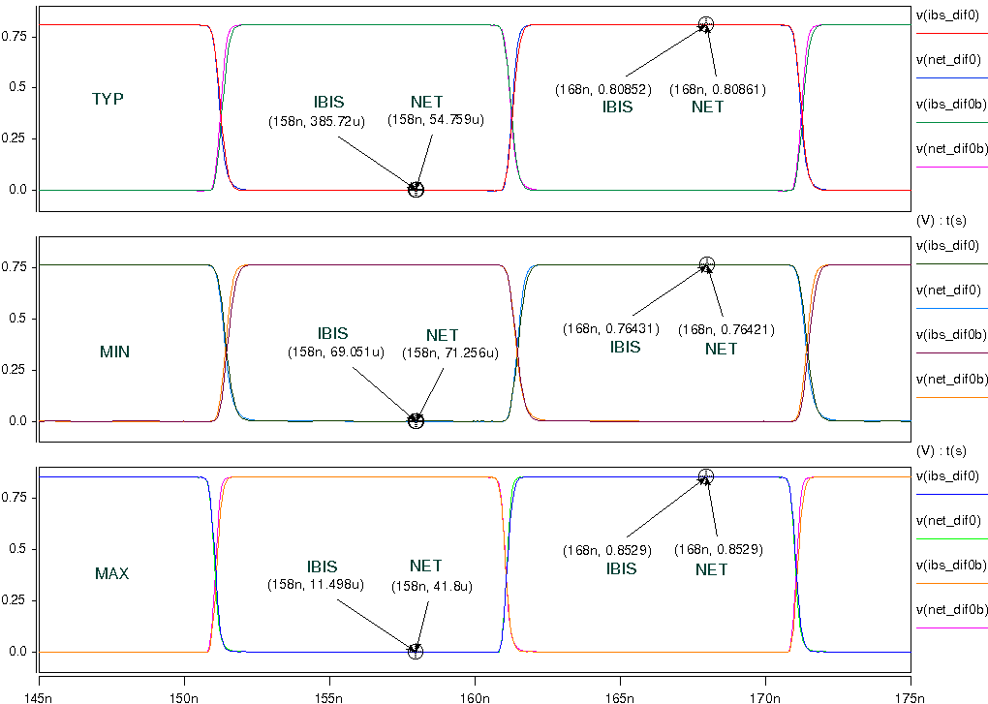

- HCSL_0P9_FAST
- Simulation without package data;
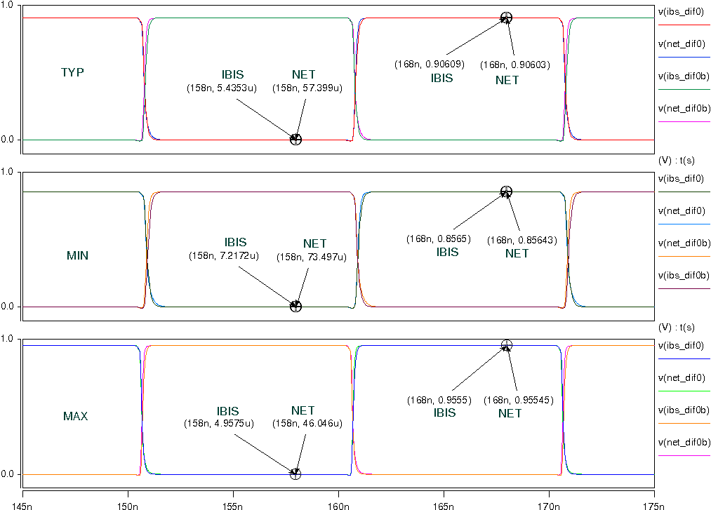
- Simulation with package data.
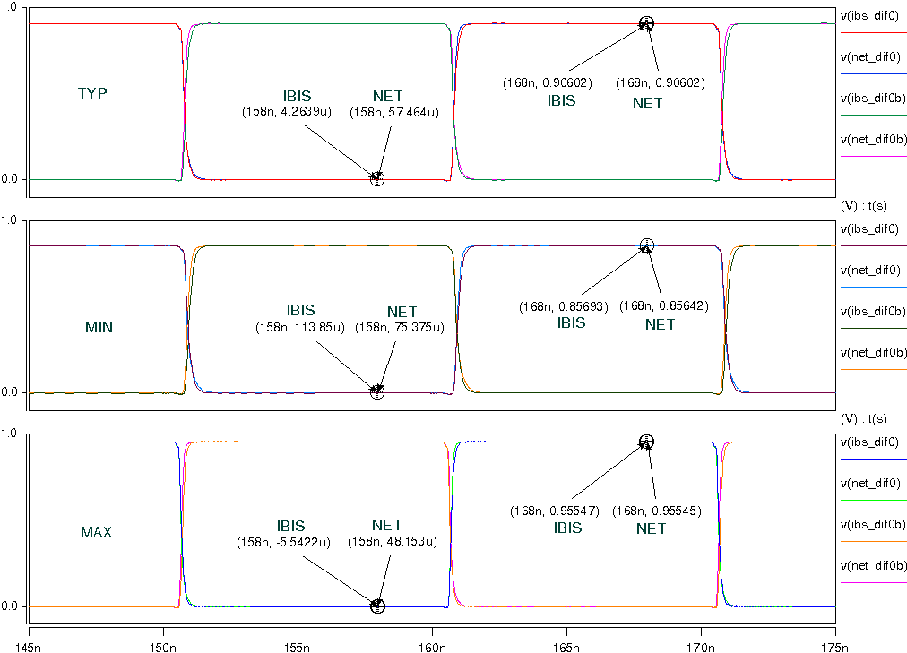

- HCSL_0P9_SLOW
- Simulation without package data;
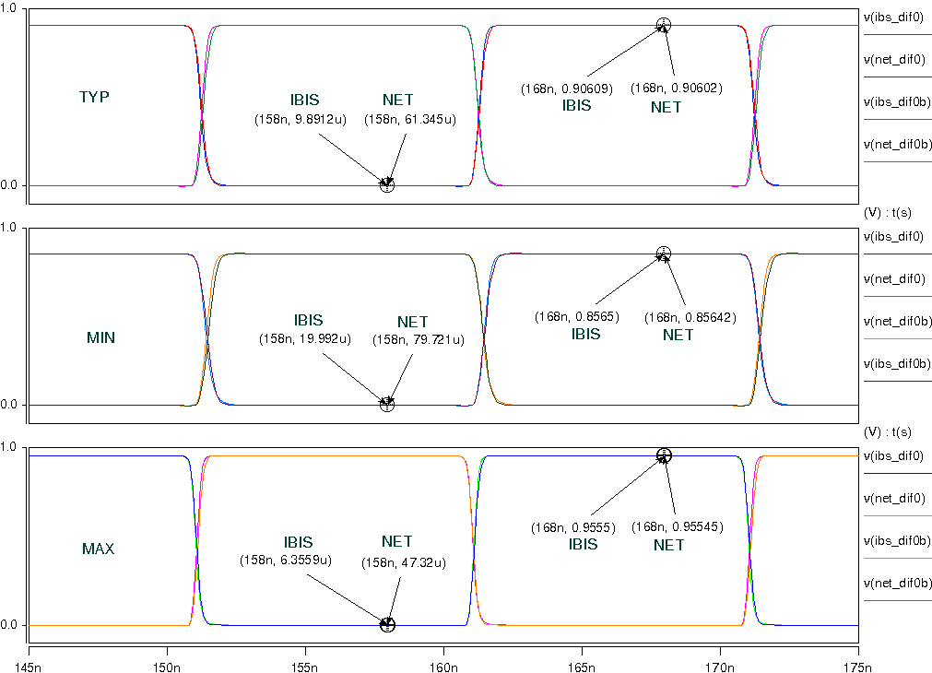
- Simulation with package data.
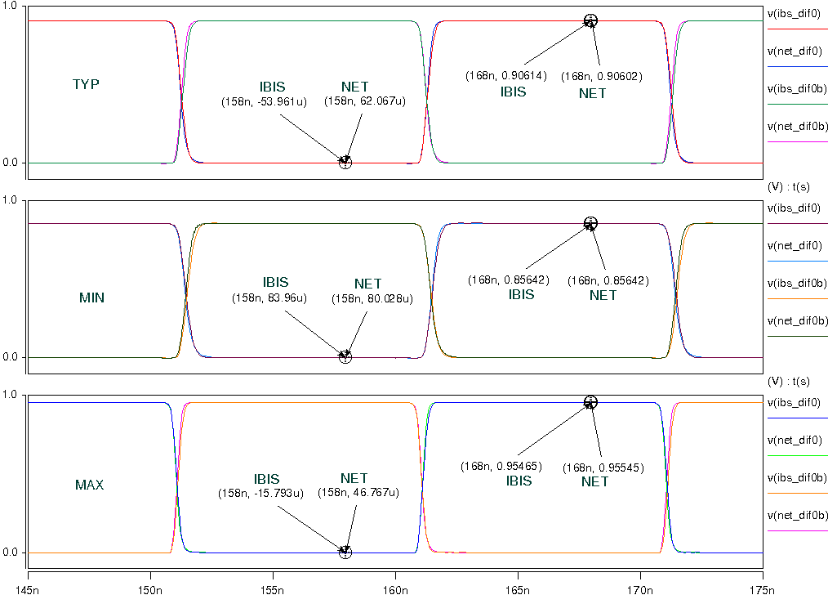

- With 5-inch trace and 2pF pulldown capacitance to the HCSL:
- HCSL_0P6_FAST
- Simulation without package data;
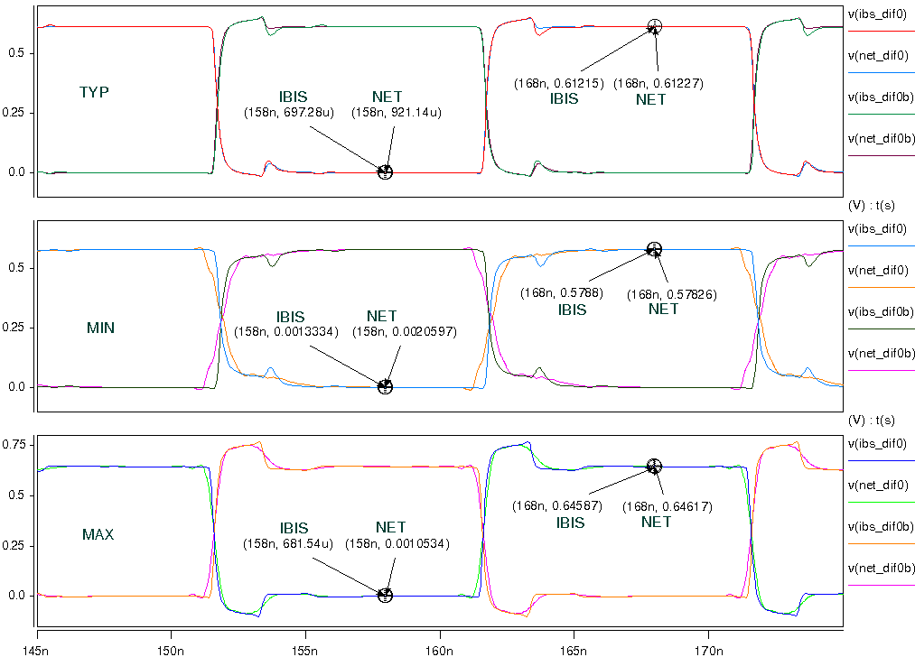
- Simulation with package data.
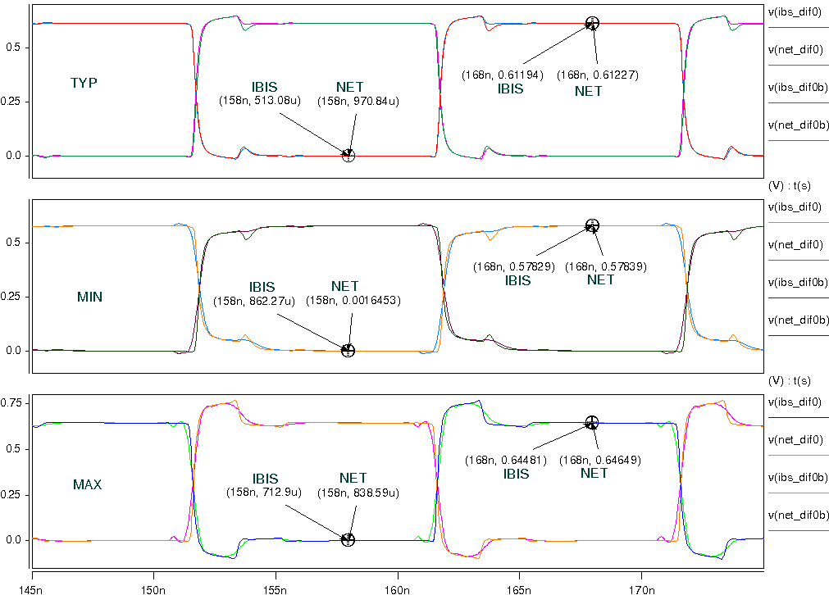
- HCSL_0P6_SLOW
- Simulation without package data;
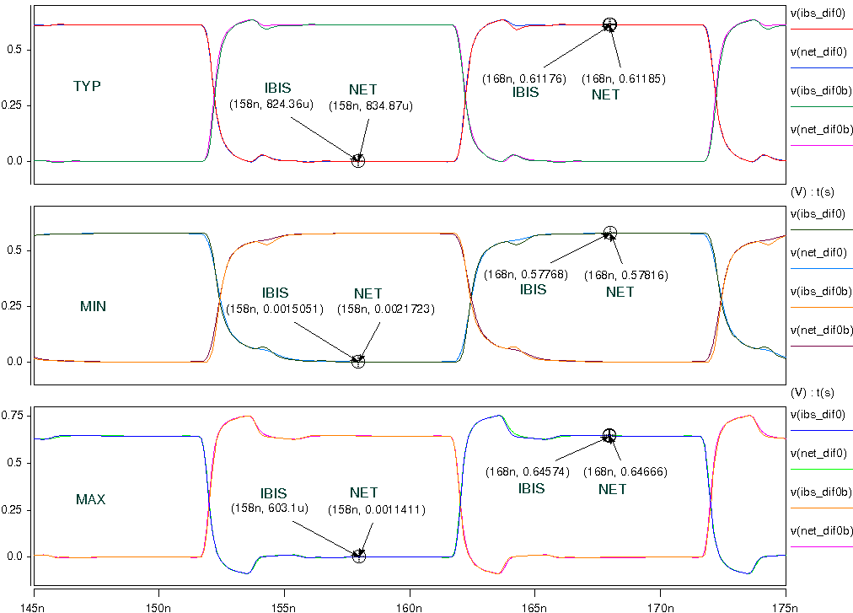
- Simulation with package data.
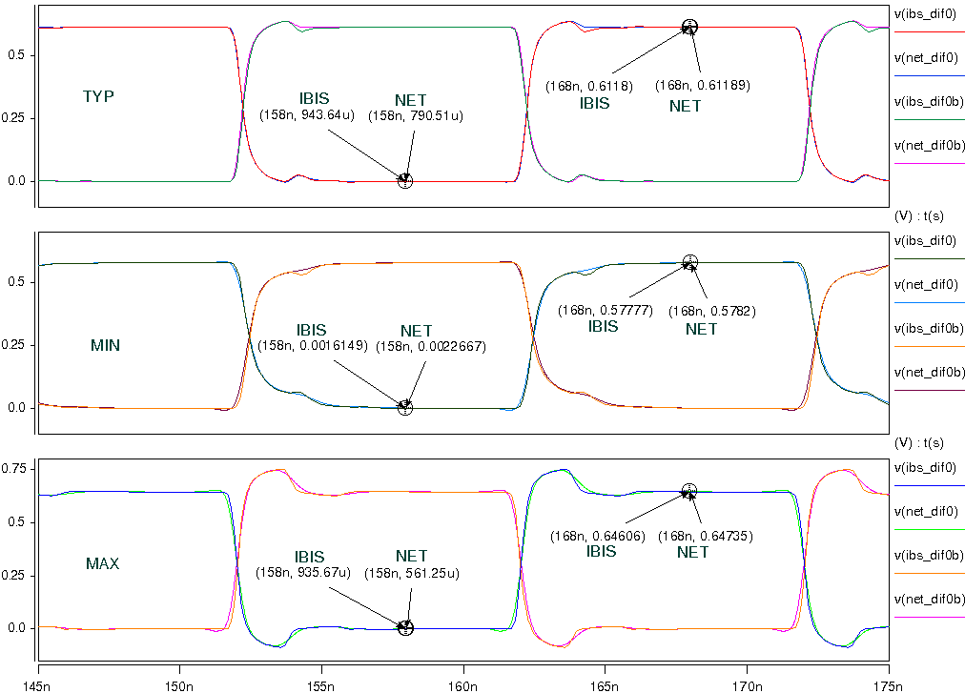

- HCSL_0P7_FAST
- Simulation without package data;
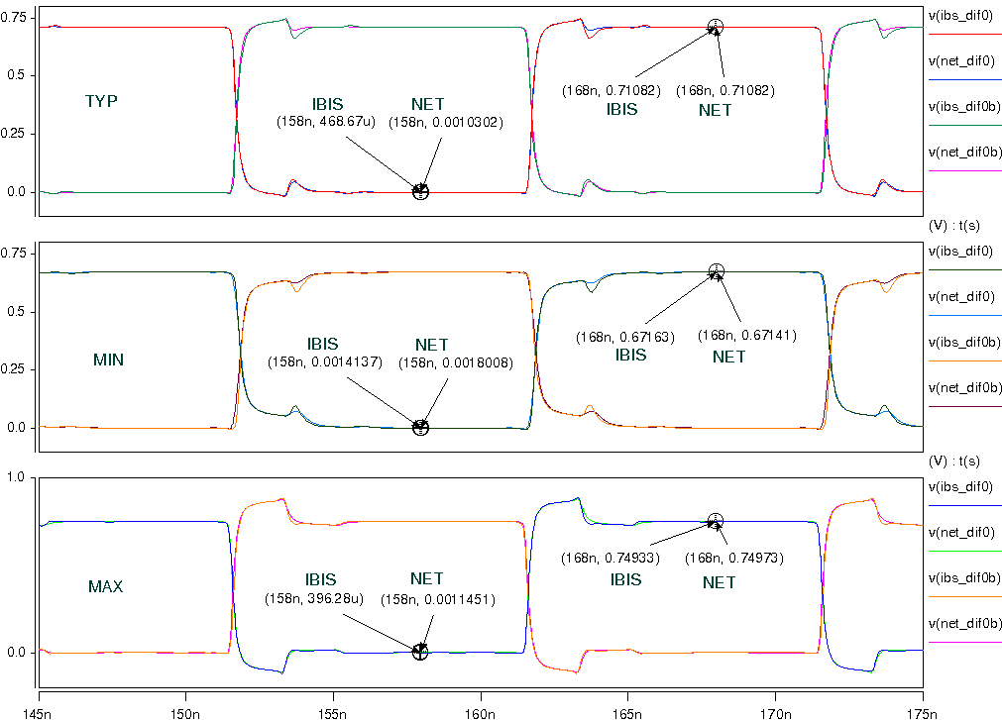
- Simulation with package data.
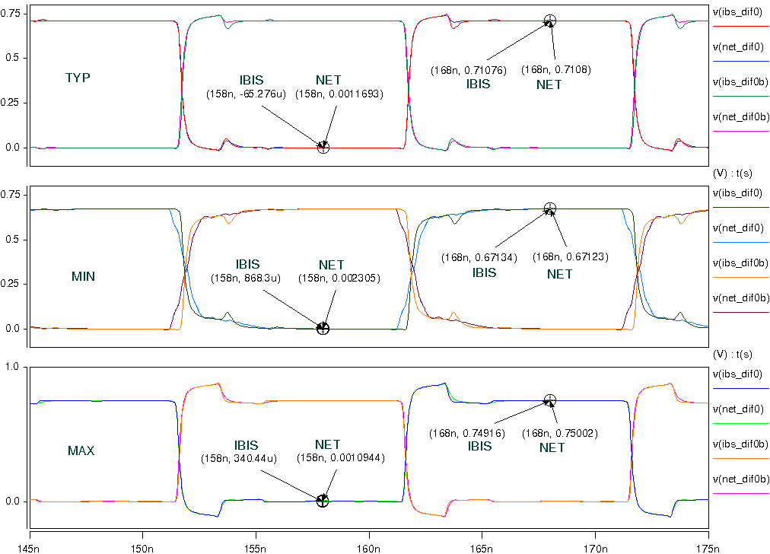

- HCSL_0P7_SLOW
- Simulation without package data;
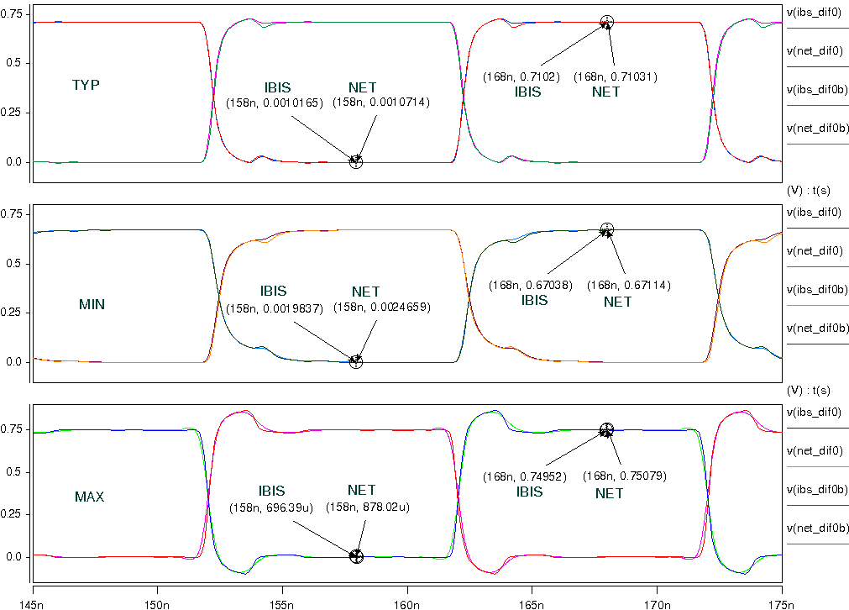
- Simulation with package data.
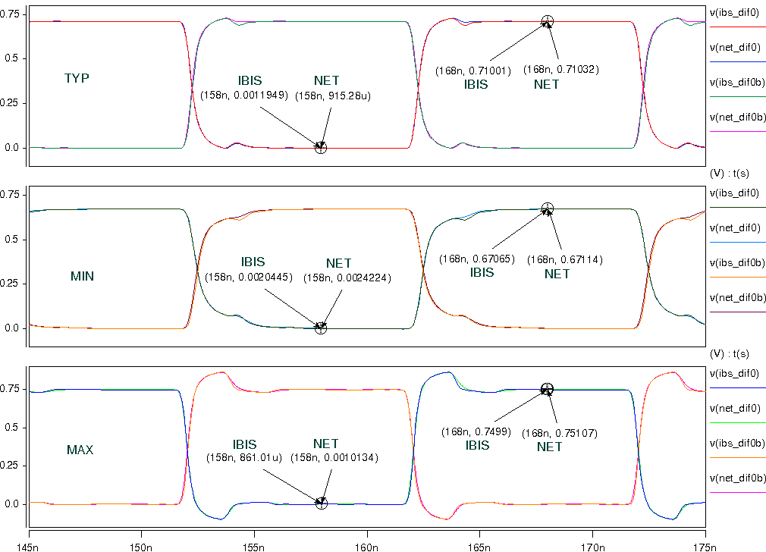

- HCSL_0P8_FAST
- Simulation without package data;
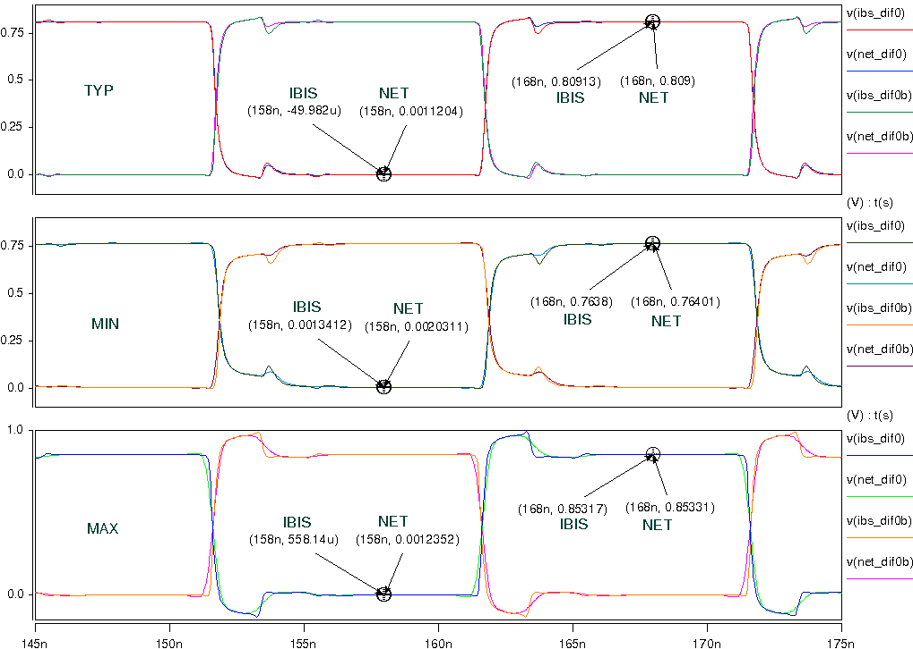
- Simulation with package data.
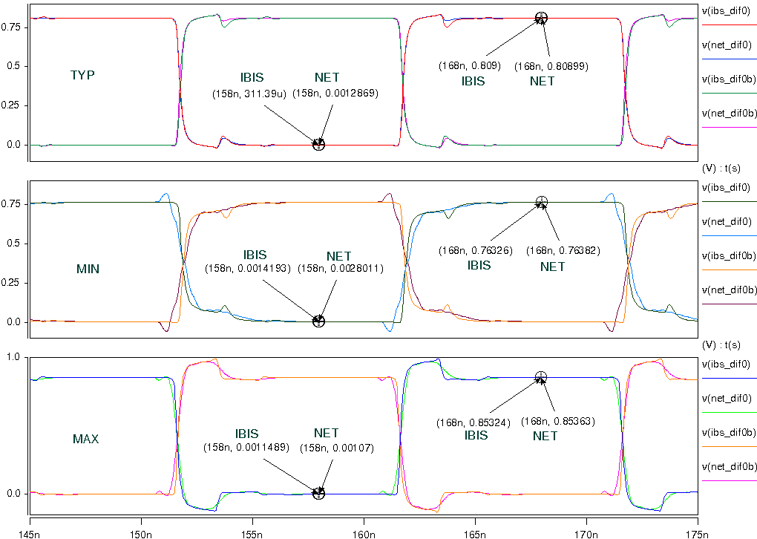

- HCSL_0P8_SLOW
- Simulation without package data;
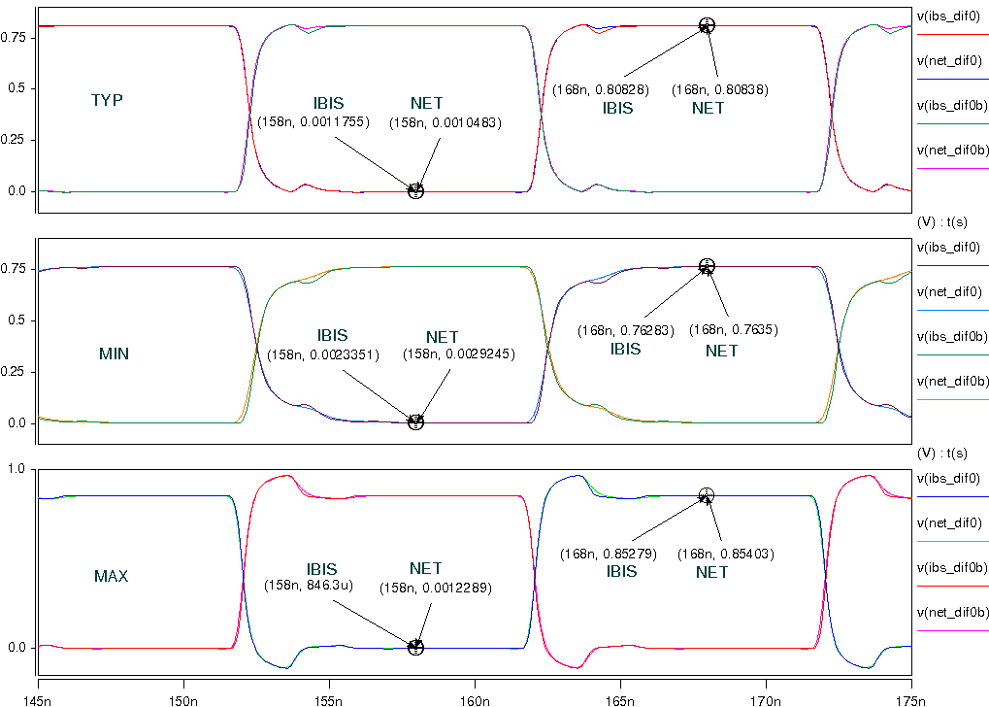
- Simulation with package data.
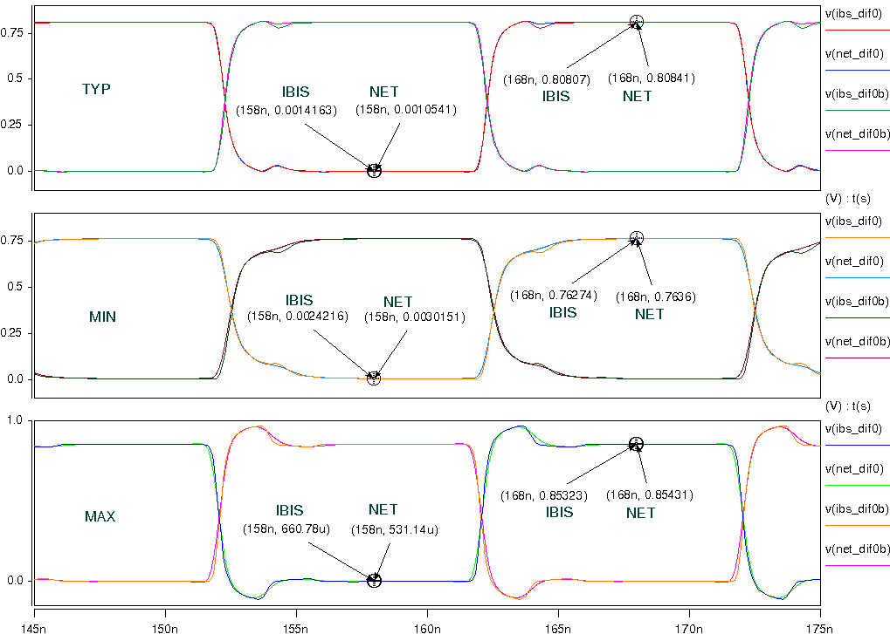

- HCSL_0P9_FAST
- Simulation without package data;
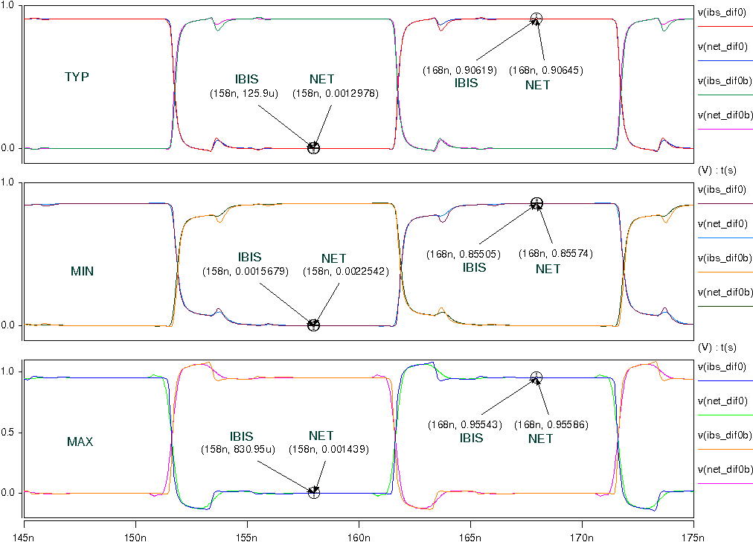
- Simulation with package data.
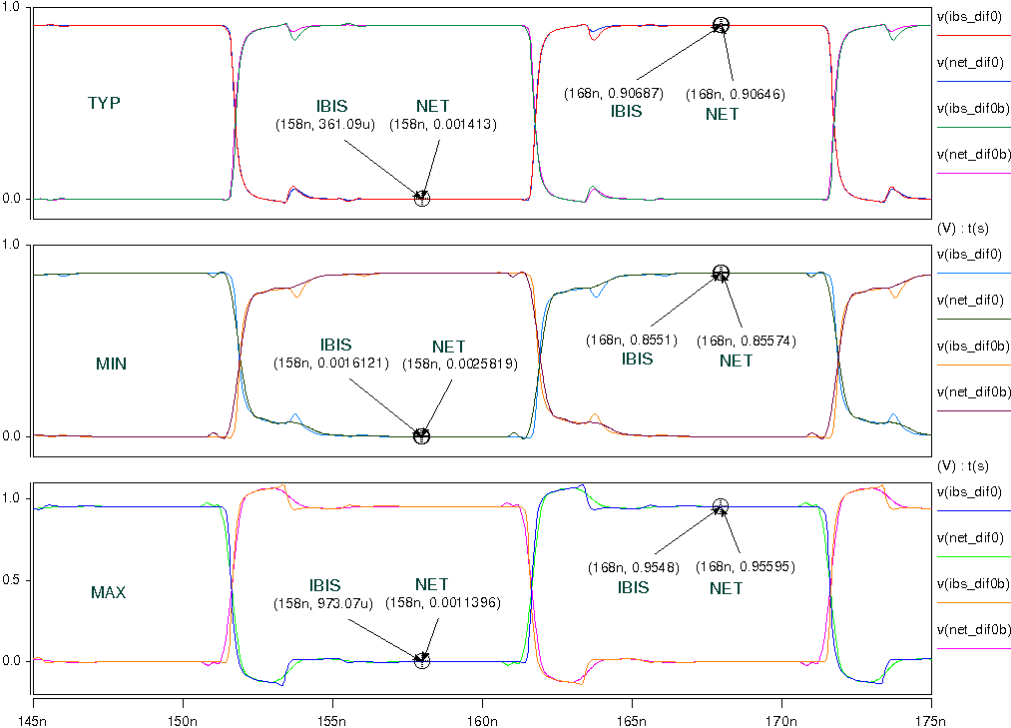

- HCSL_0P9_SLOW
- Simulation without package data;
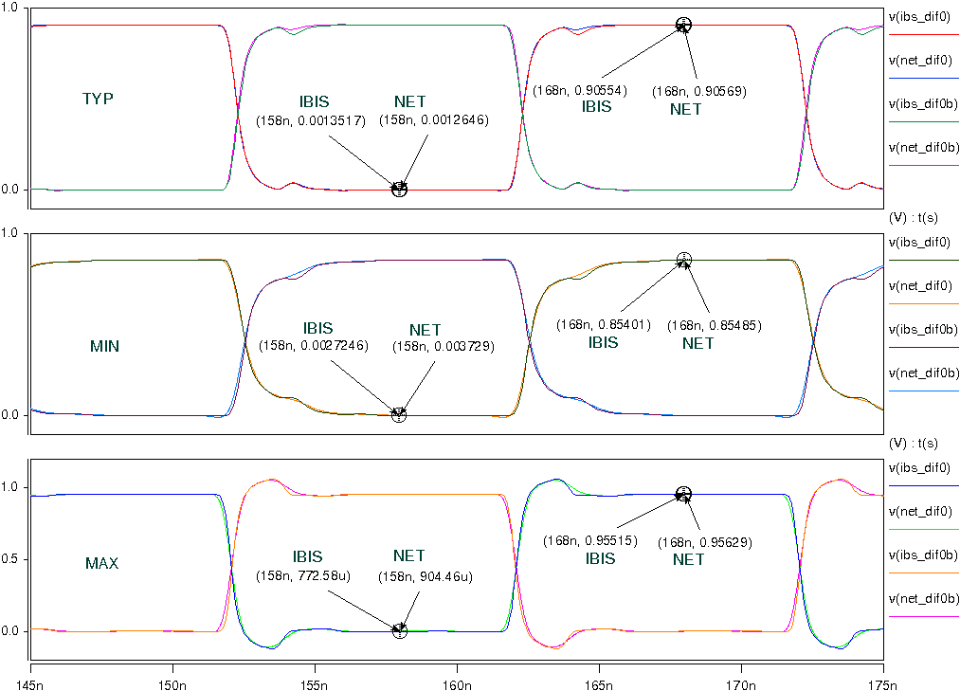
- Simulation with package data.
