Verification of PI6CFGL201B IBIS model
- Introduction:
To verify the correlation between the ibis model and hspice model, we need to do some simulations:
The frequency of signal is 100MHz:
Vvin vin 0 pulse( 3.3 0 4u 0.1n 0.1n 4.9n 10n )
Add a 50Ω resistance between signals and INPUT, with Add 50Ω pull-down resistor and 4pF pull-down capacitance to the OUTPUT：

- Add 2pF pull-down capacitance to the Output:
PI6CFGL201B
OUT

SCL_C
SDA_C
C
Input Signals

SCL_C
SDA_C
Output

SCL_C
SDA_C
VIN

SCL_C
SDA_C
- without package;
- with package.

- Add 50 Ohm pull-up resistor to the IO:
PI6CFGL201B

OUT

SCL_C
SDA_C
Input Signals

SCL_C
SDA_C
VIN

SCL_C
SDA_C
SDA_IO

SCL_C
SDA_C
SDA_IN

SCL_C
SDA_C
…..

SCL_C
SDA_C
3.3V

SCL_C
SDA_C
R=50Ohm

SCL_C
SDA_C
IO

SCL_C
SDA_C

- Conclusion:
- For OUTPUT, the simulation results of IBIS model can match very well with the HSPICE model at different load conditions;
- For IO, the simulation results of IBIS model can match very well with the HSPICE model at different load conditions.

- Simulation Result:
- OUTPUT
- without package;
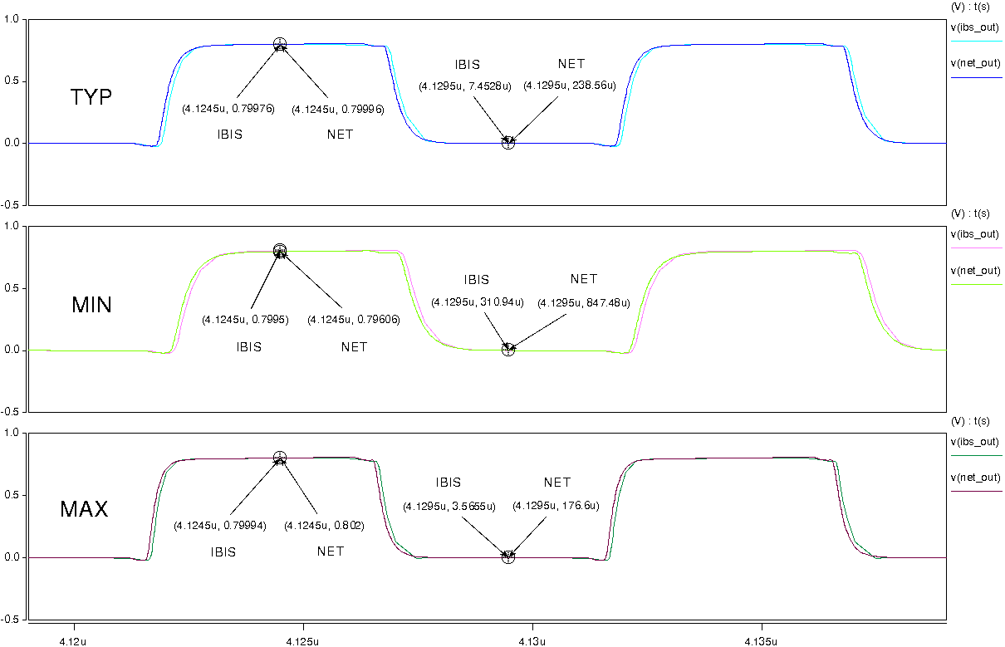

- with package.
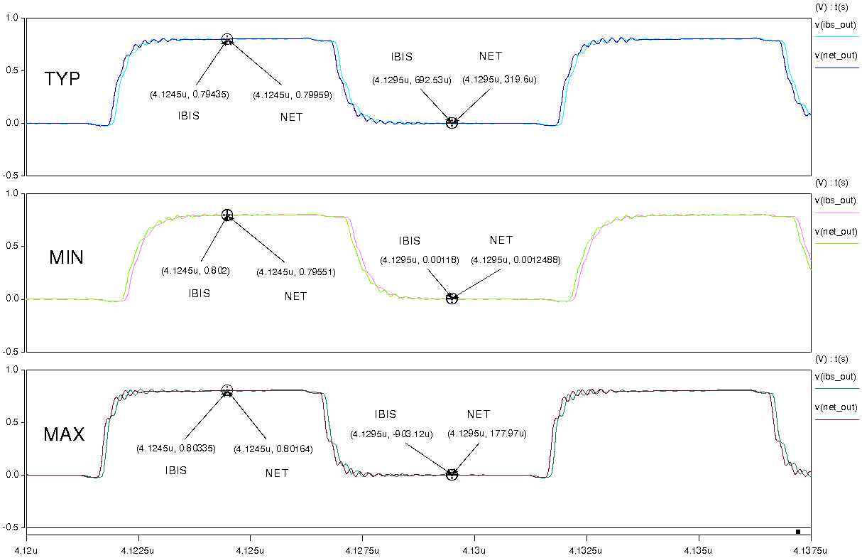

- IO
- without package;
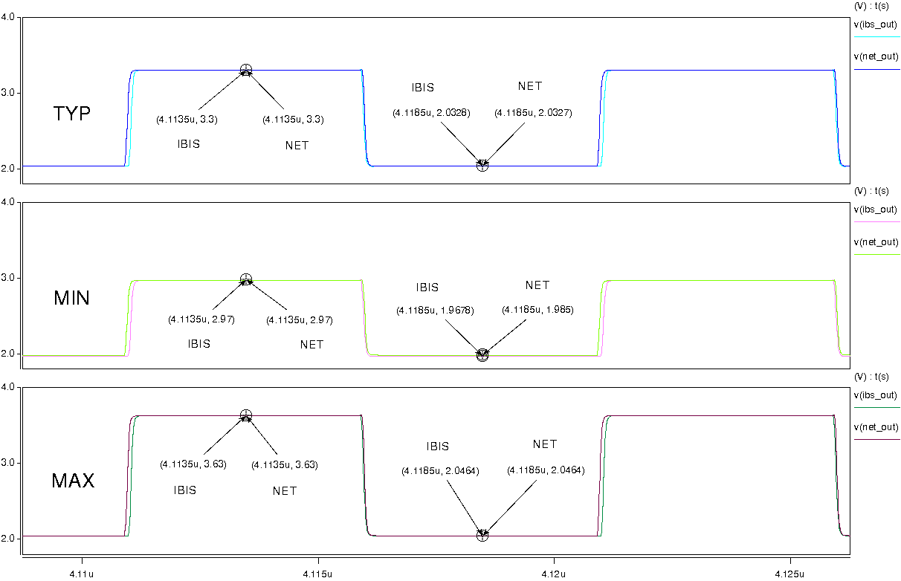
- with package;
