Verification of PI6C557-05 IBIS model

- Introduction:
To verify the correlation between the ibis model and hspice model, we need to do some simulations:

- For HCSL:
- Add each 33ohm and 50ohm at the differential output;
- Add each 33ohm resistor, 10inch trace and 2pF capacitor at the differential output, and add each 50ohm resistor to ground after 33ohm resistor;

- For LVDS:
- Add 100ohm resistor between the differential output, then add 150ohm resistor to the ground of each port, finally add another 100ohm resistor between differential output;
- Add 100ohm resistor and 10inch trace between the differential output;

- Conclusion:

The simulated results show that the generated IBIS model can match well with the HSPICE model at different load conditions.

The DC swing can also match the datasheet for both HCSL and LVDS.

- HCSL simulation:
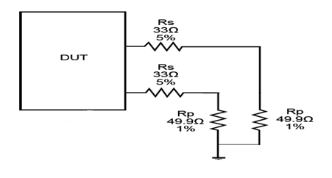
VDD=3.3V
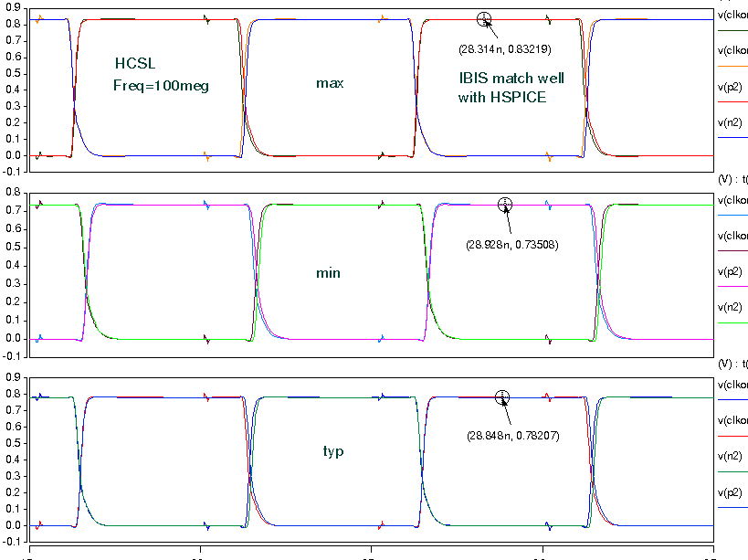

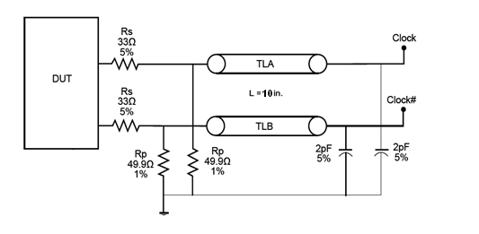
VDD=3.3V
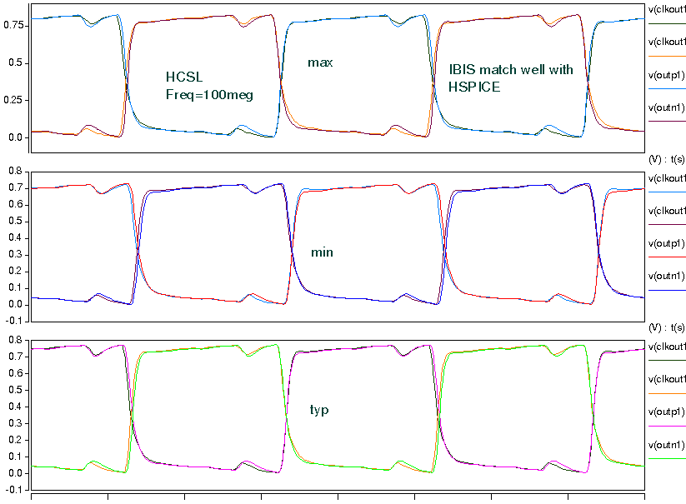

- LVDS simulation:
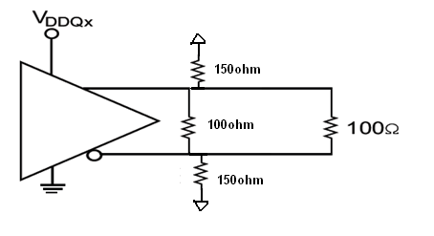
VDD=3.3V
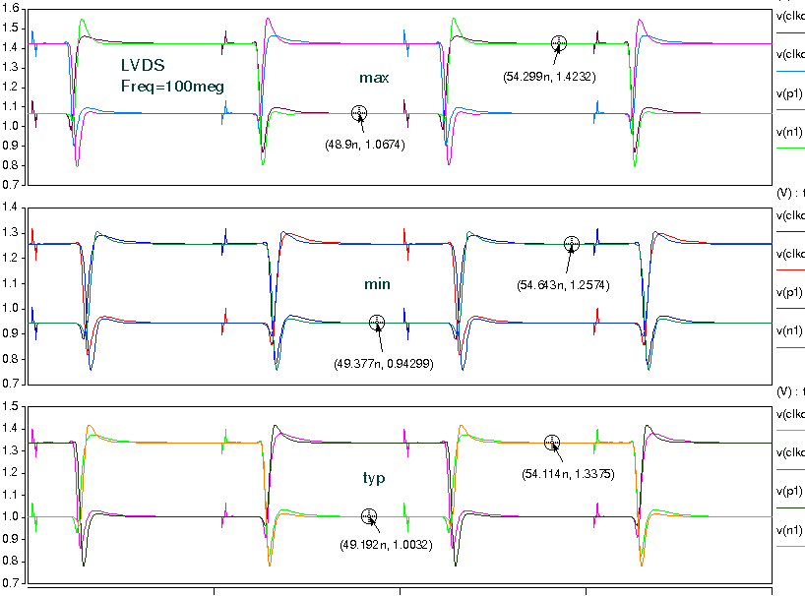

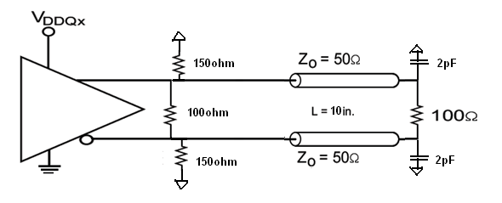
VDD=3.3V
