Verification of PI6C557-03A IBIS model
- Introduction: to verify the ibis model, we need to do some simulations for OUTPUT1:
With 33Ω resistor , 10-inch trace, 50Ω pull-down resistor and 2pF pulldown capacitance to the OUTPUT:
VOUT

SCL_C
SDA_C
IN

SCL_C
SDA_C
Input Signals

SCL_C
SDA_C
VIN

SCL_C
SDA_C
CLK

SCL_C
SDA_C
…..

SCL_C
SDA_C
10-inch
PI6C557-03A
VOUT#

SCL_C
SDA_C
IN#

SCL_C
SDA_C
CLK#

SCL_C
SDA_C
10-inch
C

SCL_C
SDA_C
C

SCL_C
SDA_C
R2

SCL_C
SDA_C
R2

SCL_C
SDA_C
R1

SCL_C
SDA_C
R1

SCL_C
SDA_C
- The frequency of signal is 20MHz, clamp=1:
vinn inn 0 pulse(0 clamp 0n 0.1n 0.1n 24.9n 50n)
vinp inp 0 pulse(clamp 0 0n 0.1n 0.1n 24.9n 50n)
- Simulation without package data;
- Simulation with package data.

- The frequency of signal is 100MHz, clamp=1:
vinn inn 0 pulse(0 clamp 0n 0.1n 0.1n 4.9n 10n)
vinp inp 0 pulse(clamp 0 0n 0.1n 0.1n 4.9n 10n)
- Simulation without package data;
- Simulation with package data.

- Simulation Result:
- 20MHz:
- Simulation without package data;
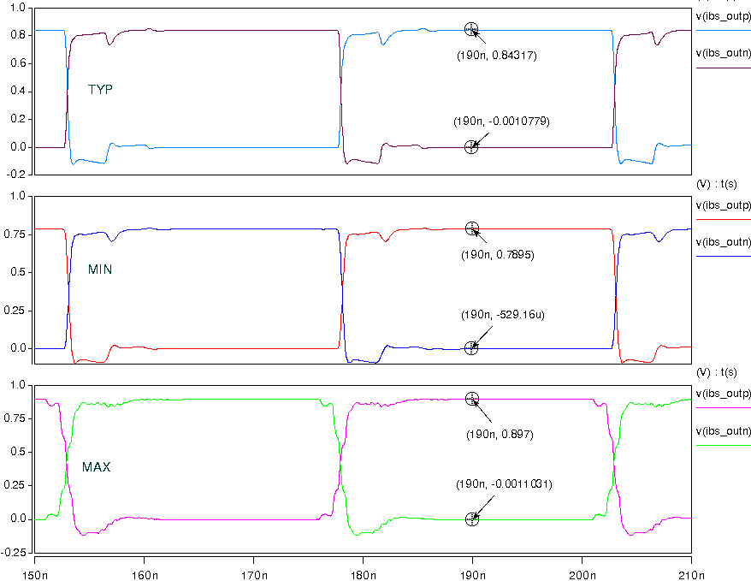
- Simulation with package data:
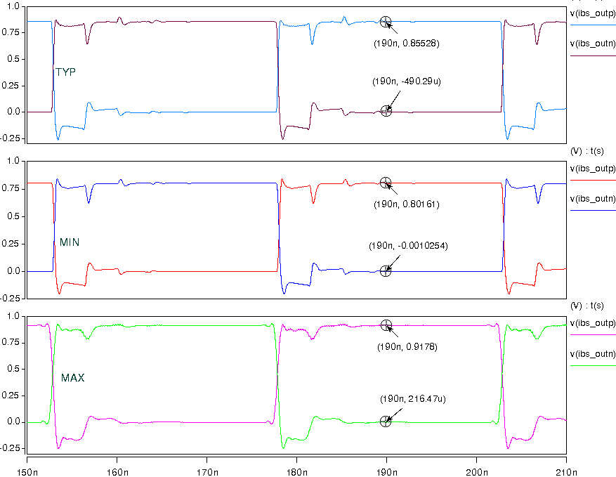
- 100MHz:
- Simulation without package data;
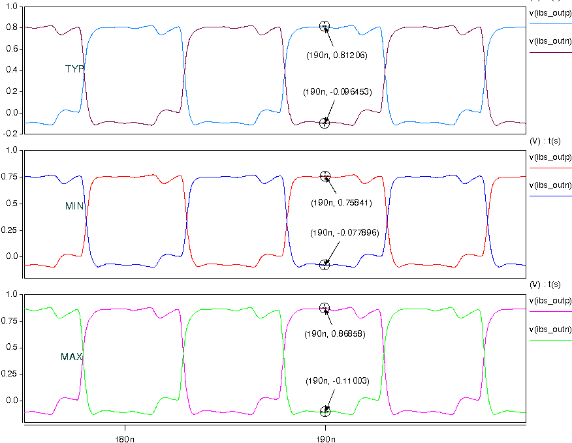
- Simulation with package data:
