PI6C49X0210
PI6C49X0210 Demo Board User Manual
by Shengjiang Pan

Table of Contents

1 Introduction 2
2 Overview 2
3 Quick Start 4
4 Detail Description 5
5 Appendix A: PI6C49X0210 Demo Board Schematic 8

Introduction
PI6C49X0210 is a high performance multi-voltage 10-outputs CMOS Fanout Buffer with internal Crystal Oscillator. PI6C49X0210 demo board is designed to demonstrate the performance and key features of PI6C49X0210. This user manual describes how to use this demo board. It will be divided into following sections:

- Overview
- Quick Start
- Detail Description
- Test Results

Overview
Figure 1 is the block diagram of PI6C49X0210 demo board and Figures 2 is the top view of Demo board. Crystal, Ref0 and Ref1 can be selected as clock source input through JP1, JP2 and JP3. There are 10 output Jumpers for clock output test.

JP7
PI6C49X0210
JP2
1’’
CLK0
JP1
JP9
JP11
JP14
Crystal
JP4
CLK1
CLK2
CLK3
CLK4
JP10
JP12
JP13
JP15
JP8
1’’
1’’
1’’
1’’
1’’
1’’
1’’
1’’
1’’
Ref1
Ref0
JP3
CLK9
CLK8
CLK7
CLK6
CLK5
Figure 1: Block Diagram of PI6C49X0210 Demo Board
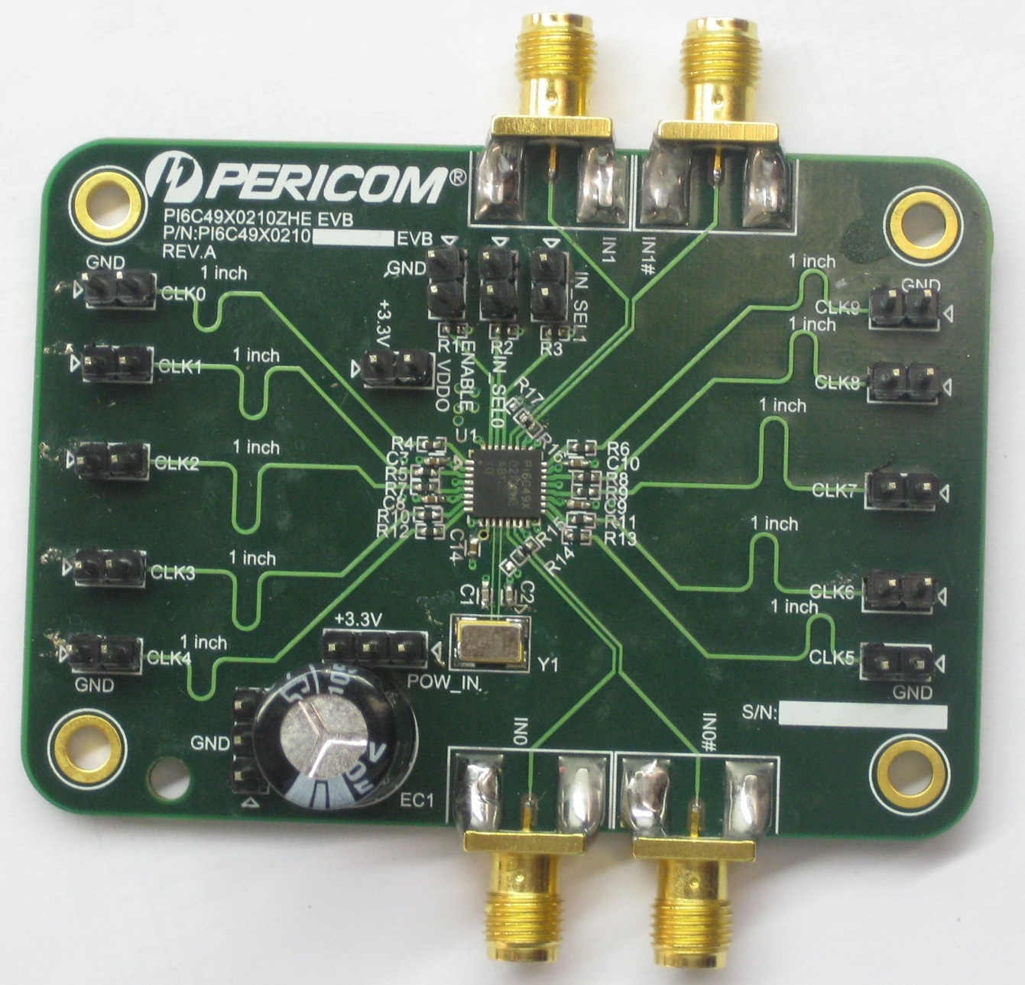
Figure 2: Top View of PI6C49X0210 Demo Board

Quick Start
To start up the PI6C49X0210 demo board, complete the following steps:
- Ensure 5pf loadings are soldered at clock output header pins.
- Supply 3.3V to demo board at JP18 (Power) and JP19 (Ground).
- Place jumper at JP190.
- Set JP1 open: enable all clock outputs
- Set JP2 and JP3 open: Crystal is selected as source input.

JP1 | JP2 | JP3 | JP190
Open | Open | Open | Short
Table 1: Jumpers Connection at Quick Start

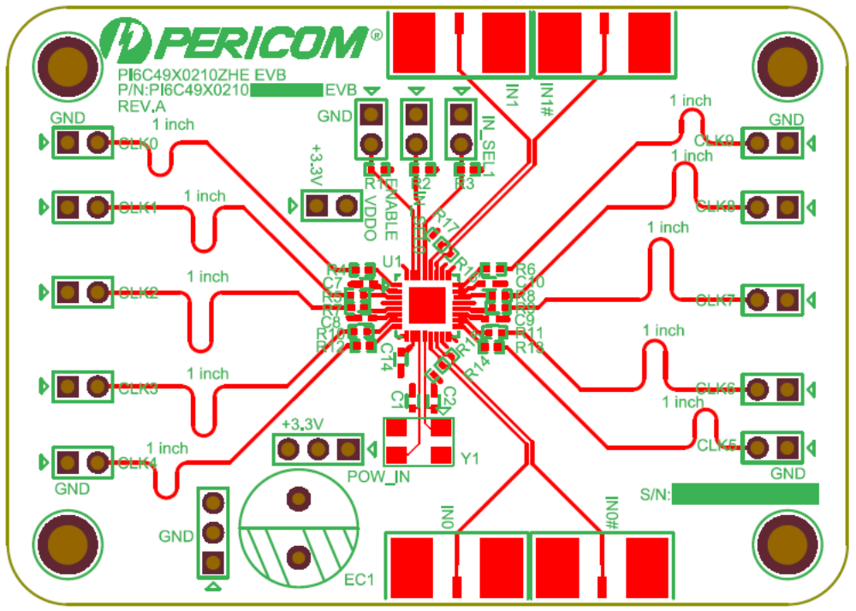
PIC49X0210
JP1
JP2
JP3
JP4
JP7
JP9
JP11
JP14
JP8
JP10
JP12
JP13
JP15
Crystal
Ref 0
Ref 1
JP190
JP19
JP18

Figure 3: Layout of PI3HDMI336 Demo Board (Top View)

Detail Description
The functionality of Jumpers and key circuits are described in detail in this section.

  - Functionality of Jumpers

Jumper | Description
JP1 | Output enable/disable:  Short: disabled  Open: enabled
JP2, JP3 | Selection of source input:  JP2 JP3 Source selection  Open Open Crystal  Short Open Crystal  Open Short Ref1 or Single End  Short Short Ref0 or Single End
JP4, JP7, JP8, JP9, JP10, JP11, JP12, JP13, JP14, JP15 | Clock output test Jumpers
JP18 | Power pin
JP19 | Ground pin
JP190 | Power supply for Vddo:  Open: Vddo does not connect to power supply.  Short: Vddo connects to power supply.
Table 2: Function of Jumpers

  - Key Circuits Description

- Source Termination Circuit
33Ω source termination is placed more closed to IC within 0.1 inch to reduce reflection.

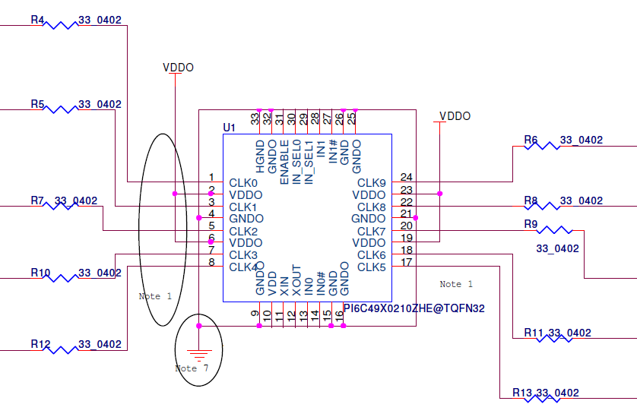
Figure 4: Termination at Clock Output

- Termination Circuit at Clock Input
PI6C49X0210 accepts single end clock or differential clock. If differential clock is as input, 100Ω termination should be soldered on the PCB; if single end clock is as input, 50Ω termination should be soldered on the PCB.

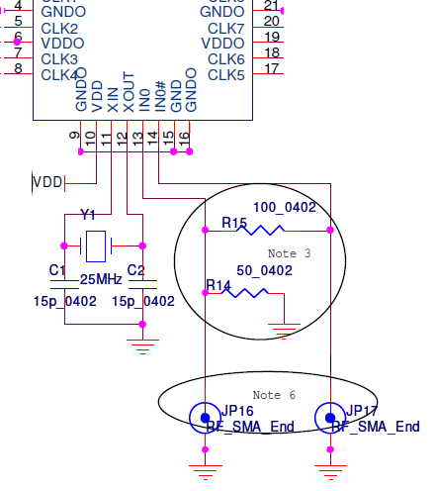
100Ω differential termination
50Ω single end termination
Figure 5: Termination at Clock Input

Appendix A: PI6C49X0210 Demo Board Schematic

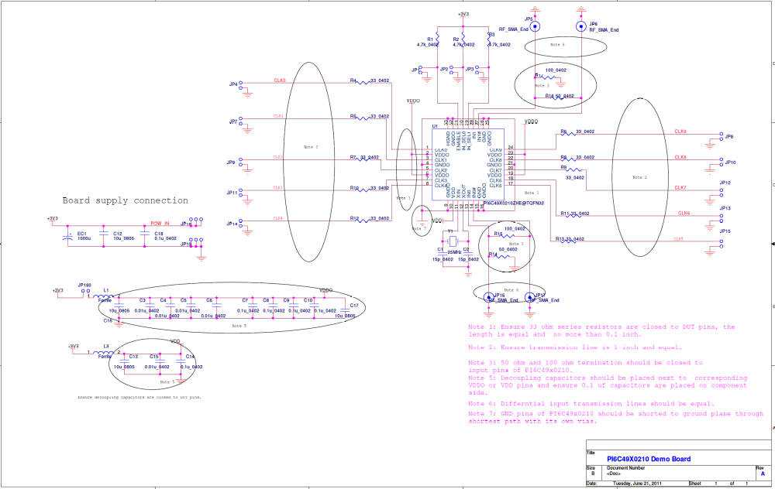

For more clear on viewing the schematic diagram, please click on this icon to open the PDF file. 

