Verification of PI6C49X0206T IBIS model
- Introduction:
To verify the correlation between the ibis model and hspice model, we need to do some simulations:

The frequency of signal is 100MHz:
Vin0 in0 0 pulse(0 3.3 0 .2n .2n 9.8n 20n)
- Add 50Ω pull-down resistor to VDD, and 5pf pull-down capacitance to the OUTPUT
PI6C49X0206T
VOUT

SCL_C
SDA_C
R

SCL_C
SDA_C
CLK

SCL_C
SDA_C
C

SCL_C
SDA_C
Input Signals

SCL_C
SDA_C
Q0

SCL_C
SDA_C
VIN

SCL_C
SDA_C
Q1

SCL_C
SDA_C
- Simulation without package data;
- Simulation with package data.

- Add 50Ω pull-up resistor to VDD, and 5pf pull-down capacitance to the OUTPUT
PI6C49X0206T
VOUT

SCL_C
SDA_C
R

SCL_C
SDA_C
CLK

SCL_C
SDA_C
C

SCL_C
SDA_C
Input Signals

SCL_C
SDA_C
Q0

SCL_C
SDA_C
VIN

SCL_C
SDA_C
Q1

SCL_C
SDA_C
VDDO

SCL_C
SDA_C
- Simulation without package data;
- Simulation with package data.

- Add 33Ω resistor, 5 inches trace and 5pf pull-down capacitance to the OUTPUT
PI6C49X0206T
VOUT

SCL_C
SDA_C
R

SCL_C
SDA_C
CLK

SCL_C
SDA_C
C

SCL_C
SDA_C
Input Signals

SCL_C
SDA_C
Q0

SCL_C
SDA_C
VIN

SCL_C
SDA_C
Q1

SCL_C
SDA_C
Trace

SCL_C
SDA_C
- Simulation without package data;
- Simulation with package data.

- Conclusion:
- For OUTPUT, the simulation results of IBIS model can match very well with the HSPICE model at different simulating conditions.
- Simulation Result:
- Add 50Ω pull-down resistor to VDD, and 5pf pull-down capacitance to the OUTPUT
- Simulation without package data;
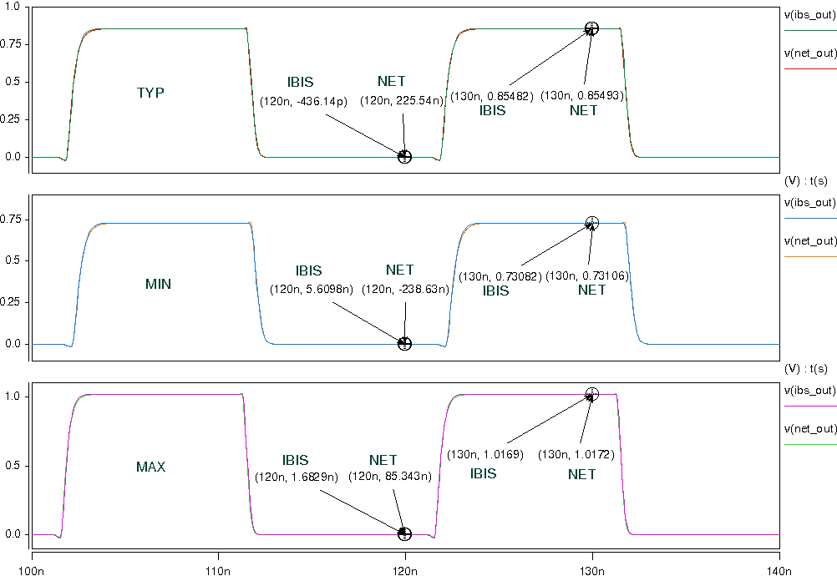
- Simulation with package data.
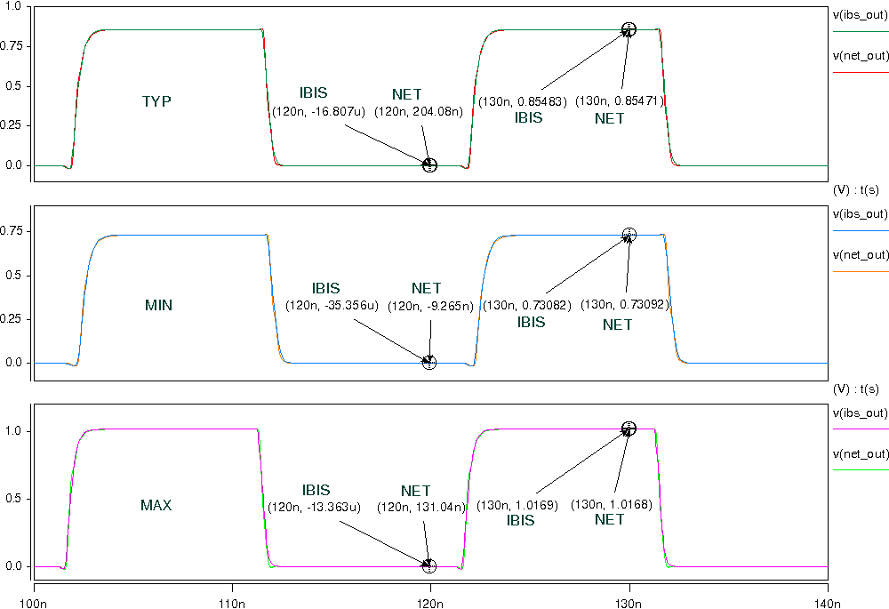

- Add 50Ω pull-up resistor to VDD, and 5pf pull-down capacitance to the OUTPUT
- Simulation without package data;
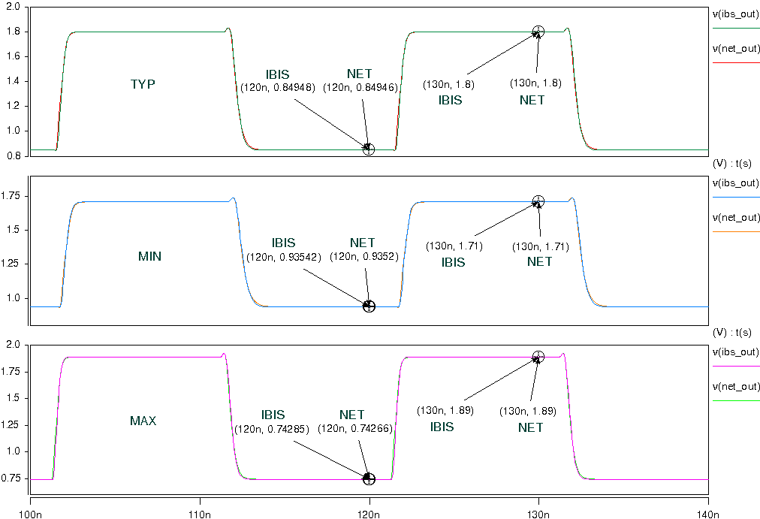
- Simulation with package data.
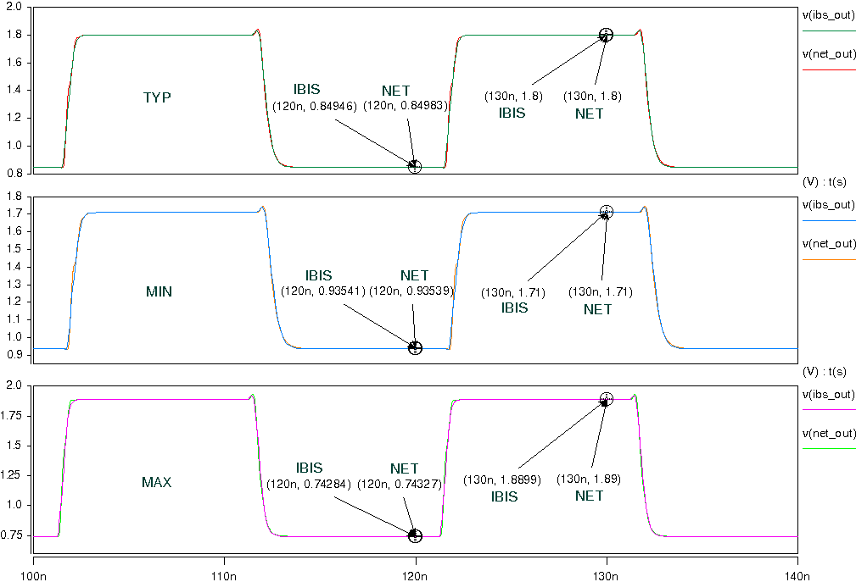

- Add 33Ω resistor, 5 inches trace and 5pf pull-down capacitance to the OUTPUT
- Simulation without package data;
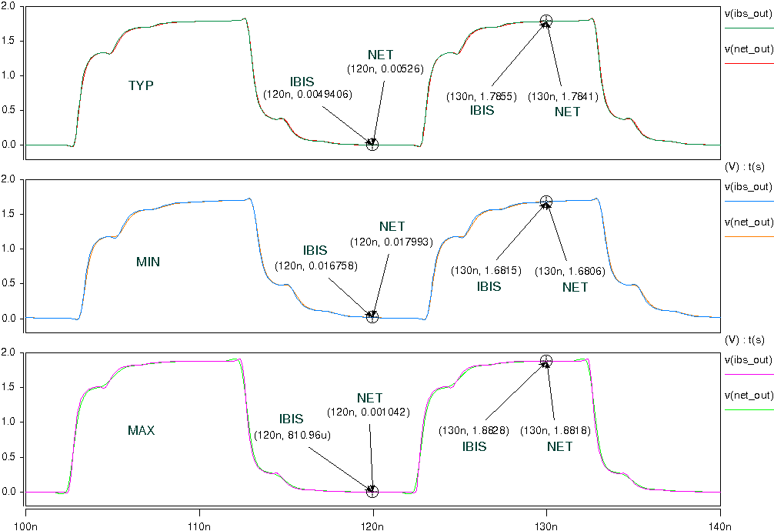
- Simulation with package data.
