Verification of PI6C49X0202 IBIS model
- Introduction:
To verify the correlation between the ibis model and hspice model, we need to do some simulations:

The frequency of signal is 250MHz:
vin clk 0 pulse ( 0 2.5 0 .2n .2n 1.8n 4n)
- Pull-Down Output:
PI6C49X0202
VOUT

SCL_C
SDA_C
R

SCL_C
SDA_C
CLK

SCL_C
SDA_C
C

SCL_C
SDA_C
Input Signals

SCL_C
SDA_C
Q0

SCL_C
SDA_C
VIN

SCL_C
SDA_C
Q1

SCL_C
SDA_C
- Add 50Ω pull-down resistor and without capacitance to the output;
- Add 5p pull-down capacitance and without resistor to the output;
- Add 50Ω pull-down resistor and 5pF pull-down capacitance to the output;

- Pull-Up Output:
PI6C49X0202
VOUT

SCL_C
SDA_C
R

SCL_C
SDA_C
CLK

SCL_C
SDA_C
C

SCL_C
SDA_C
Input Signals

SCL_C
SDA_C
Q0

SCL_C
SDA_C
VIN

SCL_C
SDA_C
Q1

SCL_C
SDA_C
VDDO

SCL_C
SDA_C
- Add 50Ω pull-up resistor and without capacitance to the output;
- Add 50Ω pull-up resistor and 5pF pull-down capacitance to the output;

- With 3.9 inches Trace Output:
PI6C49X0202
VOUT

SCL_C
SDA_C
R

SCL_C
SDA_C
CLK

SCL_C
SDA_C
C

SCL_C
SDA_C
Input Signals

SCL_C
SDA_C
Q0

SCL_C
SDA_C
VIN

SCL_C
SDA_C
Q1

SCL_C
SDA_C
Trace

SCL_C
SDA_C
- Add 33Ω resistor, 3.9inch trace and without capacitance to the output;
- Add 33Ω resistor, 3.9inch trace and 5pF pull-down capacitance to the output;

- Conclusion:
- For OUTPUT, the simulation results of IBIS model can match very well with the HSPICE model at different simulating conditions.
- Simulation Result:
- Pull-Down Output:
PI6C49X0202
VOUT

SCL_C
SDA_C
R

SCL_C
SDA_C
CLK

SCL_C
SDA_C
C

SCL_C
SDA_C
Input Signals

SCL_C
SDA_C
Q0

SCL_C
SDA_C
VIN

SCL_C
SDA_C
Q1

SCL_C
SDA_C
- Add 50Ω pull-down resistor and without capacitance to the output;
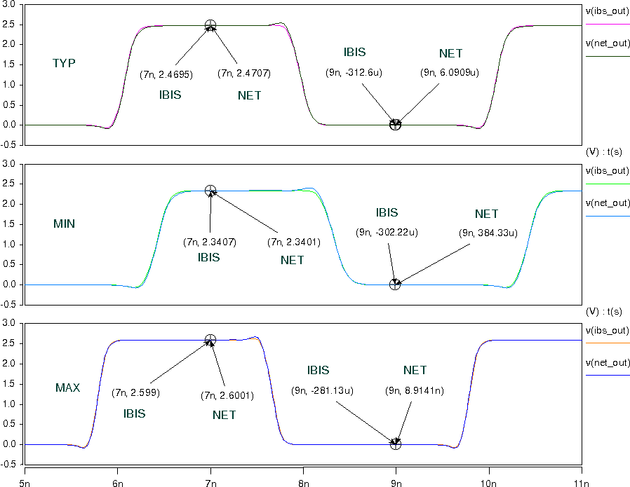
- Add 5p pull-down capacitance and without resistor to the output;
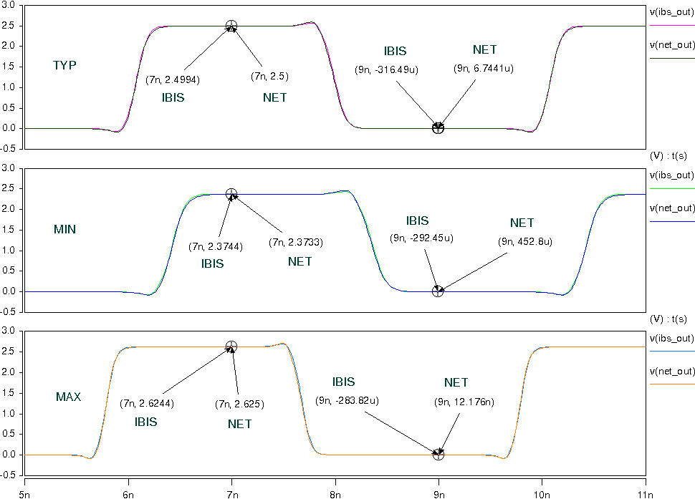

- Add 50Ω pull-down resistor and 5pF pull-down capacitance to the output;
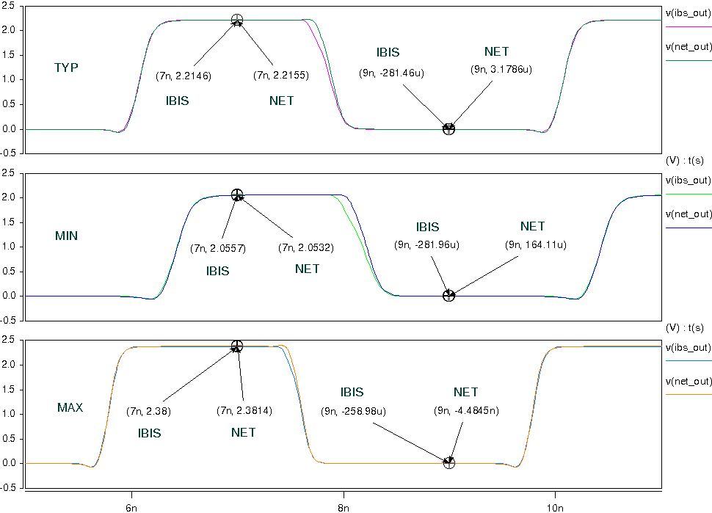

- Pull-Up Output:
PI6C49X0202
VOUT

SCL_C
SDA_C
R

SCL_C
SDA_C
CLK

SCL_C
SDA_C
C

SCL_C
SDA_C
Input Signals

SCL_C
SDA_C
Q0

SCL_C
SDA_C
VIN

SCL_C
SDA_C
Q1

SCL_C
SDA_C
VDDO

SCL_C
SDA_C
- Add 50Ω pull-up resistor and without capacitance to the output;
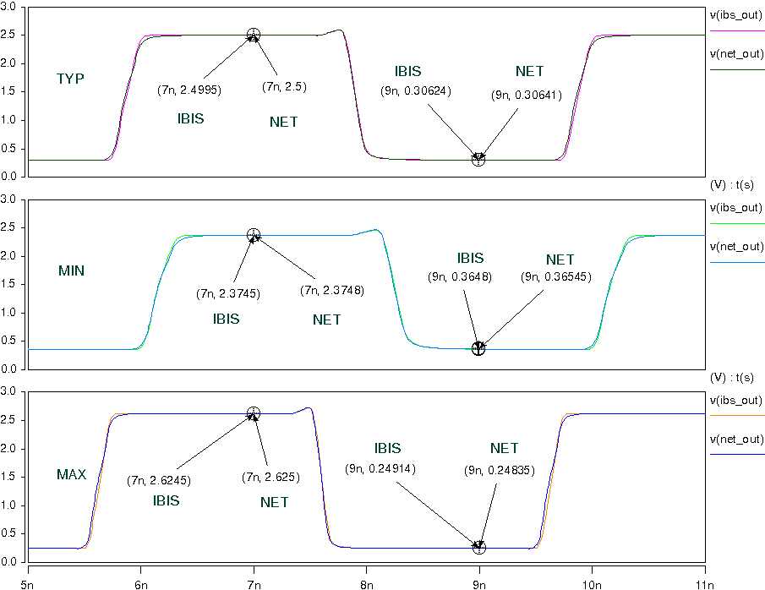

- Add 50Ω pull-up resistor and 5pF pull-down capacitance to the output;
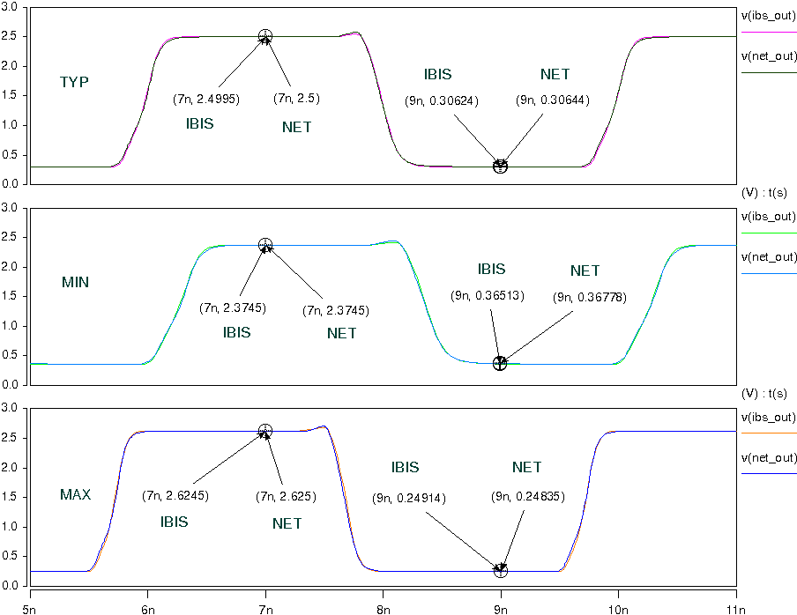

- With 3.9 inches Trace Output:
PI6C49X0202
VOUT

SCL_C
SDA_C
R

SCL_C
SDA_C
CLK

SCL_C
SDA_C
C

SCL_C
SDA_C
Input Signals

SCL_C
SDA_C
Q0

SCL_C
SDA_C
VIN

SCL_C
SDA_C
Q1

SCL_C
SDA_C
Trace

SCL_C
SDA_C
- Add 33Ω resistor, 4inch trace and without capacitance to the output;
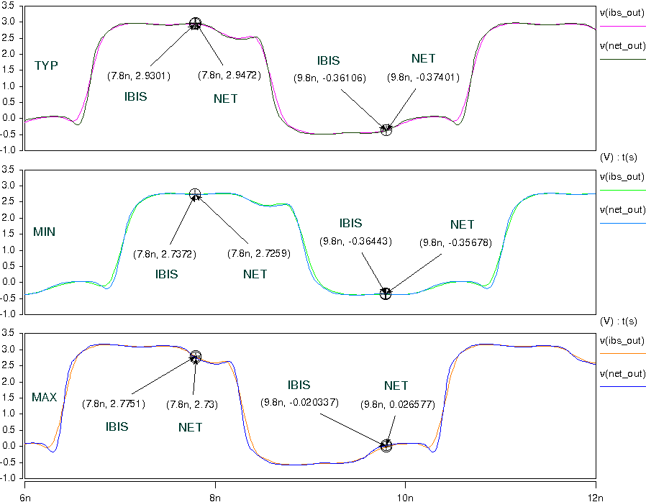

- Add 33Ω resistor, 4inch trace and 5pF pull-down capacitance to the output;
