Verification of PI6C49S1510A IBIS model

- Introduction:
To verify the correlation between the ibis model and hspice model, we need to do some simulations:

- For LVPECL:
- Add each 150ohm resistor to ground and 100ohm between the differential output;
- Add each 150ohm resistor to ground, 2inch trace and 100ohm between the differential output;

- For LVDS:
- Add 100ohm resistor between the differential output;
- Add 100ohm resistor and 2inch trace between the differential output;

- For HCSL:
- Add each 33ohm and 50ohm at the differential output;
- Add each 33ohm resistor, 2inch trace and 2pF capacitor at the differential output, and add each 50ohm resistor to ground after 33ohm resistor;

- Conclusion:

The simulated results show that the generated IBIS model can match well with the HSPICE model at different load conditions.

But there are still some issues:

- There is some over shoot at the rise-edge and fall-edge of “LVPECL” IBIS simulation while it is disappeared in the HSPICE simulation.
- LVPECL simulation:
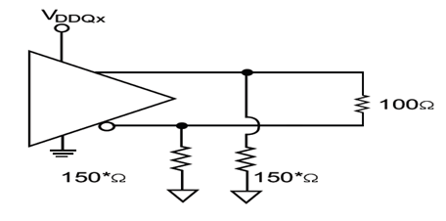
VDD=2.5V
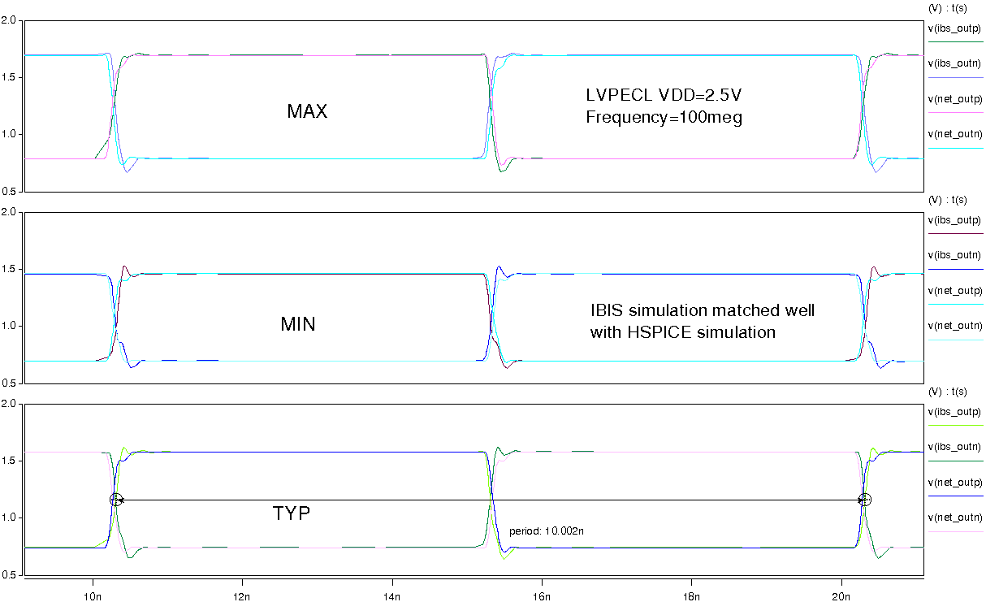
VDD=3.3V
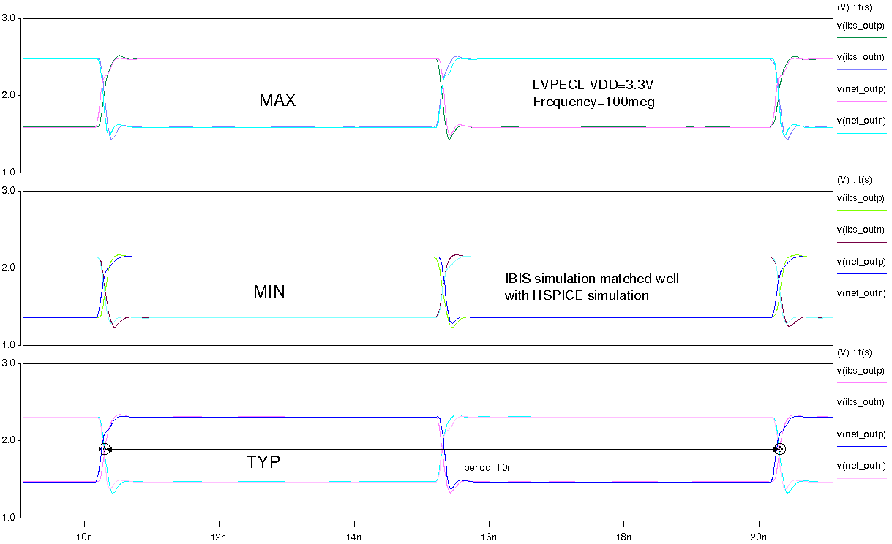
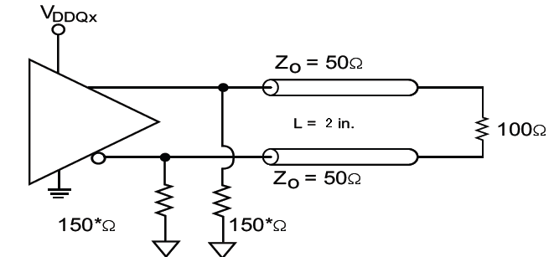
VDD=2.5V
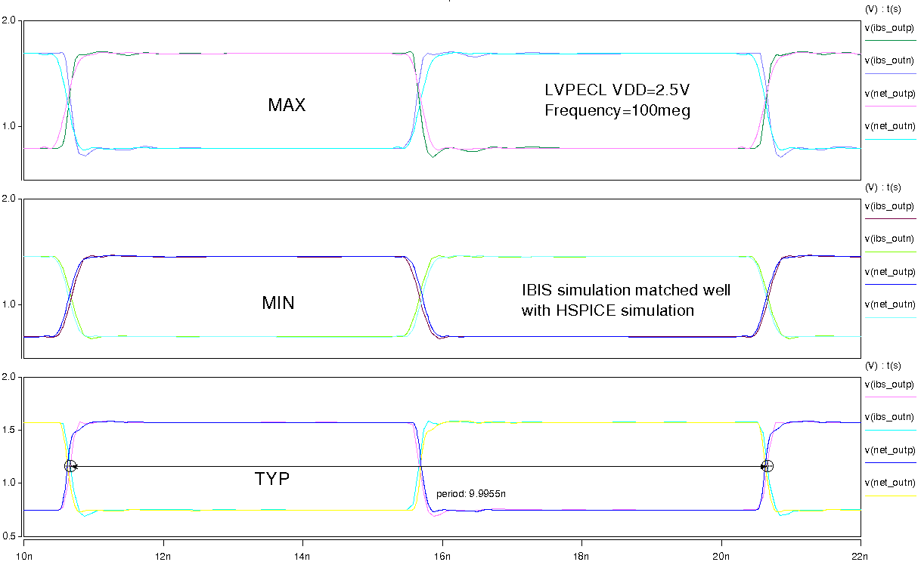
VDD=3.3V
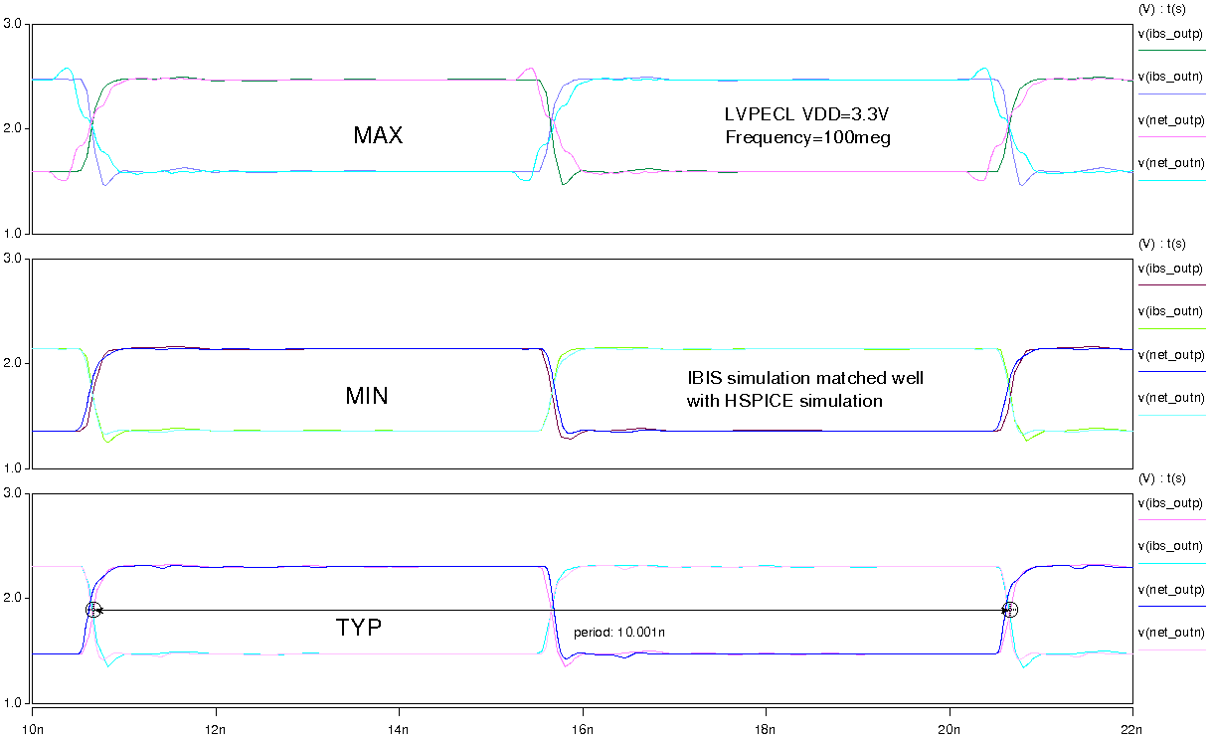
- LVDS simulation:
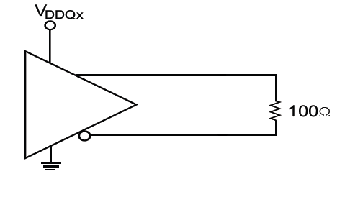
VDD=2.5V
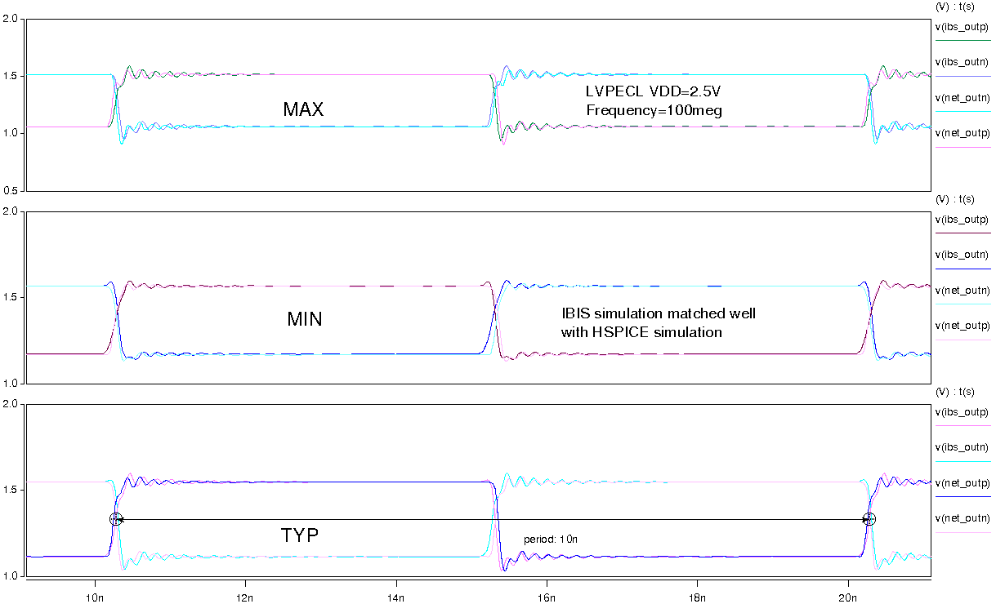
VDD=3.3V
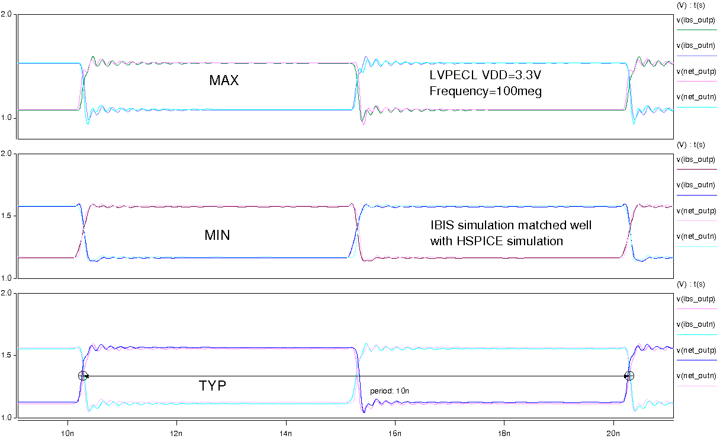
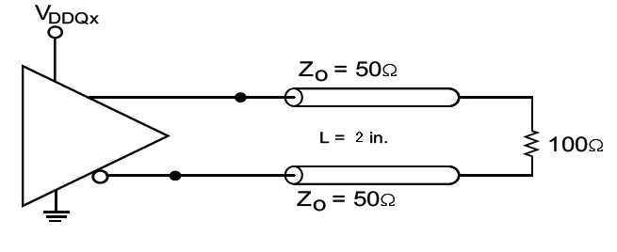
VDD=2.5V
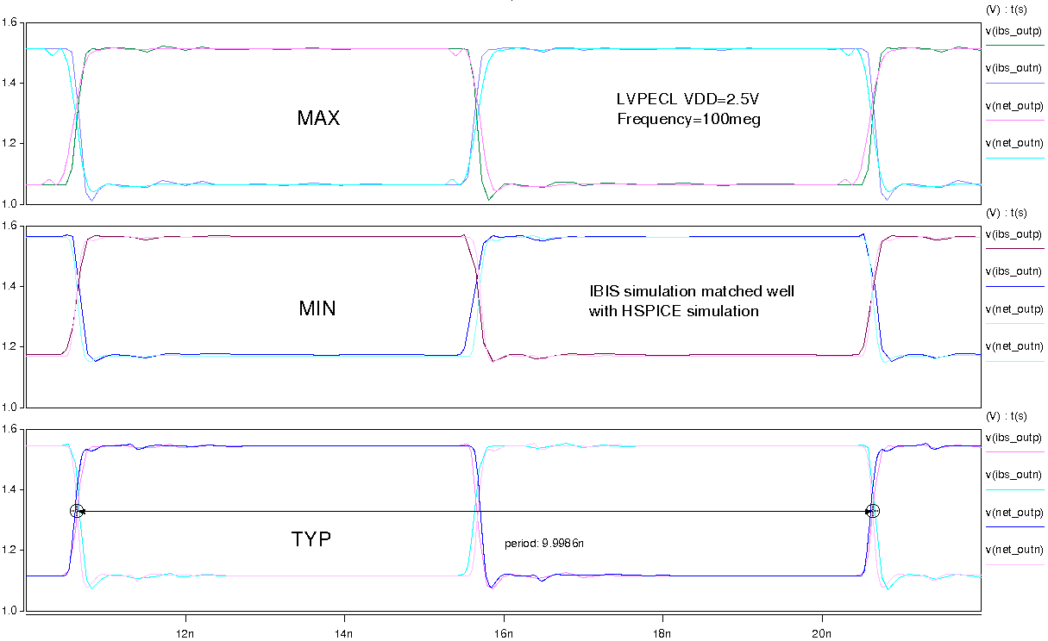
VDD=3.3V
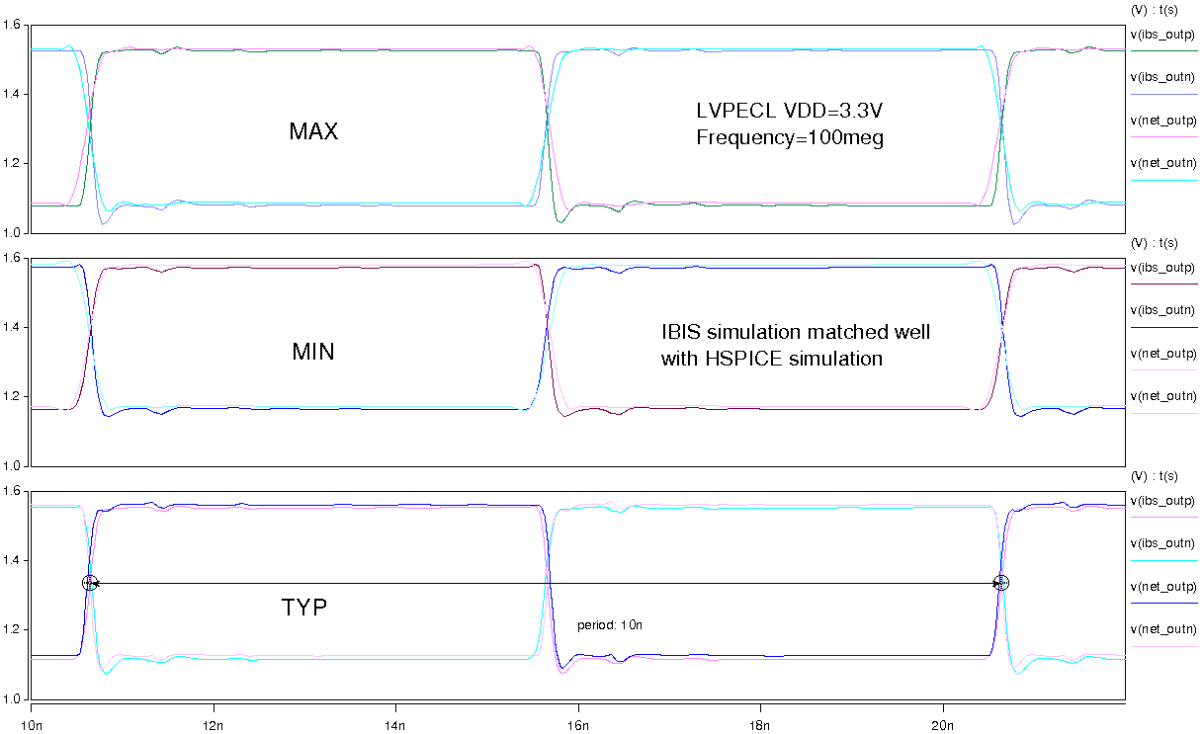

- HCSL simulation:
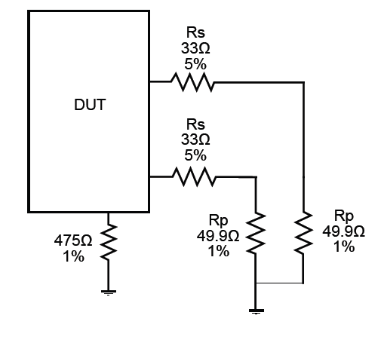
VDD=2.5V
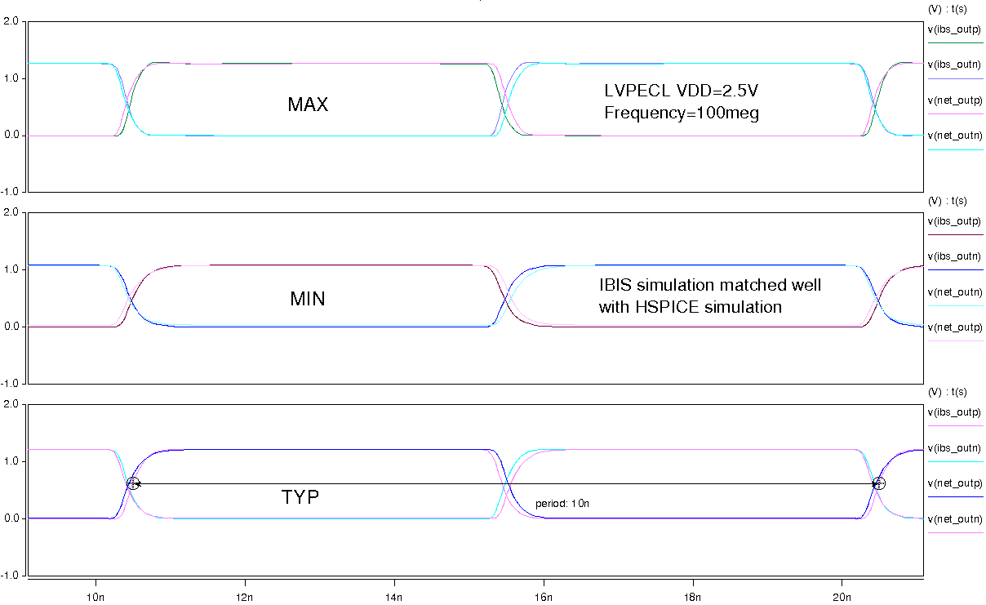
VDD=3.3V
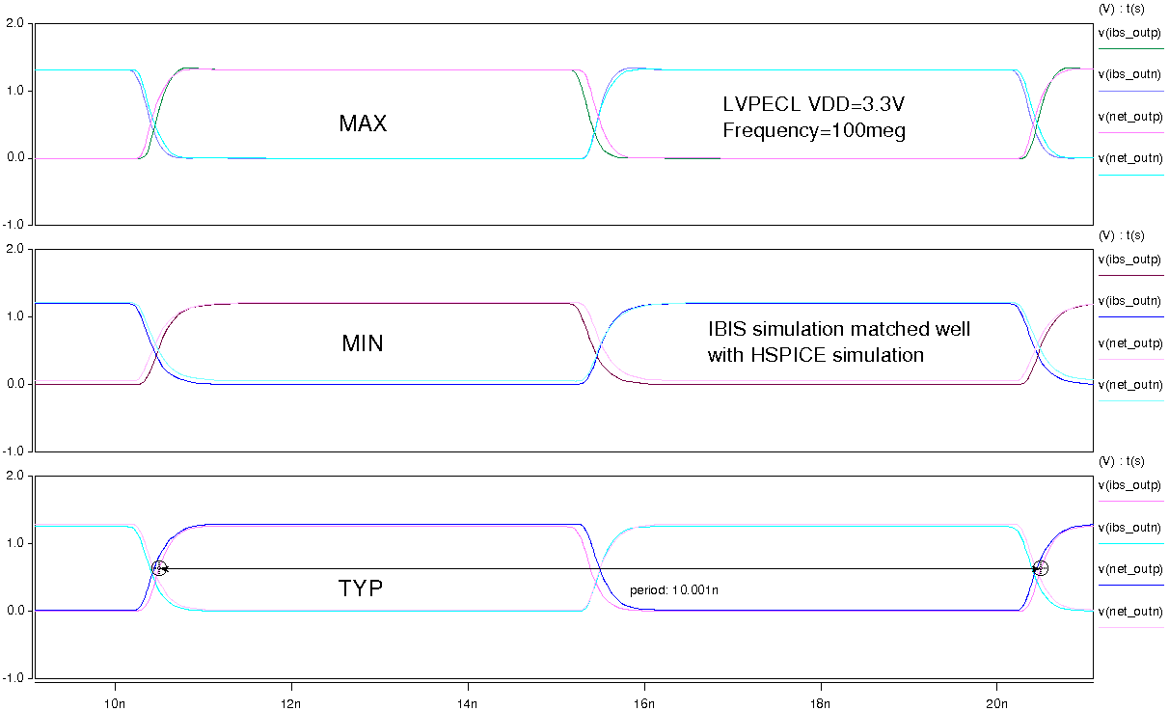
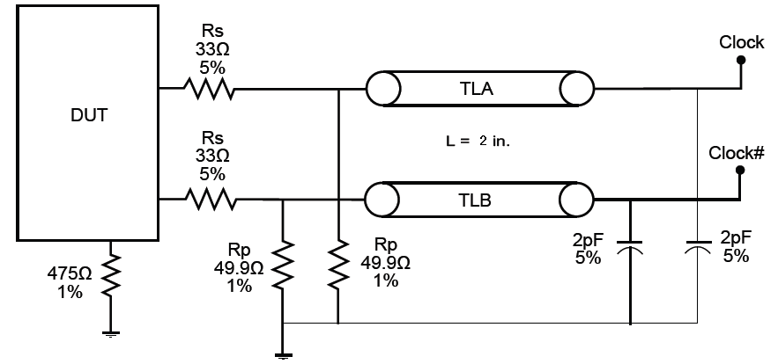
VDD=2.5V
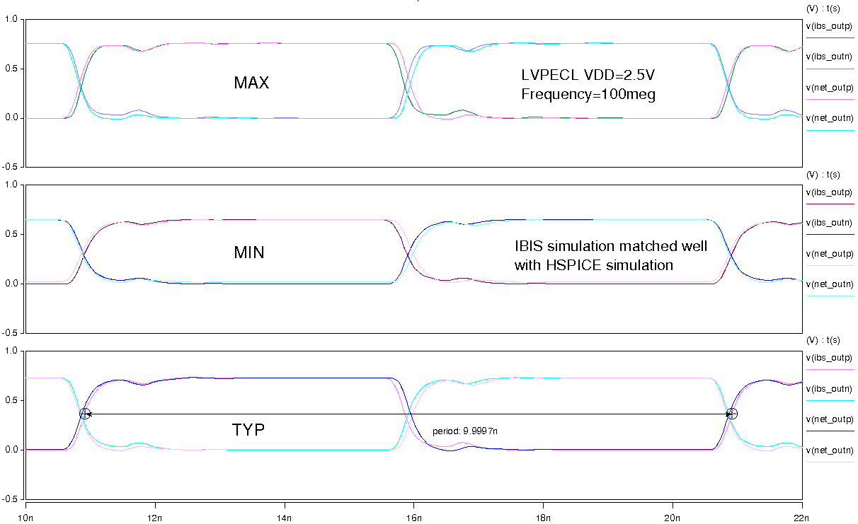
VDD=3.3V
