Verification of PI49S1510A IBIS model
- Introduction: to verify the correlation between the ibis model and hspice model, we need to do some simulations:

- Add 100 Ohm resistor between the differential output(LVDS):
PI49S1510A
VOUT

SCL_C
SDA_C
Input Signals

SCL_C
SDA_C
VIN

SCL_C
SDA_C
IOA+

SCL_C
SDA_C
IN

SCL_C
SDA_C
R=100Ohm

SCL_C
SDA_C

IOA-

SCL_C
SDA_C
- Simulation without package data;
- Simulation with package data.

- Add 150 Ohm pull-down resistor and 100 Ohm resistor between the differential output(LVPECL):
PI49S1510A
VOUT

SCL_C
SDA_C
Input Signals

SCL_C
SDA_C
VIN

SCL_C
SDA_C
IOB+

SCL_C
SDA_C
IN

SCL_C
SDA_C
R=150Ohm

SCL_C
SDA_C
R=100ohm

SCL_C
SDA_C
R=150Ohm

SCL_C
SDA_C
Gnd

SCL_C
SDA_C
Gnd

SCL_C
SDA_C
IOB-

SCL_C
SDA_C
- Simulation without package data;
- Simulation with package data.

- Conclusion:
For the verification, the simulation results of IBIS model can match very well with the HSPICE model at different simulating conditions.

- Simulation Result : (the former is 2.5V while the later is 3.3V)

- For the power supply is 2.5V.

- Typ:
- Simulation without package data;
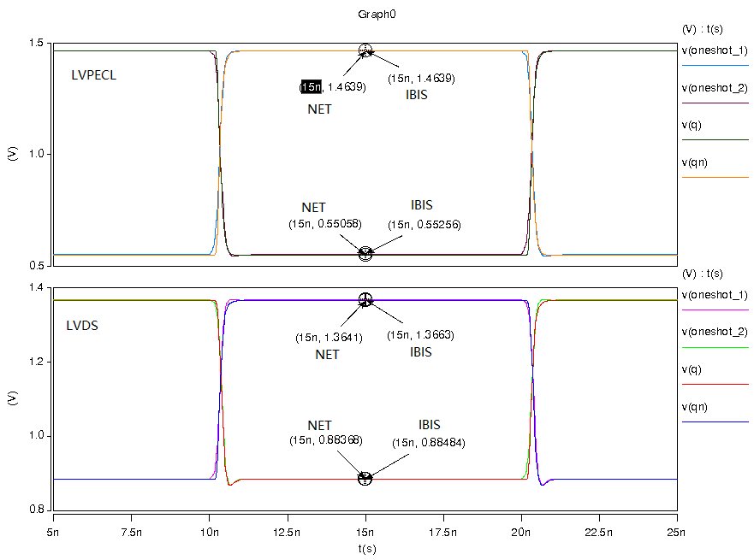
- Simulation with package data.
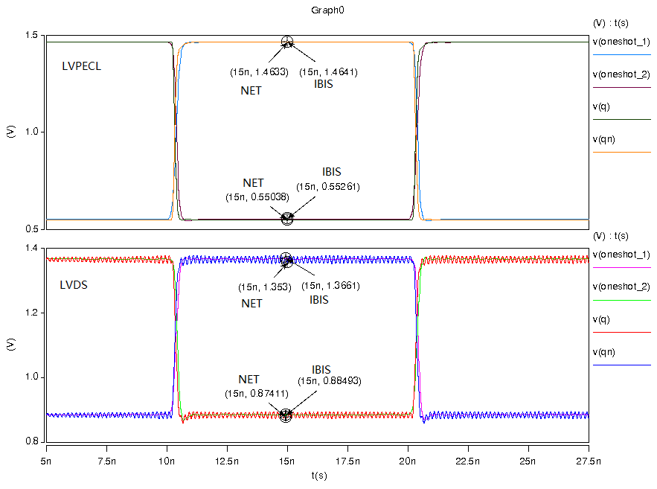
- Min:
- Simulation without package data;
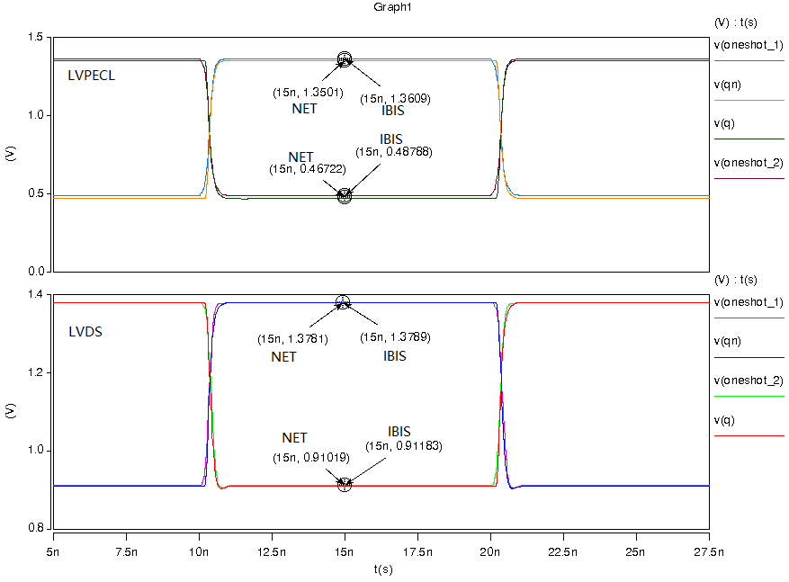
- Simulation with package data.
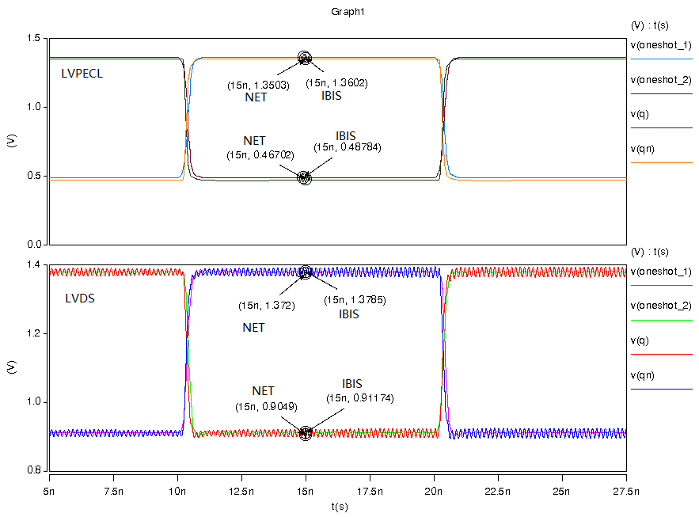
- Max:
- Simulation without package data;
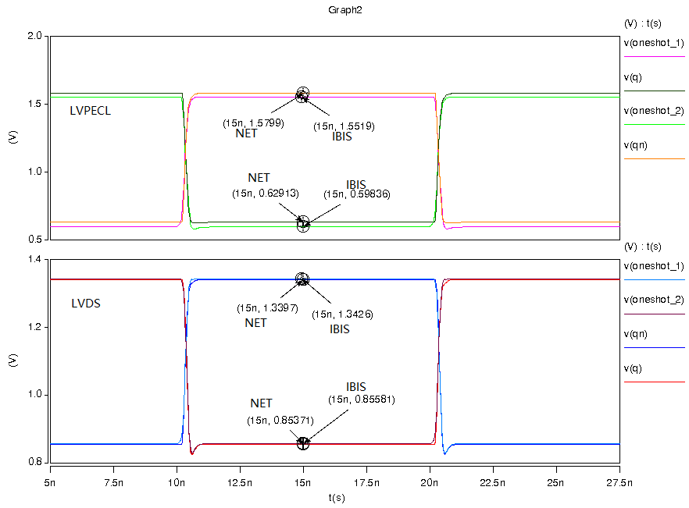
- Simulation with package data.
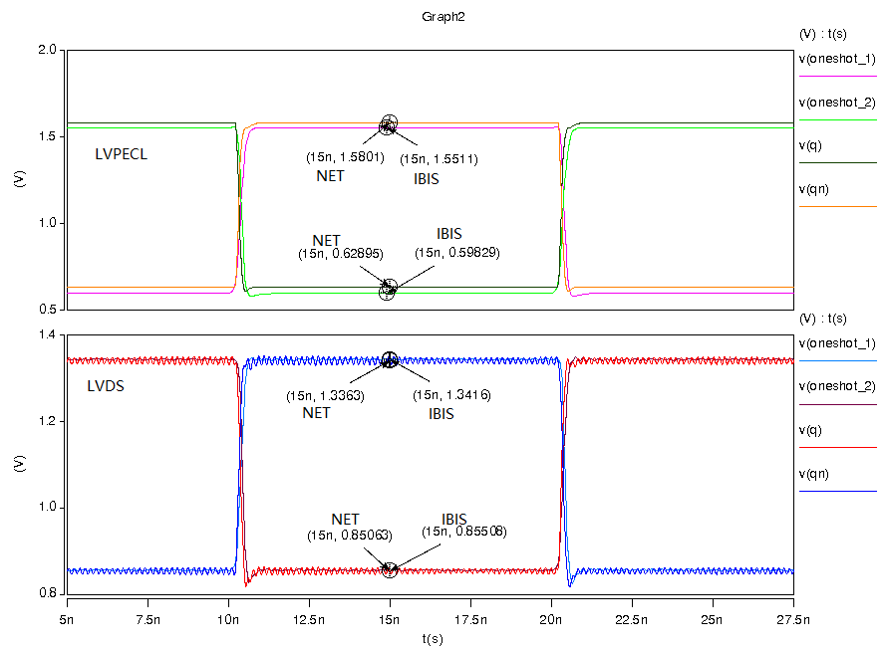

- For the power supply is 3.3V.
- TYP:
  - Without the package:
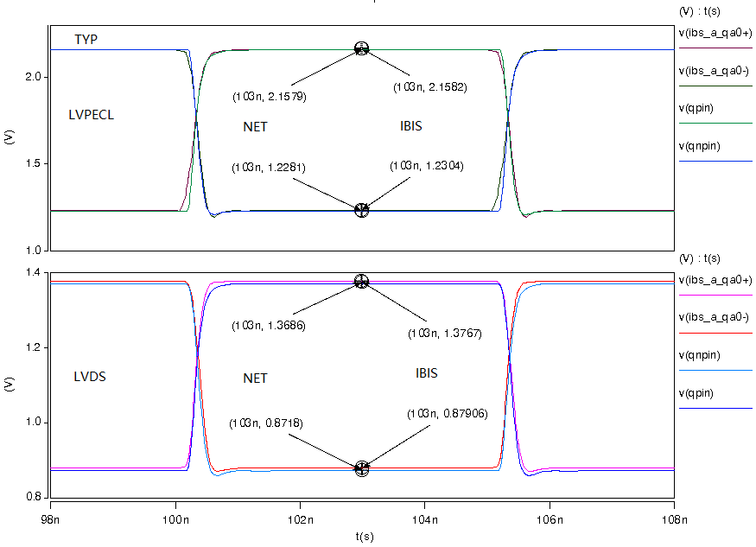
  - With the package:
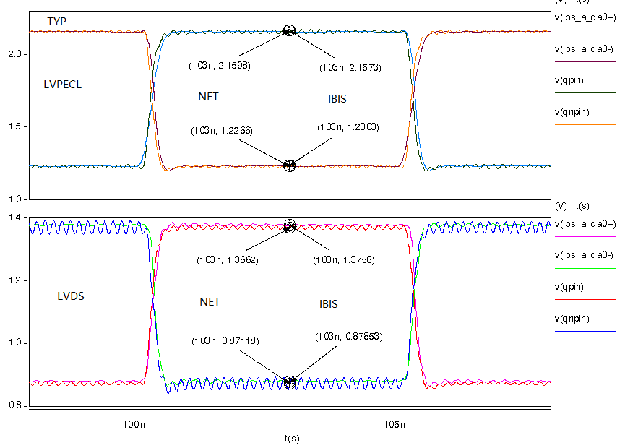
- MIN:
  - Without the package:
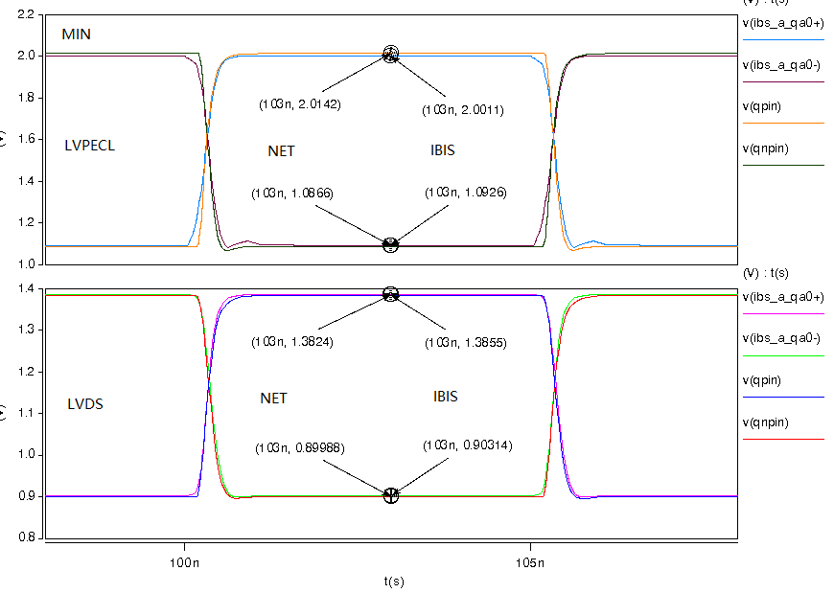
  - With the package:
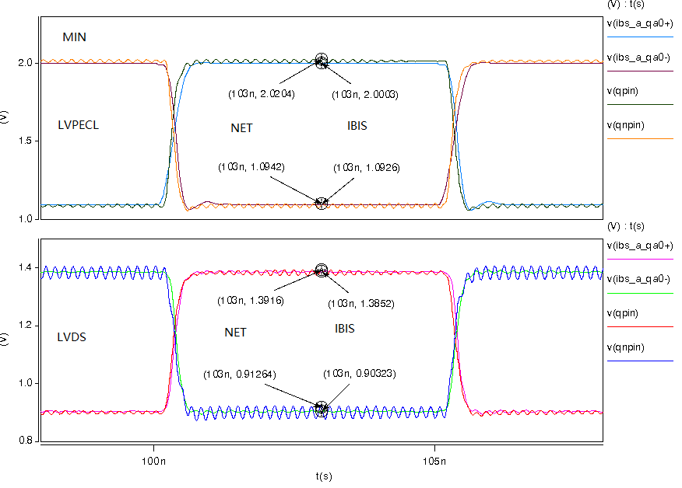

- MAX:
  - Without the package:
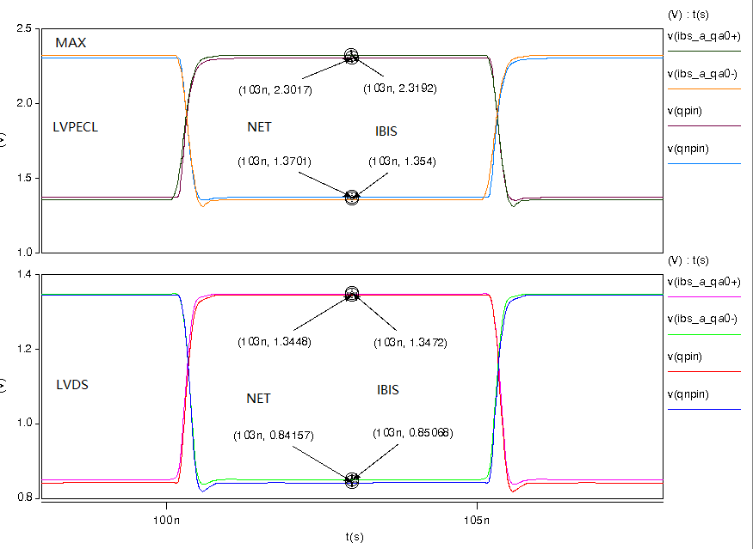
  - With the package:
