Check Report of PI6C10810 IBIS model
Introduction:
To verify the correlation between the ibis model and hspice model, we need to do some simulations:
The frequency of signal is 100MHz:
Vclk in 0 pulse ( 0 pwr 0 0.1n 0.1n 4.9n 10n)

- Without trace to the OUTPUT:
PI6C10810
VOUT

SCL_C
SDA_C
in

SCL_C
SDA_C
Input Signals

SCL_C
SDA_C
VIN

SCL_C
SDA_C
out

SCL_C
SDA_C
…..

SCL_C
SDA_C
- With 33Ωresistor and 2-inch trace to the OUTPUT:
PI6C10810
VOUT

SCL_C
SDA_C
in

SCL_C
SDA_C
Input Signals

SCL_C
SDA_C
VIN

SCL_C
SDA_C
out

SCL_C
SDA_C
…..

SCL_C
SDA_C
33Ω
2-inch

- Simulation without package data:
- Without trace to the OUTPUT:
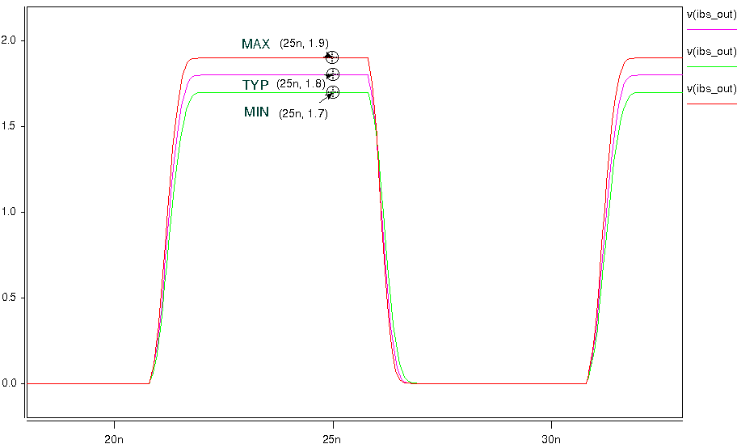
- With 33Ωresistor and 2-inch trace to the OUTPUT:
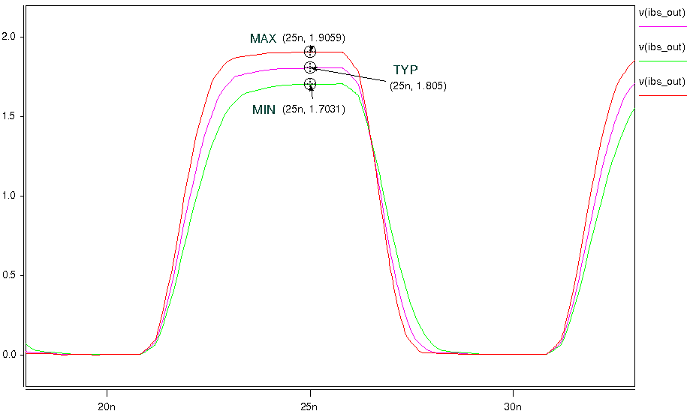

- Simulation with package data:
- Without trace to the OUTPUT:
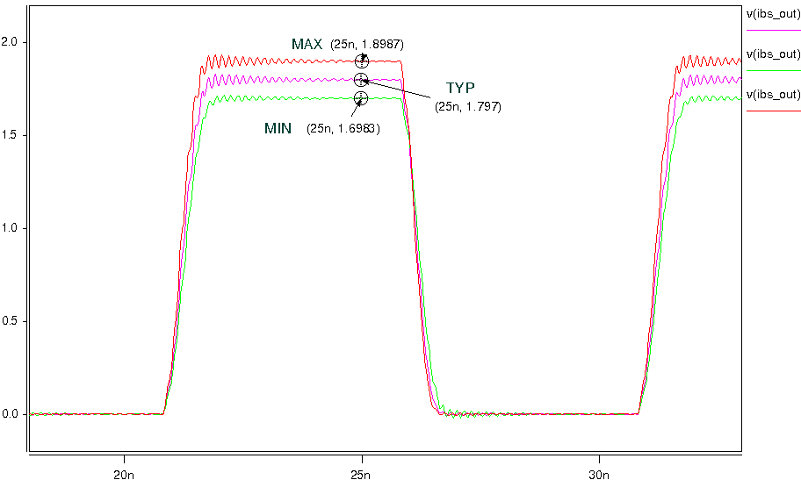
- With 33Ωresistor and 2-inch trace to the OUTPUT:
