Verification of PI6C10806B IBIS model
- Introduction: to verify the correlation between the ibis model and hspice model, we need to do some simulations:
The frequency of signal is 20MHz: Vin in 0 pulse (0 pwr 0 0.1n 0.1n 24.9n 50n)

- Without any load to the OUTPUT

- Add 50Ω resistor to 1/2 VDD, and 5pf pull-down capacitance to the OUTPUT
PI6C10806B
VOUT

SCL_C
SDA_C
R

SCL_C
SDA_C
Input Signals

SCL_C
SDA_C
VIN

SCL_C
SDA_C
CLK0

SCL_C
SDA_C
IN

SCL_C
SDA_C
1/2 VDD

SCL_C
SDA_C
C

SCL_C
SDA_C
- Add 50Ω resistor to 1/2 VDD directly:
- Add 50Ω resistor between OUTPUT and out1, and then add 100Ω Pull-Up and 100Ω pull-down resistors to out1:

- Add 33Ω resistor, 5 inches trace and 5pf pull-down capacitance to the OUTPUT
VOUT

SCL_C
SDA_C
IN

SCL_C
SDA_C
Input Signals

SCL_C
SDA_C
VIN

SCL_C
SDA_C
CLK0

SCL_C
SDA_C
5-inch
PI6C10806B
-06
C

SCL_C
SDA_C
R

SCL_C
SDA_C

- Conclusion:
Without any load to the output, the simulation result of IBIS model is ideal, while Add 50Ω pull-down resistor to the output, the result is a little bad with obvious undershoot.

- Simulation Result:
- Without any load to the output
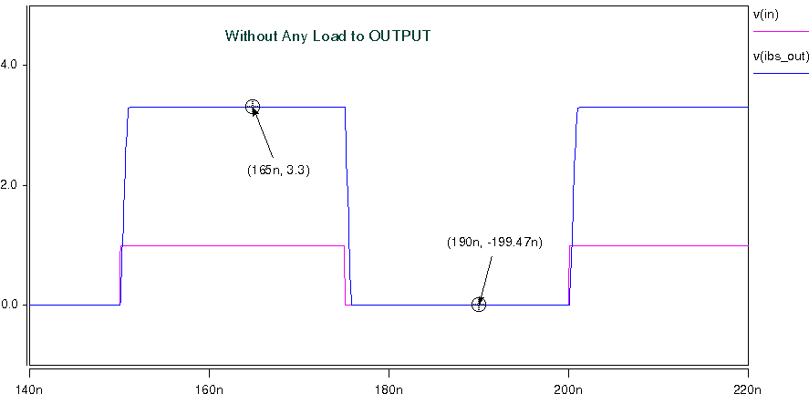

- Add 50Ω resistor to 1/2 VDD, and 5pf pull-down capacitance to the OUTPUT
- Add 50Ω resistor to 1/2 VDD directly:
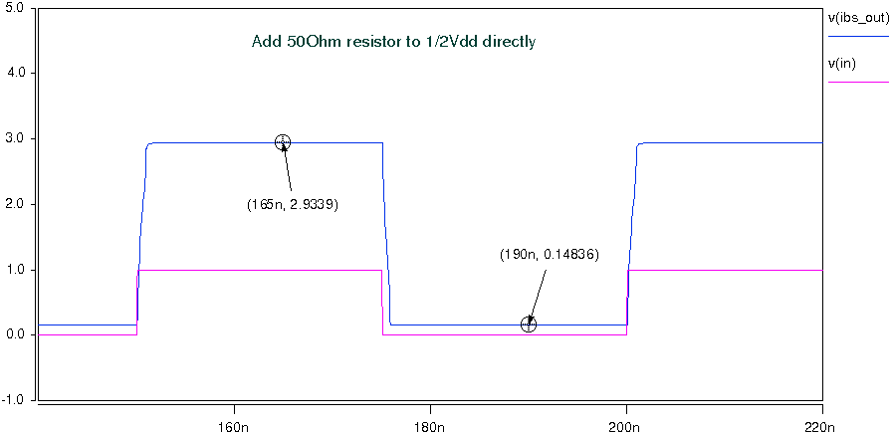
- Add 50Ω resistor between OUTPUT and out1, and then add 100Ω Pull-Up and 100Ω pull-down resistors to out1:
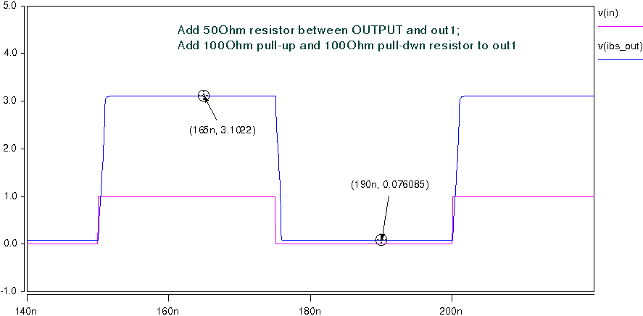

- Add 33Ω resistor, 5 inches trace and 5pf pull-down capacitance to the OUTPUT
