Verification of PI6C10806B IBIS model
- Introduction: to verify the ibis models, we need to do some simulations:
The frequency of signal is 25MHz: Vin in 0 pulse (0 pwr 0 0.1n 0.1n 19.9n 40n)

- With 50Ω resistor load to VDD/2
PI6C10806B
VOUT

SCL_C
SDA_C
R

SCL_C
SDA_C
Input Signals

SCL_C
SDA_C
VIN

SCL_C
SDA_C
CLK0

SCL_C
SDA_C
IN

SCL_C
SDA_C
VDD/2

SCL_C
SDA_C
- PI6C10806B_L_33V_10p.ibs;
- PI6C10806B_L_33V_15p.ibs.

- Add 33Ω resistor, 5 inches trace and 5pf pull-down capacitance
VOUT

SCL_C
SDA_C
IN

SCL_C
SDA_C
Input Signals

SCL_C
SDA_C
VIN

SCL_C
SDA_C
CLK0

SCL_C
SDA_C
5-inch
PI6C10806B
-06
C

SCL_C
SDA_C
R

SCL_C
SDA_C
- PI6C10806B_L_33V_10p.ibs;
- PI6C10806B_L_33V_15p.ibs.

- Conclusion:
Choose 10pF created ibis, considering mini. and max. normally we like to give a little faster rate ibis to customer.

- Simulation Result:
- With 50Ω resistor load to VDD/2
- PI6C10806B_L_33V_10p.ibs;
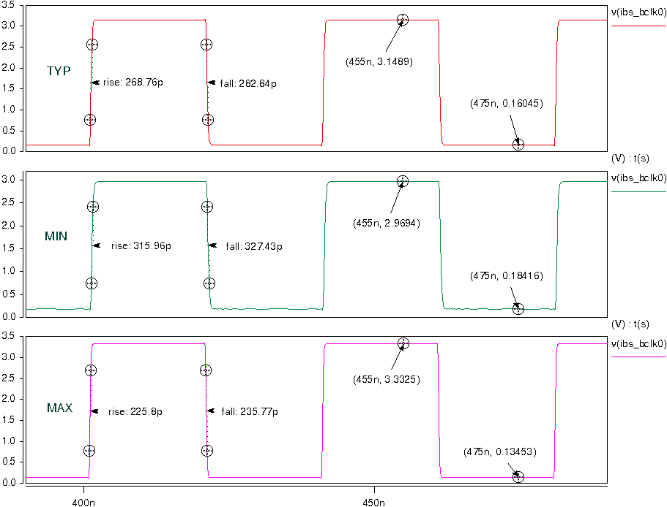

- PI6C10806B_L_33V_15p.ibs.
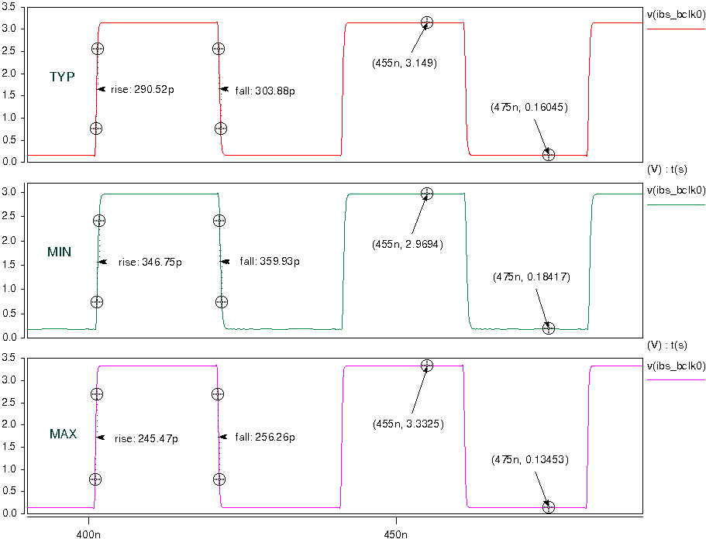

- Add 33Ω resistor, 5 inches trace and 5pf pull-down capacitance
- PI6C10806B_L_33V_10p.ibs;
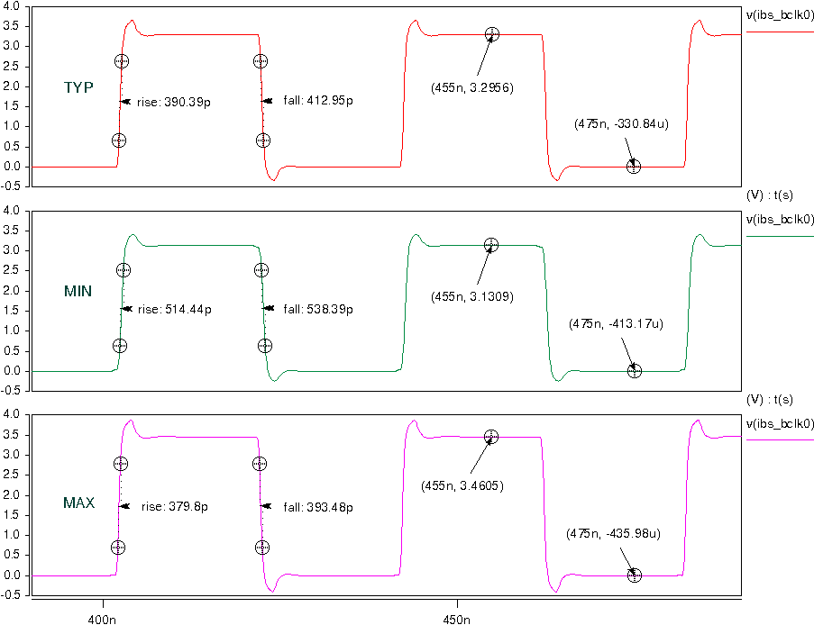
- PI6C10806B_L_33V_15p.ibs.
