Verification of PI6C10804 IBIS model
- Introduction: to verify the correlation between the ibis model and hspice model, we need to do some simulations:
The frequency of signal is 100MHz: Vin in 0 pulse (0 pwr 0 0.2n 0.2n 4.8n 10n)
Add 50Ω resistor between the output and VDD and 5p capacitance to the OUTPUT
PI6C10804
VOUT

SCL_C
SDA_C
R

SCL_C
SDA_C
Input Signals

SCL_C
SDA_C
VIN

SCL_C
SDA_C
VDD

SCL_C
SDA_C
CLK0

SCL_C
SDA_C
IN

SCL_C
SDA_C
C

SCL_C
SDA_C
- Vdd=1.5V
- Simulation without package data;
- Simulation with package data.
- Vdd=1.8V
- Simulation without package data;
- Simulation with package data.
- Vdd=2.5V
- Simulation without package data;
- Simulation with package data.

- Conclusion:
For the verification, the simulation results of IBIS model can match quite well with the HSPICE model at different simulating conditions.

- Simulation Result:
- Vdd=1.5V
- Simulation without package data;
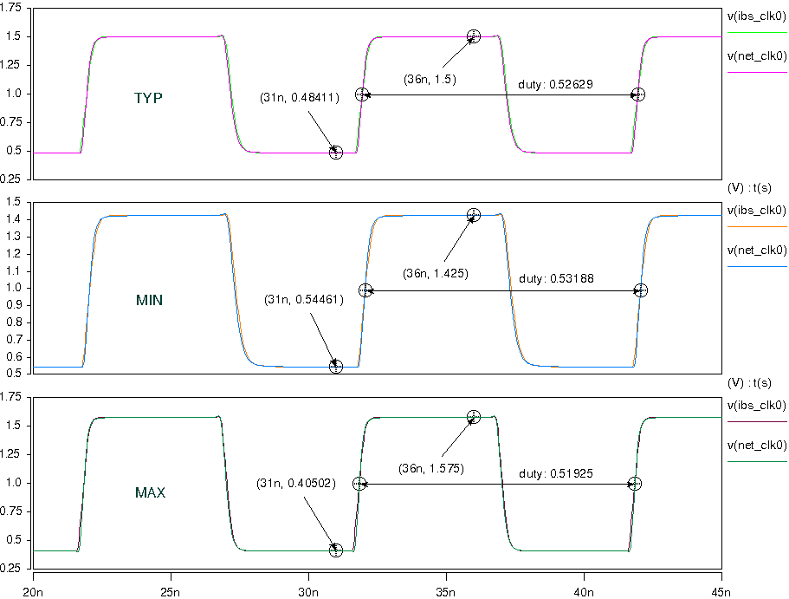
- Simulation with package data.
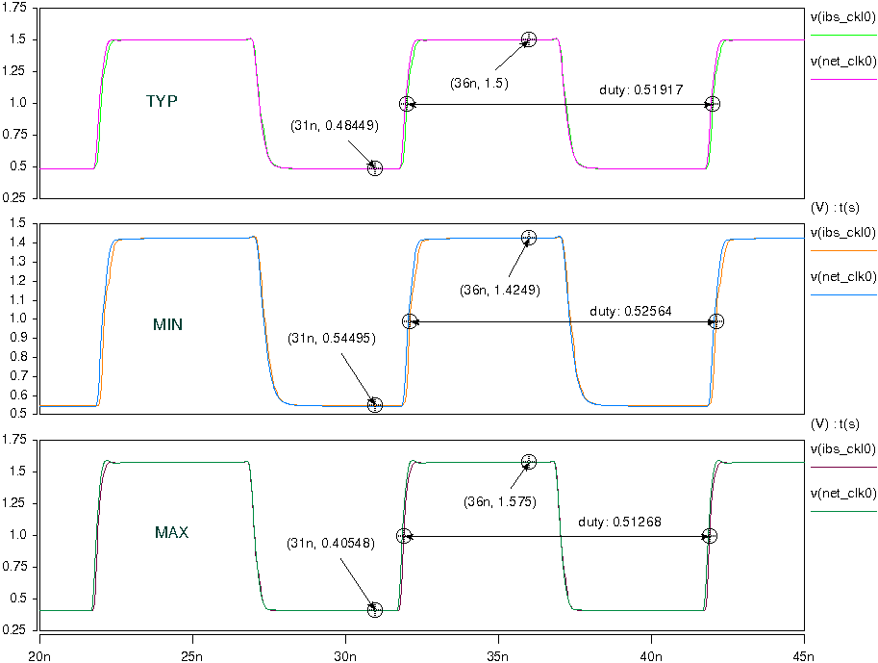
- Vdd=1.8V
- Simulation without package data;
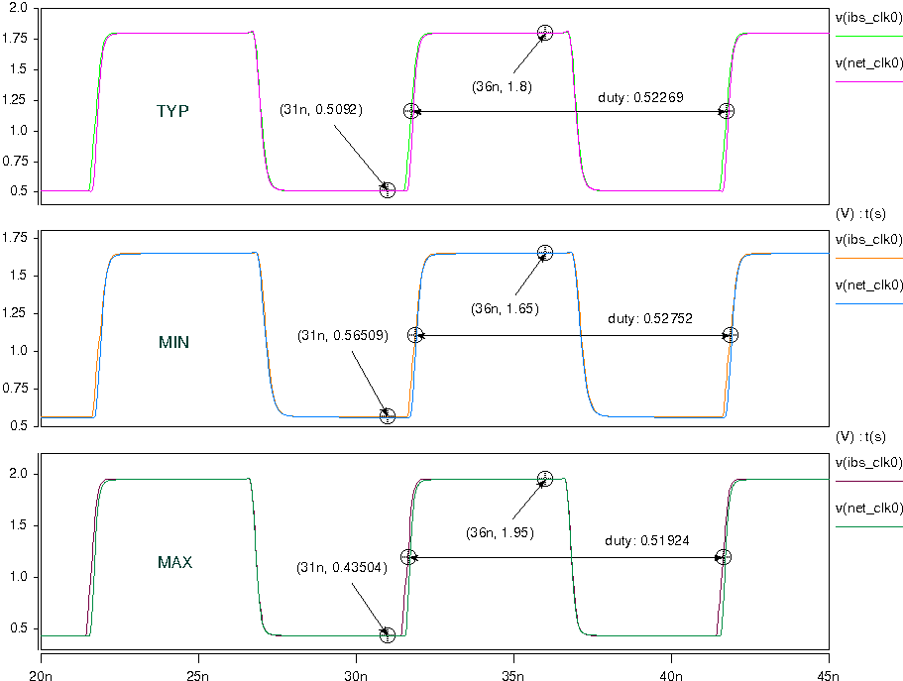
- Simulation with package data.
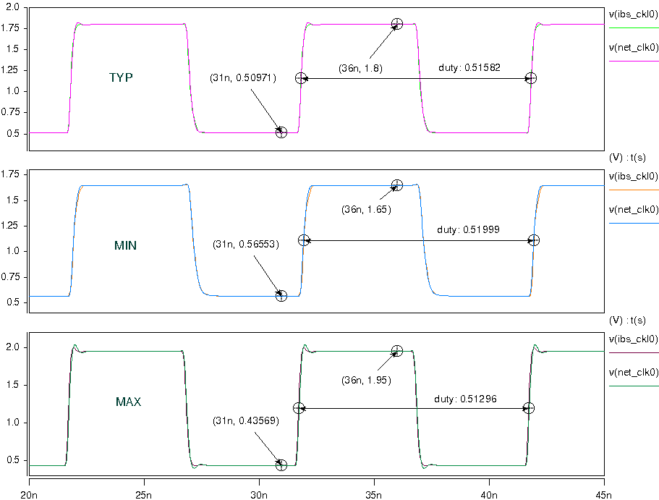
- Vdd=2.5V
- Simulation without package data;
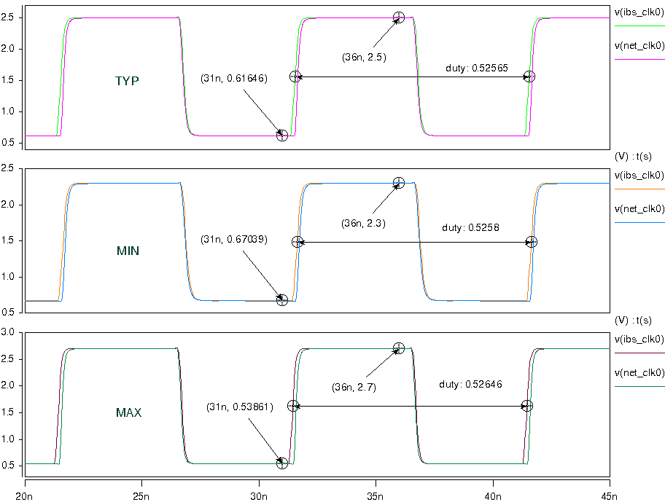
- Simulation with package data.
