PI5USB30213XEA
Demo Board Rev.B User Manual
by Justin Lee

Table of Contents
1 Introduction 2
2 Overview 2
3 Quick Start 4
3.1 Source(DFP) Mode 4
3.2 Battery-powered Sink(UFP) Mode 5
3.3 Try.SNK DRP Mode 6
4 Circuit Description 8
4.1 DIP Switch Setting 8
4.2 Mode Selection, I2C Address and I2C Bus 8
4.3 VBUS Power Supply 8
4.4 Power 9
4.5 Disable/Low Power State 10
5 Appendix A: Demo Board Schematic 12
6 Appendix B: Demo Board Picture 13

Introduction

PI5USB30213 is a dual differential channel bi-directional Mux/Demux switch with plug-in detector for USB 3.1 Type-C connector applications.

PI5USB30213 is designed for USB 3.1 Gen1 (5.0 Gbps) application.

The device includes:
- The Plug-in Detector for Type-C connector (CC Sensing)
- Supports Source/Sink/DRP/Try.SRC DRP/Try.SNK DRP
- Integrated 2:1 USB3.0 Mux/DeMux
- Auto-configure ports orientation through CC Sensing
- Integrated VCONN switch to power active cable

PI5USB30213 detects the plug-in orientation of the cable at a Type-C connector and switches between the USB controller and the new Type-C connector. It supports Host(Source/DFP) mode, Device(Sink/UFP) mode, Dual Role Port(DRP), Try.SRC DRP and Try.SNK DRP with automatic configuration based on the voltage levels detected on CC pins. It offers excellent signal integrity for high-speed signals at low power dissipation. PI5USB30213 enters disabled state when ENB pin is pulled up to VDD through an internal resistor.

PI5USB30213 supports both pin and I2C control base on ADDR pin setting. It allows the system choose between pin control and I2C control mode. In pin control mode, the PORT input pin determines the port setting in which Source(DFP) only mode, Sink(UFP) only mode or Try.SNK DRP can be selected. Enabling I2C control mode allows higher flexibility for port control and communications through registers read/write in PI5USB30213. There is also flexibility to support Default, 1.5A and 3A current modes. An interrupt signal for indicating changes with the I2C registers is sent to the master to notify the system any change in the Type-C connector while in parallel the system can still monitor ID pin.

This user manual describes the components and the usage of PI5USB30213 Demo Board Rev.B.

Overview

Figure 1 is the block diagram of Diodes PI5USB30213 demo board and figure 2 shows the demo board layout. A USB-C cable can be connected between the USB-C receptacle connector (J1) on PI5USB30213 demo board and another USB-C device. A USB-C to USB-A cable can be connected between J1 and a USB host, such as PC. A USB-C to USB-A receptacle adapter can be connected between J1 and a USB device, such as USB flash drive. One USB3 micro-AB receptacle (J2) is used to connect mobile phones/notebook/tablet/PC to transmit USB3 data to/from J1.

Slide switch at reference SW1 is used to set control mode (GPIO/I2C) and operating mode (Source/Sink/DRP) of PI5USB30213 and LED indicator to SDA/SCL/INTB/ID pins of PI5USB30213. The processor can connect to SDA/SCL/INTB/ID pins through pin header JP18/JP17/JP15 or Test Header J3.

+5V can be employed to the demo board via 5VPW header pin or mini-B receptacle (J4).

VBUS of Type-C connector can be source from on-board VBUS switch via JP4.
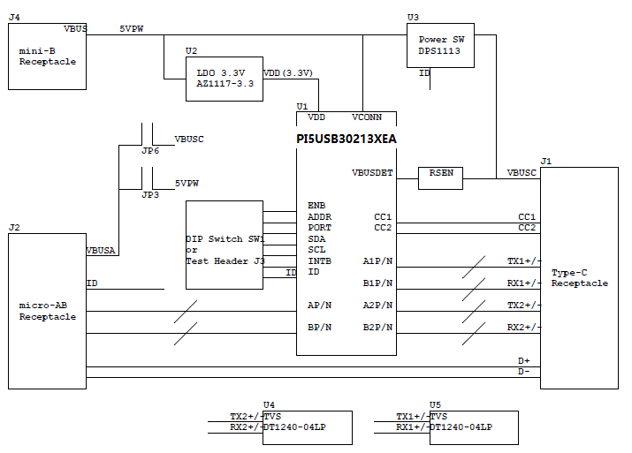
Figure 1: Simplified Block Diagram of PI5USB30213 Demo Board Rev.B
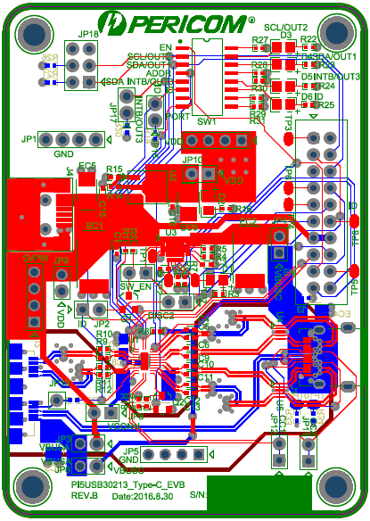
Figure 2: Layout of PI5USB30213 Demo Board Rev.B

Quick Start

This section provides different configuration examples to start-up PI5USB30213 demo board rev.B in Source, Sink or DRP mode.

3.1 Source(DFP) Mode

To start-up the PI5USB30213 demo board rev.B in pin control DFP mode, complete the following steps:
- Configure pin headers and DIP switches SW1 as shown in Table 1.
- Power-up PI5USB30213 demo board by connecting J2 to a USB host using Type-A to micro-B cable. D2 should light up indicating the board has power.
- Connect PI5USB30213 demo board to a Type-C Sink(UFP) using a Type-C cable. D6 should light up indicating ID pin is pulled low and 5V VBUS is provided by the demo board.
.

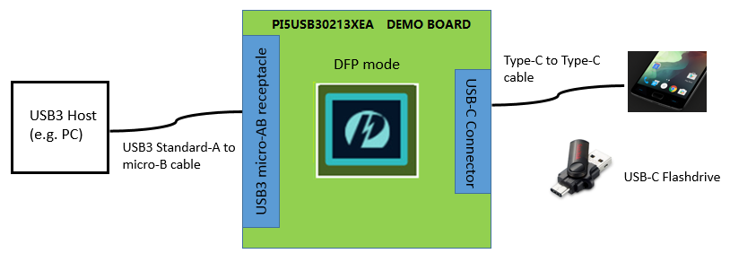
Figure 3: PI5USB30213 Demo Board DFP mode illustration.
Header pin/  Switch | Pin name/  Function | Setting
SW1.1 | ENB = L | ON
SW1.2 | SCL/OUT2 LED indicator | OFF
SW1.3 | SDA/OUT1 LED indicator | OFF
SW1.4 | ADDR | OFF
SW1.5 | INTB/OUT3 LED indicator | ON
SW1.6 | ID LED indicator | ON
SW1.7 | PORT = H | ON
SW1.8 | PORT = L | OFF
JP2 | Enable On-board VBUS switch | ON
SW_EN | Enable On-board VBUS switch | ON
DISC2 | Enable On-board VBUS switch | ON
JP3 | Demo board power by VBUSA | ON
JP4 | Connect output of VBUS switch to VBUSC | ON
JP6 | Connect VBUSC to VBUSA | OFF
JP8 | Connect VCONN to 5VPW | ON
JP9 | Connect 5VPW to VDD | OFF
JP10 | Enable 3.3V VDD | ON
Table 1: PI5USB30213 Demo Board Rev.B DFP mode configuration.

3.2 Battery-powered Sink(UFP) Mode

To start-up the PI5USB30213 demo board rev.B in pin control battery-powered UFP mode, complete the following steps:
- Configure pin headers and DIP switches SW1 as shown in Table 2.
- Connect J2 to a USB device using micro-A to Type-A receptacle.
- Power up PI5UB30213 demo board by connecting J4 to a USB host using Type-A to mini-B cable (or connect +5V to 5VPW pin header). D2 should light up indicating the board has power.
- Connect PI5USB30213 demo board to a Type-C Source(DFP) using a Type-C cable. 5V VBUS should be provided by the Type-C Host/Source/DFP. D3 and D4 might light up depends on the DFP’s Type-C current mode setting.
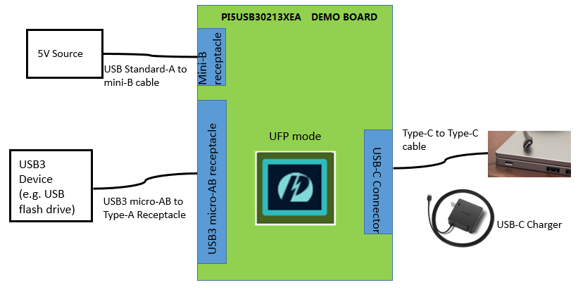
Figure 4: PI5USB30213 Demo Board battery-powered UFP mode illustration.
Header pin/  Switch | Pin name/  Function | Setting
SW1.1 | ENB = L | ON
SW1.2 | SCL/OUT2 LED indicator | ON
SW1.3 | SDA/OUT1 LED indicator | ON
SW1.4 | ADDR | OFF
SW1.5 | INTB/OUT3 LED indicator | OFF
SW1.6 | ID LED indicator | OFF
SW1.7 | PORT = H | OFF
SW1.8 | PORT = L | ON
JP2 | Enable On-board VBUS switch | OFF
SW_EN | Enable On-board VBUS switch | OFF
DISC2 | Enable On-board VBUS switch | OFF
JP3 | Demo board power by VBUSA | OFF
JP4 | Connect output of VBUS switch to VBUSC | OFF
JP6 | Connect VBUSC to VBUSA | ON
JP8 | Connect VCONN to 5VPW | OFF
JP9 | Connect 5VPW to VDD | OFF
JP10 | Enable 3.3V VDD | ON
Table 2: PI5USB30213 Demo Board Rev.B battery-powered UFP mode configuration.

3.3 Try.SNK DRP Mode

To start-up the PI5USB30213 demo board rev.B in pin control Try.SNK DRP mode, complete the following steps:
- Configure pin headers and DIP switches SW1 as shown in Table 3 in the next page.
- Power up PI5UB30213 demo board by connecting J4 to a USB host using Type-A to mini-B cable. D2 should light up indicating the board has power.
- Connect PI5USB30213 demo board to a Type-C Sink(UFP) using a Type-C cable. D6 should light up indicating ID pin is pulled low and 5V VBUS is provided by the demo board.
- Connect PI5USB30213 demo board to a Type-C Source(DFP) using a Type-C cable. 5V VBUS should be provided by the Type-C Host/Source/DFP. D3 and D4 might light up depends on the DFP’s Type-C current mode setting
- Connect PI5USB30213 demo board to a Type-C DRP using a Type-C cable. PI5USB30213 should connect as Sink/UFP due to Try.SNK feature. 5V VBUS should be provided by the port partner. D3 and D4 might light up depends on port partner’s Type-C current mode setting.
- Connect PI5USB30213 demo board to a Type-C Try.SNK DRP using a Type-C cable. PI5USB30213 may result in either DFP or UFP mode. The result is random.
- When connect as a Source/DFP/Host, D6 should light up indicating ID pin is pulled low and 5V VBUS is provided by the demo board.
- When connect as a Sink/UFP/Device. 5V VBUS should be provided by the port partner. D3 and D4 might light up depends on port partner’s Type-C current mode setting.

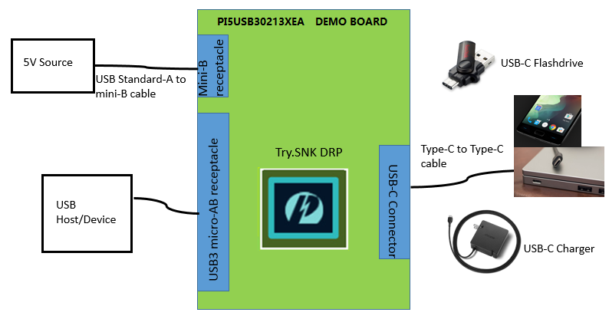
Figure 5: PI5USB30213 Demo Board Try.SNK DRP mode illustration.

Header pin/  Switch | Pin name/  Function | Setting
SW1.1 | ENB = L | ON
SW1.2 | SCL/OUT2 LED indicator | ON
SW1.3 | SDA/OUT1 LED indicator | ON
SW1.4 | ADDR | OFF
SW1.5 | INTB/OUT3 LED indicator | ON
SW1.6 | ID LED indicator | ON
SW1.7 | PORT = H | OFF
SW1.8 | PORT = L | OFF
JP2 | Enable On-board VBUS switch | ON
SW_EN | Enable On-board VBUS switch | ON
DISC2 | Enable On-board VBUS switch | ON
JP3 | Demo board power by VBUSA | OFF
JP4 | Connect output of VBUS switch to VBUSC | ON
JP6 | Connect VBUSC to VBUSA | OFF
JP8 | Connect VCONN to 5VPW | ON
JP9 | Connect 5VPW to VDD | OFF
JP10 | Enable 3.3V VDD | ON
Table 3: PI5USB30213 Demo Board Rev.B Try.SNK DRP mode (pin control mode) configuration.

Circuit Description

DIP Switch Setting

The DIP switch (SW1) is used to configure PI5USB30213 in different mode.

Header pin/  Switch | Pin name/  Function | Description
SW1.1 | ENB | ENB = Low if SW1.1 is ON.  ENB = High if SW1.1 is OFF.
SW1.2 | SCL/OUT2 LED indicator | For pin control mode:  OUT2 is connected to LED if SW1.2 is ON  For I2C mode:  SW1.2 shall be OFF.
SW1.3 | SDA/OUT1 LED indicator | For pin control mode:  OUT1 is connected to LED if SW1.3 is ON  For I2C mode:  SW1.2 shall be OFF.
SW1.4 | ADDR | For pin control mode: SW1.4 is OFF.  For I2C mode: SW1.4 is ON.  I2C mode; 0x0D (Default)  I2C mode; 0x2D (Remove R30 and solder R28)
SW1.5 | INTB/OUT3 LED indicator | OUT3 is connected to LED if SW1.5 is ON
SW1.6 | ID LED indicator | ID is connected to LED if SW1.6 is ON
SW1.7 | PORT = H | PORT = Open if SW1.7 is OFF  PORT = High if SW1.7 is ON
SW1.8 | PORT = L | PORT = Open if SW1.8 is OFF  PORT = Low if SW1.8 is ON
Table 4: DIP Switch SW1 settings

Mode Selection, I2C Address and I2C Bus

PI5USB30213 can be controlled via either GPIO or I2C mode. The control mode and I2C address is configured via ADDR pin (refer to section 4.1). Pins 1 and 24 of PI5USB30213 are used for transmitting I2C SCL and SDA, respectively. External pull-ups may be required for SCL(OUT2) and SDA(OUT1) pins when reading/writing I2C. Alternatively, pull-ups for SCL(OUT2) and SDA(OUT1) can be enabled by short pins 1-2 and 3-4 of JP18.

VBUS Power Supply

The system should drive 5V to VBUS of USB-C receptacle connector (J1) when a sink/UFP is attached. If an external VBUS switch not available, a discrete VBUS switch DPS1113 is assembled on EVB, which is controlled by ID pin of PI5USB30213. This switch will turn on and drive VBUS, when a sink/UFP is attached. To use the on-board VBUS switch, please shorts JP2, jumper SW_EN, jumper DISC2 and jumper JP4.

For detailed DPS1113 function and setting, please refer to DPS1113 datasheet.
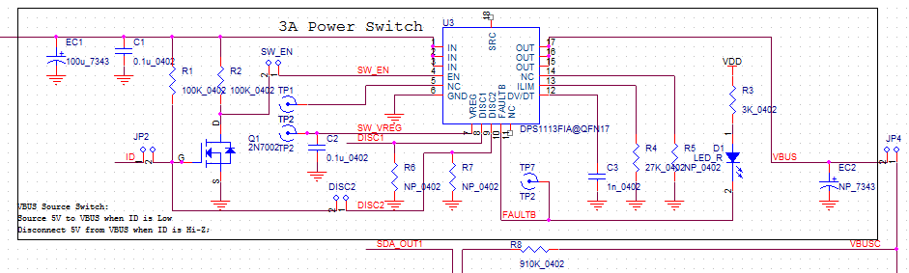
Figure 6: VBUS switch of PI5USB30213 Demo Board Rev.B

Power

In DRP and battery-powered UFP mode, the demo board can be powered by +5V VBUS through mini-B connector J4 or by +5V through pin header 5VPW.

In DFP mode, the system/host can provide +5V through the USB micro-AB connector J2 to power up the board via JP3.

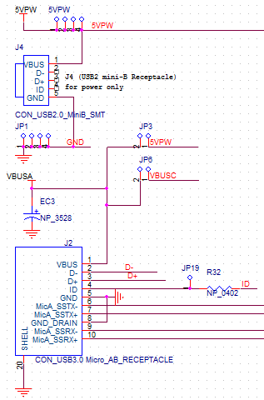
Figure 7: Power Supply option of PI5USB30213 Demo Board Rev.B

Disable/Low Power State

PI5USB30213 can be disabled by setting ENB pin to a high voltage level. Please refer section 4.1.

References

- Universal Serial Bus Type-C Cable and Connector Specification Version 1.1, April 3, 2015

Appendix A: Demo Board Schematic

For clearer view of schematic diagram, please click the PDF file icon on the right.

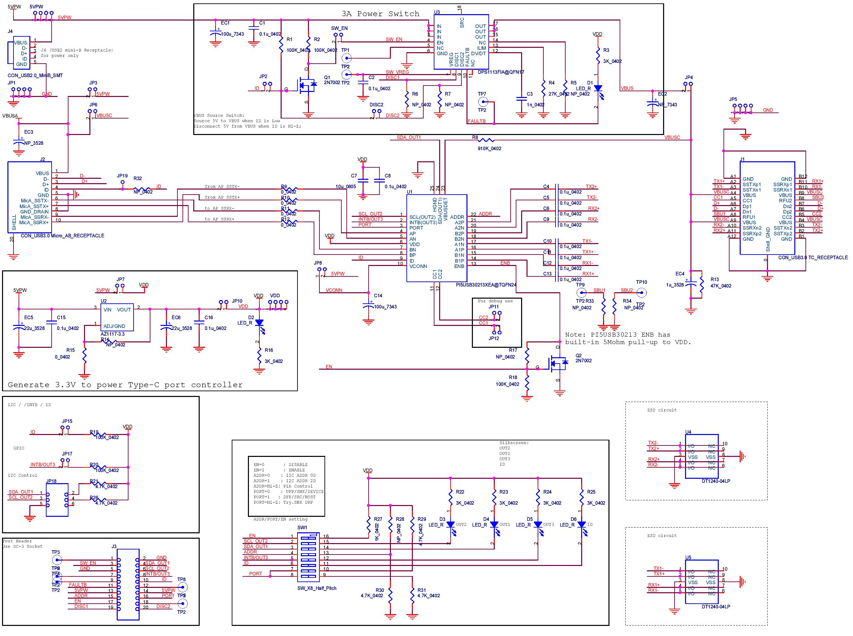

Appendix B: Demo Board Picture

