Verification of PI4ULS5V202 IBIS model
- Introduction: to verify the correlation between the ibis model and hspice model, we need to do some simulations:

- The description of pi4uls5v202 ibis model:
Using [Driver Schedule] to describe the relative model switching sequence for referenced models to produce amulti-staged driver. But if EDA tools not support [Driver Schedule] syntactic, it will just use top-level [Model] to simulation(top-level [Model] created by opening one-shot).

- Test circuits(Add 20pf capacitance to the IOA/IOB):
PI4ULS5V202
VOUT

SCL_C
SDA_C
Input Signals

SCL_C
SDA_C
VIN

SCL_C
SDA_C
IOA/IOB

SCL_C
SDA_C
IN

SCL_C
SDA_C
…..

SCL_C
SDA_C
C=20p

SCL_C
SDA_C
- Simulation without package data;
- Simulation with package data.

- Simulation Result list
Vcca=1.2 v, vccb=5.0 v. signals from IOB to IOA, test IOA
Vcca=1.2 v, vccb=5.0 v. signals from IOA to IOB, test IOB

Vcca=1.5 v, vccb=5.0 v. signals from IOB to IOA, test IOA
Vcca=1.5 v, vccb=5.0 v. signals from IOA to IOB, test IOB

Vcca=1.8 v, vccb=2.8 v. signals from IOB to IOA, test IOA
Vcca=1.8 v, vccb=2.8 v. signals from IOA to IOB, test IOB

Vcca=2.5 v, vccb=3.3 v. signals from IOB to IOA, test IOA
Vcca=2.5 v, vccb=3.3 v. signals from IOA to IOB, test IOB

- Top-level model Simulation Result list
Vcca=1.2 v, vccb=5.0 v. signals from IOB to IOA, test IOA
Vcca=1.2 v, vccb=5.0 v. signals from IOA to IOB, test IOB

Vcca=1.5 v, vccb=5.0 v. signals from IOB to IOA, test IOA
Vcca=1.5 v, vccb=5.0 v. signals from IOA to IOB, test IOB

Vcca=1.8 v, vccb=2.8 v. signals from IOB to IOA, test IOA
Vcca=1.8 v, vccb=2.8 v. signals from IOA to IOB, test IOB

Vcca=2.5 v, vccb=3.3 v. signals from IOB to IOA, test IOA
Vcca=2.5 v, vccb=3.3 v. signals from IOA to IOB, test IOB

- Conclusion:
For the verification, the simulation results of IBIS model can match very well with the HSPICE model at different simulating conditions.

- Simulation Result:
- Vcca=1.2 v, vccb=5.0 v. signals from IOB to IOA, test IOA:
- Simulation without package data;
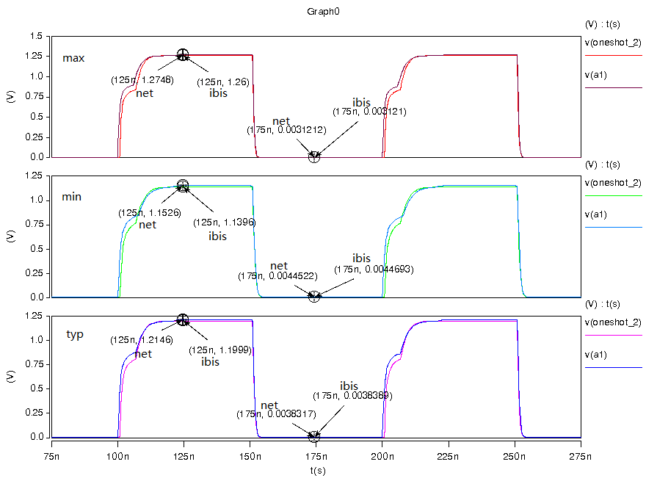
- Simulation with package data.
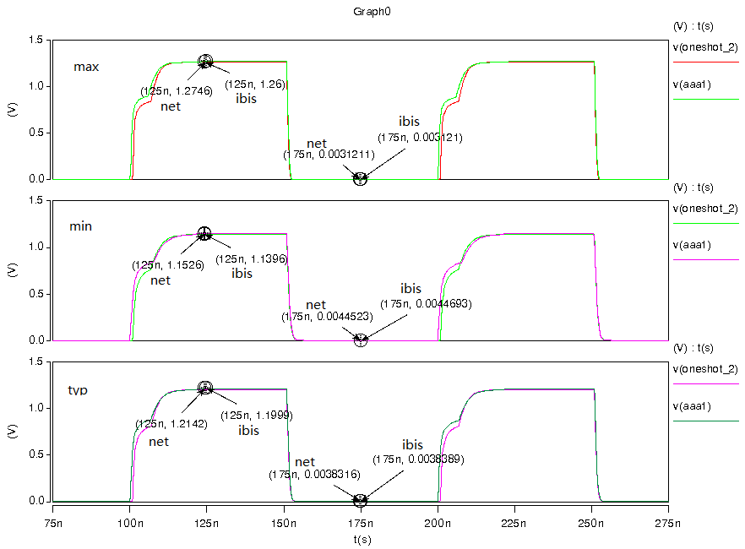
- Vcca=1.2 v, vccb=5.0 v. signals from IOA to IOB, test IOB:
- Simulation without package data;
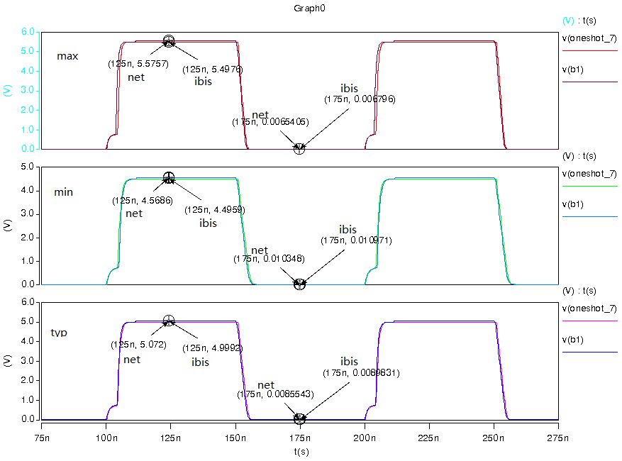
- Simulation with package data.
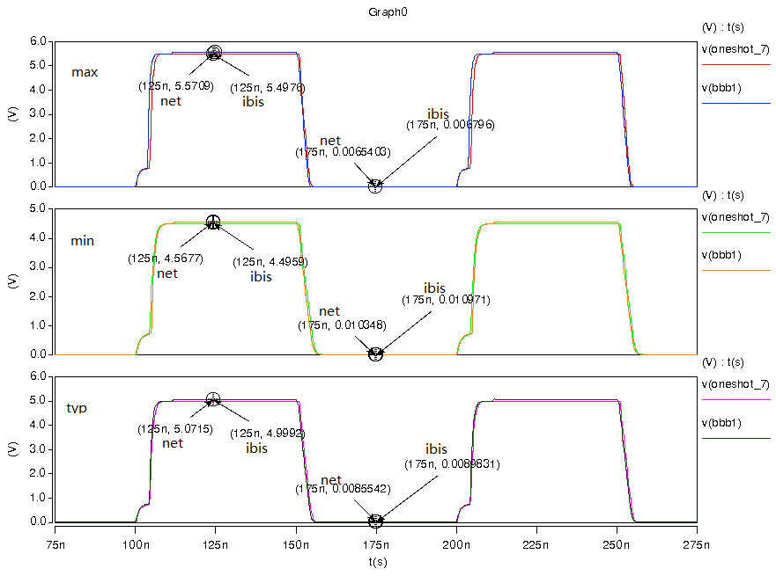

- Vcca=1.5 v, vccb=5.0 v. signals from IOB to IOA, test IOA:
- Simulation without package data;
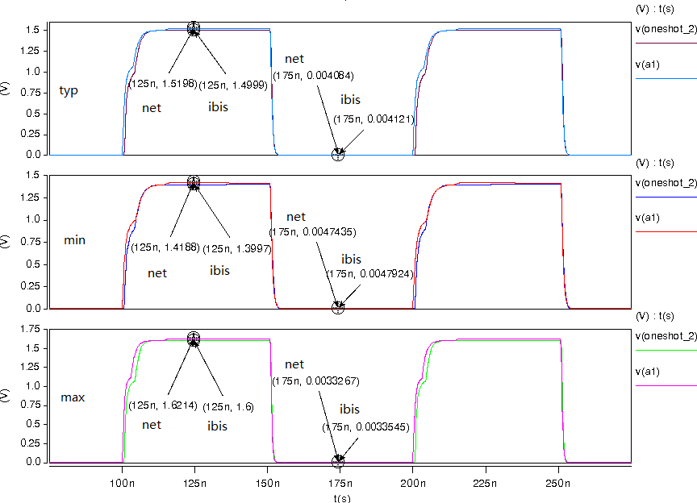
- Simulation with package data.
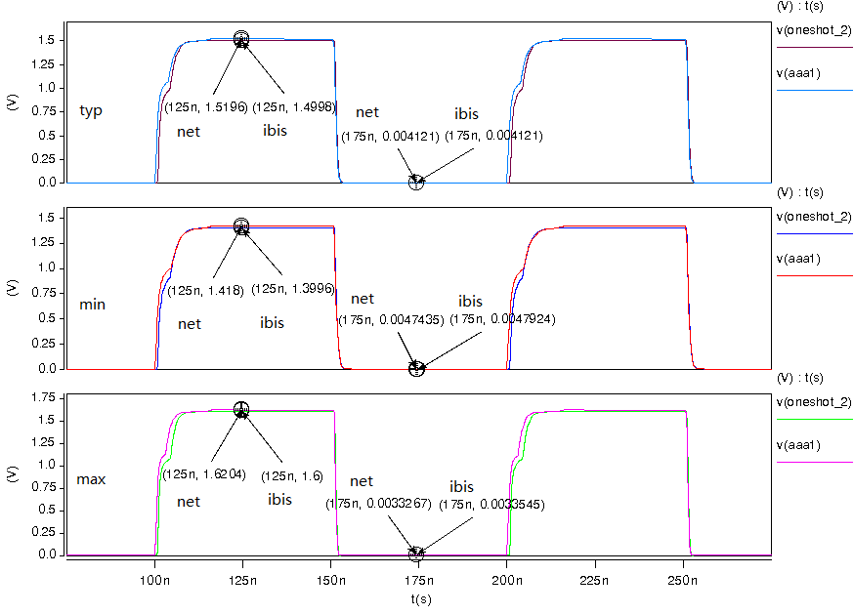

- Vcca=1.5 v, vccb=5.0 v. signals from IOA to IOB, test IOB:
- Simulation without package data;
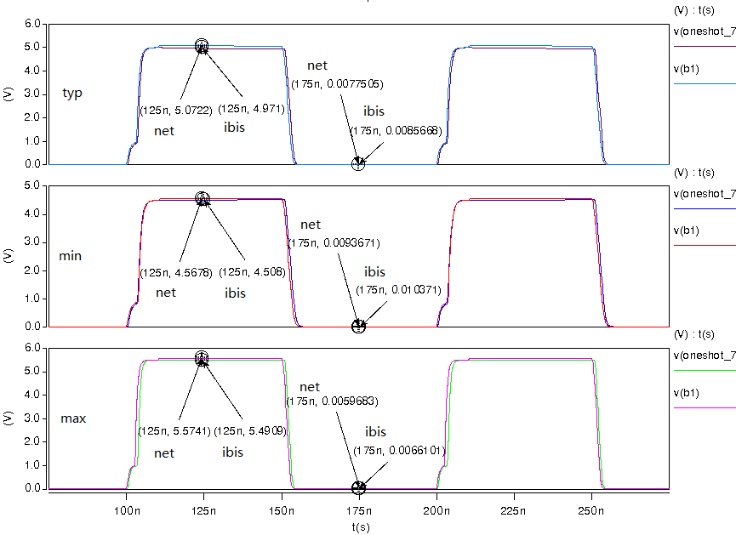
- Simulation with package data.
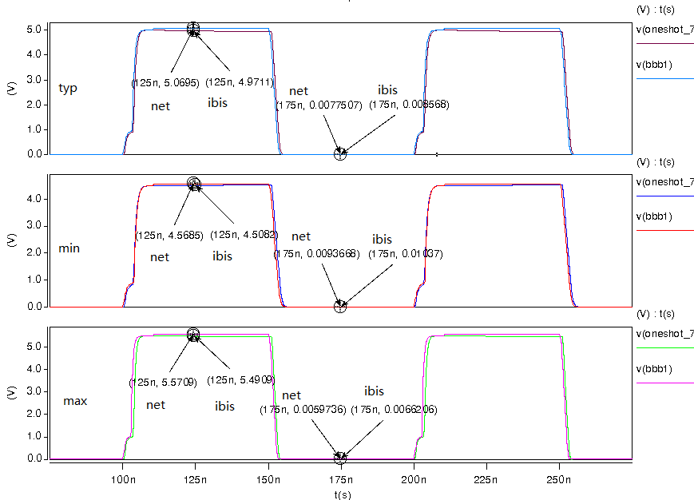

- Vcca=1.8 v, vccb=2.8 v. signals from IOB to IOA, test IOA:
- Simulation without package data;
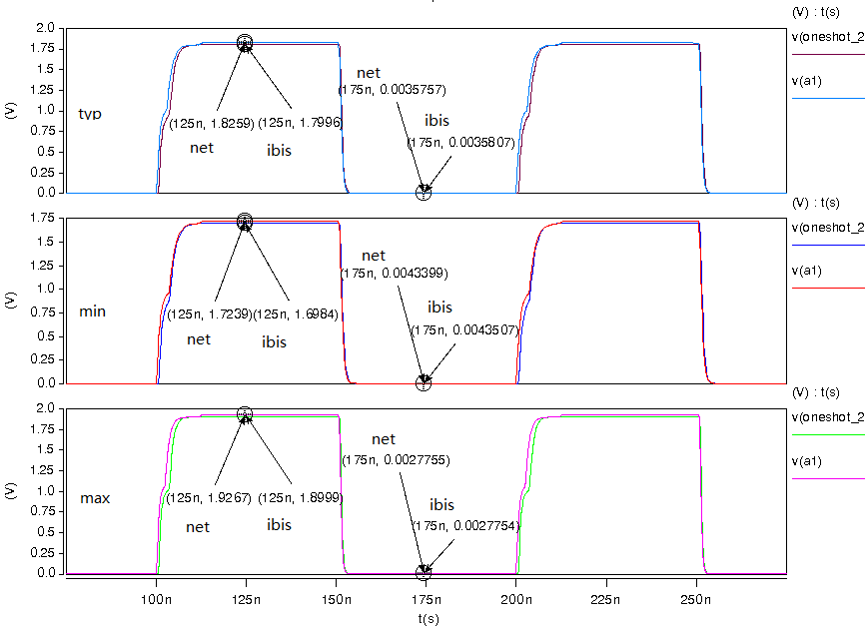
- Simulation with package data.
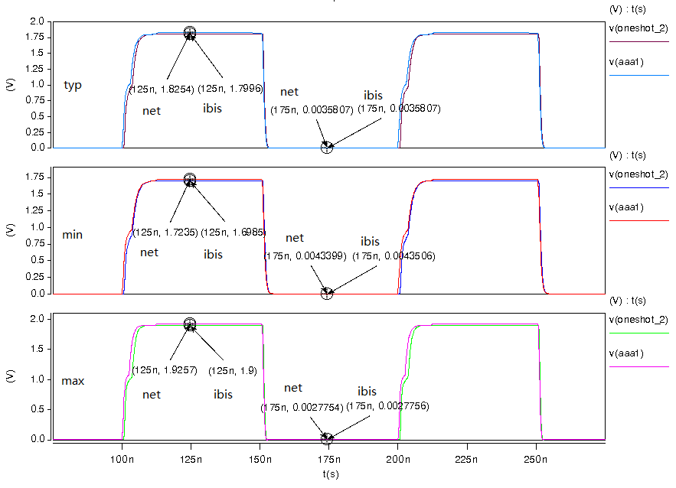

- Vcca=1.8 v, vccb=2.8 v. signals from IOA to IOB, test IOB:
- Simulation without package data;
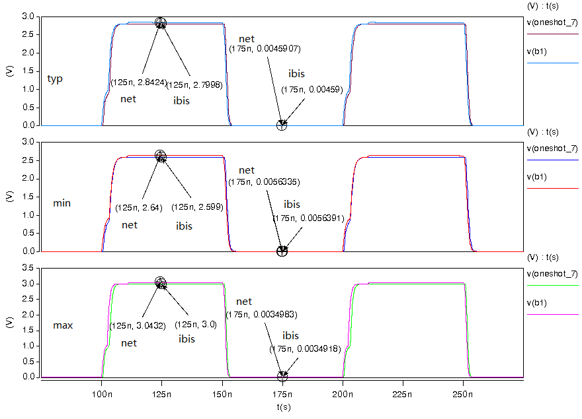
- Simulation with package data.
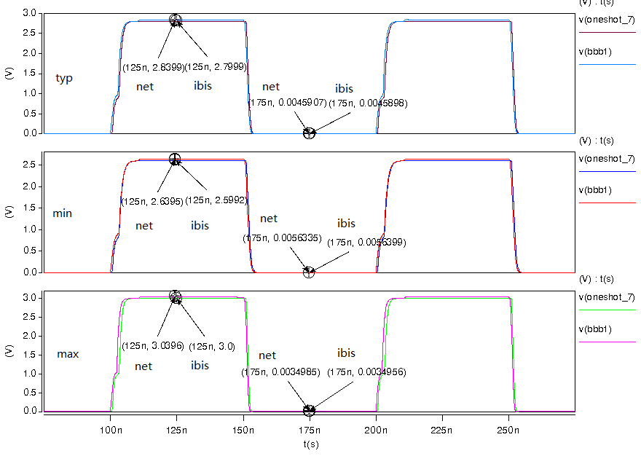

- Vcca=2.5 v, vccb=3.3 v. signals from IOB to IOA, test IOA:
- Simulation without package data;
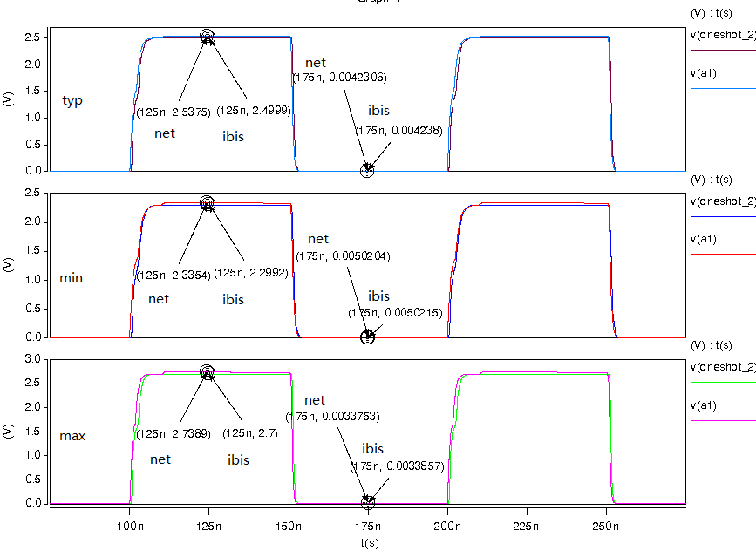
- Simulation with package data.
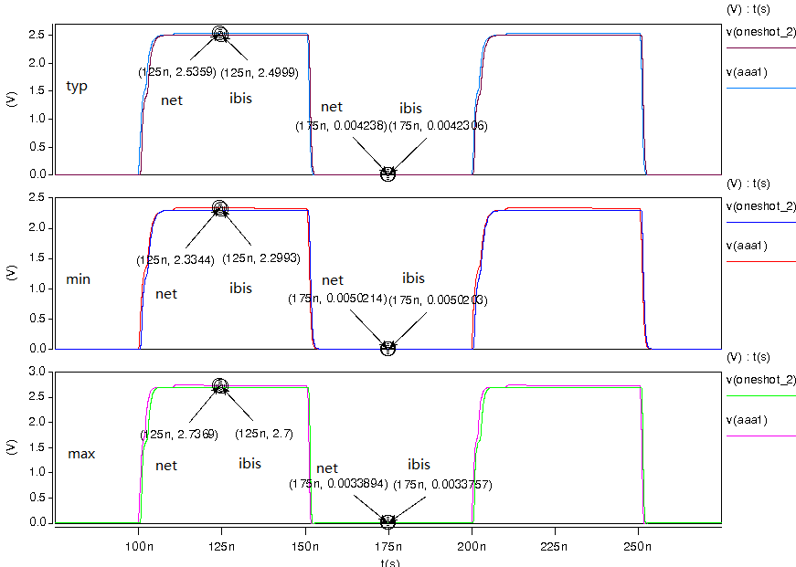

- Vcca=2.5 v, vccb=3.3 v. signals from IOA to IOB, test IOB:
- Simulation without package data;
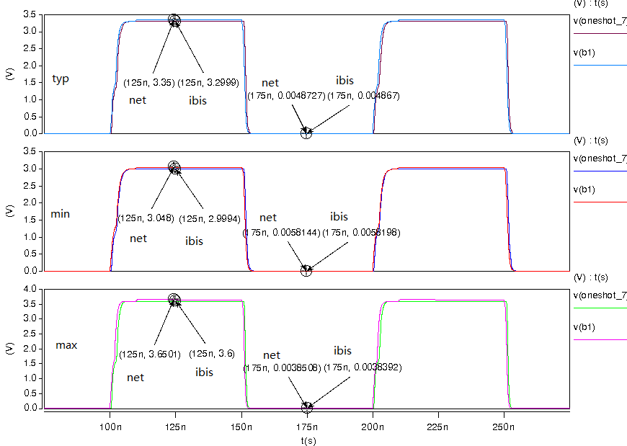
- Simulation with package data.
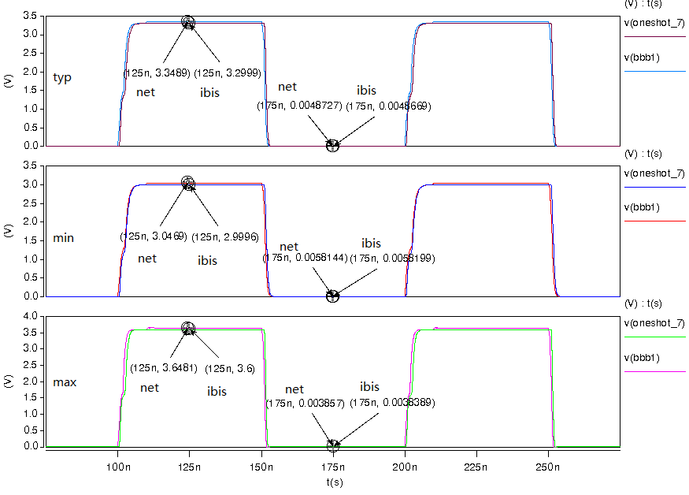

- Top-level mode Simulation Result:
- Vcca=1.2 v, vccb=5.0 v. signals from IOB to IOA, test IOA:
- Simulation without package data;
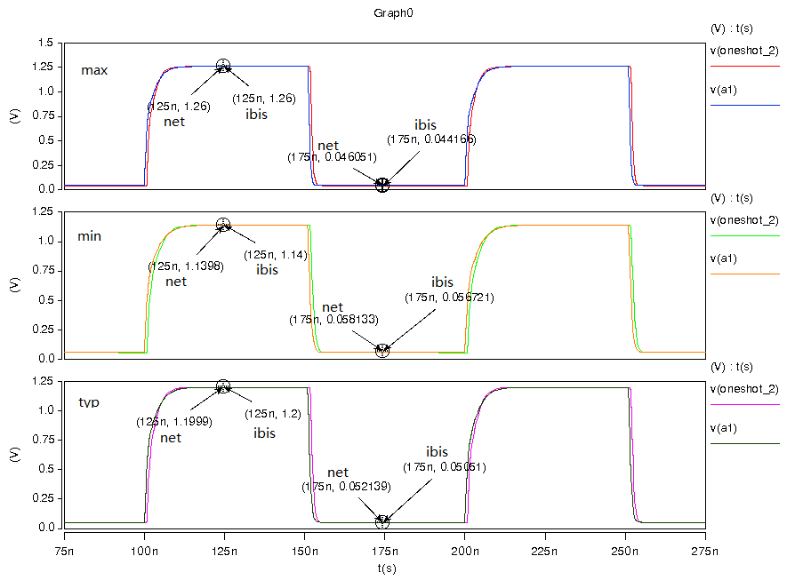
- Simulation with package data.
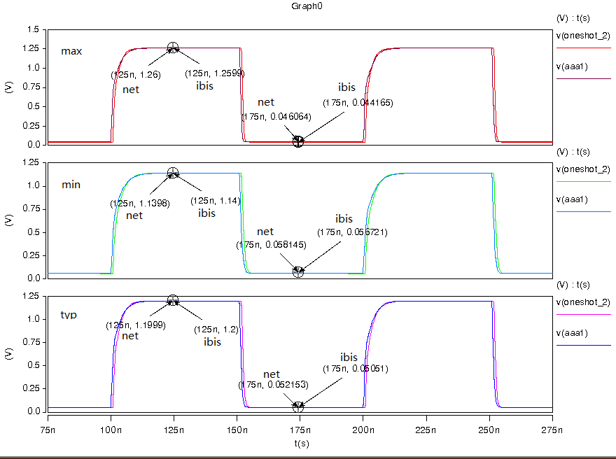
- Vcca=1.2 v, vccb=5.0 v. signals from IOA to IOB, test IOB:
- Simulation without package data;
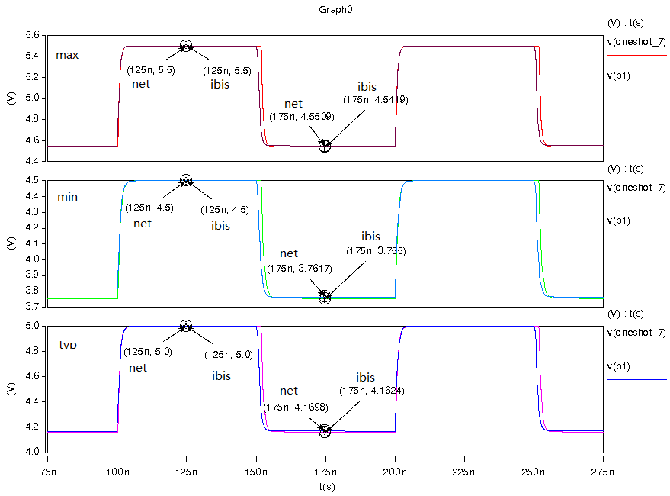
- Simulation with package data.
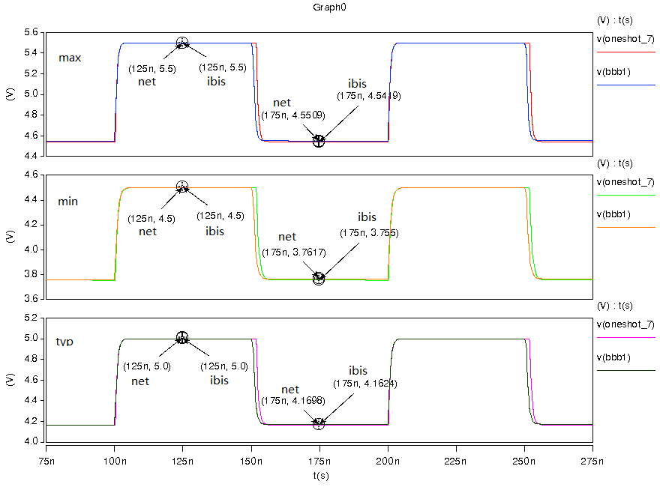

- Vcca=1.5 v, vccb=5.0 v. signals from IOB to IOA, test IOA:
- Simulation without package data;
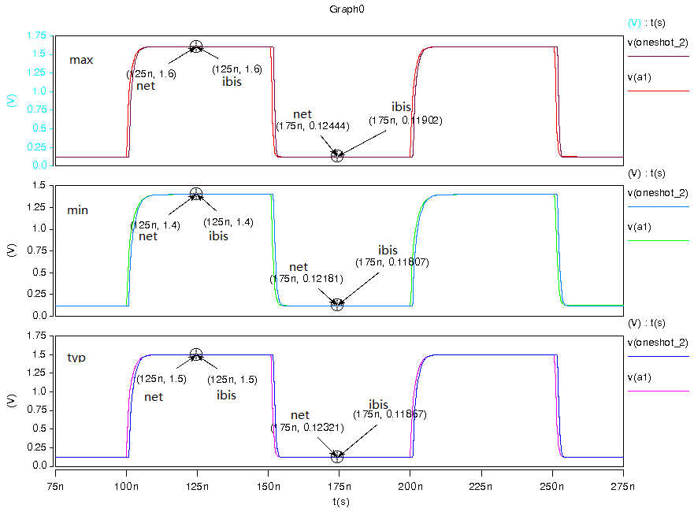
- Simulation with package data.
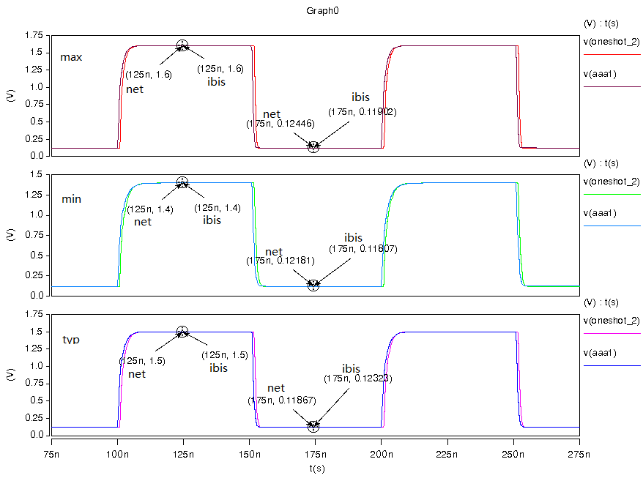

- Vcca=1.5 v, vccb=5.0 v. signals from IOA to IOB, test IOB:
- Simulation without package data;
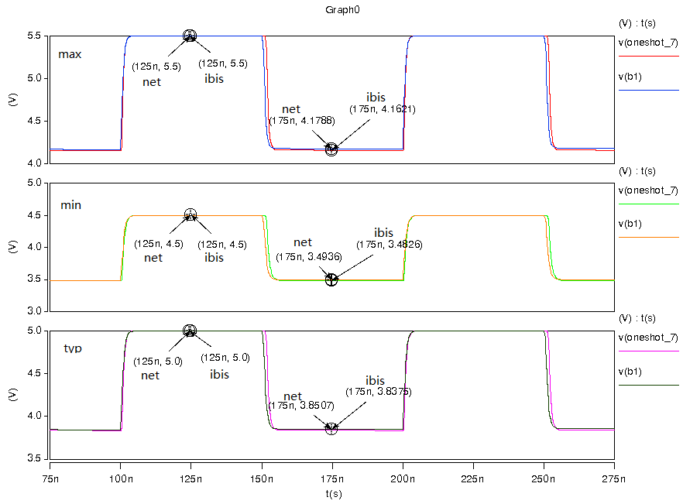
- Simulation with package data.
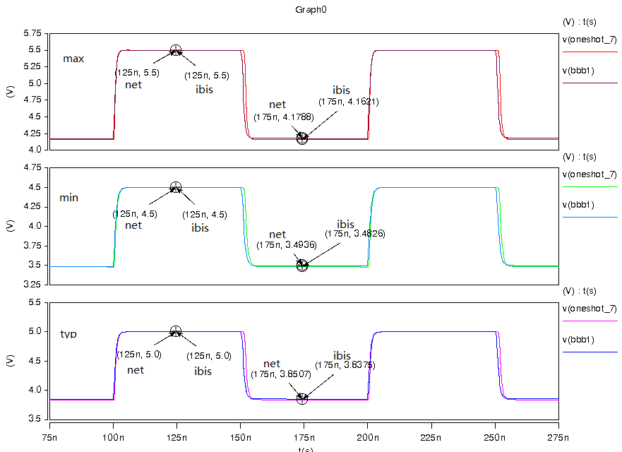

- Vcca=1.8 v, vccb=2.8 v. signals from IOB to IOA, test IOA:
- Simulation without package data;
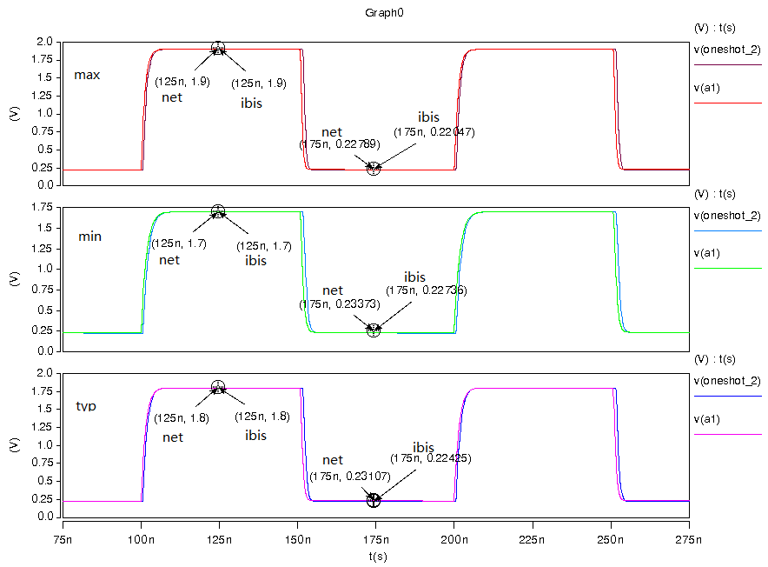
- Simulation with package data.
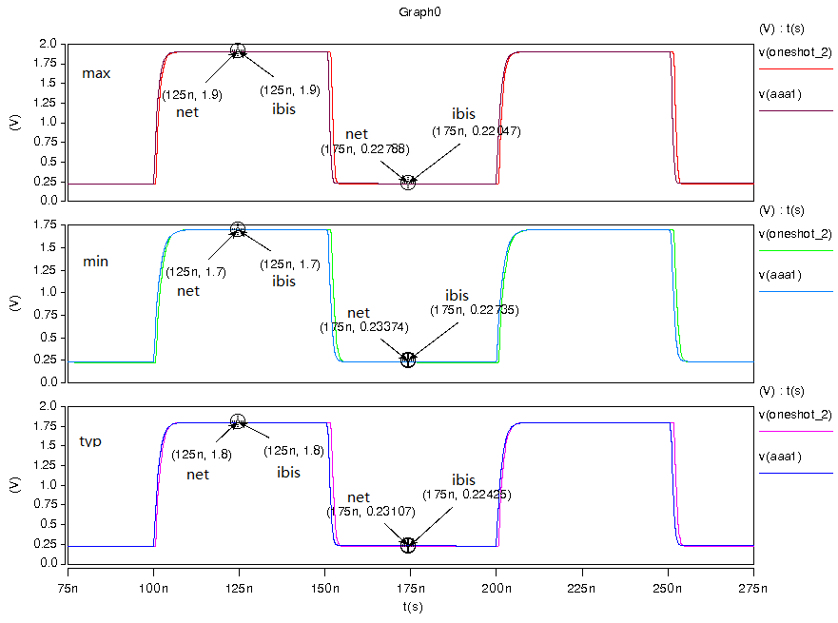

- Vcca=1.8 v, vccb=2.8 v. signals from IOA to IOB, test IOB:
- Simulation without package data;
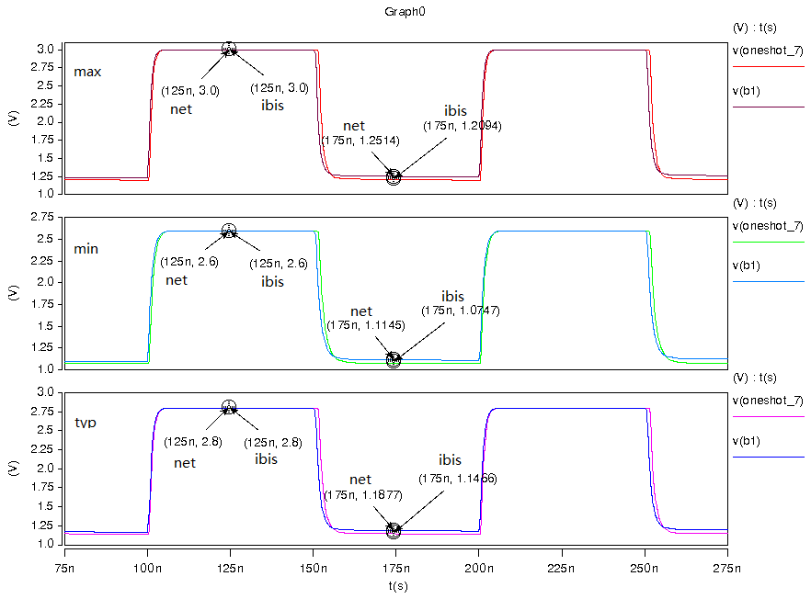
- Simulation with package data.
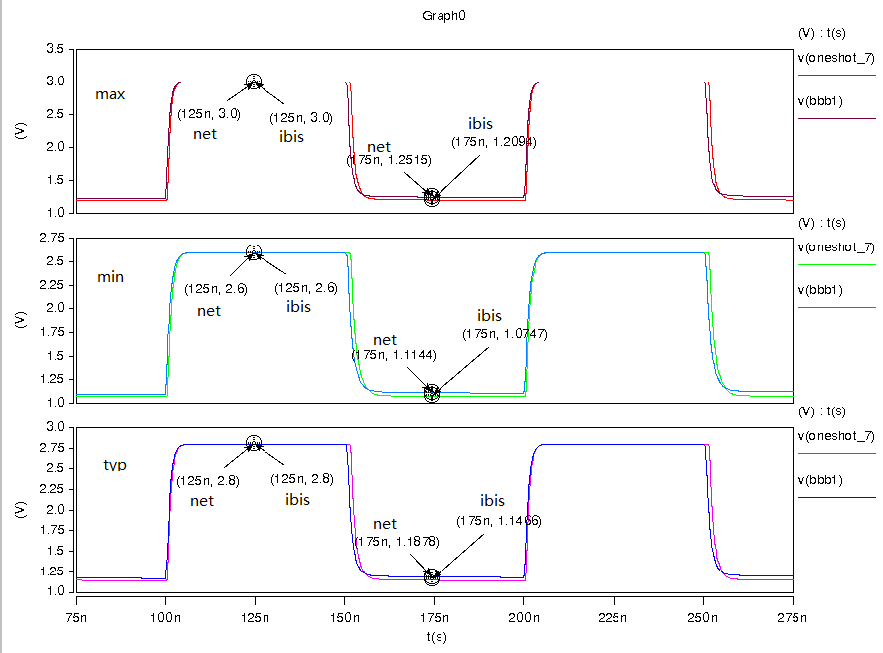

- Vcca=2.5 v, vccb=3.3 v. signals from IOB to IOA, test IOA:
- Simulation without package data;
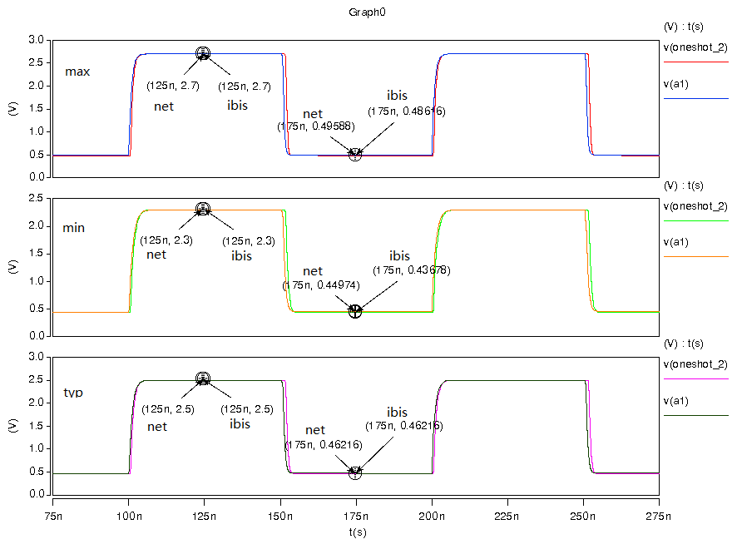
- Simulation with package data.
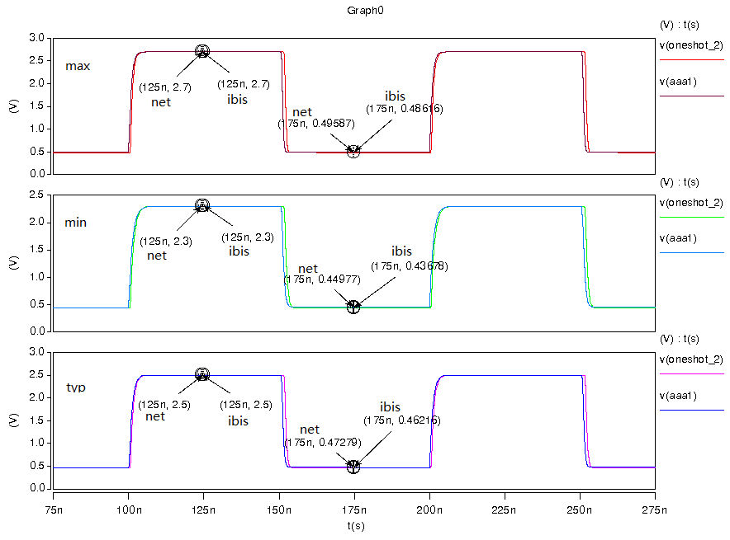

- Vcca=2.5 v, vccb=3.3 v. signals from IOA to IOB, test IOB:
- Simulation without package data;
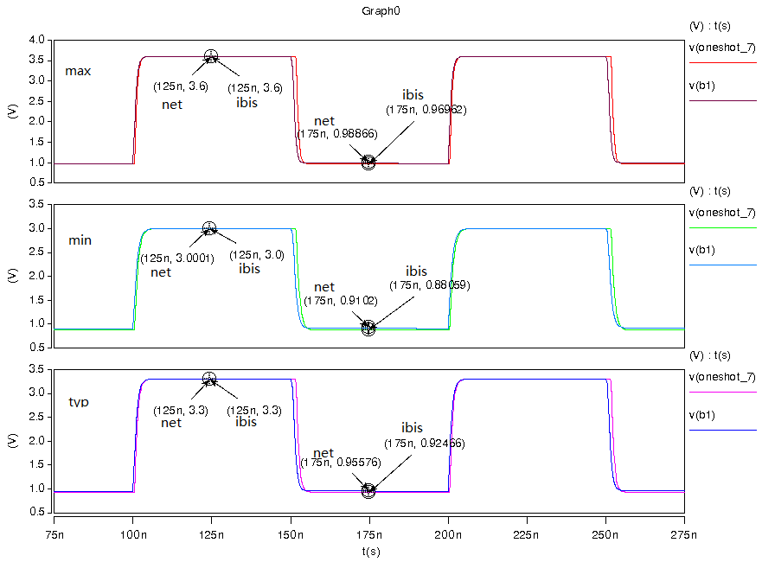
- Simulation with package data.
