IBIS model verification of PI4ULS5V106
Introduction: to verify the correlation between the ibis model and hspice model, we need to do some simulations:
The frequency of input signal is 62.5MHz, clamp=1:
vin in 0 pulse 0 pwr 0 1n 1n 79n 160n

- Netlist simulation V.S. IBIS simulation on A-side:
PI4ULS5V106
VOUT

SCL_C
SDA_C
Input Signals

SCL_C
SDA_C
VIN

SCL_C
SDA_C
A1

SCL_C
SDA_C
B1

SCL_C
SDA_C
…..

SCL_C
SDA_C
VREFA

SCL_C
SDA_C
R=145Ohm

SCL_C
SDA_C
- VREFB=1.8V, VREFA=0.95V
- Simulation without package data;
- Simulation with package data.

- VREFB=3.3V, VREFA=1.8V
- Simulation without package data;
- Simulation with package data.

- Netlist simulation V.S.IBIS simulation on B-side:
PI4ULS5V106

VOUT

SCL_C
SDA_C
Input Signals

SCL_C
SDA_C
VIN

SCL_C
SDA_C
B1

SCL_C
SDA_C
A1

SCL_C
SDA_C
…..

SCL_C
SDA_C
VREFB

SCL_C
SDA_C
R=465Ohm

SCL_C
SDA_C
- VREFA=0.95V, VREFB=1.8V
- Simulation without package data;
- Simulation with package data.

- VREFA=1.8V, VREFB=3.3V
- Simulation without package data;
- Simulation with package data.

- Conclusion:
For the verification, the simulation results of IBIS model can match very well with the HSPICE model at above simulating conditions.
- Simulation waveform on A-side:
- VREFB=1.8V, VREFA=0.95V
- Simulation without package data;
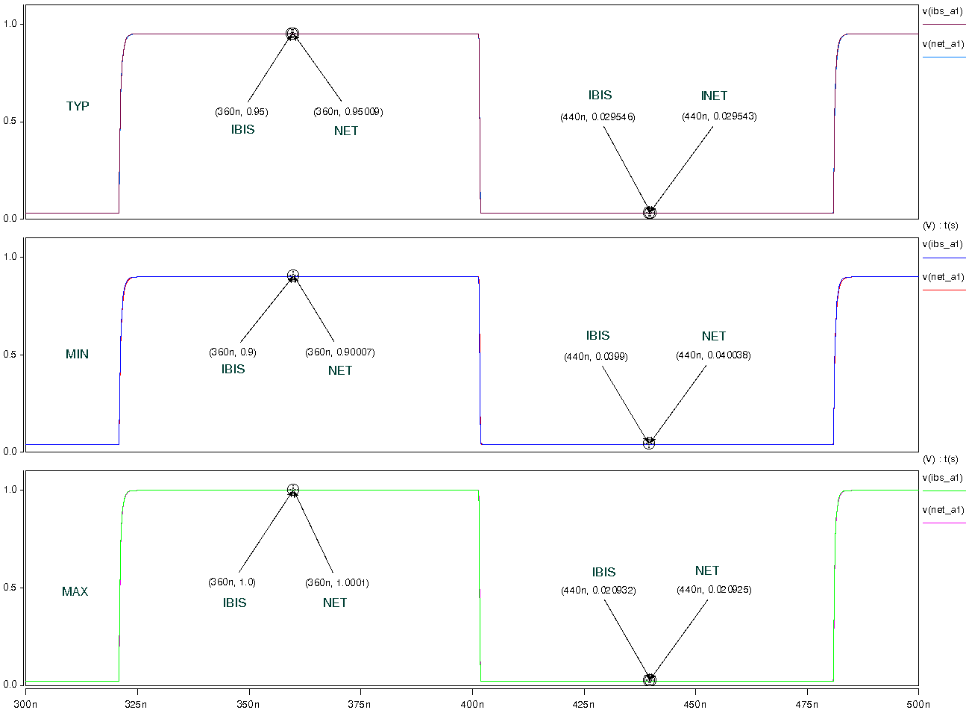
- Simulation with package data.
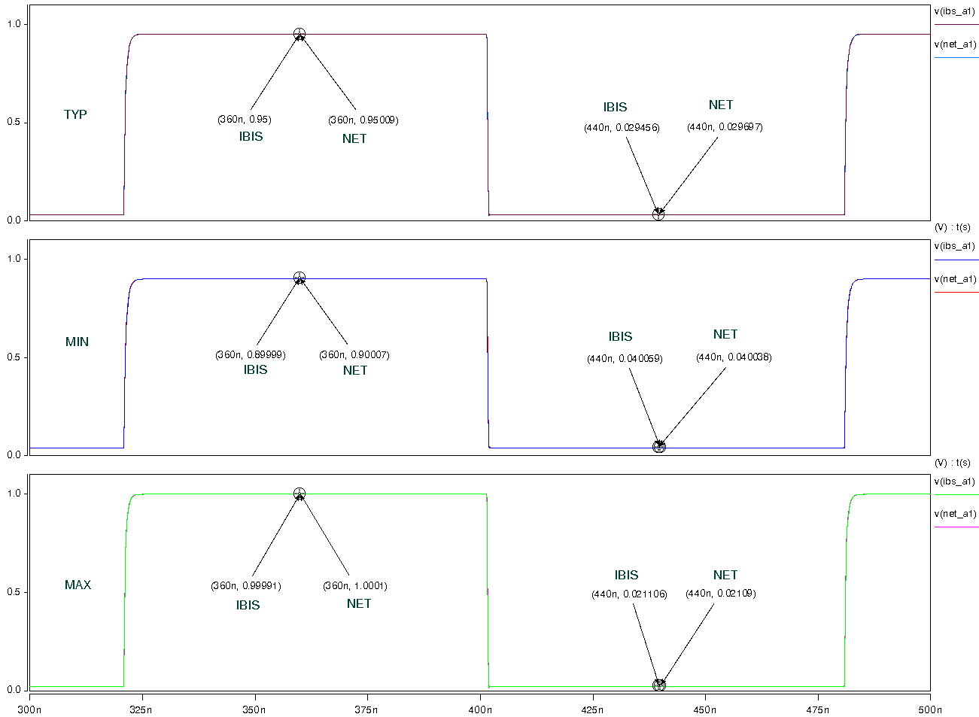
- VREFB=3.3V, VREFA=1.8V
- Simulation without package data;
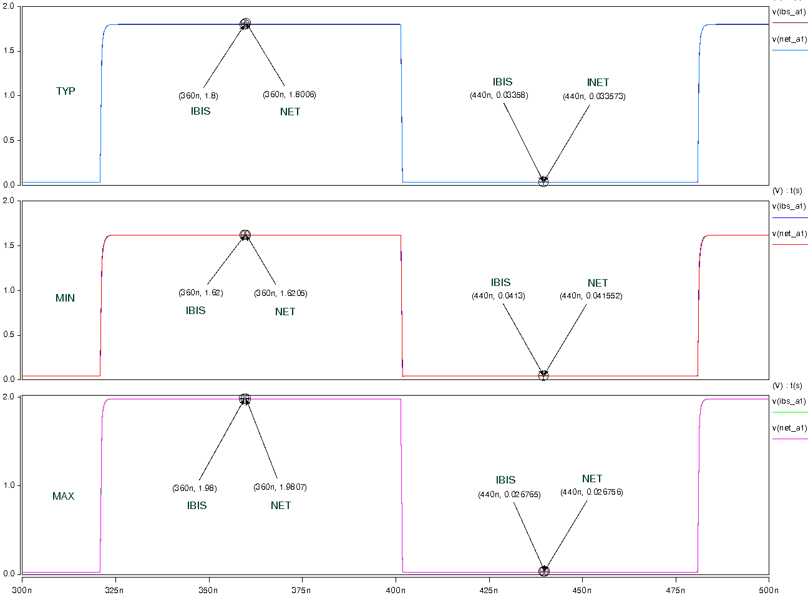

- Simulation with package data.
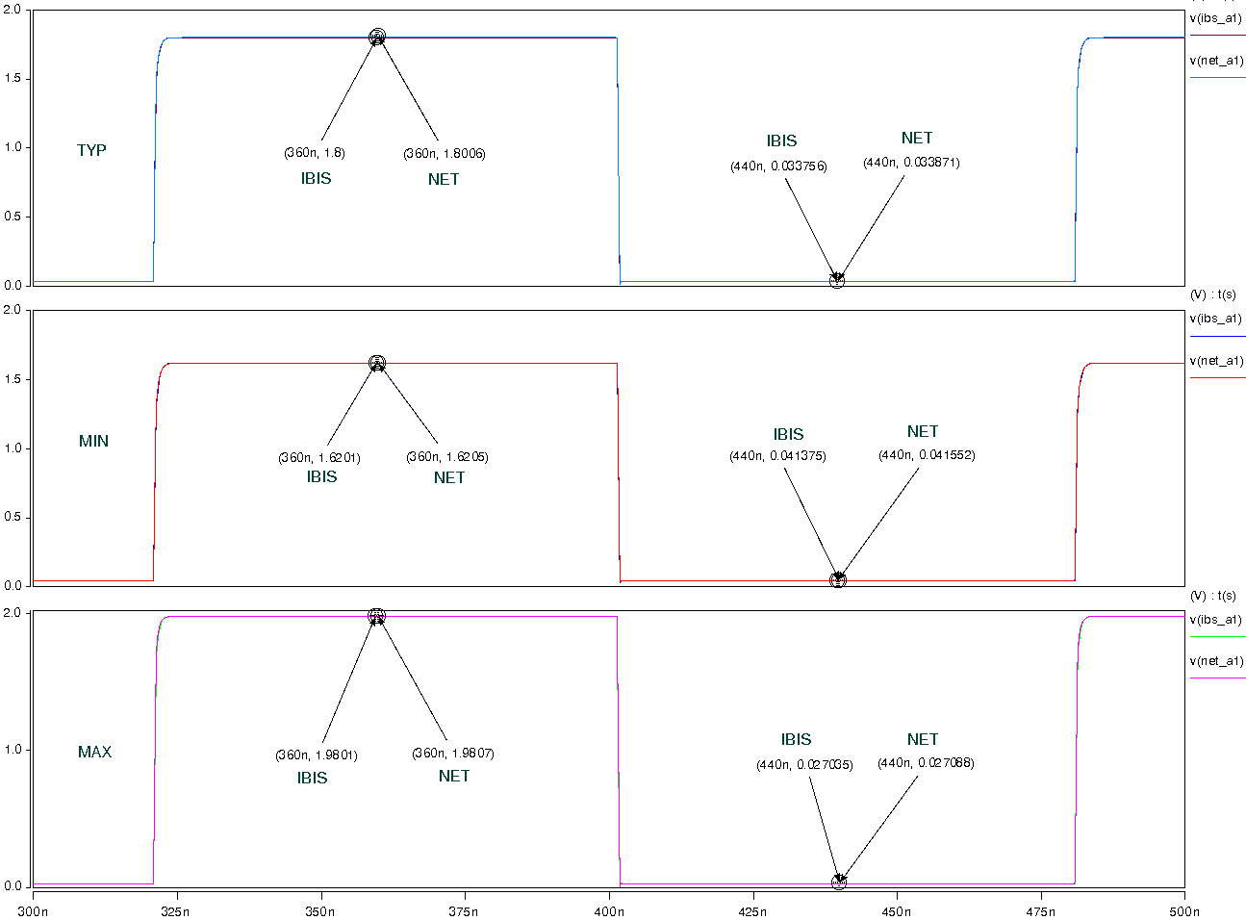
- Simulation waveform on b-side:
- VREFA=0.95V, VREFB=1.8V
- Simulation without package data;
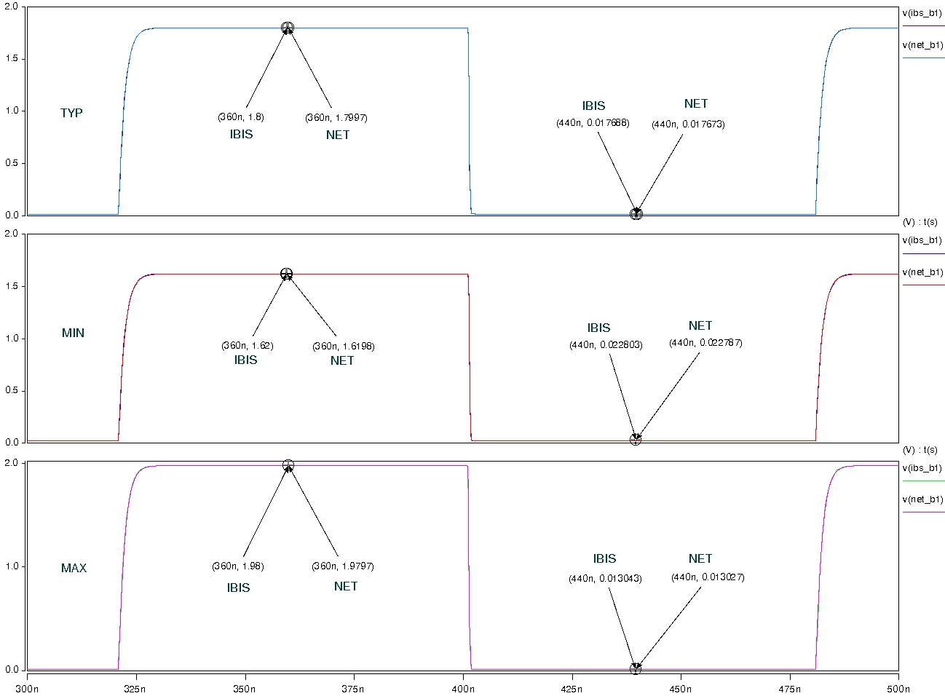
- Simulation with package data.
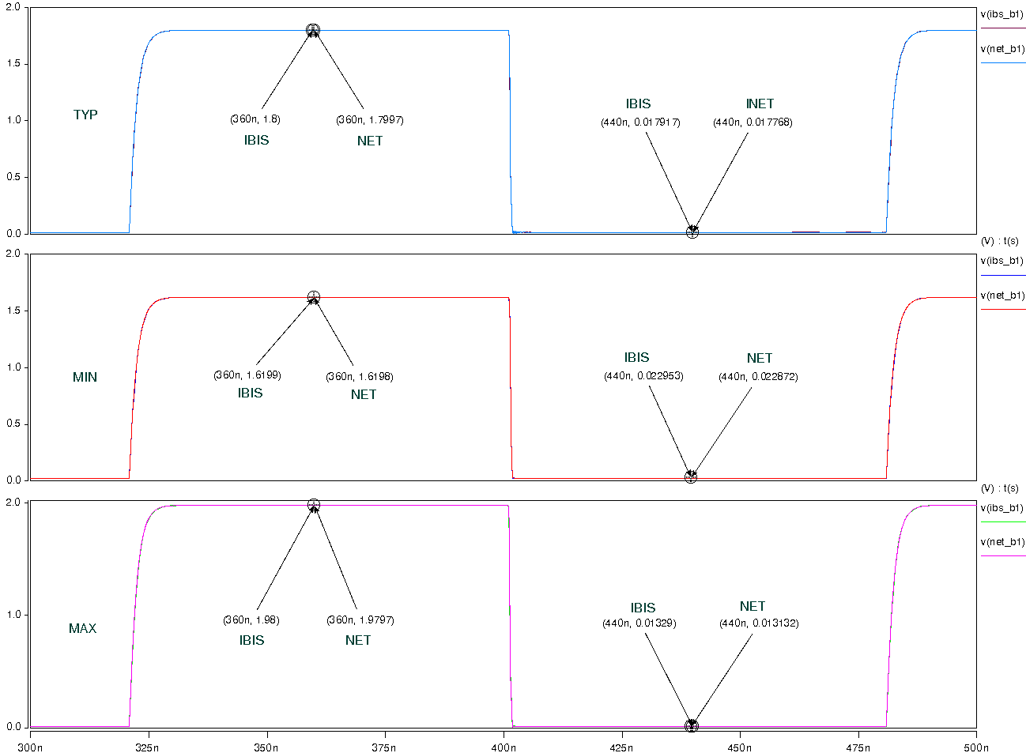
- VREFA=1.8V, VREFB=3.3V
- Simulation without package data;
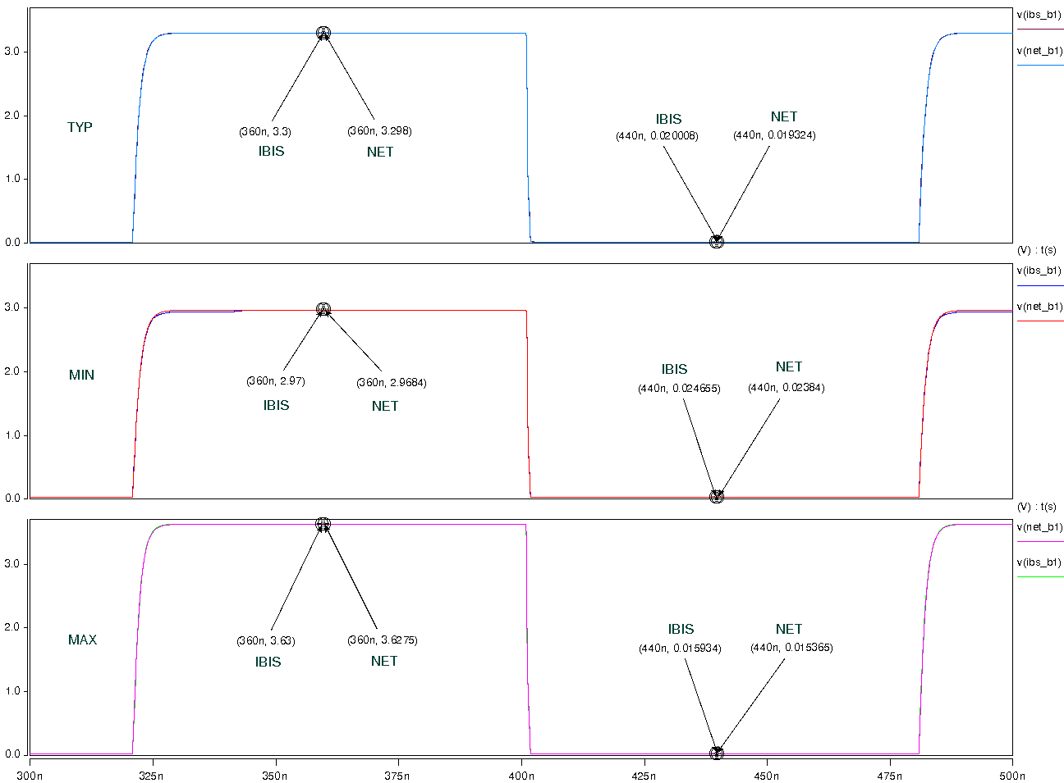
- Simulation with package data.
