Verification of PI4ULS5V104 IBIS model

- Introduction:
To verify the correlation between the ibis model and hspice model, we need to do some simulations:

Simulation condition: (VCCA=3.3, VCCB=5.0, frequency=5megHz)
- Add 1meg ohm resistor to ground;
- Add 1meg ohm resistor and 15pF capacitor to ground;
- Add 10k ohm resistor to ground;
- Add 10k ohm resistor and 15pF capacitor to ground;

- Conclusion:

The simulated results show that the generated IBIS model can match well with the HSPICE model at different load conditions.

But there are still some issues:

- There is some undershoot at the fall-edge of IBIS simulation while it is disappeared in the HSPICE simulation.

- simulation:

- Add 1meg ohm resistor to ground;
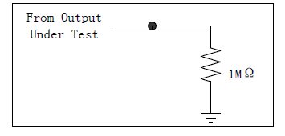

VCC=3.3V
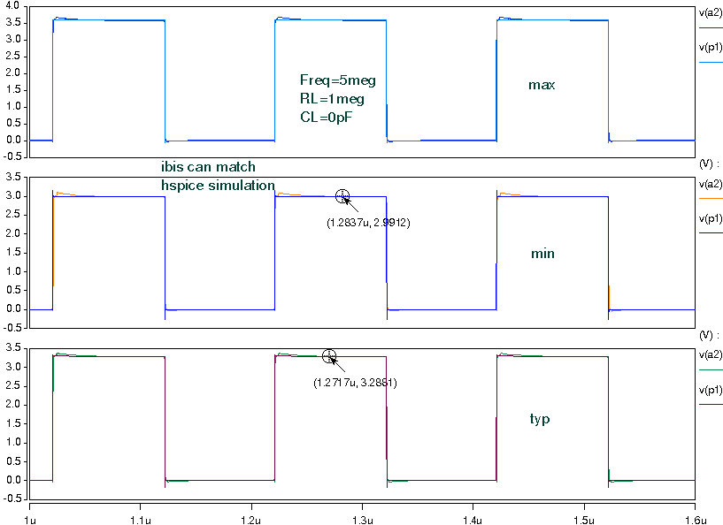

- Add 1meg ohm resistor and 15pF capacitor to ground;

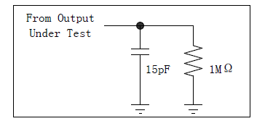
VCC=3.3V
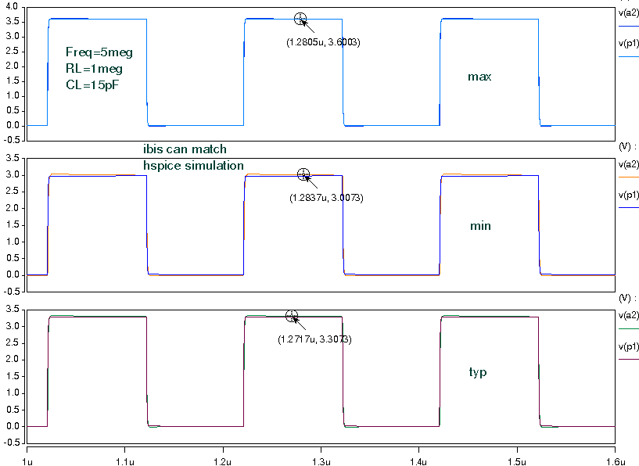

- Add 10k ohm resistor to ground;

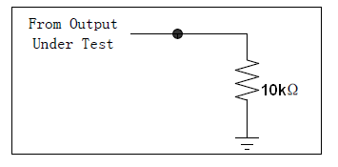
VCC=3.3V
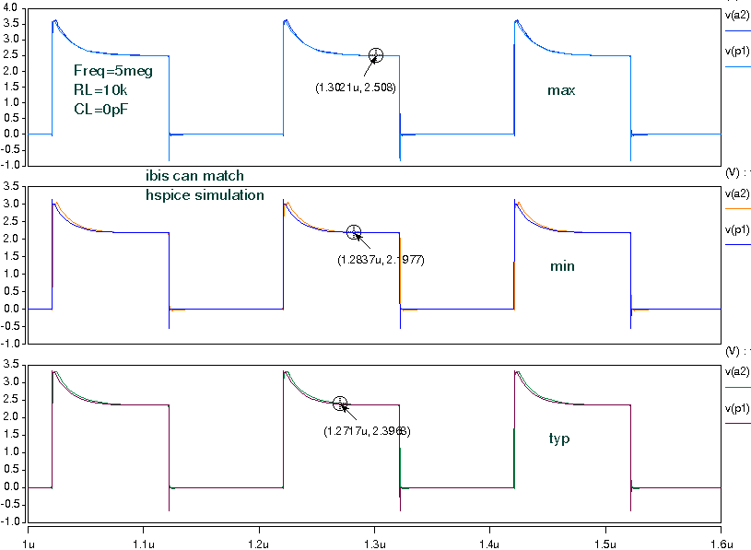

- Add 10k ohm resistor and 15pF capacitor to ground;
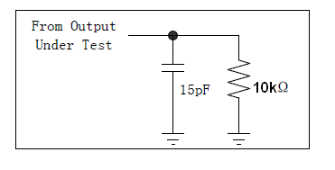
VCC=3.3V
