Verification of PI4MSD5V9545A IBIS model
- Introduction:
To verify the correlation between the ibis model and hspice model, we need to do some simulations:

The frequency of signal is 1MHz:
vin sc0 0 pulse 0 high-level 0 2n2n 498n 1000n

Add 500Ω pull-down resistor to the OUTPUT：
high-level=0.5V
PI4MSD5V9545A
OUT

SCL_C
SDA_C
R

SCL_C
SDA_C
sc0

SCL_C
SDA_C
Input Signals

SCL_C
SDA_C
Output

SCL_C
SDA_C
scl

SCL_C
SDA_C
VIN

SCL_C
SDA_C
- without package;
- with package.

- Conclusion:
- For SWITCH1, the simulation results of IBIS model can match quite well with the HSPICE model at different load conditions.

- Simulation Result:
high-level=0.5V
- without package;
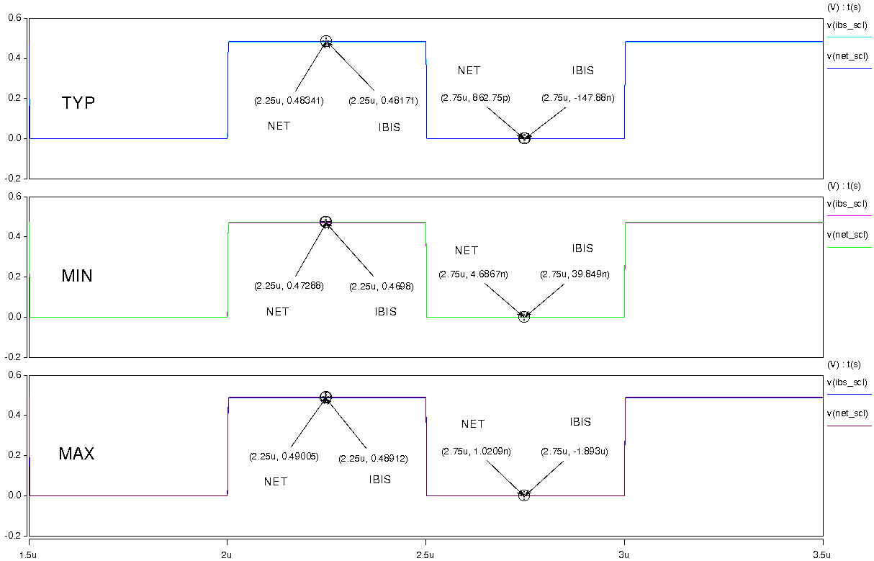
- with package.
