Verification of PI4IOE5V9554 IBIS model
Introduction:
To verify the correlation between the ibis model and hspice model, we need to do some simulations:
- IO(I/O)
PI4IOE5V9554
VOUT

SCL_C
SDA_C
R

SCL_C
SDA_C
input

SCL_C
SDA_C
Input Signals

SCL_C
SDA_C
VIN

SCL_C
SDA_C
VDD

SCL_C
SDA_C
IO0

SCL_C
SDA_C
…..

SCL_C
SDA_C
The frequency of signal is 5MHz:
Vin input 0 pulse (0 power 0 1n 1n 99n 200n)
- Add 1kΩ pull-up resistor and without package data to the output;
- With ZH package data to the output;
- With L package data to the output.

- OUTPUT(_INT)
PI4IOE5V9554
VOUT

SCL_C
SDA_C
R

SCL_C
SDA_C
input

SCL_C
SDA_C
Input Signals

SCL_C
SDA_C
VIN

SCL_C
SDA_C
VDD

SCL_C
SDA_C
_INT

SCL_C
SDA_C
…..

SCL_C
SDA_C
The frequency of signal is 20MHz:
Vin input 0 pulse (0 power 0 1n 1n 24n 50n)
- Add 1kΩ pull-up resistor and without package data to the output;
- With ZH package data to the output;
- With L package data to the output.

- IO_OD(SDA)
PI4IOE5V9554
VOUT

SCL_C
SDA_C
R

SCL_C
SDA_C
input

SCL_C
SDA_C
Input Signals

SCL_C
SDA_C
VIN

SCL_C
SDA_C
VDD

SCL_C
SDA_C
SDA
SCL_C
SDA_C
…..

SCL_C
SDA_C
The frequency of signal is 20MHz:
Vin input 0 pulse (0 power 0 1n 1n 24n 50n)
- Add 1kΩ pull-up resistor and without package data to the output;
- With ZH package data to the output;
- With L package data to the output.

Simulation Result:
- IO
- Add 1kΩ pull-up resistor and without package data to the output;
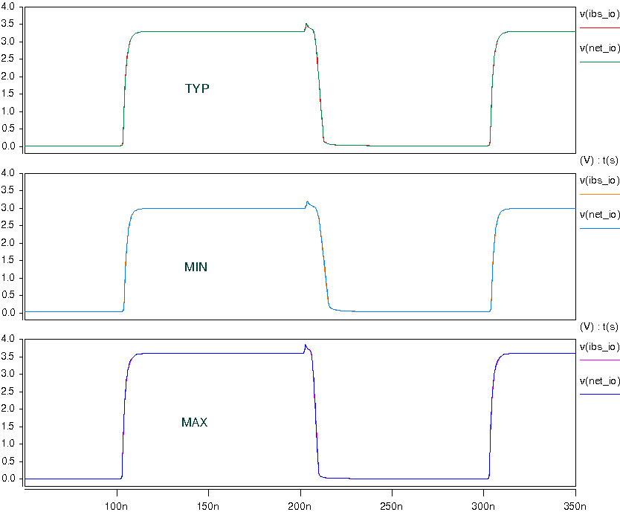
- With ZH package data to the output;
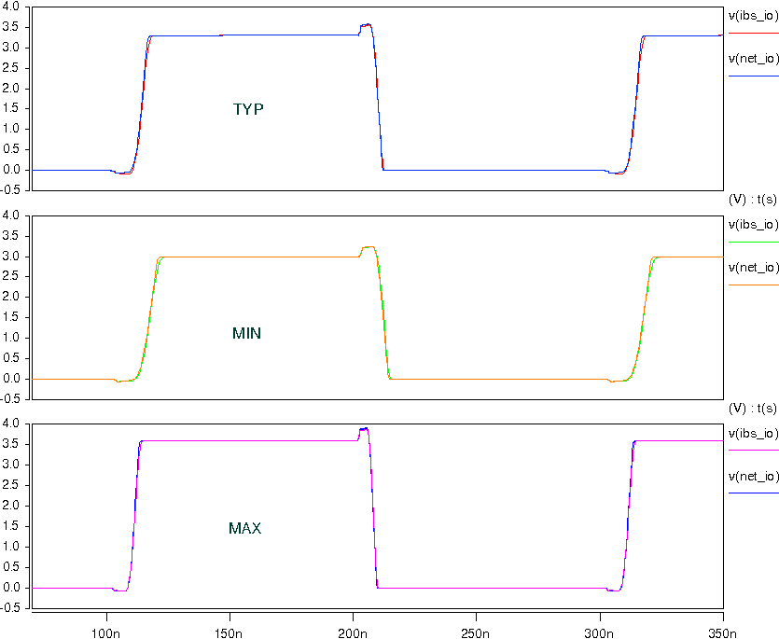
- With L package data to the output.
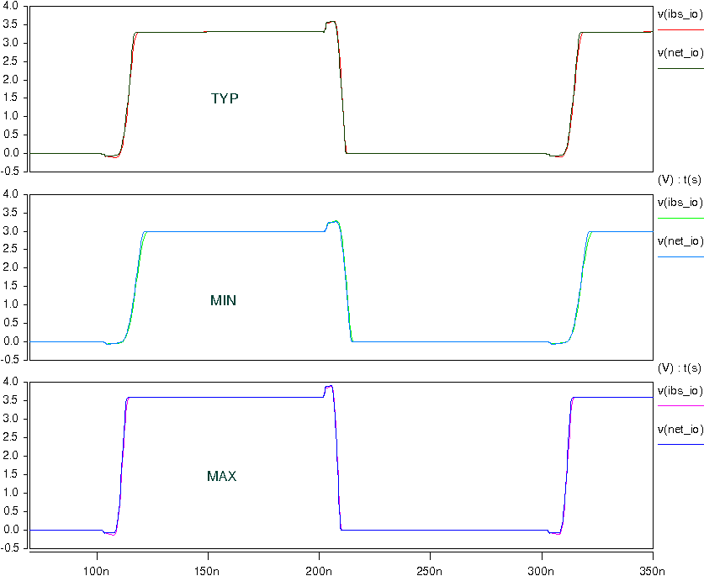

- OUTPUT
- Add 1kΩ pull-up resistor and without package data to the output;
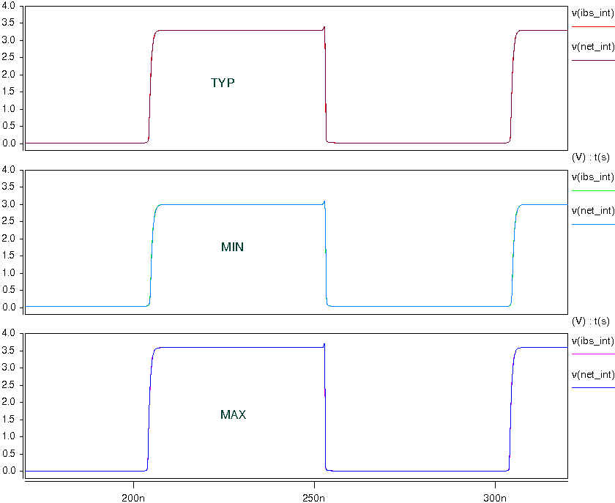
- Add 1kΩ pull-up resistor and with ZH package data to the output;
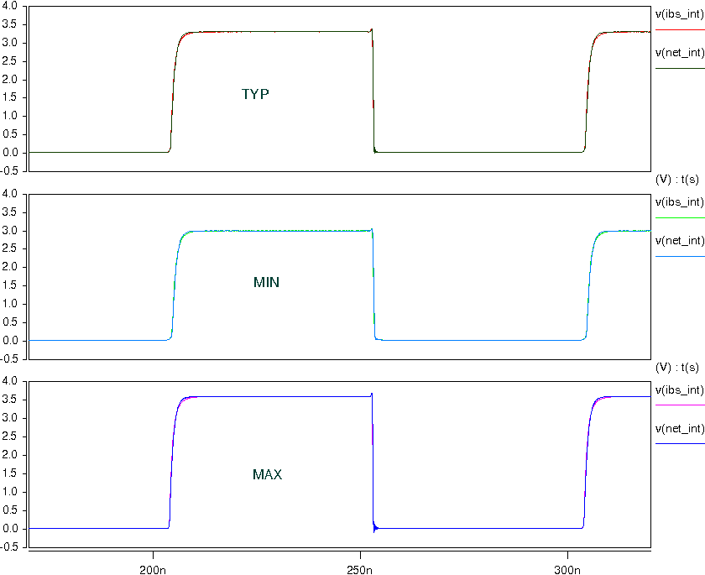
- Add 1kΩ pull-up resistor and with L package data to the output.
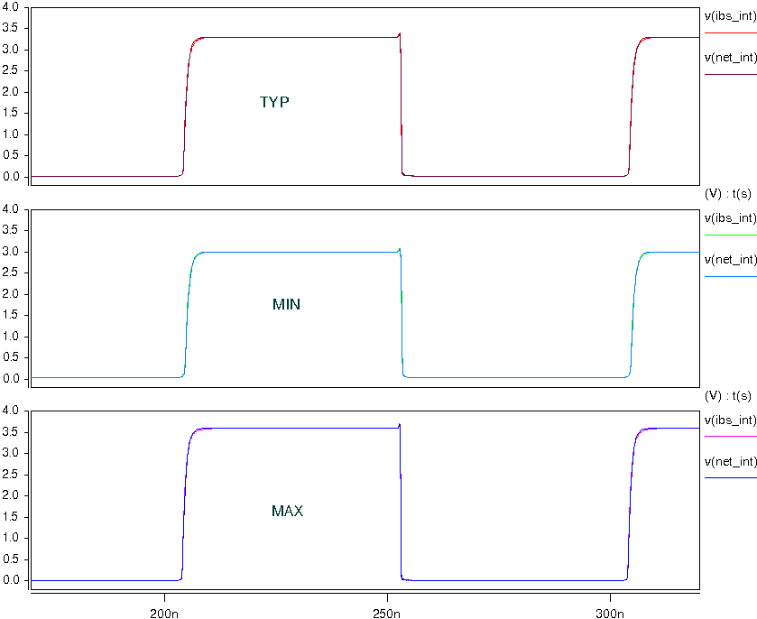

- IO_OD
- Add 1kΩ pull-up resistor and without package data to the output;
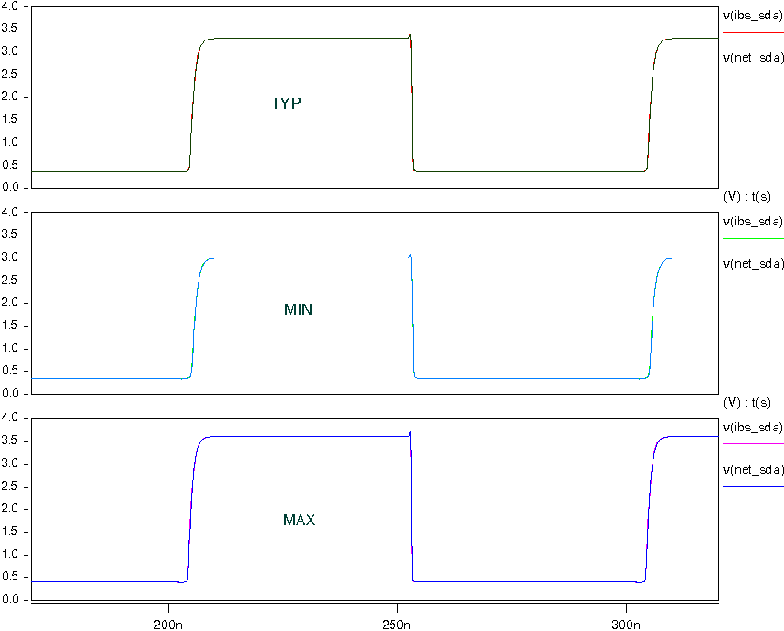
- Add 1kΩ pull-up resistor and with ZH package data to the output;
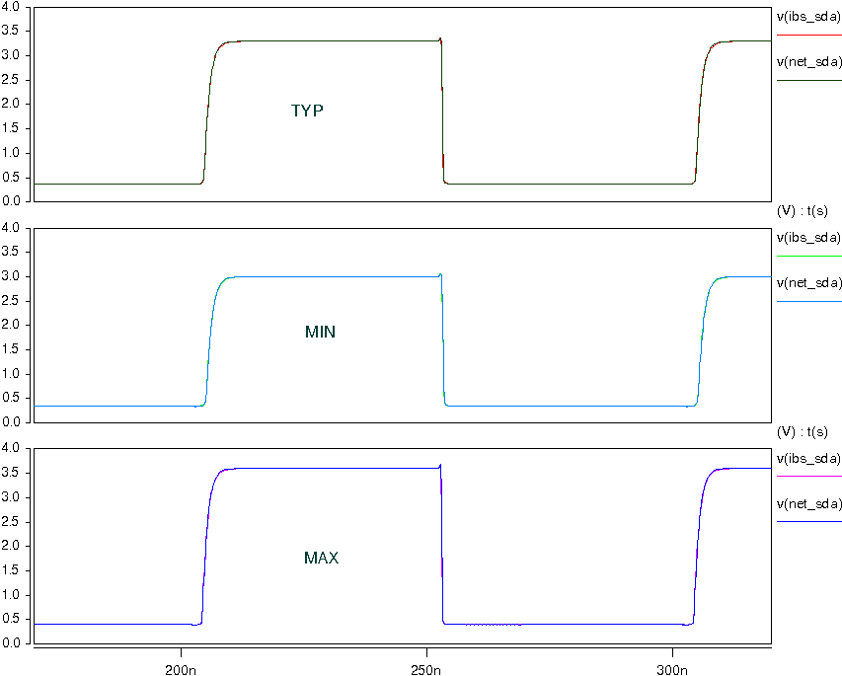
- Add 1kΩ pull-up resistor and with L package data to the output.
