Verification of PI3USB221 IBIS model
- Introduction:
To verify the correlation between the ibis model and hspice model, we need to do some simulations:

The frequency of signal is 10MHz:
vin a 0 pulse 0 high-level 0 2n2n 48n 100n

Add 50Ω pull-down resistor and 50pF pull-down capacitance to the OUTPUT：
high-level=1V
PI3USB221
OUT

SCL_C
SDA_C
R

SCL_C
SDA_C
a

SCL_C
SDA_C
C

SCL_C
SDA_C
Input Signals

SCL_C
SDA_C
Output

SCL_C
SDA_C
b1

SCL_C
SDA_C
VIN

SCL_C
SDA_C
- without package;
- with package.

- Conclusion:
- For SWITCH1, the simulation results of IBIS model can match quite well with the HSPICE model at different load conditions.

- Simulation Result:
high-level=1V
- without package;
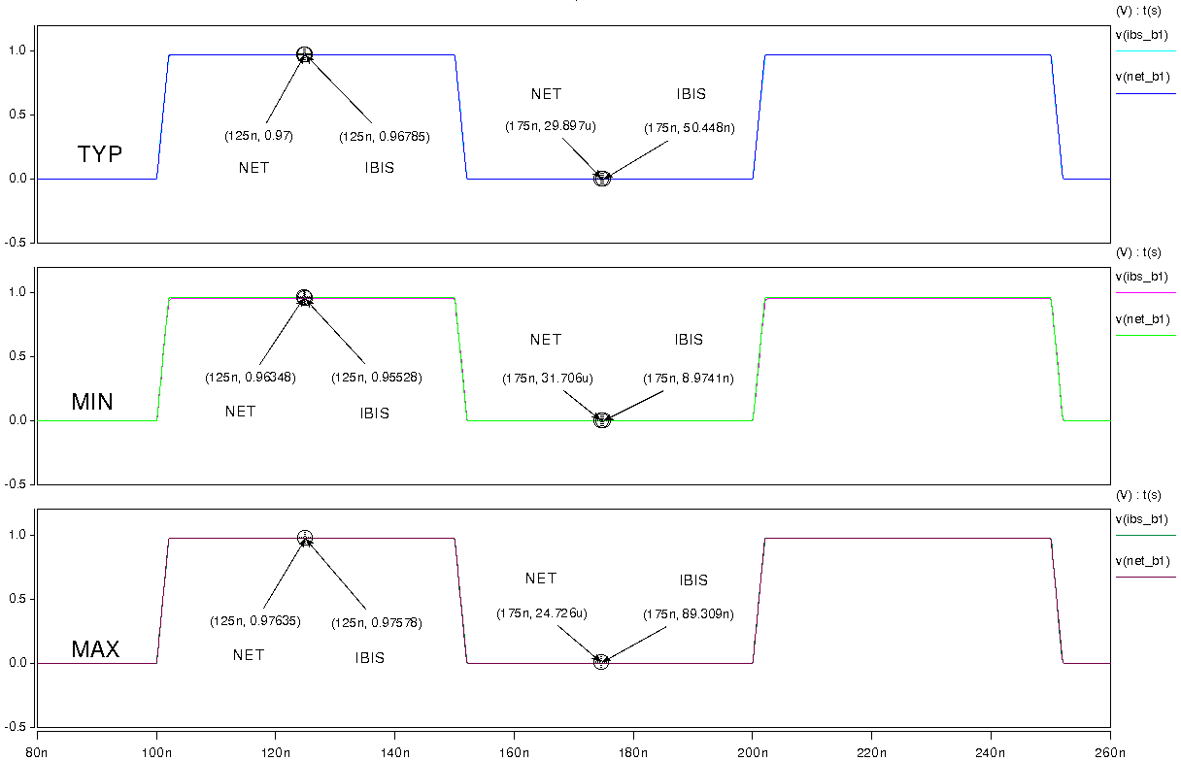
- with package.
