Verification of PI3L500-A IBIS model
- Introduction:
To verify the correlation between the ibis model and hspice model, we need to do some simulations with following conditions:
PI3L500-A
OUT0

SCL_C
SDA_C
OUT1

SCL_C
SDA_C
R

SCL_C
SDA_C
R

SCL_C
SDA_C
A0

SCL_C
SDA_C
C

SCL_C
SDA_C
C

SCL_C
SDA_C
Differential Signals

SCL_C
SDA_C
Output

SCL_C
SDA_C
A1

SCL_C
SDA_C
······

·
·
·

······

·
·
·

0B1

SCL_C
SDA_C
1B1

SCL_C
SDA_C
IINN

SCL_C
SDA_C
INP

SCL_C
SDA_C
R=50Ω

SCL_C
SDA_C
R=50Ω

SCL_C
SDA_C
- The frequency of signal is 50MHz (100Mbps).
vinn a0 0 pulse ( 3 0 0 .1n .1n 9.9n 20n)
vinp a1 0 pulse ( 0 3 0 .1n .1n 9.9n 20n)
Adding 50Ω resistor between the signal and INPUT, with 10pF pull-down capacitance and 500Ω pull-down resistor to the OUTPUT:
- without package
- with package

- The frequency of signal is 250MHz (500Mbps).
vinn a0 0 pulse ( 3 0 0 .1n .1n 1.9n 4n)
vinp a1 0 pulse ( 0 3 0 .1n .1n 1.9n 4n)
Adding 50Ω resistor between the signal and INPUT, with 2pF pull-down capacitance and 50Ω pull-down resistor to the OUTPUT:
- without package
- with package

- Conclusion:
- For SWITCH1, the simulation results of IBIS model can match quite well with the HSPICE model at different load conditions.

- Simulation Result:
- The frequency of signal is 50MHz (100Mbps).
With 10pF pull-down capacitance and 500Ω pull-down resistor to the OUTPUT:
- without package
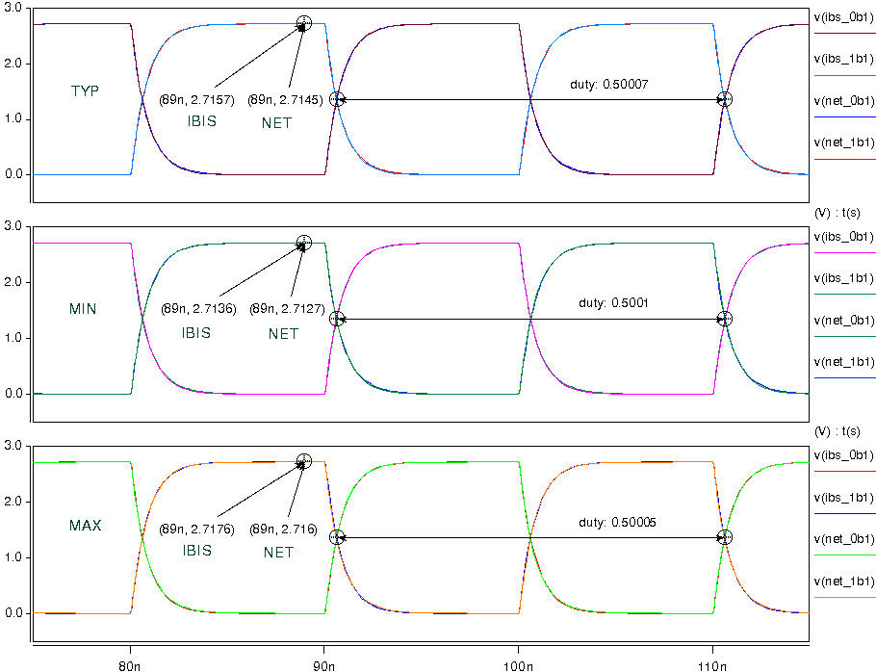
- with package
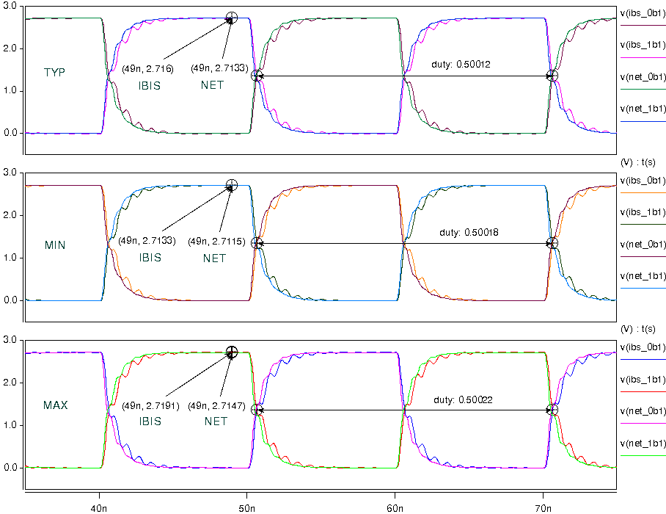
- The frequency of signal is 250MHz (500Mbps).
With 2pF pull-down capacitance and 50Ω pull-down resistor to the OUTPUT:
- without package
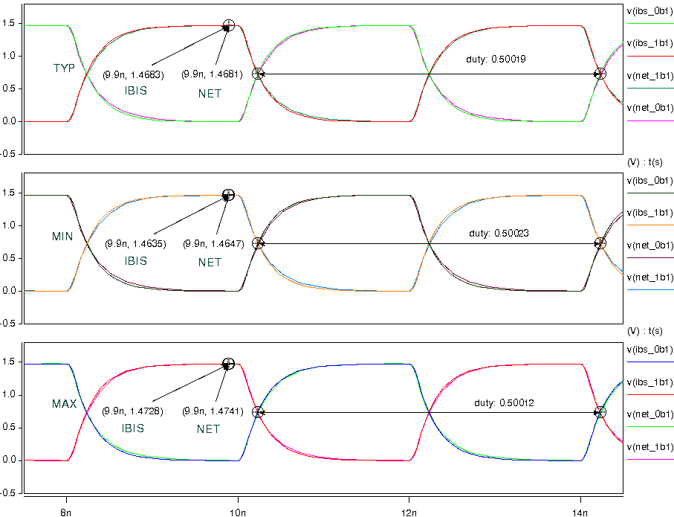
- with package
