PI3HDMI511
Demo Board Rev.B User Manual
by Ada Yip

Table of Contents

1 Introduction 2
2 Overview 2
3 Quick Start 4
4 Circuit Description 5
4.1 Equalization Setting 5
4.2 Swing and Pre-emphasis Settings 5
4.3 5V Power Supply 6
4.4 Power Saving Mode 6
4.5 Output DDC Pull-up 6
5 References 7
6 Appendix A: Demo Board Schematic 8

Introduction

PI3HDMI511 HDMI1.4 re-driver is designed for source applications. This user manual describes the components and the usage of PI3HDMI511 Demo Board Rev.B.

Overview

Figure 1 is the block diagram of Pericom PI3HDMI511 demo board and figures 2 and 3 show the top and bottom views of the demo board. One HDMI plug connector (J101) on PI3HDMI511 demo board is used for plugging a source device, such as a DVD player. An HDMI cable can be connected between an HDMI receptacle connector (J102) on the demo board and a sink device, such as HDTV. +5V DC can be employed to the demo board via a mini USB female connector (J103) and/or the source device provided that a header pin JP105 is shorted. Through a 3.3V regulator (U102), PI3HDMI511 on the demo board can then be powered up.

For source application evaluation, SCL and SDA are pulled to 5V at output HDMI connector through shorting header pins JP103-4. Swing, pre-emphasis and equalization settings of PI3HDMI511 can be adjusted via a SPDT switch (SW101).

PI3HDMI511
J102
3.3V Regulator
Mini USB Connector
Input Port
U102
SW101
SPDT Switch
J101
HDMI Input Connector
HDMI Output Connector
Output Port
U101
+5V_A
J103
+5V_USB
+3V3

Figure 1: Block Diagram of PI3HDMI511 Demo Board Rev.B

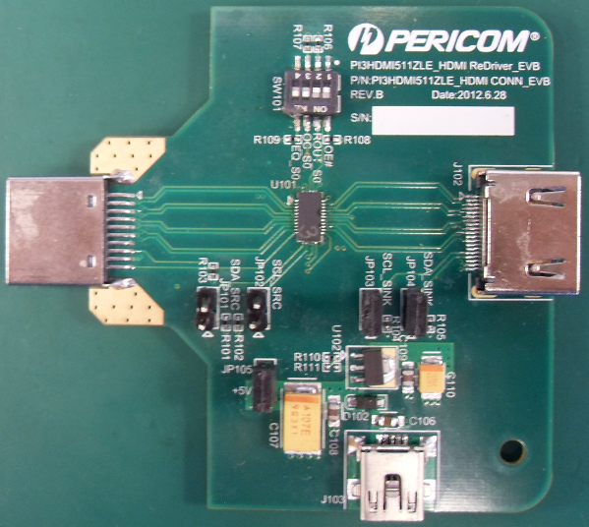

Figure 2: Top View of PI3HDMI511 Demo Board Rev.B
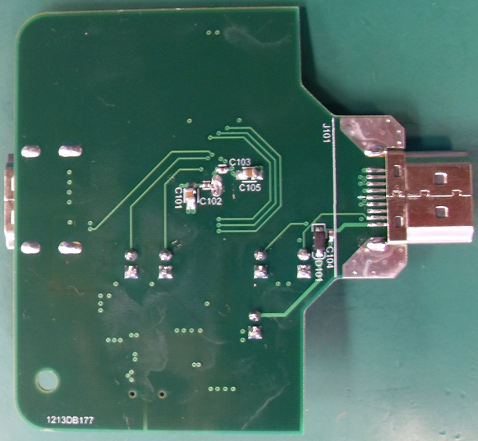

Figure 3: Bottom View of PI3HDMI511 Demo Board Rev.B

Quick Start

To start-up the PI3HDMI511 demo board rev.B, complete the following steps:
- Short header pins JP103-4 to pull DDC signals to 5V at output HDMI connector side;
- Keep pins 1 and 8 of switch SW101 open to enable PI3HDMI511;
- Keep pins 4 and 5 of switch SW101 open to set equalization to 3dB;
- Keep pins 3 and 6 of switch SW101 open to set 500mV swing and 2.5dB pre-emphasis;
- Connect pins 2 and 7 of switch SW101 to set PI3HDMI511 in normal operation;
- Short JP105 to allow employing a 5V DC to the demo board from a source device;
- Supply 5V to demo board from mini USB connector at J103;
- Connect a source device, e.g. DVD player, to HDMI input connectors at J101;
- Connect a sink device, e.g. HDTV, to HDMI output connector at J102.

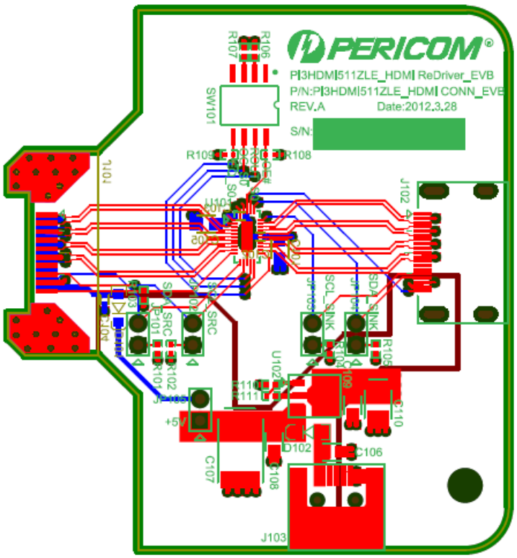

Figure 4: Layout of PI3HDMI511 Demo Board Rev.B

Circuit Description

Equalization Setting

PI3HDMI511 offers strong equalization strength for long input trace application; for instance, notebook docking. EQ setting can be set to 9dB or 15dB depending on individual PCB design. Setting below is for referencing.

Equalization | Pins 4 and 5 of SW101 | Input Trace
9 dB | Short | 2 – 18”
15 dB | Open | 16 – 30”

Table 1: EQ Setting of PI3HDMI511 Demo Board Rev.B for Source Application
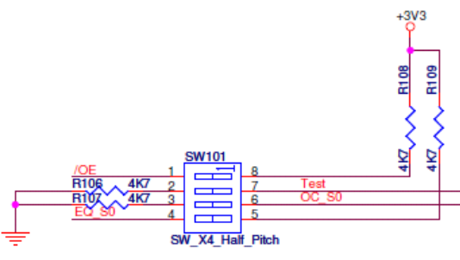

Figure 5: SW101 on PI3HDMI511 Demo Board Rev.B

Swing and Pre-emphasis Settings

Swing and pre-emphasis settings of PI3HDMI511 are designated for fulfilling source eye diagram requirement specified in HDMI specification. Swing is desired as 500mV while 0 or 2.5dB pre-emphasis can be picked depending on individual PCB design.

Swing | Pre-emphasis | Pins 3 and 6 of SW101 | Output Trace
500 mV | 0 dB | Short | 2 – 8”
500 mV | 2.5 dB | Open | 6 – 16”

Table 2: OC Setting of PI3HDMI511 Demo Board Rev.B for Source Application

5V Power Supply

By shorting header JP105, PI3HDMI511 demo board rev.B can be powered up through two methods. 5V can be employed from:
- any source connected to input HDMI connector J101 via +5V_A power rail;
- Mini-USB adaptor connected to mini USB2.0 connector J103 via +5V_USB power rail.
Short
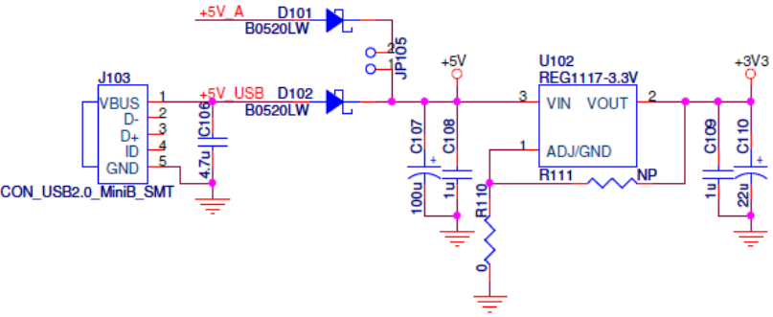

Figure 6: Power Circuit of PI3HDMI511 Demo Board Rev.B

Power Saving Mode

PI3HDMI511 can enter power saving mode by setting /OE pin to high voltage level.

/OE | Pins 1 and 8 of SW101 | Output TMDS of PI3HDMI511
L | Short | Normal Mode
H | Open | Power Saving Mode

Table 3: /OE Setting of PI3HDMI511 Demo Board Rev.B

Output DDC Pull-up

Per HDMI specification, DDC lines are required to be pulled to 5V for source application. To evaluate PI3HDMI511 in source application, headers JP103-4 are shorted so as to pull SCL and SDA to 5V via 2.2kΩ resistors at output HDMI connector.

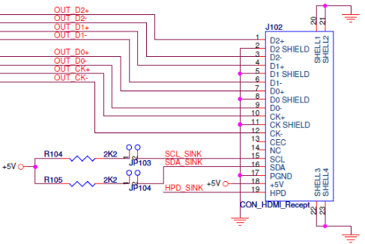
Short

Figure 7: DDC Pull-up at Output HDMI Connector of PI3HDMI511 Demo Board Rev.B
47kΩ pull-up resistors are also reserved for DDC lines at input HDMI connector of PI3HDMI511 demo board rev.B. These two resistors may be needed for cable evaluation. The resistors can pull SCL and SDA to 5V by shorting headers JP101-2.

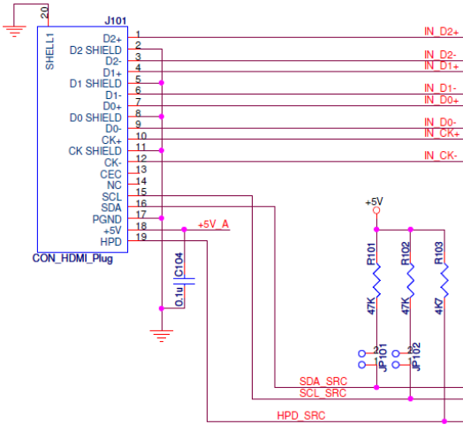
Short

Figure 8: DDC Pull-up at Input HDMI Connector of PI3HDMI511 Demo Board Rev.B

References

- High-Definition Multimedia Interface Specification Version 1.4b, HDMI Licensing, LLC, October 11, 2011
- High-Definition Multimedia Interface Compliance Test Specification Version 1.4a, HDMI Licensing, LLC, March 4, 2010

Appendix A: Demo Board Schematic

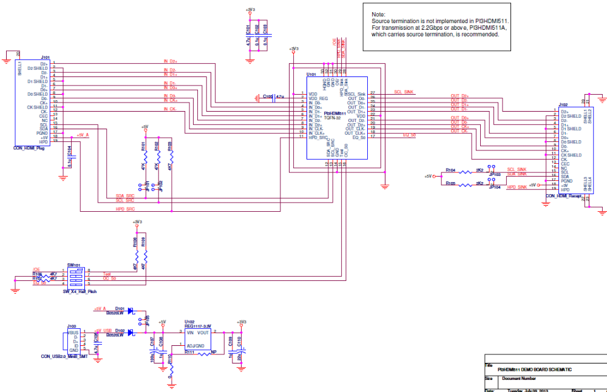
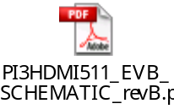For clearer view of schematic diagram, please click the PDF file icon on the right.

