PI3HDMI101
PI3HDMI101 HDMI-HDMI Demo Board Rev.B User Manual
by Ada Yip

Introduction
This user manual describes the components and the usage of PI3HDMI101 HDMI-HDMI Demo Board Rev.B. HDMI connectors are used as input and output connectors for the following HDMI-HDMI demo board version.

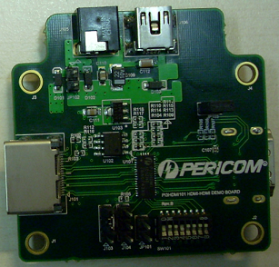

Figure 1a: Top View of PI3HDMI101 HDMI-HDMI Demo Board Rev.B

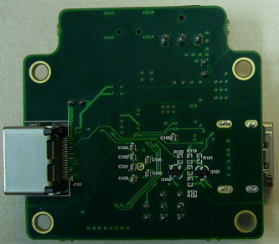

Figure 1b: Bottom View of PI3HDMI101 HDMI-HDMI Demo Board Rev.B
Key Components / Circuits
- 5V of PI3HDMI101 demo board can be supplied via three ways, i.e. using 5V supplied from Input Port, Power Jack, or from USB Type B Connector. Jumpers on demo boards are not connected at default. If using voltage of input port to power up the entire board, jumper must be added at JP102. JP103 is shorted so as to supply 5V to +5V pin at the output HDMI connector J102.

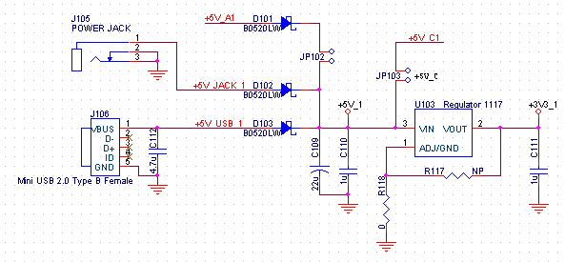

Figure 2: Schematic of 5V Power Supply of PI3HDMI101 HDMI-HDMI Demo Board Rev.B

- Assuming that a Source is connected to HDMI connector J101, after a Sink is attached to HDMI connector J102, Sink will signal the source it is connected by pulling HPD_C1 signal (HPD pin of J102) to high level. HPD_A1 signal (HPD pin of J101) will be pulled up by +5V supplied by Source in the circuit shown below.

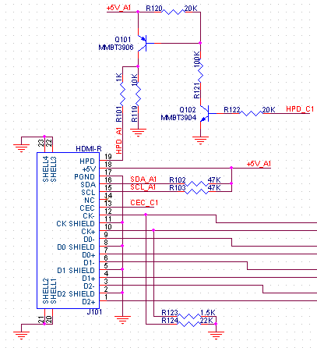

Figure 3: Schematic of Sink HPD of PI3HDMI101 HDMI-HDMI Demo Board Rev.B
- One AT24C02B EEPROM is implemented in PI3HDMI101 demo board to model I2C application. The EEPROM is for DDC line capacitance measurement purpose. Please refer to p.16 for measurement result. A0 and A1 address inputs of AT24C02B are pulled to low by external pull-down resistors while address A2 is pulled high. Write protection of the EEPROM is disabled.

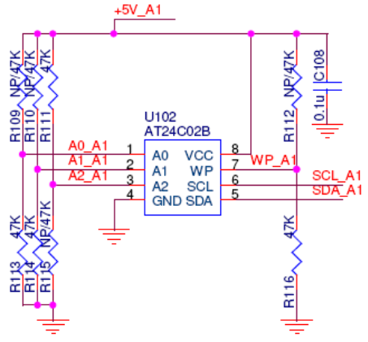

Figure 4: Schematic of EEPROM of PI3HDMI101 HDMI-HDMI Demo Board Rev.B

- Enable, /OE, pin is used to enable TMDS outputs. As this pin is enable low, jumper J104 in the schematic below is tied to low to enable outputs.

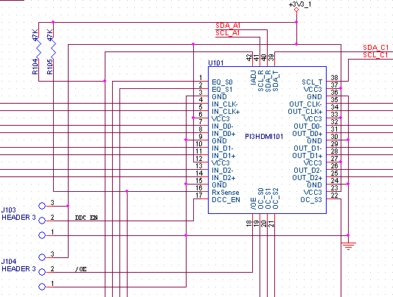

Figure 5: Enabling Circuit of PI3HDMI101 HDMI-HDMI Demo Board Rev.B

- To enable I2C path, DDC_EN pin 17 is tied to high. As shown in the schematic above, DDC_EN can be shorted to +3V3_1 using jumper J103.
- RxSense support is implemented in clock channels of PI3HDMI101.

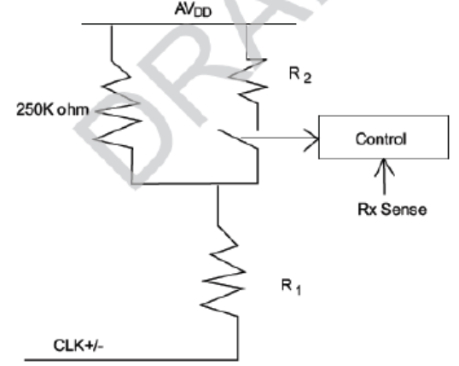

Figure 6: RxSense Scheme of PI3HDMI101

When RxSense is tied to low, the R2 switch above is open, clock channels are then terminated by 250kΩ. On the contrary, when RxSense is tied to high, R2 switch is closed to change clock termination to 50Ω. This feature can be controlled using RxSense pin 16 on PI3HDMI101. On HDMI-HDMI demo board, RxSense pin is pulled high by a resistor R105 at default. Switch SW101 can be used to pull RxSense to low.

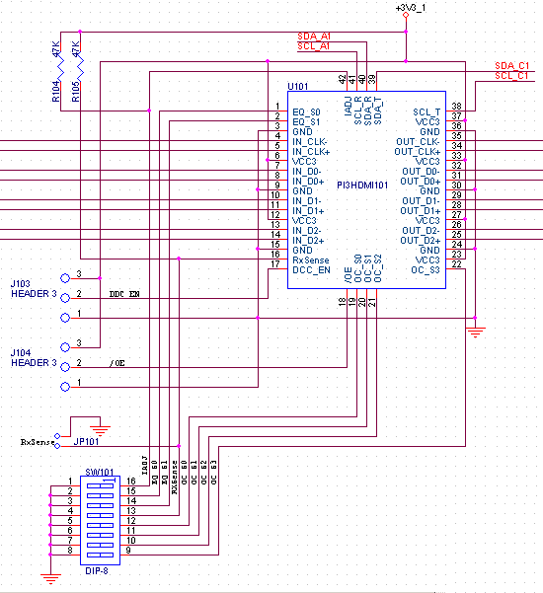

Figure 7: Schematic of RxSense/IADJ of PI3HDMI101 HDMI-HDMI Demo Board Rev.B
- Voltage selection using IADJ pin 42 for I2C buffer of PI3HDMI101 is chosen according to I2C external pull-up range at output connector J102. IADJ is set to high via a resistor R104 at default in the schematic above. Switch SW101 is used to change IADJ to low. IADJ should be set to high if external pull-up at output connector ranges from 1kΩ to 2kΩ or low if external pull-up is larger than 3kΩ. 2kΩ pull-ups are employed at R107 and 108 on PI3HDMI101 HDMI-HDMI demo board as shown below.

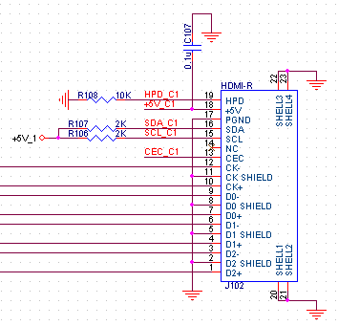

Figure 8: I2C External Pull-up of PI3HDMI101 HDMI-HDMI Demo Board Rev.B

- When source chipset does not generate CLK signal, noise may pass through an active PI3HDMI101 to cause output oscillation. To implement fail-safe feature to prevent from output oscillation, the input CLK is recommended to be biased externally. 100mV DC bias can be added to CLK+ by adding a 1.5kΩ pull-down resistor. To maintain trace impedance consistency, it is recommended to avoid stub between pull-down resistor pad and CLK signal trace on PCB layout.

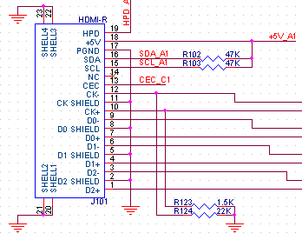

Figure 9: Input CLK External Pull-down of PI3HDMI101 HDMI-HDMI Demo Board Rev.B

In some DVD players, no sink current circuitry is implemented in TMDS. When these DVD players are de-selected, CLK signals stay at high level. To ensure the DVD players can enter idle mode when being de-selected, input CLK+/- pins are pulled down externally. By keeping 1.5kΩ pull-down resistor at CLK+ unchanged, another 22kΩ resistor is added to CLK- to pull CLK to low level when there is no 50Ω termination. HDCP can then be reset by RxSense when the port is being selected back.
Test Results
Few Source and Sink pre-test items are performed on PI3HDMI101 Demo Board Rev.A below. Source pre-test results with three output settings of swing and pre-/de-emphasis are tabulated. These three settings can generate passing eye diagrams with 1-meter cables connecting to both input and output connectors. All the eye diagrams of 15 different output settings are attached in section (d) below for reference.

- Source Test ID 7-4: TMDS – Rise Time or Fall Time at 3dB Equalization & 1920x1080i Resolution

OC_S[3:0] | Output | T_{RISE} | T_{FALL} | Min Spec | Units
0000 | CLK+/- | 114.39 | 115.97 | 75 | ps
0000 | D2+/- | 115.60 | 117.05 | 75 | ps
0001 | CLK+/- | 112.10 | 114.09 | 75 | ps
0001 | D2+/- | 122.73 | 151.04 | 75 | ps
0101 | CLK+/- | 104.83 | 106.47 | 75 | ps
0101 | D2+/- | 108.62 | 107.69 | 75 | ps

Table 1: Rise/Fall Times of TMDS at J102 when EQ=3dB and Resolution=1920x1080i

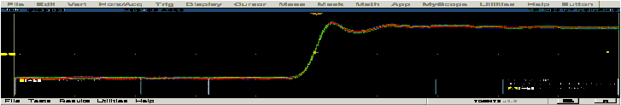

Figure 10a: T_{RISE} of CLK when OC_S[3:0]=0000, EQ=3dB and Resolution=1920x1080i

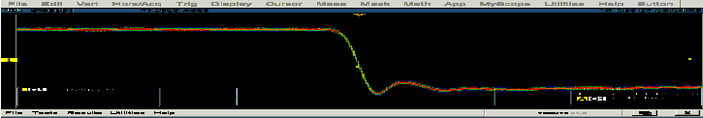

Figure 10b: T_{FALL} of CLK when OC_S[3:0]=0000, EQ=3dB and Resolution=1920x1080i

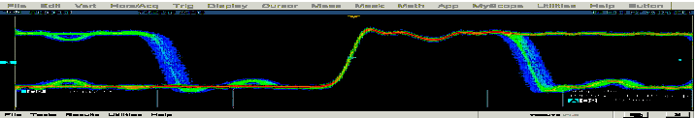

Figure 10c: T_{RISE} of D2 when OC_S[3:0]=0000, EQ=3dB and Resolution=1920x1080i

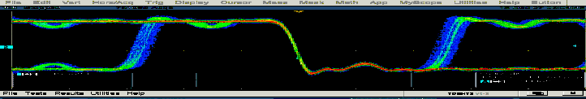

Figure 10d: T_{FALL} of D2 when OC_S[3:0]=0000, EQ=3dB and Resolution=1920x1080i

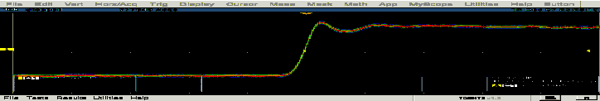

Figure 11a: T_{RISE} of CLK when OC_S[3:0]=0001, EQ=3dB and Resolution=1920x1080i

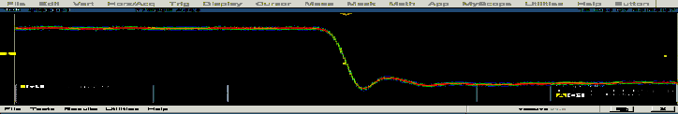

Figure 11b: T_{FALL} of CLK when OC_S[3:0]=0001, EQ=3dB and Resolution=1920x1080i

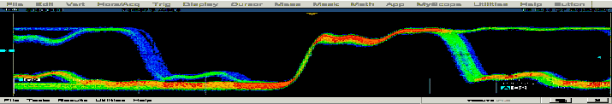

Figure 11c: T_{RISE} of D2 when OC_S[3:0]=0001, EQ=3dB and Resolution=1920x1080i

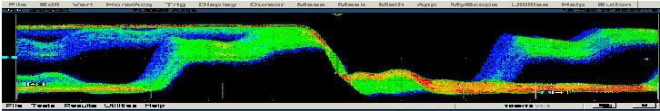

Figure 11d: T_{FALL} of D2 when OC_S[3:0]=0001, EQ=3dB and Resolution=1920x1080i

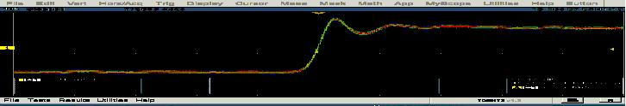

Figure 12a: T_{RISE} of CLK when OC_S[3:0]=0101, EQ=3dB and Resolution=1920x1080i

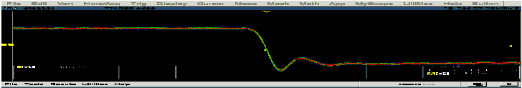

Figure 12b: T_{FALL} of CLK when OC_S[3:0]=0101, EQ=3dB and Resolution=1920x1080i

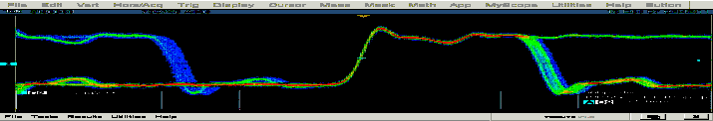

Figure 12c: T_{RISE} of D2 when OC_S[3:0]=0101, EQ=3dB and Resolution=1920x1080i

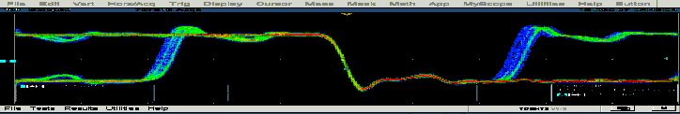

Figure 12d: T_{FALL} of D2 when OC_S[3:0]=0101, EQ=3dB and Resolution=1920x1080i
b. Source Test ID 7-8: TMDS – Clock Duty Cycle at 3dB Equalization & 1920x1080i Resolution

Output | Min Duty Cycle | Max Duty Cycle | Min Spec | Max Spec | Units
CLK+/- | 49.38 | 50.49 | 40 | 60 | %

Table 2: Clock Duty Cycle at J102 when EQ=3dB and Resolution=1920x1080i

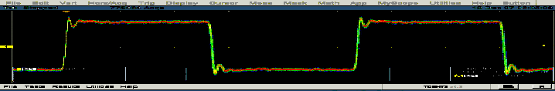

Figure 13a: Max Duty Cycle of CLK when OC_S[3:0]=0000, EQ=3dB and Resolution=1920x1080i

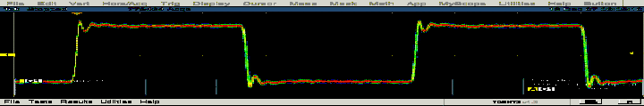

Figure 13b: Min Duty Cycle of CLK when OC_S[3:0]=0000, EQ=3dB and Resolution=1920x1080i

- Source Test ID 7-9: TMDS – Clock Jitter at 3dB Equalization & 1920x1080i Resolution

OC_S[3:0] | Output | Clock Jitter | Max Spec | Units
0000 | CLK+/- | 0.105 | 0.25 | T_{BIT}
0001 | CLK+/- | 0.083 | 0.25 | T_{BIT}
0101 | CLK+/- | 0.081 | 0.25 | T_{BIT}

Table 3: Clock Jitter at J102 when EQ=3dB and Resolution=1920x1080i

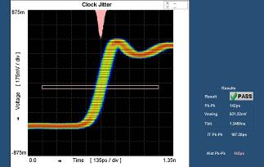
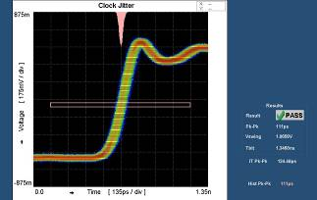

Figure 14: Clock Jitter of CLK when OC_S[3:0]=0000
Figure 15: Clock Jitter of CLK when OC_S[3:0]=0001

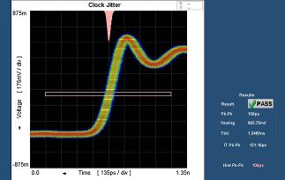

Figure 16: Clock Jitter of CLK when OC_S[3:0]=0101

Source Test ID 7-10: TMDS – Data Jitter & Eye Diagrams at 3dB Equalization & 1920x1080i Resolution

OC_S[3:0] | Output | Data Jitter | Max Spec | Units
0000 | D2+/- | 0.13 | 0.3 | T_{BIT}
0001 | D2+/- | 0.13 | 0.3 | T_{BIT}
0101 | D2+/- | 0.16 | 0.3 | T_{BIT}

Table 4: Data Jitter at J102 when EQ=3dB and Resolution=1920x1080i

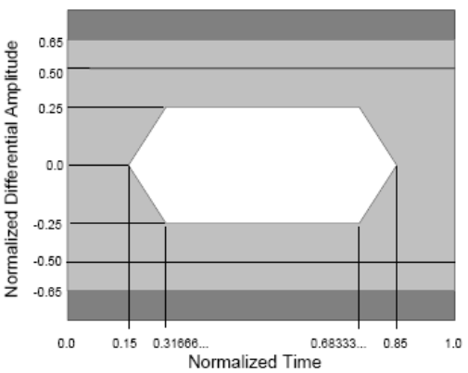
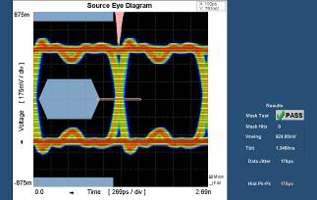

Figure 17: Source Eye Diagram

Figure 18: Eye Diagram of D2 when OC_S[3:0]=0000

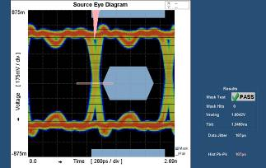
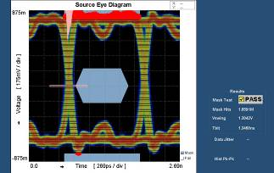

Figure 19: Eye Diagram of D2 when OC_S[3:0]=0001

Figure 20: Eye Diagram of D2 when OC_S[3:0]=0010

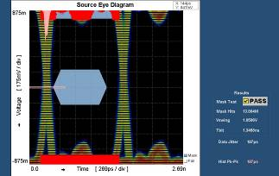
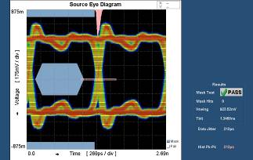

Figure 21: Eye Diagram of D2 when OC_S[3:0]=0011

Figure 22: Eye Diagram of D2 when OC_S[3:0]=0101

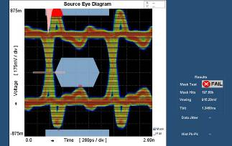
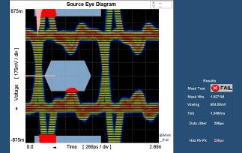

Figure 23: Eye Diagram of D2 when OC_S[3:0]=0110

Figure 24: Eye Diagram of D2 when OC_S[3:0]=0111

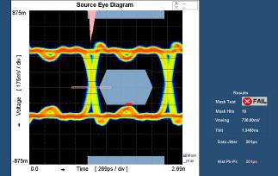
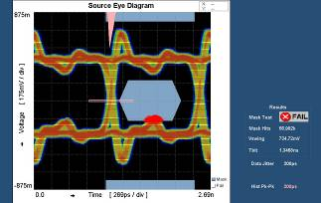

Figure 25: Eye Diagram of D2 when OC_S[3:0]=1000

Figure 26: Eye Diagram of D2 when OC_S[3:0]=1001

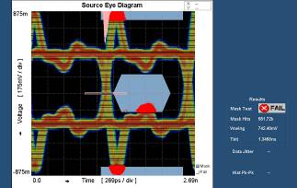
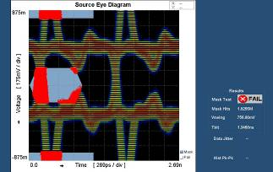

Figure 27: Eye Diagram of D2 when OC_S[3:0]=1010

Figure 28: Eye Diagram of D2 when OC_S[3:0]=1011

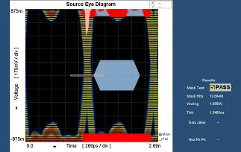
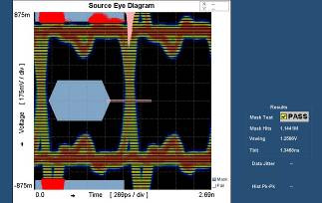

Figure 29: Eye Diagram of D2 when OC_S[3:0]=1100

Figure 30: Eye Diagram of D2 when OC_S[3:0]=1101

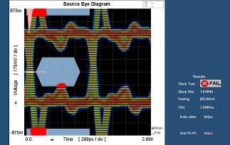

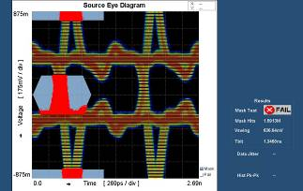

Figure 31: Eye Diagram of D2 when OC_S[3:0]=1110
Figure 32: Eye Diagram of D2 when OC_S[3:0]=1111

Sink Test ID 8-8: TDR Measurement

Differential impedance of PI3HDMI101 on an HDMI-HDMI demo board is measured to confirm the trace impedance is within the requirement described in Test ID 8-8 in HDMI Compliance Test Specification Version 1.3a.

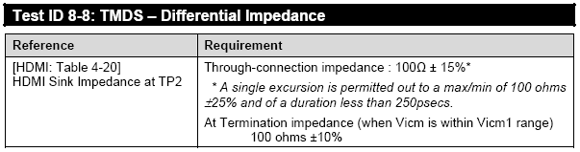

Table 5: HDMI Pre-test Test ID 8-8 Specification

CDF field Sink_Diff_PowerOn = N for each high speed signal input. At-termination impedance can be measured without powering up PI3HDMI101. The termination of each clock is switched from 50Ω to 250kΩ pull-up when PI3HDMI101 is not powered up. Thus, at-termination impedance cannot be obtained at clock signal.

Through impedance is measured at input side of the HDMI-HDMI demo board. Filter of 180ps is employed throughout the following measurement.
Sink_Term_Distance of CLK = 0.5ns

Through Impedance | D2 | D1 | D0 | CLK | Spec |  | Units
 |  |  |  |  | Min | Max | Units
Min | 95 | 90 | 91 | 94 | 85 | 115 | Ω
Max | 113 | 105 | 104 | 105 | 85 | 115 | Ω

Table 6: Through Impedance Result at Connector J101

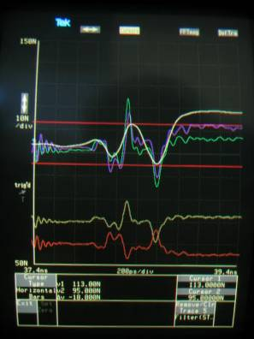
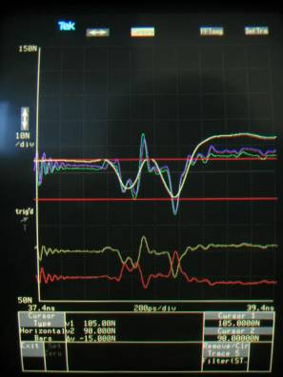

Figure 33a: Through Impedance at D2

Figure 33b: Through Impedance at D1

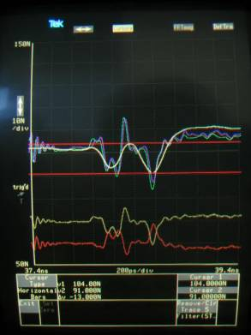
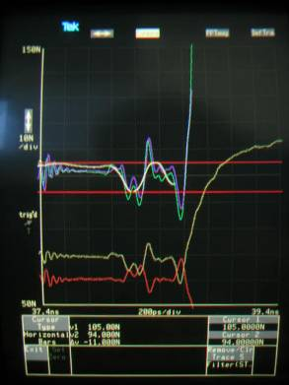

Figure 33c: Through Impedance at D0

Figure 33d: Through Impedance at CLK

Sink Test ID 8-9: DDC/CEC Line Capacitance Measurement

The capacitances of SDA and SCL signals which go through EEPROM AT24C02B are tested. The capacitance of CEC line connecting input to output HDMI is also measured. Results below show that the capacitances are within HDMI CTS V1.3a requirement.

C_{DUT} = C2 – C1
Setting of Impedance Analyzer for measuring capacitance:
For SDA/SCL, Freq=100kHz, DC Bias=2.5V, Power=15dBm (AC~1.8Vpp at DUT), IF BW=1kHz,
Sweep Time=1s
For CEC, Freq=100kHz, DC Bias=1.65V, Power=15dBm (AC~1.8Vpp at DUT), IF BW=1kHz,
Sweep Time=1s

Pin | Parameter | DUT Power |  | Spec |  | Units
Pin | Parameter | Off | On | Min | Max | Units
SDA | C1 | 7.2 | 7.2 | NA | NA | pF
SDA | C2 | 18.3 | 18.0 | NA | NA | pF
SDA | C_{DUT} | 11.1 | 10.8 |  | 50 | pF
SCL | C1 | 6.9 | 6.9 | NA | NA | pF
SCL | C2 | 16.9 | 16.7 | NA | NA | pF
SCL | C_{DUT} | 10.0 | 9.8 |  | 50 | pF
CEC | C1 | 7.1 | 7.1 | NA | NA | pF
CEC | C2 | 14.5 | 14.6 | NA | NA | pF
CEC | C_{DUT} | 7.4 | 7.5 |  | 200 | pF

Table 7: DDC/CEC Line Capacitance Result at Connector J101

Appendix A: Test Setup

Test setup:
- For Source Test
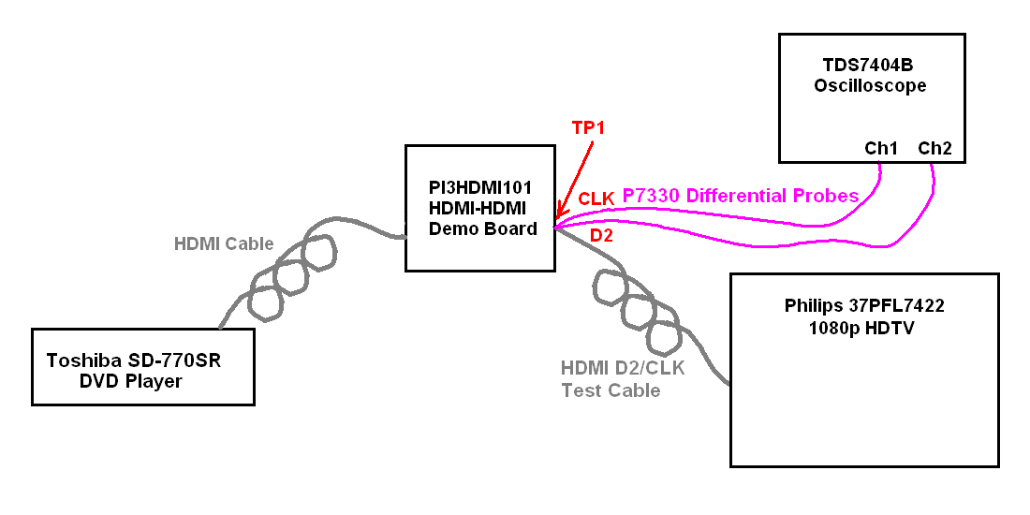

Equipment Use:
- For Source Test
  - TDS7404B Oscilloscope with P7330 Differential Probes
  - 1-meter HDMI Cable
  - 1-meter HDMI D2/CLK Test Cable
  - Toshiba SD-770SR DVD Player
  - Philips 37PFL7422 HDTV
  - Agilent Power Supply
  - 5V DC Adaptor

- For Sink Test
  - Tek11801C Digital Sampling Oscilloscope
  - Agilent 4395A Impedance Analyzer with 43961A and 16092A
  - SMA Matching Cables
  - PSC High BW TDR Test Fixture
  - PSC High BW Cap Test Fixture
  - Agilent Power Supply
  - 5V DC Adaptor

Appendix B: PCB Schematic

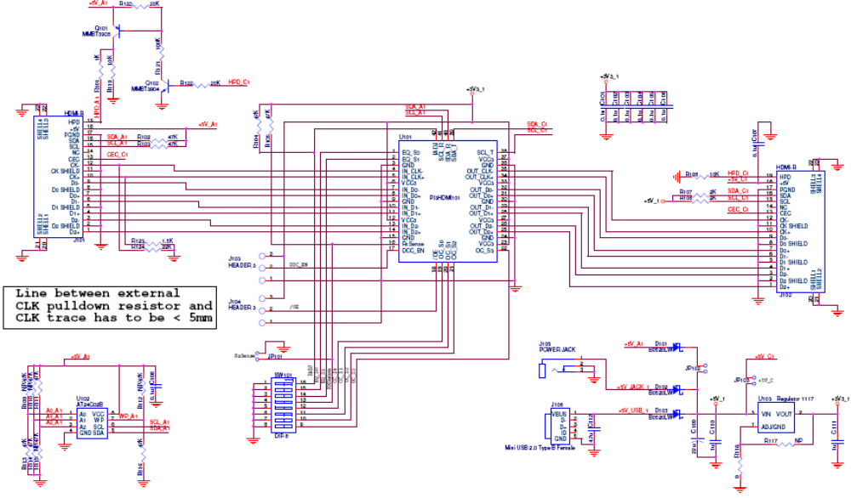

Appendix C: PCB Layout Requirements

- Stack Up:
Plane | Material | Thickness (mil)
Signal |  | 1.9
Prepreg | 1080 + 2116 | 7.3
Ground |  | 1.2
Core |  | 44
Power |  | 1.2
Prepreg | 1080 + 2116 | 7.3
Signal |  | 1.9

- Isolation Spacing = 30 mil

- Width & Spacing (W/S) of 100Ω Differential Trace = 9.0 / 10 mil
* W/S for 80 mils before and after contacting the TMDS input/output pads of PI3HDMI101 = 5.0 / 15 mil to compensate the impedance drop of PI3HDMI101 solder pads

Appendix D: BOM List

Item | Quantity | Reference | Description
1 | 8 | C101, C102, C103, C104, C105, C106, C107, C108 | 0.1uF Capacitor
2 | 1 | C109 | 22uF Capacitor
3 | 2 | C110, C111 | 1uF Capacitor
4 | 3 | D101, D102, D103 | B0520LW Schottky Rectifier
5 | 3 | JP101, JP102, JP103 | 2-pin Header
6 | 2 | J101, J102 | HDMI Receptacle Connector
7 | 2 | J103, J104 | 3-pin Header
8 | 1 | J105 | Power Jack
9 | 1 | J106 | Mini USB Type B Connector
10 | 1 | Q101 | MMBT3906 PNP Transistor
11 | 1 | Q102 | MMBT3904 NPN Transistor
12 | 5 | R109, R110, R112, R115, R117 | NOT AVAILABLE
13 | 9 | R101, R102, R103, R104, R105, R111, R113, R114, R116 | 47kΩ Resistor
14 | 2 | R108, R119 | 10kΩ Resistor
15 | 2 | R106, R107 | 2kΩ Resistor
16 | 1 | R118 | 0Ω Resistor
17 | 2 | R120, R122 | 20kΩ Resistor
18 | 1 | R121 | 100kΩ Resistor
19 | 1 | R123 | 1.5kΩ Resistor
20 | 1 | R124 | 22 kΩ Resistor
21 | 1 | SW101 | DIP-8 Switch
22 | 1 | U101 | PI3HDMI101 HDMI Switch
23 | 1 | U102 | AT24C02B EEPROM
24 | 1 | U103 | 1117 Regulator

