PI3EQXDP1201
Demo Board Rev.A User Manual
by Ada Yip

Table of Contents

1 Introduction 2
2 Overview 2
3 Quick Start 4
4 Circuit Description 5
4.1 Single or Dual Power Supply Option 5
4.2 Control Pin Settings 5
4.3 External SCL_CTL and SDA_CTL Pull-ups 5
5 Equalization, Swing and Pre-emphasis Settings 6
5.1 Equalization Setting via Pin Control 6
5.2 Swing and Pre-emphasis Settings via Pin Control 7
5.3 Equalization Setting via SMBus Control 7
5.4 Swing and Pre-emphasis Settings via SMBus Control 9
6 Relative References 10
7 Appendix A: Demo Board Schematic 10

Introduction

PI3EQXDP1201 DisplayPort 1.2 re-driver is designed for source application. PI3EQXDP1201 is DisplayPort 1.1a and 1.2 standard compliant. It supports dual-mode displayPort inputs as well as outputs. This user manual describes the components and the usage of PI3EQXDP1201 demo board rev.A.

Overview

Figure 1 is the block diagram of Pericom PI3EQXDP1201 demo board rev.A and figures 2 and 3 show the top and bottom views of the demo board rev.A. One DP plug connector (J1) on PI3EQXDP1201 demo board rev.A is used for plugging a source device, such as a motherboard. A DP cable can be connected between a DP receptacle connector (J2) on the demo board rev.A and a sink device, such as a DP monitor. VDD_3.3V for the entire demo board rev.A is supplied from the DP source through pin 20 of the DP plug connector. VDD_1.5V will be provided through a regulator (U2) for PI3EQXDP1201 on the demo board rev.A if dual power supply is chosen. Swing, pre-emphasis and equalization can be controlled via pins or SMBus. External pull-ups on SCL_CTL and SDA_CTL pins of PI3EQXDP1201 are required before enabling SMBus for EQ setting.

DP Input Connector
PI3EQXDP1201
J2
1.5V Regulator
Input Port
U2
SW1
Switches
J1
Output Port
U1
VDD_3.3V
VDD_1.5V
(for Dual Power Supply mode)
SW2
DP Output Connector

Figure 1: Block Diagram of PI3EQXDP1201 Demo Board Rev.A

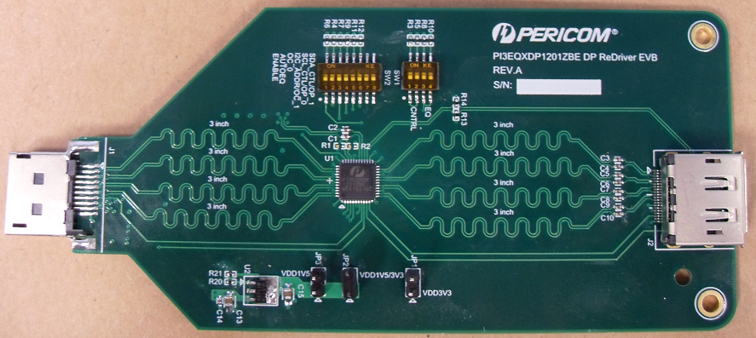

Figure 2: Top View of PI3EQXDP1201 Demo Board Rev.A
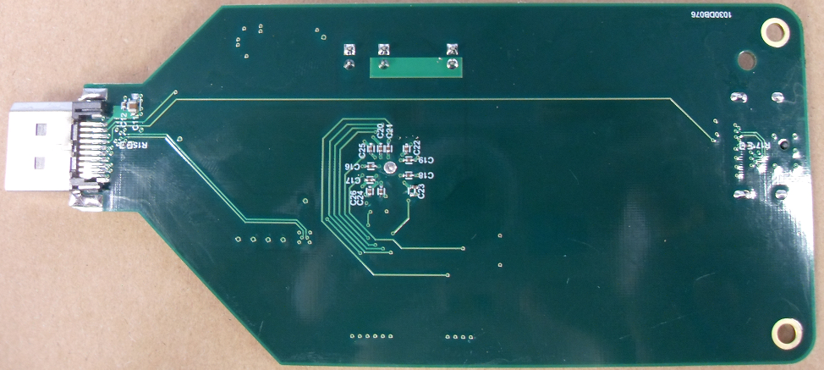

Figure 3: Bottom View of PI3EQXDP1201 Demo Board Rev.A

Quick Start

To start-up the PI3EQXDP1201 demo board rev.A, complete the following steps:
- Short header pin JP1 to set PI3EQXDP1201 to single 3.3V power supply condition;
- Leave header pins JP2 and JP3 open for single 3.3V power supply condition;
- Open all the switches on SW1 and SW2 to enable Auto EQ mode 1 and to follow DPCD register settings;
- Connect a source device, e.g. a motherboard, to DP input connectors at J1;
- Connect a sink device, e.g. DP monitor, to DP output connector at J2.

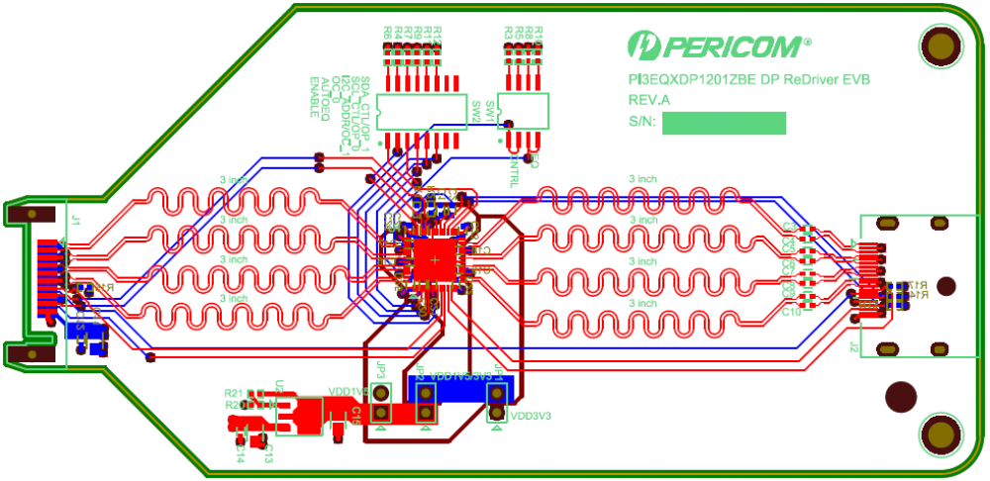

Figure 4: Layout of PI3EQXDP1201 Demo Board Rev.A

Circuit Description

Single or Dual Power Supply Option

PI3EQXDP1201 offers two configurations of power supply mode. For convenience, 3.3V single power supply can be selected. For power saving, 3.3/1.5V dual power supply mode is more preferable. On PI3EQXDP1201 demo board rev.A, header pins are used to select connecting 3.3V or 1.5V power plane to VCORE pins. To select 3.3V single power supply, short pins 1 and 2 of header JP1 on the demo board rev.A. Conversely, to select dual 3.3/1.5V power supply mode, short pins 1 and 2 of both headers JP2 and JP3.

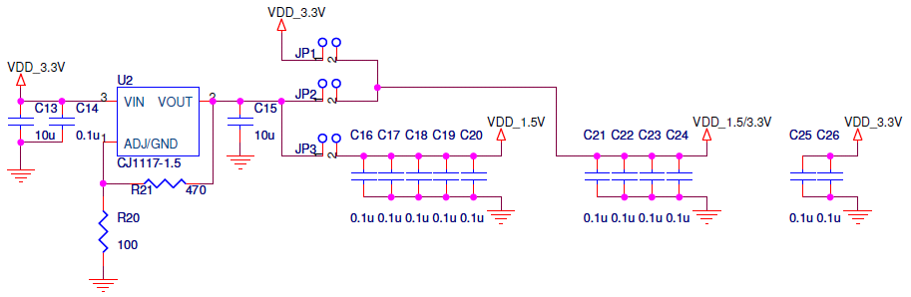

Figure 5: Single/Dual Power Supply Configuration of PIEQXDP1201 Demo Board Rev.A

Control Pin Settings

Two switches on demo board rev.A, namely SW1 and SW2, are used to set CNTRL, EQ, ENABLE, Auto-EQ, OC_0, I2CD_ADDR/OC_1, SCL_CTL/OP_0 and SDA_CTL/OP_1 control pins. As all the pins have internal pull-up resistors, external pull-down resistors are designed on the demo board rev.A.

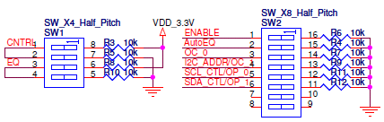

Figure 6: Control Pin Settings of PIEQXDP1201 Demo Board Rev.A

External SCL_CTL and SDA_CTL Pull-ups

When SMBus register is enabled, pins 4 and 5 of PI3EQXDP1201 are used as SCL_CTL and SDA_CTL for SMBus transaction. As internal pull-up resistors of these two pins are weak, stronger external pull-ups should be added for SMBus controller to read/write PI3EQXDP1201 properly.

Equalization, Swing and Pre-emphasis Settings

Equalization, swing and pre-emphasis of PI3EQXDP1201 can be controlled via pins or SMBus.

Equalization Setting via Pin Control

PI3EQXDP1201 offers flexible equalization setting. Three Auto EQ Modes and three Fixed EQ Modes can be selected.

EQ  (Pin 40) | Auto-EQ  (Pin 35) | Equalization Mode | Pre-emphasis Set (DPCD 00103-6h) | EQ Value
 |  |  |  | 1.62Gbps | 2.7Gbps | 5.4Gbps
L | H | Auto EQ Mode 1 | 0 0 | 2.26 | 2.74 | 2.49
L | H | Auto EQ Mode 1 | 0 1 | 0.34 | 0.57 | 0.22
L | H | Auto EQ Mode 1 | 1 0 | -1.42 | -2.01 | -2.79
L | H | Auto EQ Mode 1 | 1 1 | -2.39 | -3.62 | 4.71
M | H | Auto EQ Mode 2 | 0 0 | 3.97 | 5.92 | 7.30
M | H | Auto EQ Mode 2 | 0 1 | 1.44 | 2.50 | 3.41
M | H | Auto EQ Mode 2 | 1 0 | 0.34 | 0.57 | 0.22
M | H | Auto EQ Mode 2 | 1 1 | -1.42 | -2.01 | -2.79
H | H | Auto EQ Mode 3 | 0 0 | 3.97 | 7.27 | 8.69
H | H | Auto EQ Mode 3 | 0 1 | 3.21 | 5.10 | 6.42
H | H | Auto EQ Mode 3 | 1 0 | 1.44 | 2.50 | 3.41
H | H | Auto EQ Mode 3 | 1 1 | 0.34 | 0.57 | 0.22
L | L | Fixed EQ L | X X | -1.42 | -2.01 | -2.79
M | L | Fixed EQ M | X X | 2.41 | 3.90 | 5.16
H | L | Fixed EQ H | X X | 6.96 | 9.28 | 10.8

Table 1: EQ Setting of PI3EQXDP1201 Demo Board Rev.A

Swing and Pre-emphasis Settings via Pin Control

Swing and pre-emphasis settings of PI3EQXDP1201 are designated to use DPCD register setting or to override the register setting.

CNTRL  (Pin 7) | CAD_SNK  (Pin 10) | OC_[1:0]  (Pins 3,46) | OP_[1:0]  (Pins 5,4) | SMBus  Byte1 bit1 | Output Swing | Pre-emphasis | Aux Listener
M | 0 | 1 X | X X | X | Follow listener | Follow listener | ON, use DPCD register setting
M | 0 | 0 0 | X X | X | 800 mV | 0 dB | OFF, OC/OP override register setting
M | 0 | 0 1 | X X | X | 600 mV | 3.5 dB | OFF, OC/OP override register setting
M | 1 | X X | X X | X | 800 mV | 0 dB | OFF, default override register setting
L | 0 | X X | X X | 0 | Follow listener | Follow listener | ON, use DPCD register setting
L | 0 | X X | X X | 1 | Register Setting | Register Setting | OFF, use SMBus register setting
L | 1 | X X | X X | X | 800 mV | 0 dB | OFF, default override register setting
H | X | 0 0 | 0 0 | 0 | 400 mV | 0 dB | OFF, OC/OP override register setting
H | X | 0 1 | 0 1 | 0 | 600 mV | 3.5 dB | OFF, OC/OP override register setting
H | X | 1 0 | 1 0 | 0 | 1200 mV | 9 dB | OFF, OC/OP override register setting
H | X | 1 1 | 1 1 | 0 | 800 mV | 0 dB | OFF, OC/OP override register setting
Note: “M” means V3p3/2 voltage level.
Table 2: OC and OP Settings of PI3EQXDP1201 Demo Board Rev.A

Equalization Setting via SMBus Control

On top of pin control, SMBus can be used to set link bandwidth, lane count, equalization, swing and pre-emphasis, etc, of PI3EQXDP1201. Upon using SMBus, user must set byte17 bit1 of SMBus register to 1. I2C_ADDR pin 3 of PI3EQXDP1201 is used to select particular I2C address, i.e. 0xA8 if I2C_ADDR is set to low or 0xAA if I2C_ADDR is set to high.

SMBus Address | R/W | Data Bytes
A8 or AA | W | 11, 00, 01

Table 3: Enabling SMBus of PI3EQXDP1201 Demo Board Rev.A
The three data bytes above represent:
- 0x11 represents SMBus register byte 17 in hex;
- 0x00 is the offset;
- 0x01 sets Byte17 bit1 to 1 to enable SMBus mode.

After enabling SMBus mode, equalization setting of PI3EQXDP1201 can be selected through SMBus register Byte 0 bit[3:0].

SMBus  Byte 0 bit[7:4] | EQ Value
SMBus  Byte 0 bit[7:4] | 1.62G | 2.7G | 5.4G
0000 | 0.47 dB | 0.89 dB | 1.49 dB
0001 | -2.39 dB | -3.62 dB | -4.71 dB
0010 | 0.78 dB | 1.34 dB | 1.95 dB
0011 | -2.08 dB | -3.17 dB | -4.25 dB
0100 | 1.44 dB | 2.50 dB | 3.41 dB
0101 | -1.42 dB | -2.01 dB | -2.79 dB
0110 | 2.41 dB | 3.90 dB | 5.16 dB
0111 | -0.45 dB | -0.58 dB | -1.03 dB
1000 | 3.21 dB | 5.10 dB | 6.42 dB
1001 | 0.34 dB | 0.57 dB | 0.22 dB
1010 | 3.97 dB | 5.92 dB | 7.30 dB
1011 | 1.10 dB | 1.39 dB | 1.09 dB
1100 | 4.55 dB | 7.27 dB | 8.69 dB
1101 | 2.26 dB | 2.74 dB | 2.49 dB
1110 | 6.96 dB | 9.28 dB | 10.8 dB
1111 | 4.00 dB | 4.76 dB | 4.64 dB

Table 4: SMBus EQ Setting of PI3EQXDP1201 Demo Board Rev.A
Default value of SMBus register 0x00 is 0x06 where bit[3:0] are reserved and cannot be changed. If setting the equalization value to the highlighted set above, 0x76 will be written to register 0x00.

SMBus Address | R/W | Data Bytes
A8 or AA | W | 00, 00, 76

Table 5: Equalization Setting of PI3EQXDP1201 via SMBus

Swing and Pre-emphasis Settings via SMBus Control

After enabling SMBus control as mentioned in the previous section, swing and pre-emphasis settings of PI3EQXDP1201 can also be selected through SMBus register 0x04 to 0x07, which are the same as DPCD registers 00103-6h. Bytes 4, 5, 6 and 7 are the registers for lane settings for lanes 0, 1, 2 and 3, respectively.

SMBus  Byte 4-7 bit[1:0] | Drive Current Level | Swing
0 0 | Level 1 | 400 mV
0 1 | Level 2 | 600 mV
1 0 | Level 3 | 800 mV
1 1 | Level 4 | 1200 mV

Table 6: SMBus Swing Setting of PI3EQXDP1201 Demo Board Rev.A

SMBus  Byte 4-7 bit[4:3] | Pre-emphasis Level | Swing
0 0 | No Pre-emphasis | 0 dB
0 1 | Level 1 | 3.5 dB
1 0 | Level 2 | 6 dB
1 1 | Level 3 | 9 dB

Table 7: SMBus Pre-emphasis Setting of PI3EQXDP1201 Demo Board Rev.A
The default value of SMBus registers 0x04 to 0x07 is 0x00. If setting the swing and pre-emphasis values to the highlighted sets above for all four lanes, 0x18 will be written to these registers. Below is an example to set equalization, swing and pre-emphasis via SMBus control.

SMBus Address | R/W | Data Bytes
A8 or AA | W | 04, 00, 18, 18, 18, 18

Table 8: Swing and Pre-emphasis Settings of PI3EQXDP1201 via SMBus

Link Bandwidth and Lane Count Settings

Link bandwidth and lane count of PI3EQXDP1201 can be controlled via DPCD register or SMBus register.

Link Bandwidth and Lane Count via DPCD Register

In normal operation mode, Link Bandwidth and Lane Count follow DPCD register. They will be updated after link training.

Link Bandwidth via SMBus Control

Link bandwidth can be set via SMBus register 0x02 of PI3EQXDP1201. Default value is 5.4Gbps per lane. If setting the link bandwidth to 1.62Gbps for all four lanes, 0x06 will be written to byte 2. Below is the example.

SMBus Address | R/W | Data Bytes
A8 or AA | W | 02, 00, 06

Table 9: Link Bandwidth Setting of PI3EQXDP1201 via SMBus

Lane Count via SMBus Control

A special write operation is required when changing Lane Count via SMBus register 0x03 of PI3EQXDP1201. Default value is 4 lanes. If setting the lane count to 1, 0x01 will be written to byte 3. To update this write operation, register 0x12 has to be read. Below is the example where 0x14 is a dummy value read from register 0x12.

SMBus Address | R/W | Data Bytes
A8 or AA | W | 03, 00, 01
A8 or AA | W | 12
A8 or AA | R | 14

Table 10: Lane Count Setting of PI3EQXDP1201 via SMBus

Relative References

- VESA DisplayPort Standard Version 1 Revision 2a, Errata Version 1, Video Electronics Standards Association, February 2014
- VESA DisplayPort Link Layer Compliance Test Specification, Version 1.2 Core Revision 1.1, Video Electronics Standards Association, December 8, 2012
- VESA DisplayPort Dual-Mode Standard Version 1.1, Video Electronics Standards Association, February 8, 2013
- VESA DisplayPort Interoperability Guideline Version 1.1a, Video Electronics Standards Association, February 5, 2009

Appendix A: Demo Board Schematic

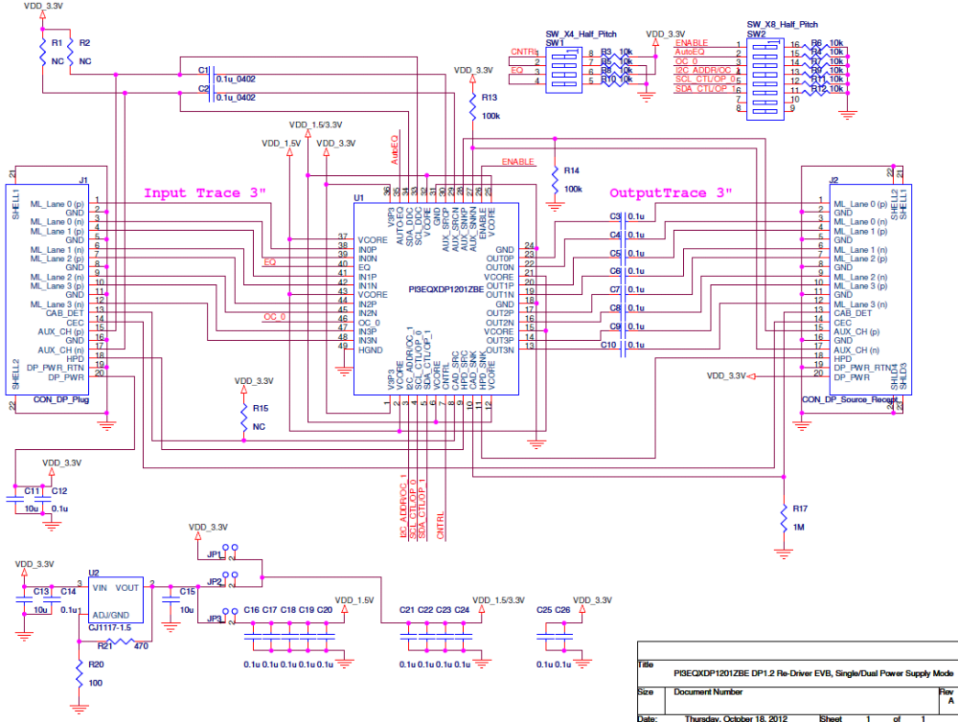
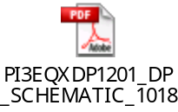For clearer view of schematic diagram, please click the PDF file icon on the right.

