PI3PCIE3413/PI2EQX59xx/PI3EQX58xx/PI2EQX88xx
PCIE switch/re-driver debug App Note
By YT Tso and Jessy Chen
- Introduce:
Use simple way to check PCIE function is work or not.
For PI3PCIE3413, PI2EQX59xx, PI3EQX58xx, PI2EQX88xx debug purpose.

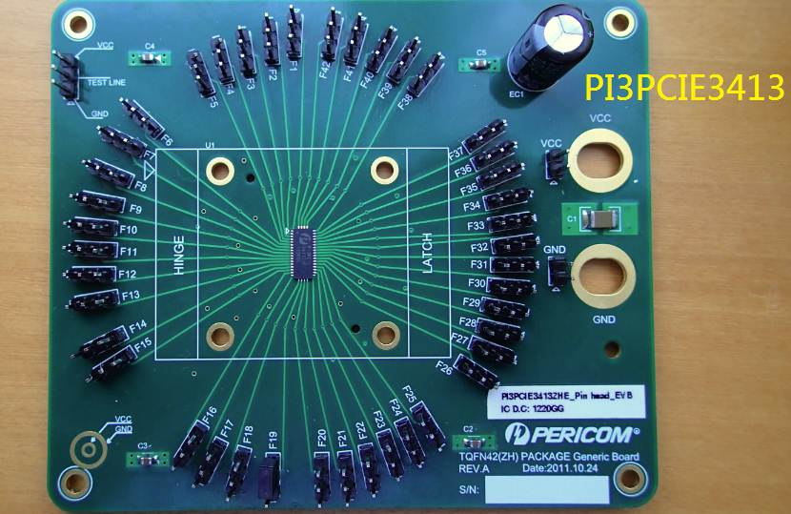
Figure 1 top view of PI3PCIE3413 EVB

- Check PCIE function workable: RX.detect
Please check the PCIE function as below block diagram
Step1. Remove red one block as below
Step2. Measurement the place at TP1

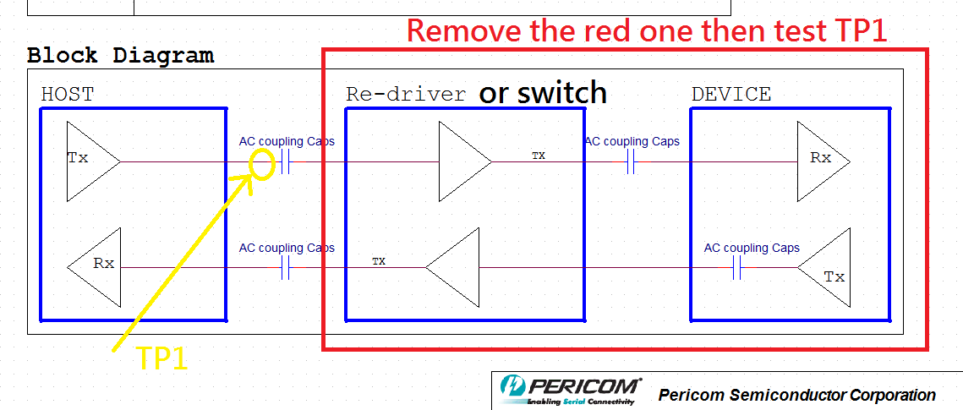

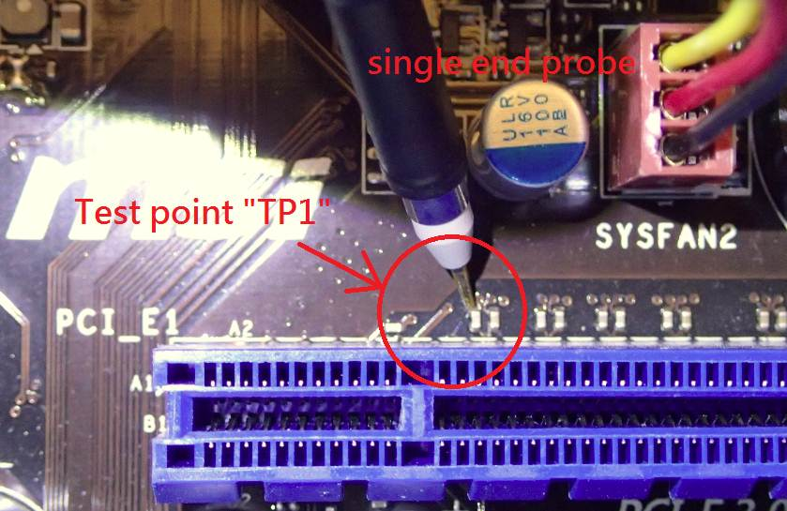
TP1 Test result
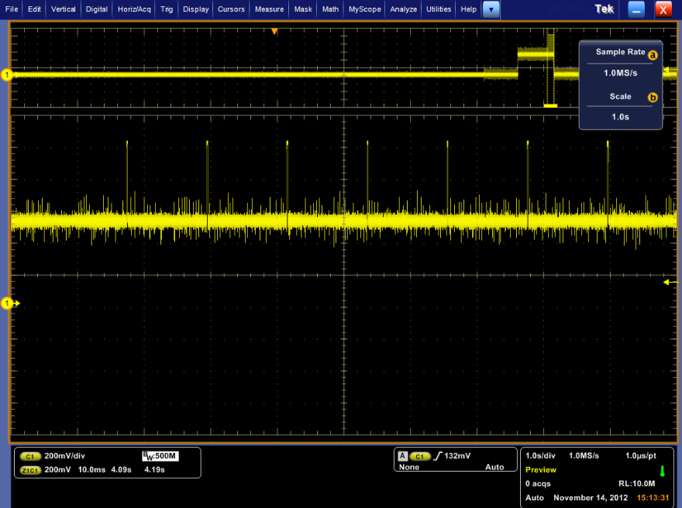
TP1: Detect Pulse

Detect Pulse
Detect Pulse Zoom In
Zoom in
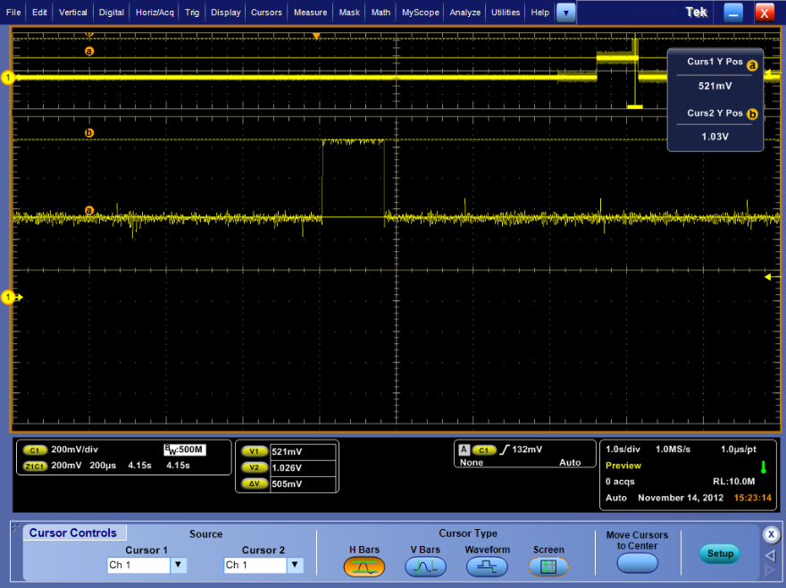
TP1: Detect Pulse Zoom In

~160us
~505mV

- Check PCIE function workable: With AC cap / Without AC cap different
Please check the PCIE function as below block diagram after power on
Step1. Test TP2
Step2. Test TP3
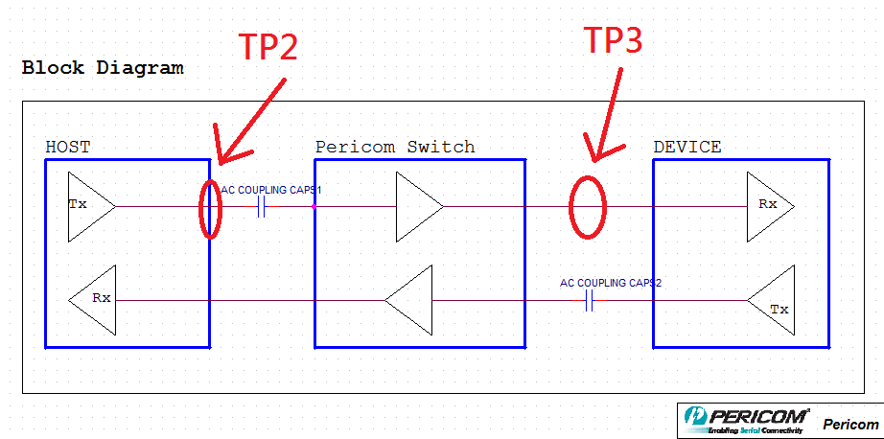
TP2
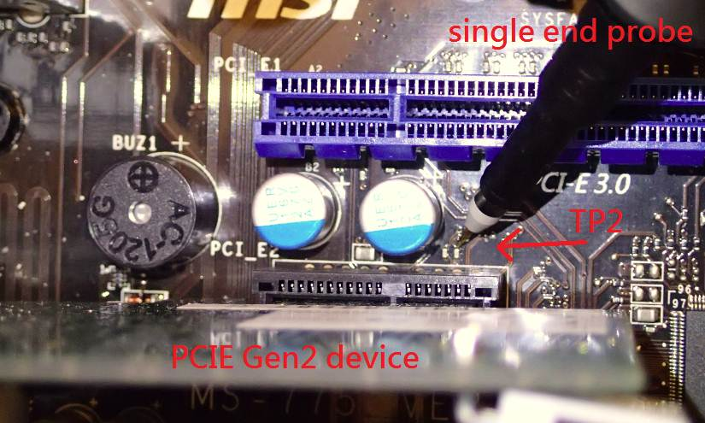
TP2 Test result
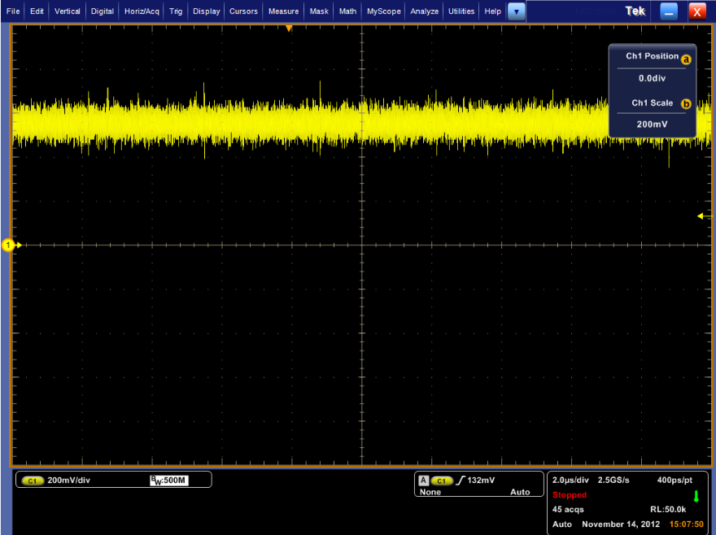
TP2: Before AC cap
DC BIAS
PCIe Gen2 : 5Gbps

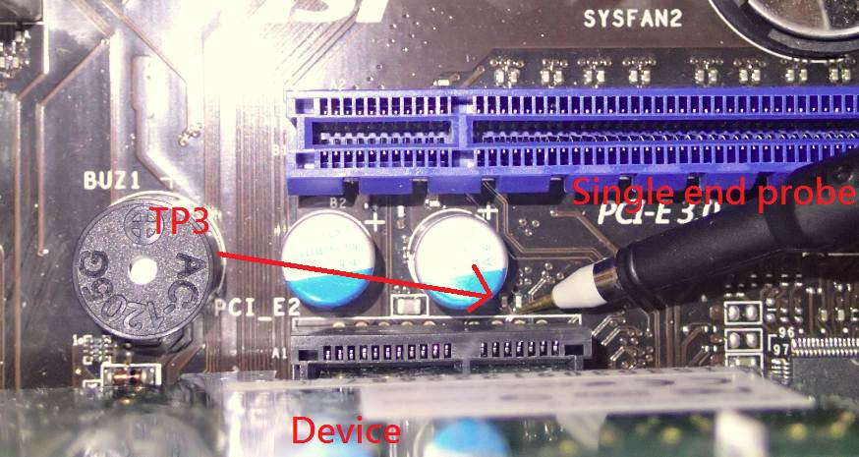

TP3 Test result
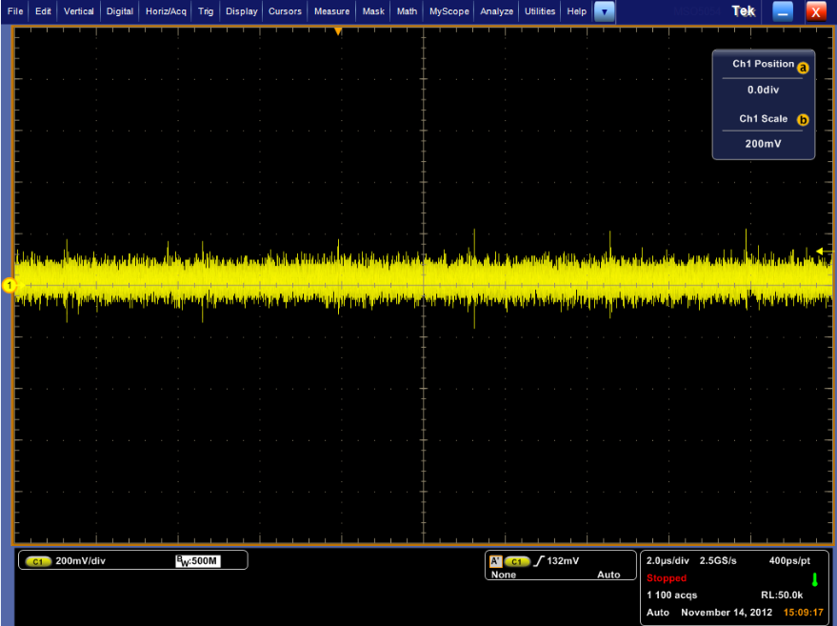
TP3: After AC cap
PCIe Gen2 : 5Gbps
Vcm = 0V

- Check PCIE function workable: From Rx.detect →polling→L0
Please check the PCIE function as below block diagram after power on
Step1. Test TP2 when power on

TP2 Test result
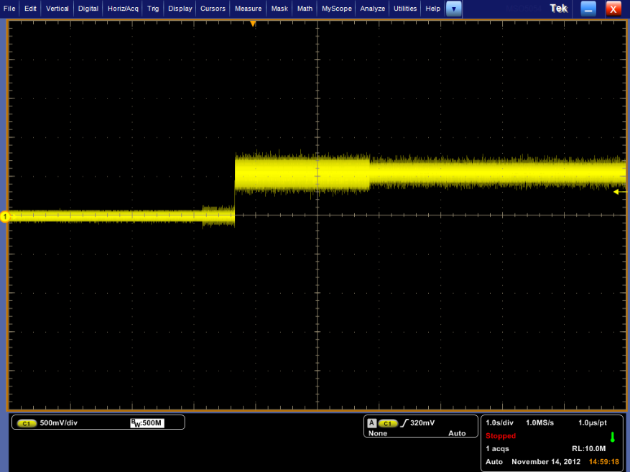
RX.detect
Power on
Gen1 Speed:
2.5Gbps
Polling
L0: Gen2 5.0Gbps
TP2: Before AC

- Check PCIE re-driver link status: Throw h/w or s/w register
Please check the PCIE function as below block diagram after power on



