PI3EQX16904GL_TTT_FG_EQ_RevA S-parameter Simulation

Introduction:
To verify the 4 ports S-parameter model of linear redriver PI3EQX16904GL which we provided to customer, we did AC simulation, transient and step response simulation with 24inch input trace。

put 24inch input trace:
PI3EQX16904GL
24inch trace
Trace_in
Output
We put 24 inch trace on the receiver side of PI3EQX16904GL, choose different 4port EQ s parameters to compensate the trace loss and get the eye-diagram at output.

Conclusion:
The S-parameter is extracted from the linear redriver, it is not bi-directional, only s(4,1) s(4,2) and s(3,1) s(3,2) should be the insertion loss

Port definition:
Port1 = input +
Port2 = input –
Port3 = output+
Port4 = output-

Customer can use below syntax to call the 4port s parameter:
.model smodeleq s n=4 tstonefile='./FGL_EQL.s4p'
spa inp inn outp outn mname=smodeleq

AC Characteristics by different EQ settings
- FG = 0

FG=0 | Differential Insertion Loss
EQ=0~7  SW=1000mV | 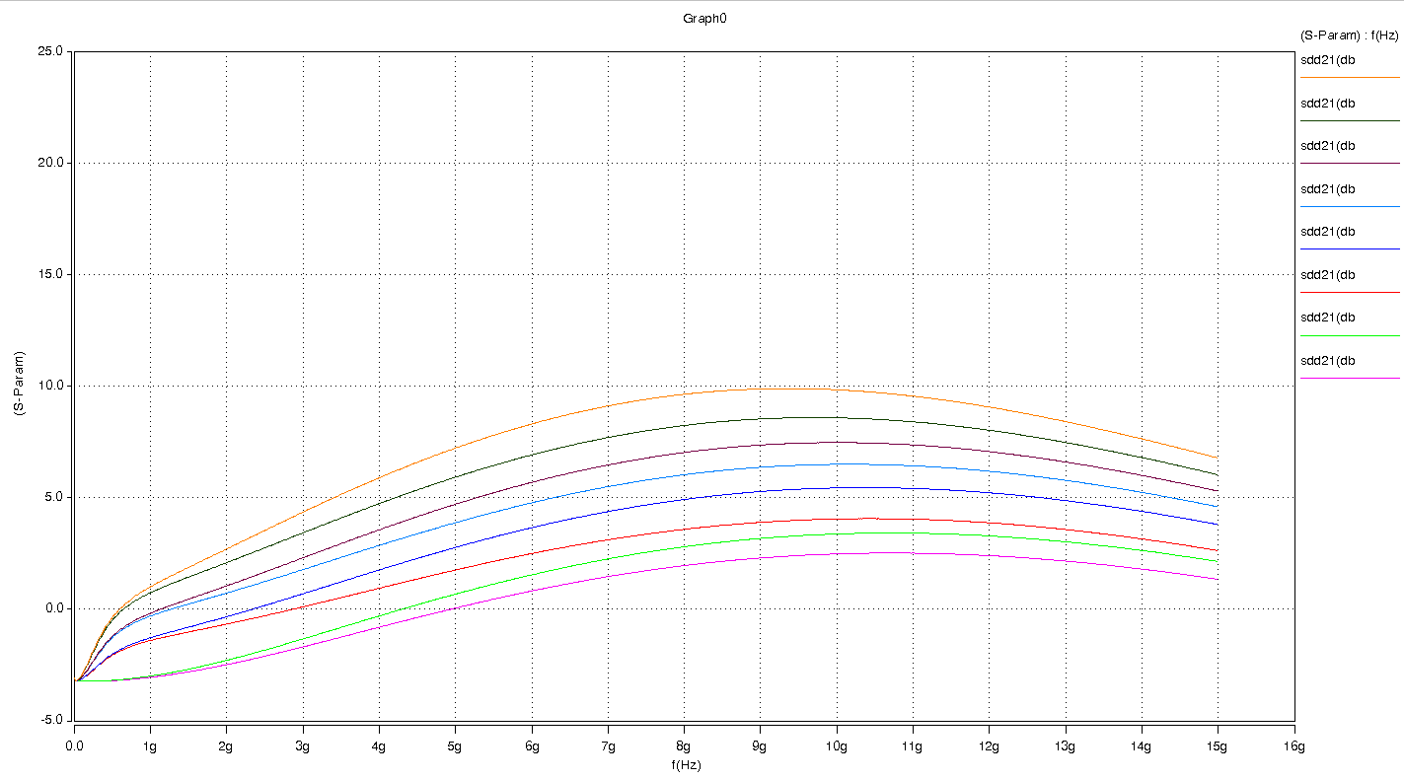

- EQ value table:
4 ports S-parameter differential insertion loss @ 100meg, 2GHz, 4GHz, 6GHz, 8GHz and 10GHz (unit: dB)

Model result:
EQ | 100MEG | 2G | 4G | 6G | 8G | 10G
0 | -3.22 | -2.48 | -0.80 | 0.83 | 1.96 | 2.49
1 | -3.22 | -2.28 | -0.29 | 1.55 | 2.81 | 3.38
2 | -3.12 | -0.66 | 0.95 | 2.50 | 3.59 | 4.05
3 | -3.11 | -0.33 | 1.77 | 3.66 | 4.93 | 5.44
4 | -3.03 | 0.73 | 2.87 | 4.78 | 6.03 | 6.50
5 | -3.03 | 1.06 | 3.57 | 5.69 | 7.03 | 7.47
6 | -2.93 | 2.10 | 4.74 | 6.93 | 8.24 | 8.58
7 | -2.92 | 2.71 | 5.90 | 8.31 | 9.64 | 9.84

Measurement result :

COMMENTS: Only measurement GAIN curves are provided which has good match with the simulation results .(mismatch is less than -0.5 dB in comparison between curve values )

- FG = 1

FG=1 | Differential Insertion Loss
EQ=0~7  SW=1000mV | 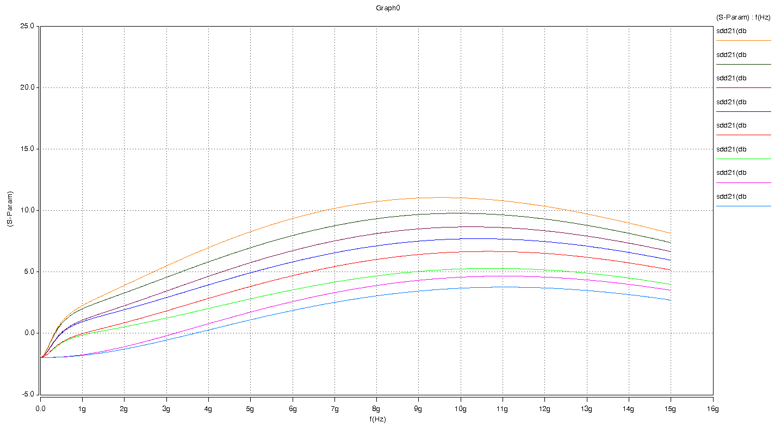

- EQ value table:
4 ports S-parameter differential insertion loss @ 100meg, 2GHz, 4GHz, 6GHz, 8GHz and 10GHz (unit: dB)

Model result:
EQ | 100MEG | 2G | 4G | 6G | 8G | 10G
0 | -1.95 | -1.28 | 0.28 | 1.87 | 3.05 | 3.68
1 | -1.95 | -1.08 | 0.79 | 2.59 | 3.90 | 4.57
2 | -1.85 | 0.54 | 2.03 | 3.54 | 4.68 | 5.24
3 | -1.84 | 0.87 | 2.85 | 4.70 | 6.02 | 6.63
4 | -1.76 | 1.93 | 3.95 | 5.82 | 7.13 | 7.69
5 | -1.76 | 2.25 | 4.65 | 6.73 | 8.12 | 8.67
6 | -1.66 | 3.30 | 5.82 | 7.97 | 9.33 | 9.77
7 | -1.65 | 3.91 | 6.98 | 9.35 | 10.73 | 11.03

Measurement result :

COMMENTS: Only measurement GAIN curves are provided which has good match with the simulation results .(mismatch is less than -0.5 dB in comparison between curve values )

- FG = 2

FG=2 | Differential Insertion Loss
EQ=0~7  SW=1000mV | 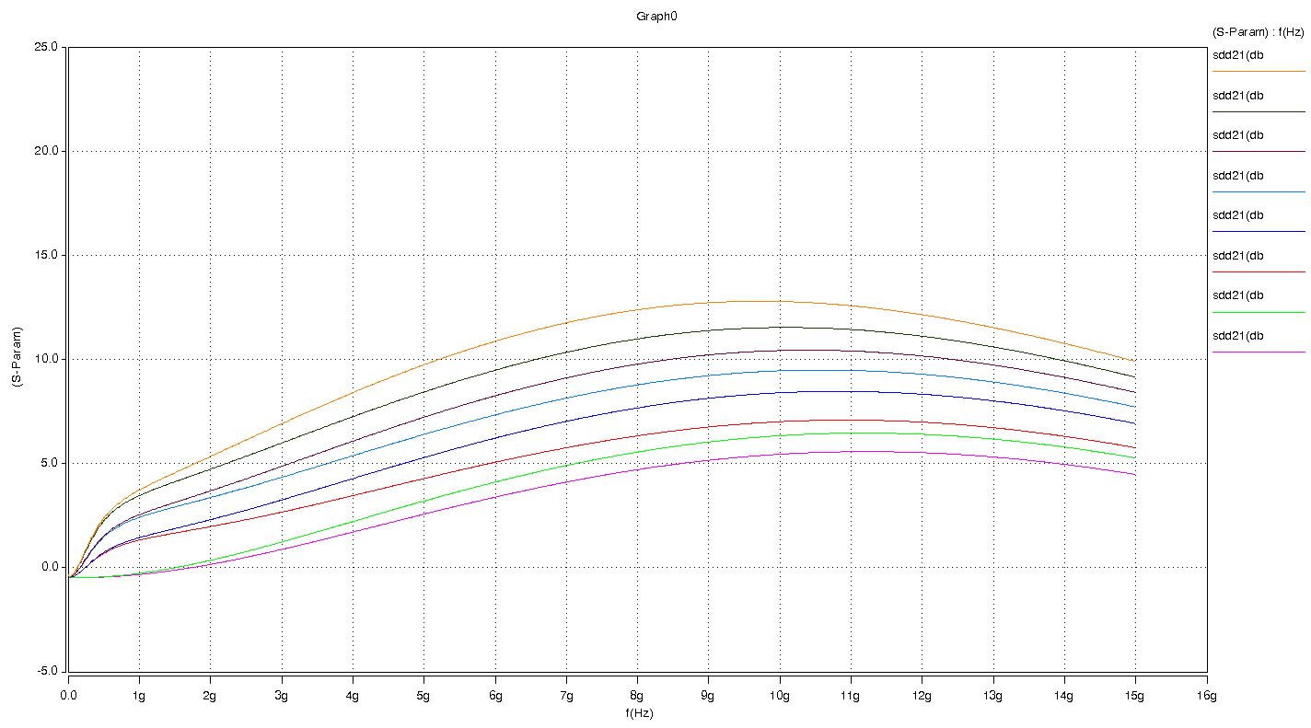

- EQ value table:
4 ports S-parameter differential insertion loss @ 100meg, 2GHz, 4GHz, 6GHz, 8GHz and 10GHz (unit: dB)

Model result:
EQ | 100MEG | 2G | 4G | 6G | 8G | 10G
0 | -0.46 | 0.17 | 1.72 | 3.40 | 4.71 | 5.45
1 | -0.46 | 0.36 | 2.22 | 4.12 | 5.56 | 6.35
2 | -0.36 | 1.98 | 3.47 | 5.07 | 6.34 | 7.02
3 | -0.35 | 2.32 | 4.29 | 6.23 | 7.68 | 8.41
4 | -0.27 | 3.38 | 5.39 | 7.35 | 8.79 | 9.46
5 | -0.27 | 3.70 | 6.09 | 8.26 | 9.78 | 10.43
6 | -0.17 | 4.74 | 7.26 | 9.49 | 10.99 | 11.54
7 | -0.16 | 5.35 | 8.42 | 10.88 | 12.39 | 12.79

Measurement result :

COMMENTS: Only measurement GAIN curves are provided which has good match with the simulation results .(mismatch is less than -0.5 dB in comparison between curve values )

- FG = 3

FG=3 | Differential Insertion Loss
EQ=0~7  SW=1000mV | 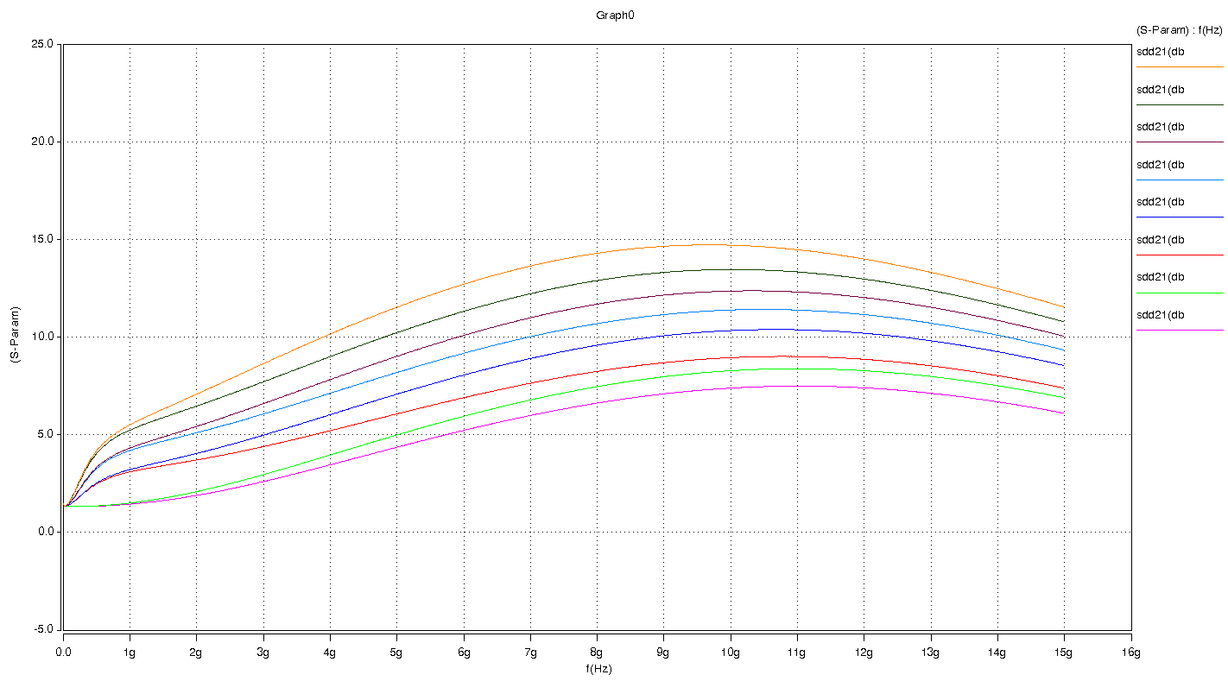

- EQ value table:
4 ports S-parameter differential insertion loss @ 100meg, 2GHz, 4GHz, 6GHz, 8GHz and 10GHz (unit: dB)

Model result:
EQ | 100MEG | 2G | 4G | 6G | 8G | 10G
0 | 1.34 | 1.90 | 3.47 | 5.23 | 6.63 | 7.39
1 | 1.34 | 2.10 | 3.97 | 5.95 | 7.47 | 8.28
2 | 1.44 | 3.72 | 5.21 | 6.90 | 8.25 | 8.95
3 | 1.44 | 4.05 | 6.03 | 8.06 | 9.59 | 10.34
4 | 1.53 | 5.11 | 7.13 | 9.18 | 10.70 | 11.39
5 | 1.53 | 5.43 | 7.83 | 10.09 | 11.69 | 12.36
6 | 1.63 | 6.48 | 9.01 | 11.33 | 12.90 | 13.47
7 | 1.64 | 7.09 | 10.17 | 12.71 | 14.30 | 14.71

Measurement result :

COMMENTS: Only measurement GAIN curves are provided which has good match with the simulation results .(mismatch is less than -0.5 dB in comparison between curve values )

Transient Characteristics
PI3EQX16904GL
24inch trace
Trace_in
Output
Transient  Simulation | OUTPUT of transient waveform | OUTPUT of eye diagram
FG=0  EQ=0 | 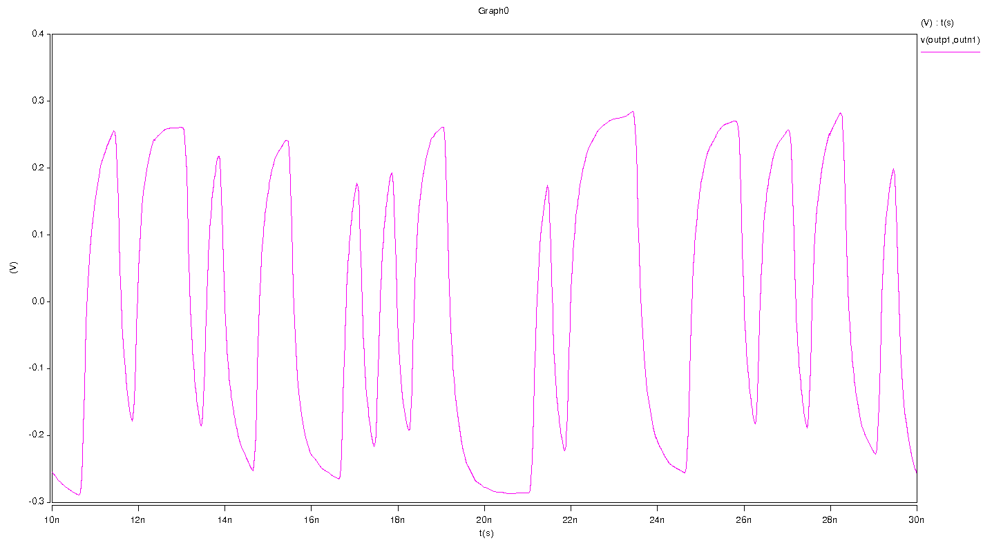 | 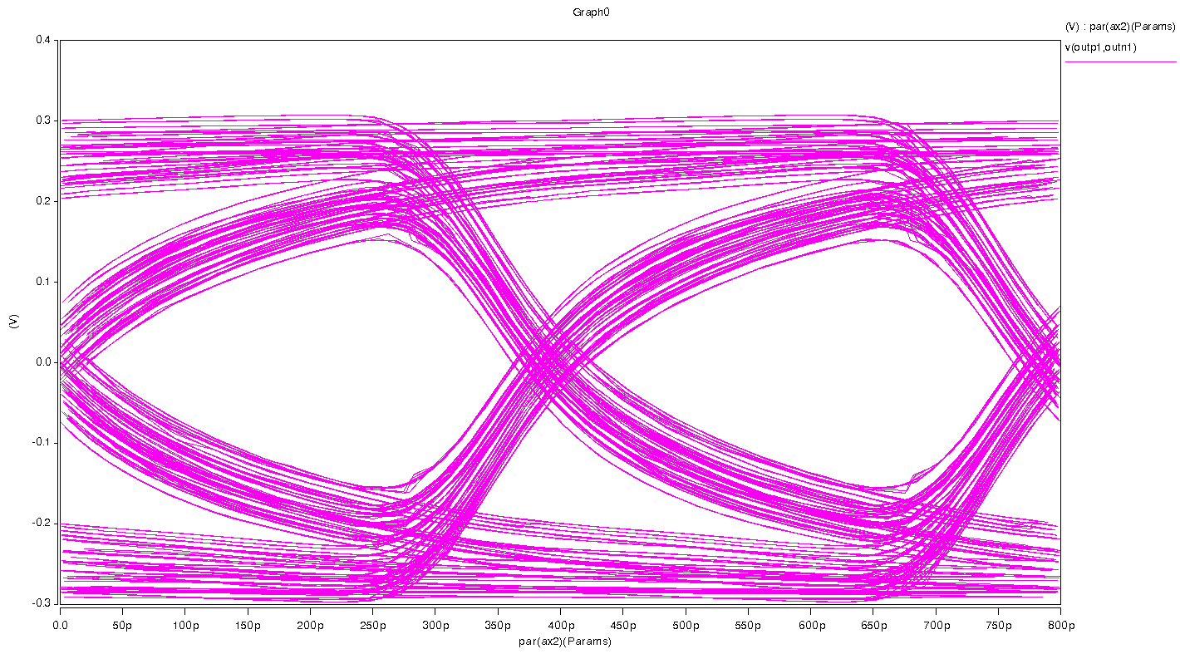
FG=3  EQ=7 | 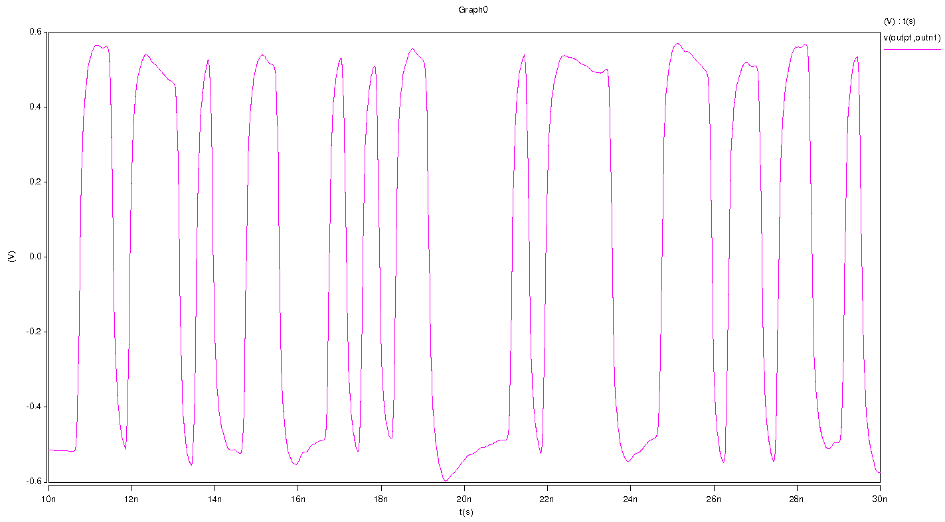 | 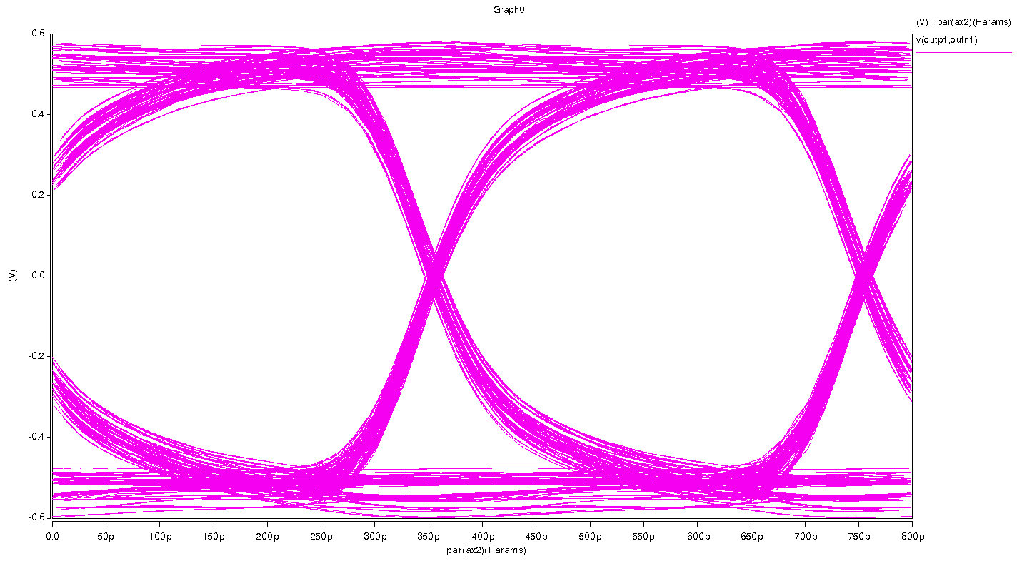

Step Response of the S-parameter model (input Tr=50ps)
PI3EQX16904GL
24inch trace
Trace_in
Output

Step  Response | Waveform
FG=0  EQ=0 | 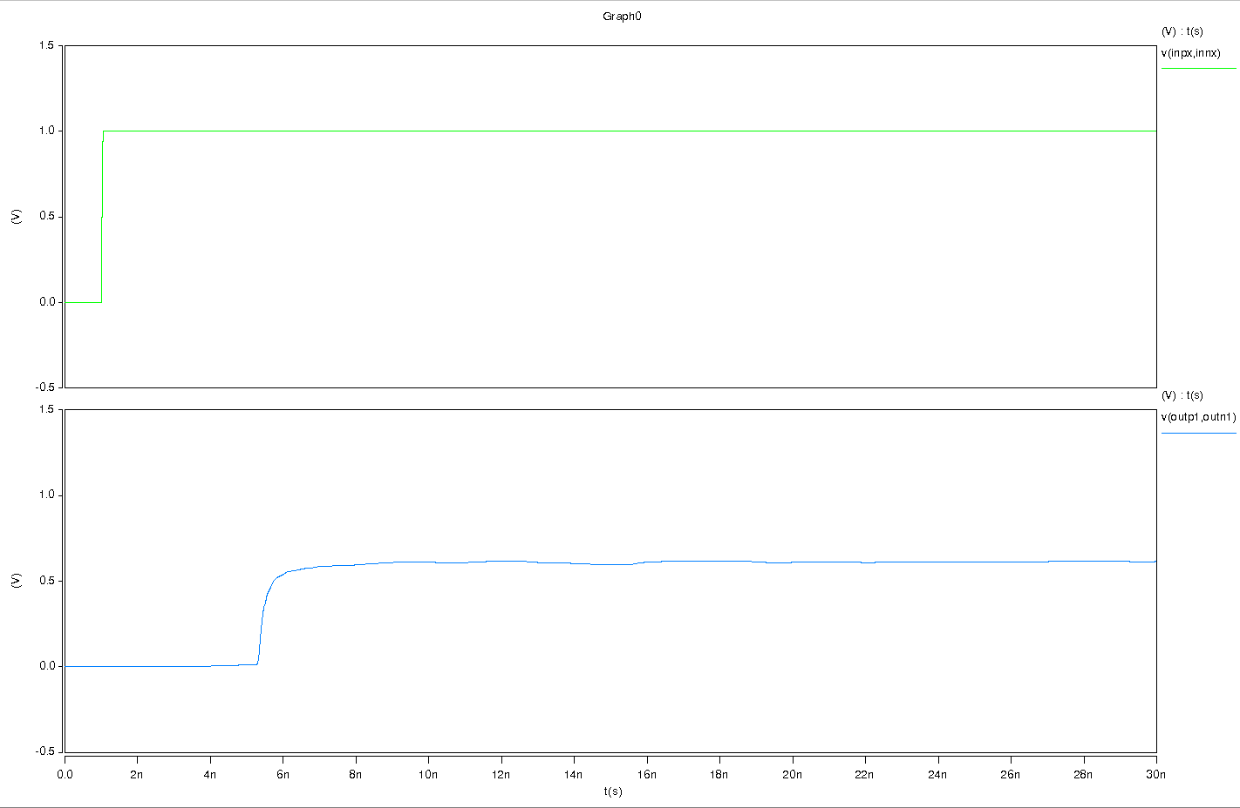
FG=3  EQ=7 | 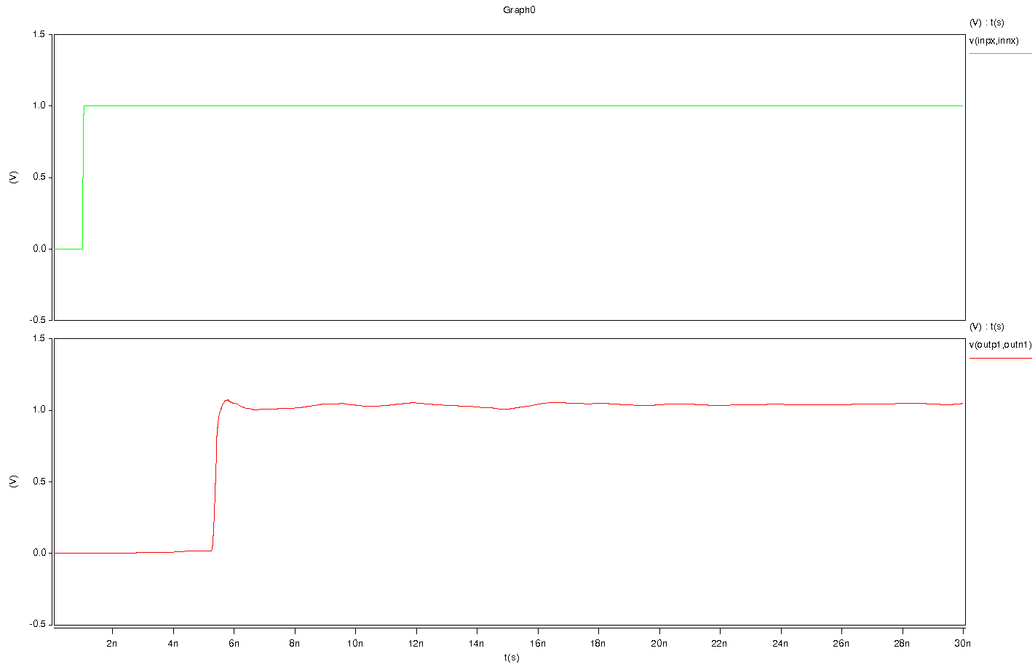

Characteristic Impedance of the S-parameter model
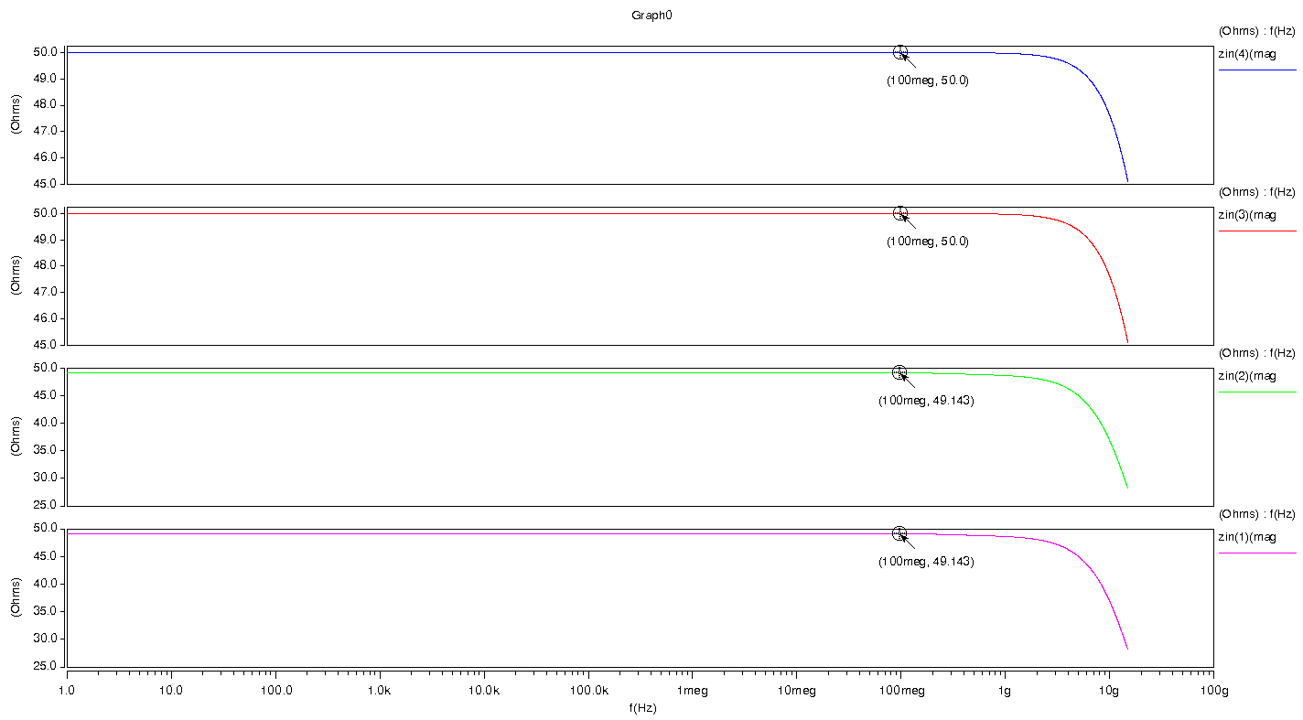

- The characteristic impedance of the Port1 is 49.143 ohm at 100meg;
- The characteristic impedance of the Port2 is 49.143 ohm at 100meg;
- The characteristic impedance of the Port3 is 50.0 ohm at 100meg;
- The characteristic impedance of the Port4 is 50.0 ohm at 100meg.

